impact of a compressive stress on water sorption and diffusion in ionomer membranes for fuel cells.
A ¹h-nmr study in vapor-equilibrated nafion.

Assma El Kaddouri^{1,2,*}, Jean-Christophe Perrin^{1,2}, Thibaut Colinart³, Christian Moyne^{1,2}, Sébastien Leclerc^{1,2}, Laouès Guendouz⁴, Olivier Lottin^{1,2}

¹ Université de Lorraine, LEMTA, UMR 7563, Vandœuvre-lès-Nancy, F-54500, France
² CNRS, LEMTA, UMR 7563, Vandœuvre-lès-Nancy, F-54500, France
³ Univ. Bretagne Sud, FRE CNRS 3744, IRDL, F-56100 Lorient, France
⁴ Institut Jean-Lamour, UMR 7198, CNRS, Université́ de Lorraine, Vandœuvre-lès-Nancy, F- 54500, France

SUPPORTING INFORMATION
- Calibration of compressive stress

A calibration of the applied stress against pressure within the NMR setup was performed using a force sensor LLB 250 purchased from Andilog. The sensor was placed between the piston and the chamber cap, with and without the porous quartz discs in order to study their influence on the measured compressive stress (Figure 1). No significant change is observed between the measured force with and without the porous quartz in the range of 0 to 8 bars.

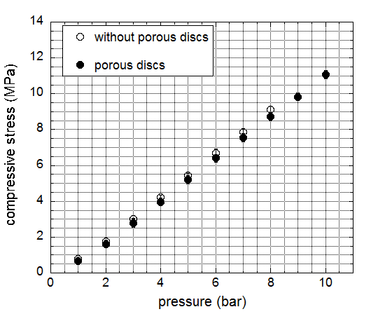
Figure 1. Calibration curve: experimental compression stress versus gas pressure applied in the chamber for the compression set up with (filled dots) and without (unfilled dots) porous discs.
- Water self-diffusion coefficient (D_{s})
The attenuation of the spin echo signal as a function of the gradient intensity g_{y} was measured in two vapor-equilibrated membrane conditions (61 and 95%RH), the logarithm of the ratio between the signal S and S₀ (i.e. S at g = 0 T/m⁻¹) as function of g_{y}² (T²/m⁻²) is represented in Figure 2. For a given RH, the NMR experiments were performed with same gradient duration δ and diffusion time Δ. The experimental data are fitted with single coefficient diffusion for both vapor relative humidity condition. The comparison between membrane under compressive stress and at initial state, for 61%RH and 95%RH, show a lower slope under applied stress which outlines a slower attenuation of spin echo signal when the membrane undergoes compressive stress, and therefore illustrates the significant decrease of D_{y} with the compressive stress.
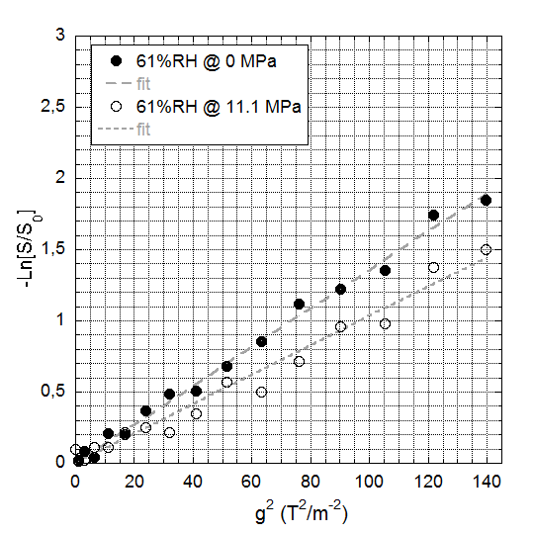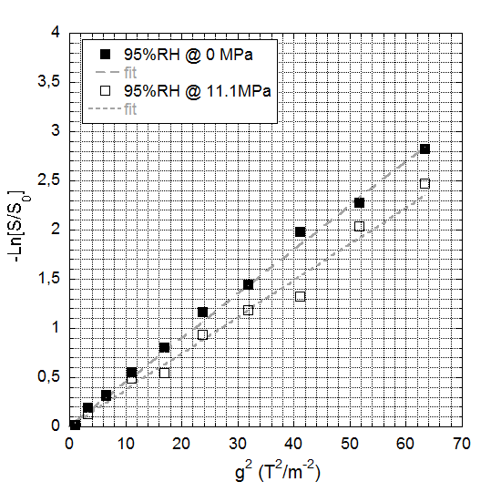

Figure 2. PGSTE NMR experimental fitting data of Nafion® N1110 under vapor relative humidity controlled condition at 24°C: (left) 61%RH, (right) 95%RH. Comparison between membrane at initial condition (0MPa) and membrane undergoing an applied stress of 11.1 MPa.
Dg

- Validation of the NMR setup for PFGNMR measurements
Measurements of bulk water self-diffusion were performed as a validation test for our compression cell. A small distilled water flask was placed in the compression cell. The experiments were performed with stainless steel screws, with brass screws and without screws in the $x$, $y$ and $z$ directions at 24 ± 2 °C. The results are shown on Figure 3. The measured values in the reference case (without screws) match the tabulated value for bulk water at the same temperature ¹. With the stainless steel screws, artifacts appear in the data as a supplementary attenuation in the echo signal and the values of the diffusion coefficients are overestimated in all the directions. Brass screws have been chosen for all the experiments presented in the main paper since, as seen on the figure, the measured values correspond to the reference, within the experimental errors.

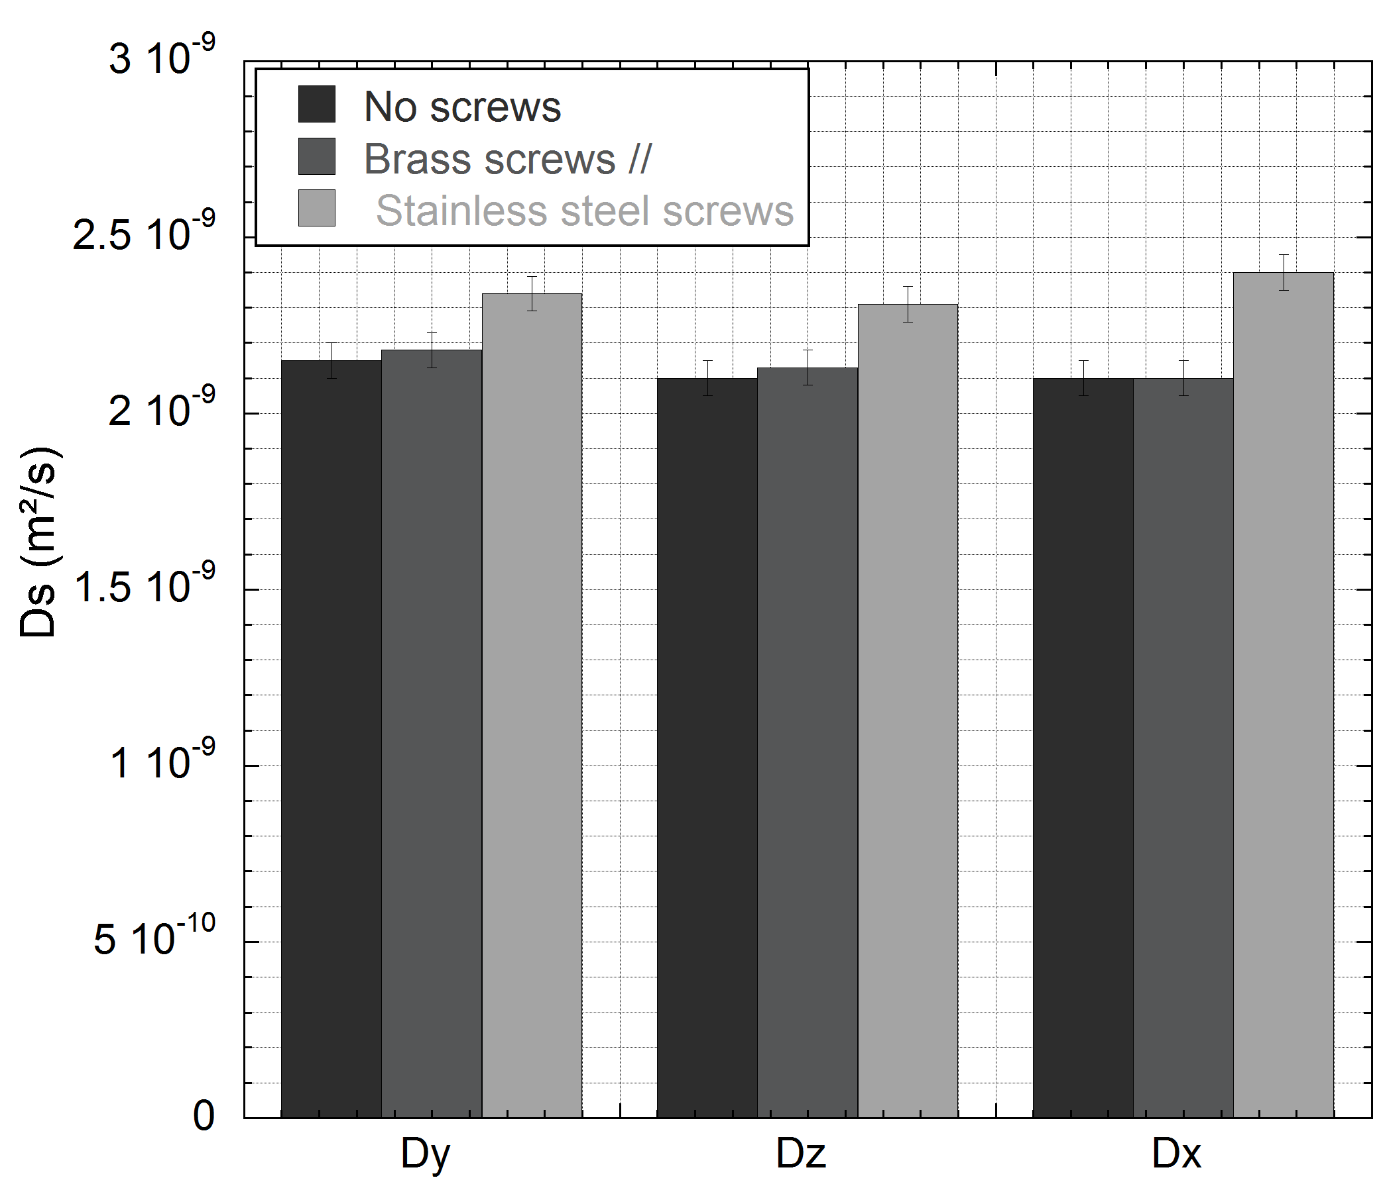
Figure 3. Bulk water self-diffusion coefficient measured at $24±2°C$ in the $x$, $y$ and $z$ directions when distilled water is placed in the compression cell equipped with stainless steel screws and brass screws. The results are compared to the reference case (without screws).

- NMR chemical shift
The evolution of chemical shift with respect to the inverse water content compared to chemical shift at dry state (λ=0) is plotted in Figure 4. Measurements were performed with and without compressive stress. As displayed in Figure 4, the calibration curve of chemical shift shows a different trend line for the membrane under a compressive stress (
Table 1). Therefore, as explained in the main paper, the chemical shift cannot be used as efficient parameter to follow the absolute water content in membrane under compressive stress.
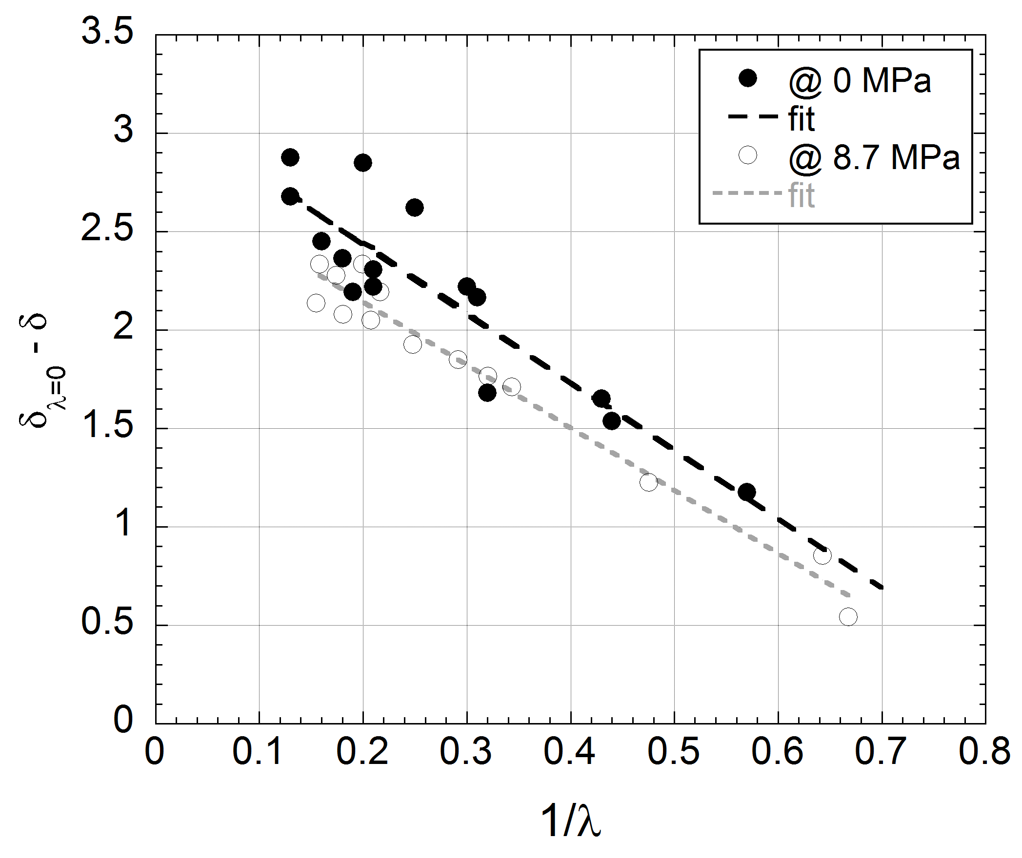
Figure 4. Calibration curve of chemical shift as a function of the inverse water content at 0MPa and 8.7MPa.
compressive stress (MPa) | a | b
0 | -3.51 | 3.15
8.7 | 3.19 | 2.78

Table 1. Coefficients of linear ax+b function used to fit the chemical shift versus the inverse water content with and without stress.

(1) Holz, M.; Heil, S. R.; Sacco, A. Temperature-dependent self-diffusion coefficients of water and six selected molecular liquids for calibration in accurate H-1 NMR PFG measurements. Physical Chemistry Chemical Physics 2000, 2, (20), 4740-4742.

* corresponding author

