Supplemental Material

Additional file: Table S1. Baseline characteristics of the study population by screening renal function strata
Characteristics | eGFR≥60 stratum | eGFR<60 stratum | p-value
N. | 3946 | 1434
Age (yrs), mean ± SD | 59.0 ± 9.4 | 66.0 ± 9.5 | <0.001
Age ≥65 yrs | 1103 (28.0%) | 804 (56.1%) | <0.001
Male sex | 2840 (72.0%) | 811 (56.6%) | <0.001
Diabetes duration (yrs), median (IQR) | 6.3 (2.3, 11.8) | 10.3 (4.4, 17.0) | <0.001
BMI (kg/m²), mean ± SD | 29.6 ± 5.5 | 29.3 ± 5.8 | 0.080
Race |  |  | <0.001
White | 2935 (74.4%) | 974 (67.9%)
Asian | 729 (18.5%) | 360 (25.1%)
Black | 162 (4.1%) | 54 (3.8%)
Other | 120 (3.0%) | 46 (3.2%)
Geographic Region |  |  | <0.001
United States, Canada | 626 (15.9%) | 227 (15.8%)
Mexico, Central/South America | 1014 (25.7%) | 379 (26.4%)
Western Europe, Australia, New Zealand, Middle East | 474 (12.0%) | 142 (9.9%)
Eastern Europe, Africa | 1162 (29.4%) | 346 (24.1%)
Asia/Pacific | 670 (17.0%) | 340 (23.7%)
Smoking | 627 (15.9%) | 107 (7.5%) | <0.001
Hypertension | 3176 (80.5%) | 1293 (90.2%) | <0.001
Previous MI | 3459 (87.7%) | 1275 (88.9%) | 0.21
PCI | 2501 (63.4%) | 871 (60.7%) | 0.077
CABG | 458 (11.6%) | 230 (16.0%) | <0.001
HF history | 975 (24.7%) | 558 (38.9%) | <0.001
Previous stroke | 234 (5.9%) | 154 (10.7%) | <0.001
PAD | 309 (7.8%) | 205 (14.3%) | <0.001
AFib | 209 (5.3%) | 167 (11.6%) | <0.001
eGFR* (ml/min/1.73m²), mean ± SD | 79.5 ± 16.8 | 47.4 ± 13.7 | <0.001
Index ACS Event Type |  |  | 0.36
Myocardial Infarction | 3034 (77.1%) | 1118 (78.2%)
Unstable Angina | 903 (22.9%) | 311 (21.8%)
Time from index ACS to randomization, median (IQR) | 44.0 (30.0, 63.0) | 43.0 (30.0, 65.0) | 0.90
Troponin I (ng/L), median (IQR) | 7.7 (4.0, 16.9) | 13.3 (6.7, 29.2) | <0.001
Heart rate (bpm), mean ± SD | 71.5 ± 10.6 | 70.8 ± 11.2 | 0.031
SBP (mmHg), mean ± SD | 128.2 ± 16.3 | 131.1 ± 17.4 | <0.001
DBP (mmHg), mean ± SD | 76.8 ± 9.4 | 75.4 ± 10.2 | <0.001
Total cholesterol (mg/dL), mean ± SD | 152.6 ± 42.7 | 159.2 ± 46.5 | <0.001
LDL cholesterol (mg/dL), mean ± SD | 43.0 ± 10.4 | 43.4 ± 11.2 | 0.23
HDL cholesterol (mg/dL), mean ± SD | 77.3 ± 33.4 | 82.2 ± 37.9 | <0.001
Triglycerides (mg/dL), mean ± SD | 163.2 ± 107.1 | 168.2 ± 94.5 | 0.12
UACR (mg/g creat.), median (IQR) | 3.4 (1.6, 10.0) | 9.7 (2.9-50.6) | <0.001
C-reactive protein (mg/dL), mean ± SD | 5.1 ± 12.3 | 6.9 ± 17.0 | <0.001
Antiplatelet agents | 3844 (97.4%) | 1388 (96.8%) | 0.22
Beta-blockers | 3247 (82.3%) | 1164 (81.2%) | 0.35
ACEi/ARBs | 3267 (82.8%) | 1144 (79.8%) | 0.011
Statins | 3594 (91.1%) | 1272 (88.7%) | 0.009
Antidiabetic agents | 3916 (99.2%) | 1409 (98.3%) | 0.002
Insulin | 1076 (27.3%) | 529 (36.9%) | <0.001
Metformin | 2861 (72.5%) | 701 (48.9%) | <0.001
Thiazolidinediones | 83 (2.1%) | 48 (3.3%) | 0.009
Sulfonylureas | 1873 (47.5%) | 630 (43.9%) | 0.022
Calcium channel blockers | 763 (19.3%) | 434 (30.3%) | <0.001
Diuretics (any) | 1240 (31.4%) | 774 (54.0%) | <0.001
Legend: MI, myocardial infarction; PCI, percutaneous coronary intervention; CABG, coronary-artery bypass grafting; HF, heart failure; PAD, peripheral artery disease; AFib, atrial fibrillation; eGFR, estimated glomerular filtration rate; ACS, acute coronary syndrome; SBP, systolic blood pressure; DBP diastolic blood pressure; ACEi/ARBs, angiotensin converting enzyme inhibitors/angiotensin receptor blockers; UACR, urinary albumin-to-creatinine ratio.
*eGFR at randomization, that occurred 9 (7-13) days after the baseline visit.
Stratification according to renal function was performed at the baseline visit, as follows: 1) “normal renal function” stratum if eGFR ≥60 ml/min/1.73m² or 2) “impaired renal function” stratum if eGFR <60 ml/min/1.73m².

Additional file: Table S2. Baseline and changes from baseline to the last visit for lipoproteins, UACR and estimated glomerular filtration rate
Variable change | Placebo | Alogliptin | P-value* | Inter. P
eGFR ≥60 stratum
Total cholesterol (mg/dL)
Baseline | 153±42 | 152±43 | 0.19
Last visit: change from baseline | 14±44 | 14±44 | 0.62 | 0.56
HDL cholesterol (mg/dL)
Baseline | 43±10 | 43±11 | 0.25
Last visit: change from baseline | 1.7±8.4 | 1.5±8.6 | 0.34 | 0.23
LDL cholesterol (mg/dL)
Baseline | 78±34 | 77±33 | 0.17
Last visit: change from baseline | 9.3±34.4 | 9.0±33.6 | 0.78 | 0.27
Triglycerides (mg/dL)
Baseline | 165±108 | 161±105 | 0.18
Last visit: change from baseline | 21±171 | 17±142 | 0.48 | 0.49
eGFR change from baseline | 0.3±15 | -0.4±14 | 0.11 | 0.15
U albumin/creatinine ratio (mg/g of creatinine)
Baseline | 17.5±54.1 | 18.1±69.1 | 0.83
12 months: change from baseline | 1.7±7.1 | 1.0±4.1 | 0.042 | 0.96
eGFR<60 stratum
Total cholesterol (mg/dL)
Baseline | 158±46 | 160±47 | 0.62
Last visit: change from baseline | 10±47 | 9±41 | 0.55 | 0.56
HDL cholesterol (mg/dL)
Baseline | 44±11 | 43±11 | 0.25
Last visit: change from baseline | 1.7±9.7 | 1.7±9.7 | 0.94 | 0.23
LDL cholesterol (mg/dL)
Baseline | 81±37 | 83±39 | 0.24
Last visit: change from baseline | 6.8±38.8 | 4.7±33.4 | 0.29 | 0.27
Triglycerides (mg/dL)
Baseline | 168±98 | 167±91 | 0.84
Last visit: change from baseline | 7±93 | 11±99 | 0.39 | 0.49
eGFR change from baseline | 0.1±11 | -0.9±11 | 0.11 | 0.15
U albumin/creatinine ratio (mg/mmol of creatinine)
Baseline | 67.8±152 | 74.1±167 | 0.53
12 months: change from baseline | 2.4±17.3 | 5.1±46.4 | 0.33 | 0.96
Legend: HDL, high-density lipoprotein; LDL, low-density lipoprotein; eGFR, estimated glomerular filtration rate in ml/min/1.73m²; Inter. P, p-value for interaction between eGFR strata and treatment allocation for each outcome in a linear regression model.
*non-parametric comparisons provide similar results.

Additional file: Table S3. Major study end-points: event rates (per 100py) and event rate comparison
End-point | Placebo | Alogliptin | ARD (95%CI) | P-value*
eGFR ≥60 stratum
Primary end-point | 6.5 (5.6-7.4) | 5.2 (4.4-6.1) | -1.3 (-2.4 to -0.4) | 0.042
Components of the primary end-point
Cardiovascular death | 1.9 (1.5-2.5) | 1.2 (0.8-1.62) | -0.7 (-1.4 to -0.1) | 0.018
Non-fatal MI | 3.8 (3.1-4.5) | 3.3 (2.7-4.0) | -0.5 (-1.4 to +0.4) | 0.27
Non-fatal stroke | 0.6 (0.4-1.0) | 0.7 (0.4-1.0) | +0.1 (-0.3 to +0.5) | 0.78
Secondary end-point | 7.7 (6.8-8.8) | 6.3 (5.5-7.3) | -1.4 (-2.8 to -0.1) | 0.042
All-cause death | 2.9 (2.3-3.5) | 2.3 (1.9-2.9) | -0.5 (-1.3 to +0.3) | 0.22
All cardiovascular deaths | 2.3 (1.8-2.9) | 1.4 (1.0-1.9) | -0.9 (-1.6 to -0.2) | 0.008
Heart failure hospitalization | 1.4 (1.0-1.9) | 1.4 (1.1-1.9) | -0.01 (-0.5 to +0.6) | 0.95
eGFR <60 stratum
Primary end-point | 12.1 (10.2-14.5) | 14.6 (12.5-17.2) | +2.5 (-0.7 to +5.7) | 0.13
Components of the primary end-point
Cardiovascular death | 4.7 (3.5-6.1) | 4.7 (3.6-6.2) | +0.1 (-1.8 to +1.9) | 0.95
Non-fatal MI | 5.8 (4.5-7.5) | 8.6 (7.0-10.6) | +2.8 (+0.5 to +5.1) | 0.017
Non-fatal stroke | 1.2 (0.7-2.1) | 0.7 (0.4-1.5) | -0.5 (-1.3 to +0.4) | 0.28
Secondary end-point | 13.2 (11.1-15.6) | 15.5 (13.2-18.1) | +2.3 (-0.9 to + 5.6) | 0.17
All-cause death | 7.7 (6.2-9.5) | 7.2 (5.7-8.9) | -0.5 (-2.7 to +1.8) | 0.66
All cardiovascular deaths | 5.3 (4.1-6.8) | 6.2 (4.9-7.8) | +0.9 (-1.1 to +2.3) | 0.40
Heart failure hospitalization | 4.4 (3.3-5.8) | 5.9 (4.6-7.6) | +1.6 (-0.3 to +3.5) | 0.12
*P-values for interaction, as follows:
- Primary outcome: treatment allocation (alogliptin or placebo) * eGFR stratum, interaction P =0.018
- Cardiovascular death: treatment allocation (alogliptin or placebo) * eGFR stratum, interaction P =0.076
- Non-fatal MI: treatment allocation (alogliptin or placebo) * eGFR stratum, interaction P =0.016
- Non-fatal stroke: treatment allocation (alogliptin or placebo) * eGFR stratum, interaction P =0.29
- Secondary end-point: treatment allocation (alogliptin or placebo) * eGFR stratum, interaction P =0.028
- All-cause death: treatment allocation (alogliptin or placebo) * eGFR stratum, interaction P =0.57
- All cardiovascular deaths: treatment allocation (alogliptin or placebo) * eGFR stratum, interaction P =0.012
- Heart failure hospitalization: treatment allocation (alogliptin or placebo) * eGFR stratum, interaction P =0.33
The primary end-point was a composite of cardiovascular death, non-fatal MI and non-fatal stroke
The secondary end point was a composite of death from cardiovascular causes, nonfatal myocardial infarction, nonfatal
stroke, or urgent revascularization due to unstable angina within 24 hours after hospital admission.
Legend: MI, myocardial infarction; ARD, absolute risk difference.

Additional file: Table S4. eGFR changes between the baseline and randomization visit
Placebo group
eGFR categories | Baseline: eGFR ≥60 | Baseline: eGFR <60
Randomization: eGFR ≥60 | 1769 (90.1%) | 117 (16.3%)
Randomization: eGFR <60 | 194 (9.9%) | 599 (83.4%)
Alogliptin group
eGFR categories | Baseline: eGFR ≥60 | Baseline: eGFR <60
Randomization: eGFR ≥60 | 1812 (91.4%) | 117 (16.3%)
Randomization: eGFR <60 | 171 (8.6%) | 601 (83.7%)
eGFR, estimated glomerular filtration rate in ml/min/1.73m2
eGFR at randomization occurred 9 (7-13) days after the baseline visit where the stratification was performed.

Additional file: Figure S1. Changes from baseline by treatment arm (within each eGFR stratum) for total, LDL and HDL cholesterol, body mass index, creatinine, eGFR, UACR, systolic and diastolic blood pressure, and c-reactive protein.

- Total cholesterol
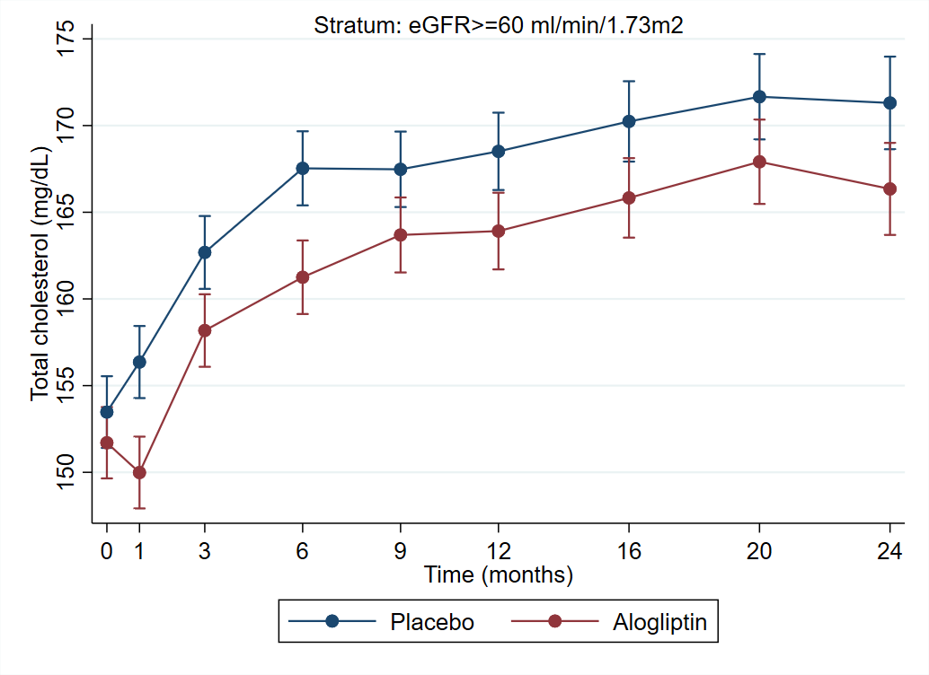
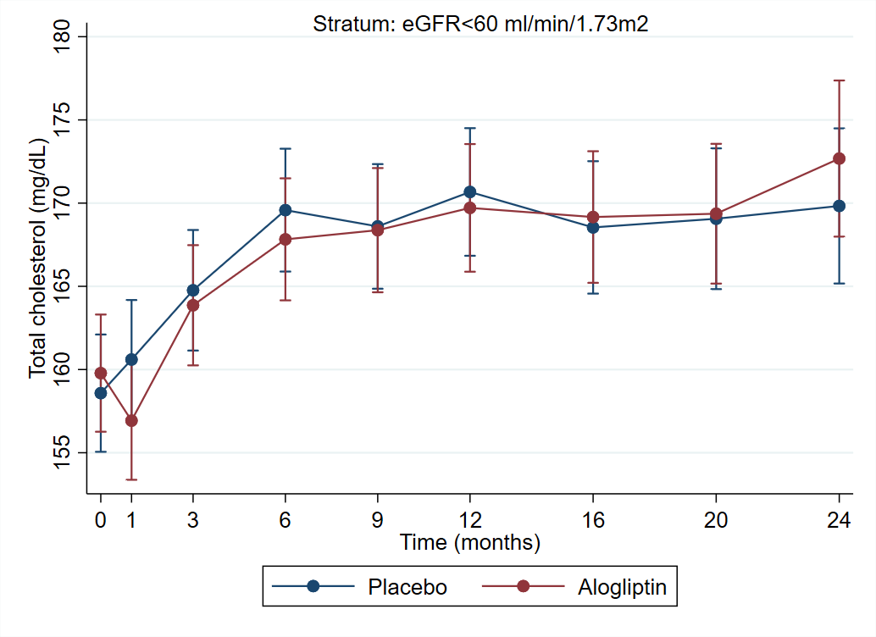

- HDL cholesterol
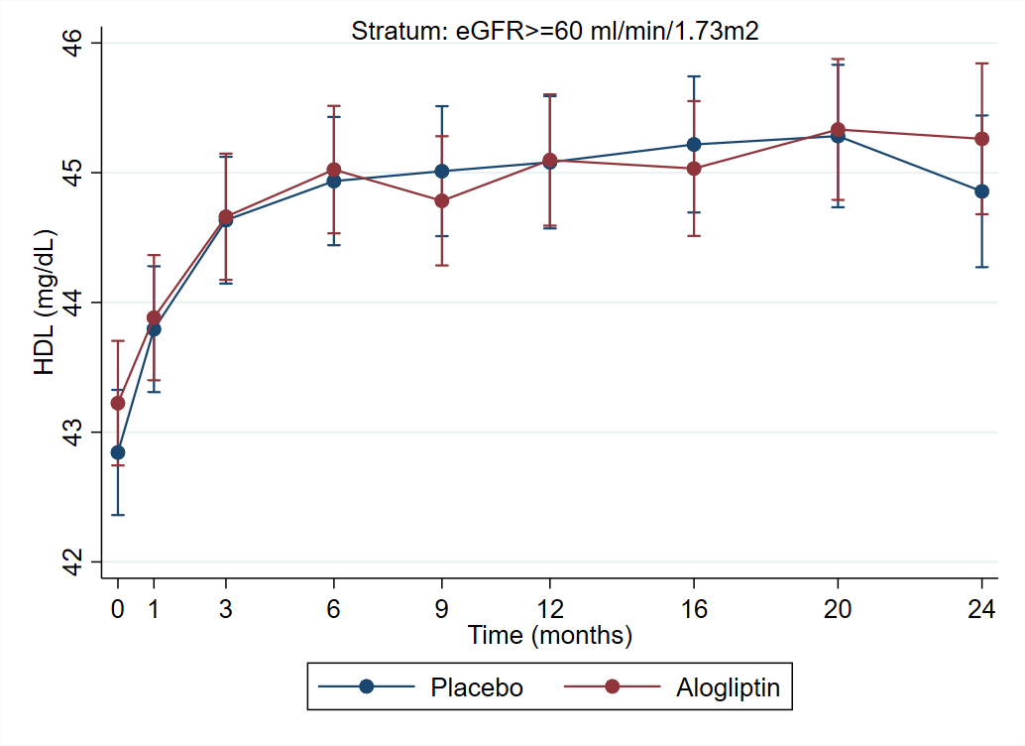

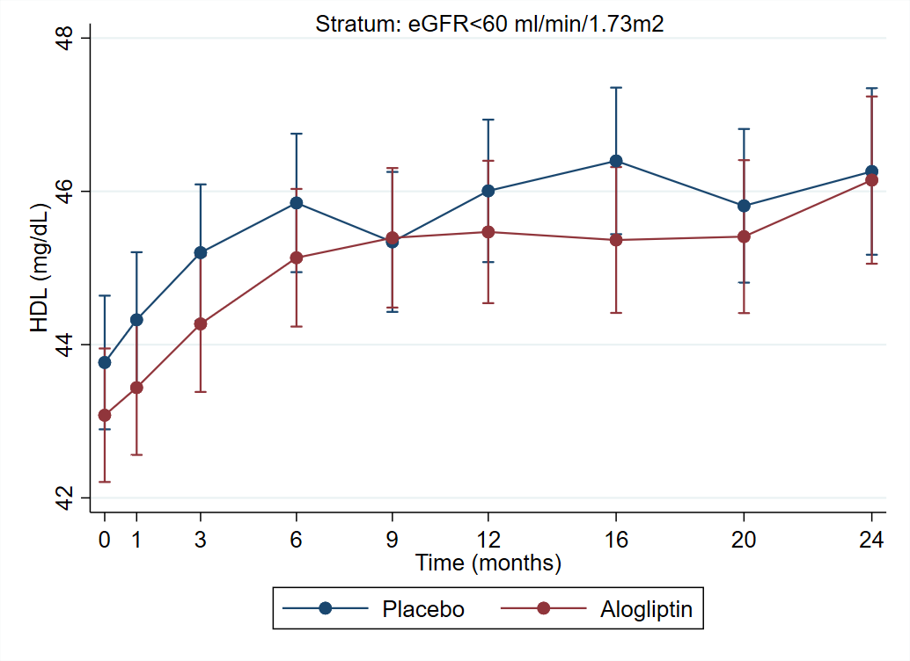

- LDL cholesterol
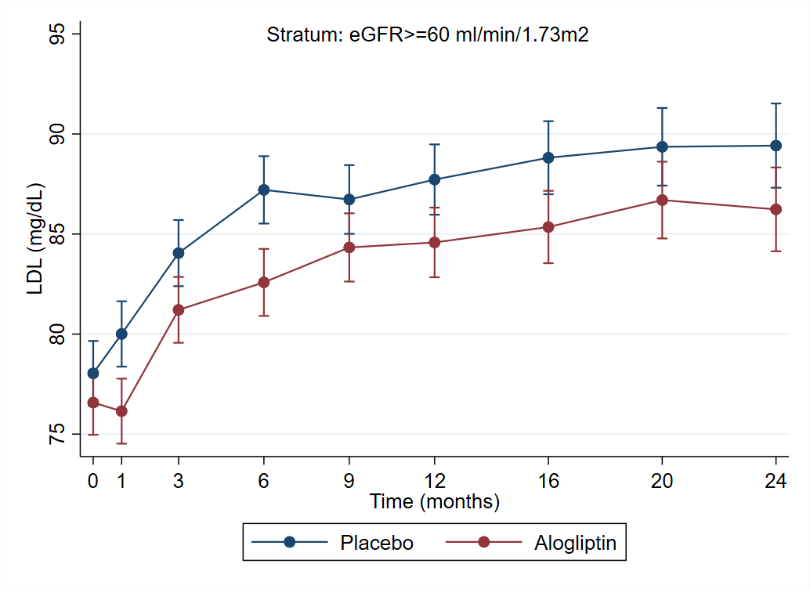
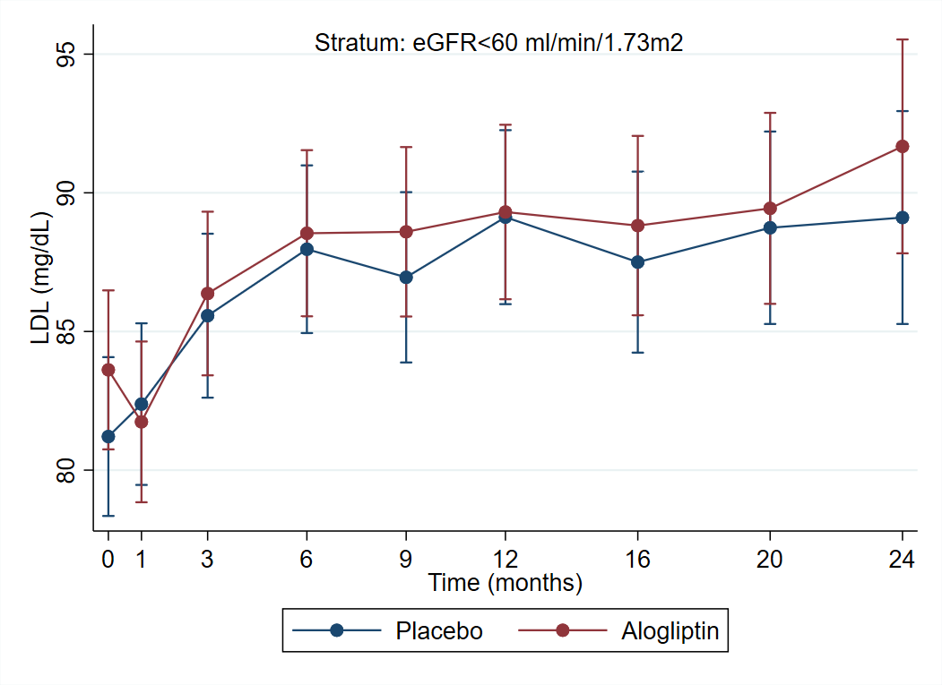

- Triglycerides
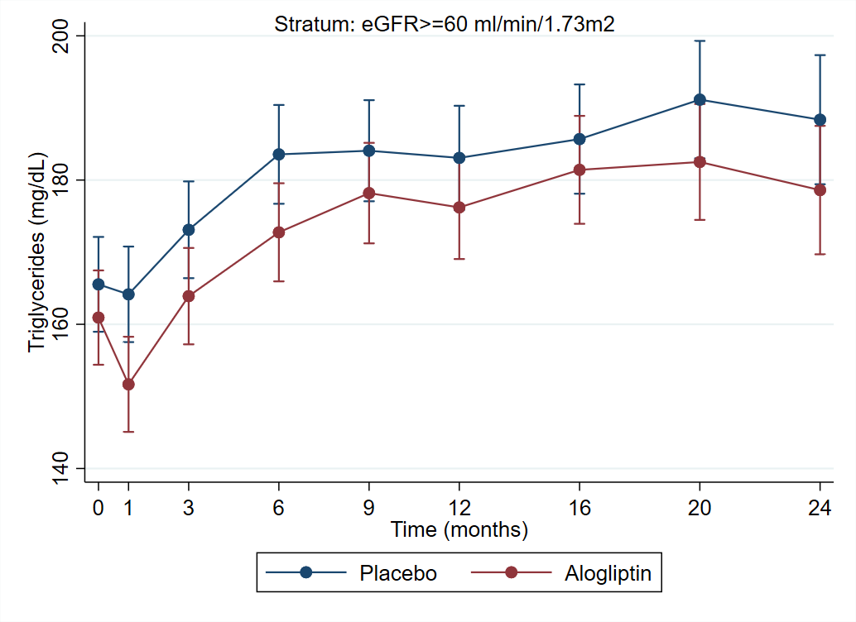
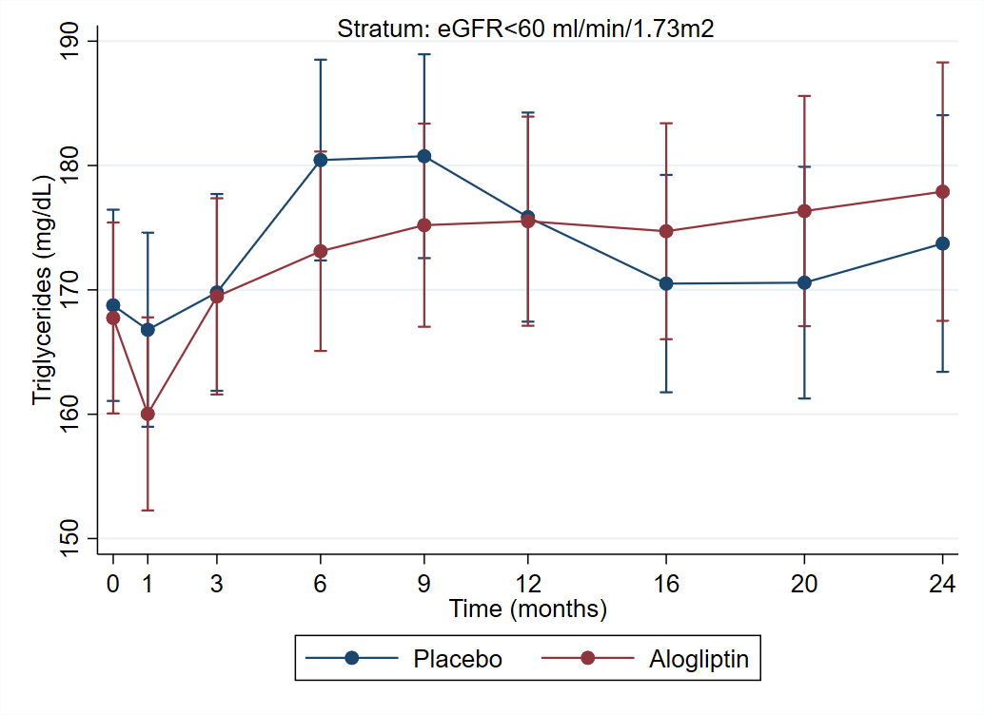

- SBP
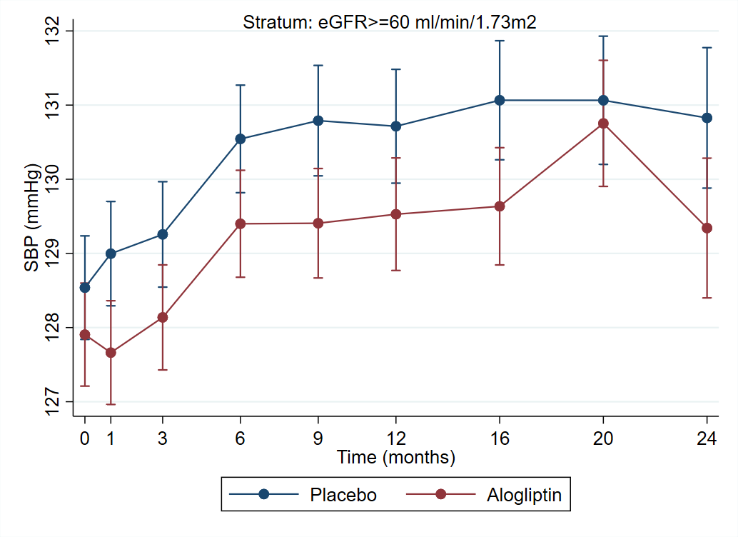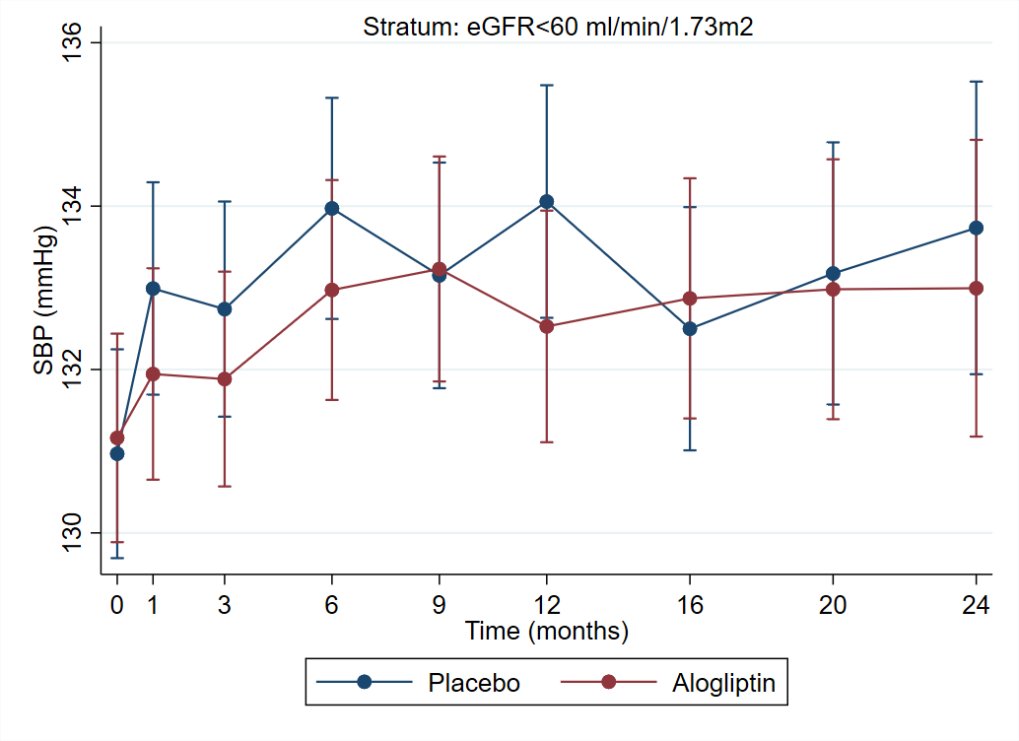

- DBP
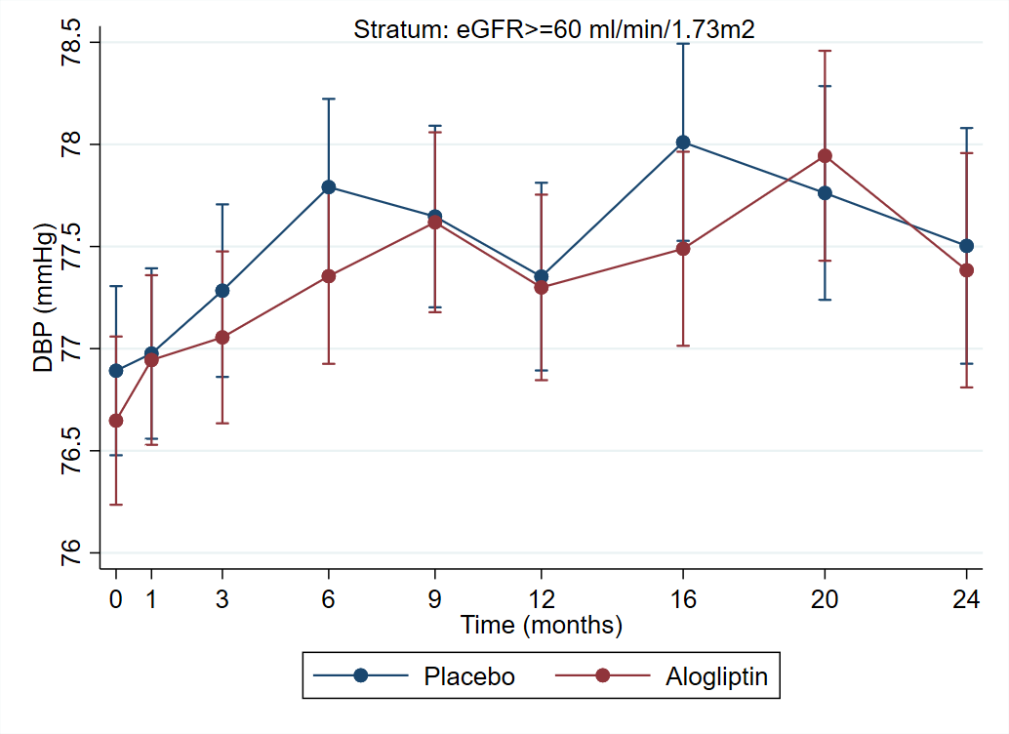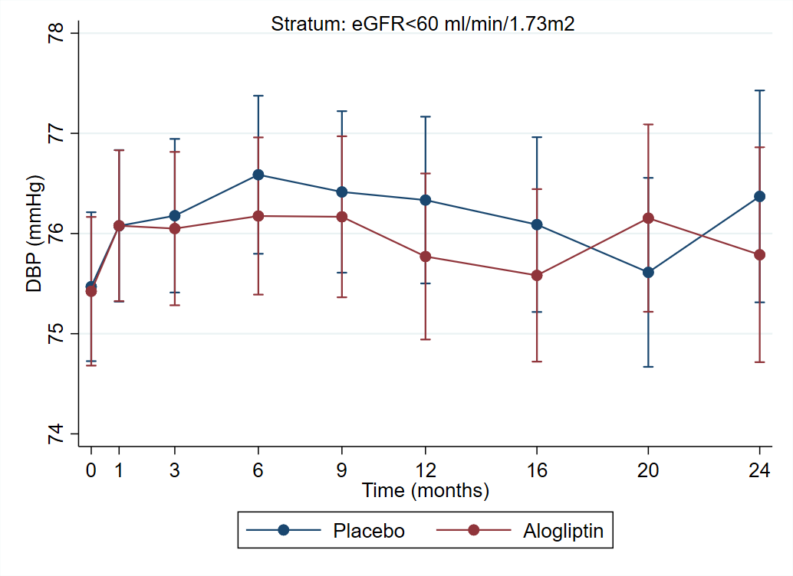

- BMI
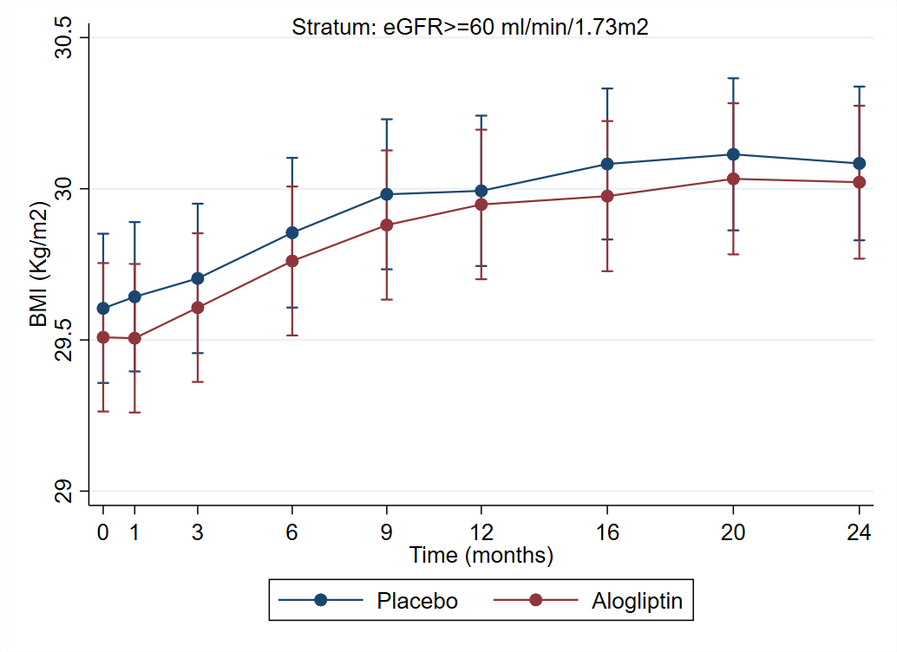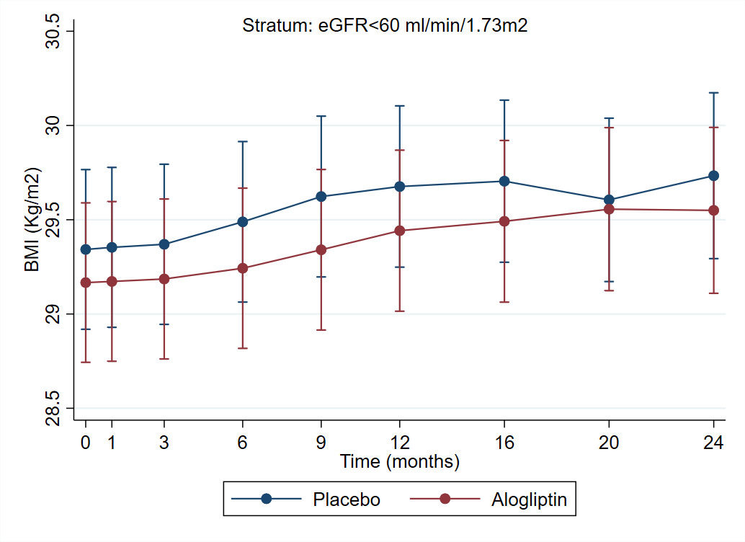

- Creatinine
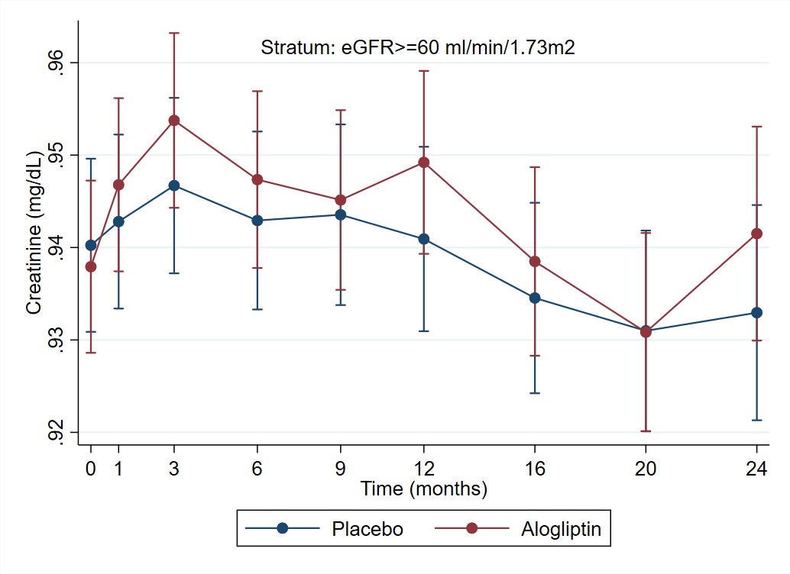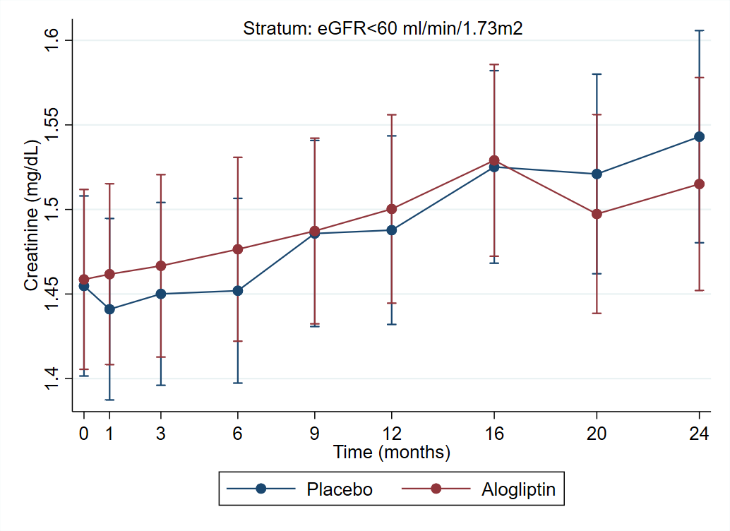

- eGFR
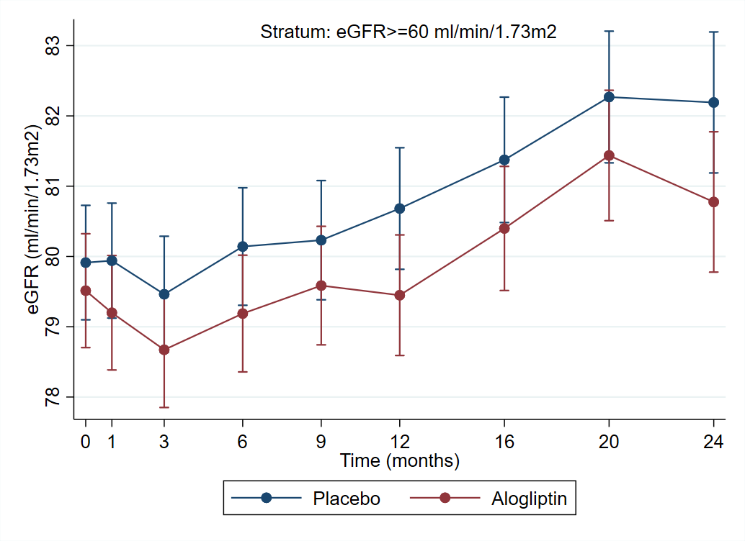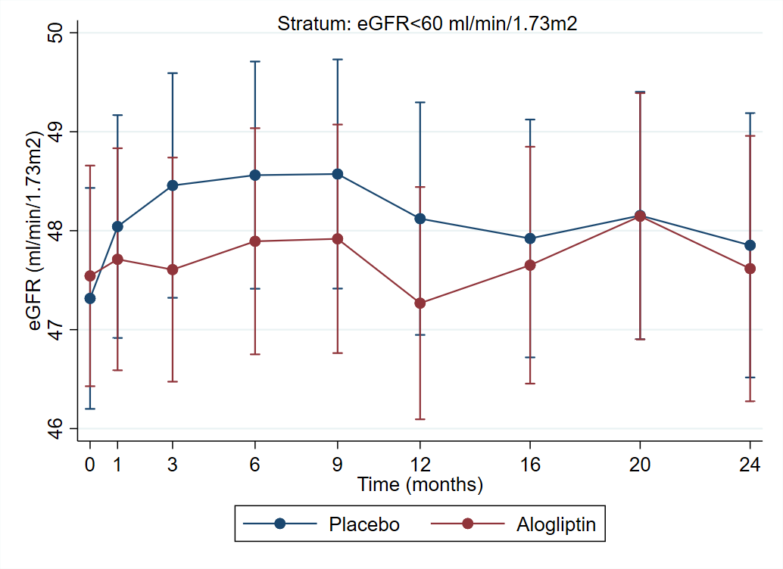

- UACR
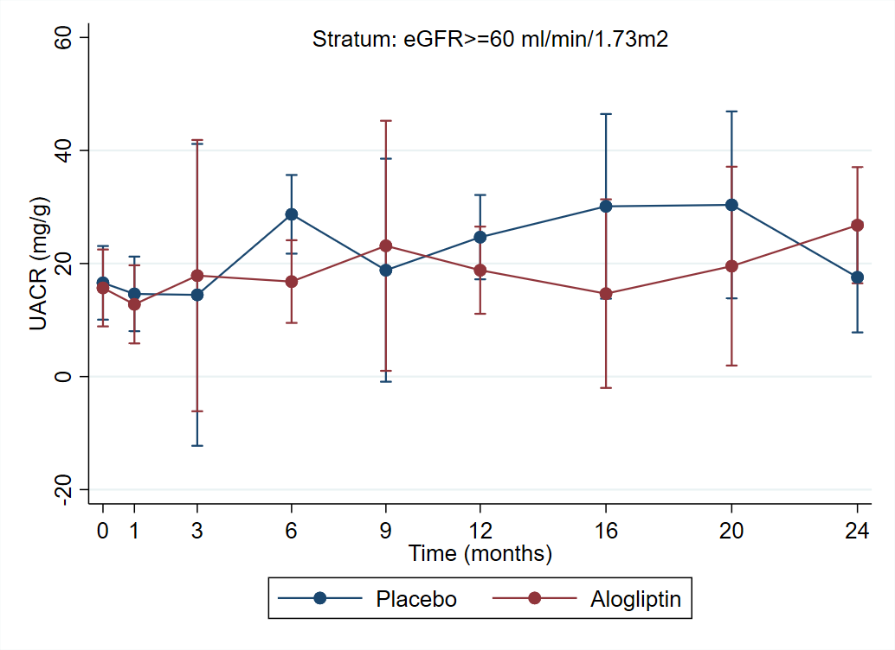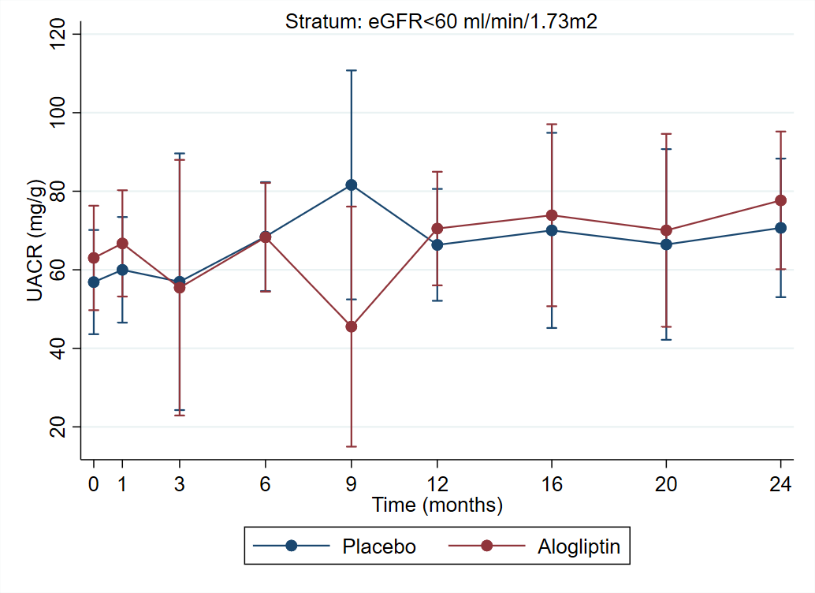

- C-reactive protein
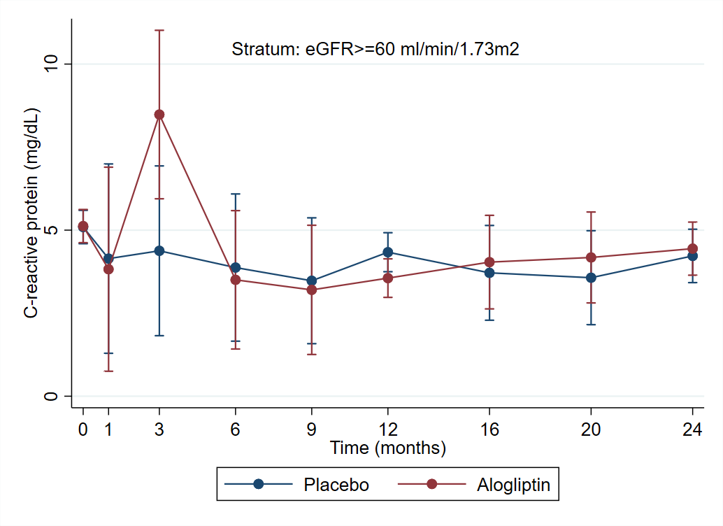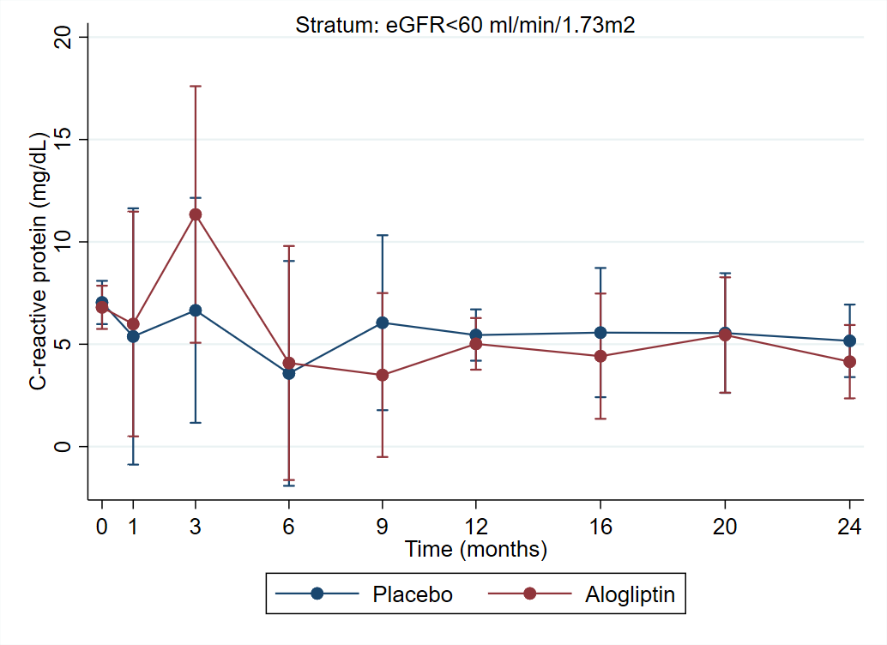
P-value >0.05 for all comparisons (multiple comparison adjusted global effect of alogliptin vs. placebo).
The p-values for each measure within the eGFR strata are:
eGFR≥60:
- Total cholesterol =0.23
- HDL cholesterol =0.39
- LDL cholesterol =0.14
- Triglycerides =0.73
- SBP =0.58
- DBP =0.70
- BMI =0.86
- Creatinine =0.62
- eGFR =0.76
- UACR =0.34
- C-reactive protein =0.29
eGFR<60:
- Total cholesterol =0.42
- HDL cholesterol =0.52
- LDL cholesterol =0.84
- Triglycerides =0.24
- SBP =0.61
- DBP =0.86
- BMI =0.67
- Creatinine =0.75
- eGFR =0.54
- UACR =0.76
- C-reactive protein =0.96
Legend: SBP, systolic blood pressure; DBP, diastolic blood pressure; BMI, body mass index; eGFR, estimated glomerular filtration rate; UACR, urinary albumin-to-creatinine ratio.

