Supplemental Appendix

This appendix has been provided by the authors to give readers additional information about their work.
Supplement to: Rossignol P, Williams B, Mayo MR, et al. Patiromer versus Placebo to Enable Spironolactone Use in Patients with Resistant Hypertension and Chronic Kidney Disease (AMBER): Results in the Pre-specified Subgroup with Heart Failure

Table of Contents
Supplemental Appendix A. Serum calcium and magnesium levels during the study. 2
Supplemental Table 1. Reasons for early discontinuation of study treatment. 3
Supplemental Table 2. Last recorded spironolactone dose in patients who discontinued because of hyperkalaemia. 4
Supplemental Table 3. Heart failure characteristics. 5
Supplemental Table 4. Cumulative spironolactone dose over 12 weeks. 6
Supplemental Table 5. Prespecified laboratory values of interest. 7
Supplemental Table 6. Estimated GFR and urine albumin/creatinine ratio change from baseline at Week 12. 8
Supplemental Table 7. Serum calcium and magnesium levels results over time and change from baseline. 9
Supplemental Figure 1. Patient disposition by HF subgroups. 10
Supplemental Figure 2. Mean (SE) central laboratory serum potassium during active treatment in patients A) with heart failure, and B) without heart failure. 11
Supplemental Figure 3. NT-proBNP levels at baseline and Week 12 in A) the overall population,
B) patients with atrial fibrillation, and C) patients without atrial fibrillation. 13

Supplemental Appendix A. Serum calcium and magnesium levels during the study.

In patients with HF, on-study serum calcium values >2.62 mmol/L (the ULN) were observed in 2 patients on placebo, and 2 patients on patiromer (Supplemental Table 5). All 4 of these patients had screening or baseline serum calcium >2.62 mmol/L. One HF patient in the patiromer group also had an AE of hypercalcemia, with a serum calcium value of 2.9 mmol/L at the time the AE was reported (the AE resolved without a change in dosing of patiromer or spironolactone). In patients without HF, on-study serum calcium values >2.62 mmol/L were observed in 3 patients on placebo (2 with serum calcium >2.62 mmol/L before treatment), and in 2 patients on patiromer. Serum calcium returned to the normal range during the follow-up visit in the 3 patients with on-study calcium above the ULN
On-study serum magnesium <0.58 mmol/L occurred in 1 HF patient (who had serum magnesium within the normal range at screening/baseline) randomized to the placebo group, and in 2 patients with HF receiving patiromer (both of whom had serum magnesium of 0.58 mmol/L at screening or baseline). At the follow-up visit, the patient on placebo had a serum magnesium of 0.58 mmol/L; serum magnesium was 0.53 mmol/L in one patient who had been taking patiromer (the other patient did not attend the follow-up visit).
One patient without HF in the patiromer group who had serum magnesium in the normal range at baseline had an on-study value <0.58 mmol/L; serum magnesium had returned to the normal range at the follow-up visit. Two patients without HF had AEs of hypomagnesaemia. One had a laboratory serum magnesium value equal to 0.58 mmol/L at the time of the AE (0.70 mmol/L at baseline, 0.74 mmol/L at follow-up). The other patient had 3 separate AEs of hypomagnesaemia, with lab values of 0.70 mmol/L at the time of each AE (0.82 mmol/L at baseline, 0.70 mmol/L at follow-up).

Supplemental Table 1. Reasons for early discontinuation of study treatment.

 | Patients With Heart Failure |  |  | Patients Without Heart Failure
 | SPIRO + PBO  (n=69) | SPIRO  + PAT  (n=63) | Subgroup total (n=132) | SPIRO  + PBO  (n=79) | SPIRO  + PAT  (n=84) | Subgroup  total  (n=163)
Discontinued early from study treatment | 22 (32) | 10 (16) | 32 (24) | 28 (35) | 11 (13) | 39 (24)
Met 1 of 3 protocol-specified withdrawal criteria* for high serum potassium: | 16 (23) | 7 (11) | 23 (17) | 18 (23) | 3 (4) | 21 (13)
1) Patiromer/placebo dose = max,  confirmed* potassium ≥ 5.5 and < 6.0 | 7 (10) | 3 (5) | 10 (8) | 14 (18) | 0 | 14 (9)
2) Patiromer/placebo dose increased by 8.4 g/day,  confirmed† potassium ≥5.5 and <6.0 | 4 (6) | 4 (6) | 8 (6) | 3 (4) | 2 (2) | 5 (3)
3) Confirmed* potassium ≥ 6.0 | 5 (7) | 0 | 5 (4) | 1 (1) | 1 (1) | 2 (1)
Had protocol-defined symptomatic hypotension‡ | 0 | 1 (2) | 1 (0.8) | 2 (3) | 3 (4) | 5 (3)
Had protocol-defined decline in eGFR§ | 2 (3) | 2 (3) | 4 (3) | 2 (3) | 1 (1) | 3 (2)
Other | 5 (7) | 2 (3) | 7 (5) | 6 (8) | 4 (5) | 10 (6)
Adverse event | 3 (4) | 1 (2) | 4 (3) | 2 (3) | 2 (2) | 4 (3)
Patient withdrawal | 2 (3) | 0 | 2 (2) | 3 (4) | 1 (1) | 4 (3)
Low serum potassium | 0 | 1 (2) | 1 (0.8) | 1 (1) | 0 | 1 (1)
Investigator decision | 0 | 0 | 0 | 0 | 1 (1) | 1 (1)
Data are n (%). Note: patients could have more than one reason for discontinuing early from study treatment.
PAT = patiromer; PBO = placebo; SPIRO = spironolactone
* Repeat potassium measurement (taken within 1 day) that confirms the initial measurement
† Repeat potassium measurement (taken within 3 days after the 8.4 g/day dose increase) that confirms the initial measurement
‡ Systolic AOBP < 100 mmHg, or symptoms of hypotension and systolic AOBP < 120 mmHg.
§ eGFR decrease of 30–50% from baseline that did not return to ≤ 30% of baseline within 4 weeks.

Supplemental Table 2. Last recorded spironolactone dose in patients who discontinued because of hyperkalaemia.

 | Patients With Heart Failure |  | Patients Without Heart Failure
 | Spironolactone + Placebo  (n=16/69) | Spironolactone + Patiromer  (n=7/63) | Spironolactone + Placebo  (n=18/79) | Spironolactone + Patiromer  (n=3/84)
Spironolactone dose 25 mg, n | 10 | 5 | 11 | 2
Spironolactone dose 50 mg, n | 6 | 2 | 7 | 1
All patients were receiving placebo or patiromer at the time of spironolactone discontinuation; if spironolactone was discontinued, double-blind study drug (patiromer or placebo) was discontinued at the same time, and if patiromer/placebo was discontinued, spironolactone was discontinued at the same time.

Supplemental Table 3. Heart failure characteristics.

Characteristic | Patients With Heart Failure
 | Spironolactone + Placebo  (n=69) | Spironolactone + Patiromer  (n=63)
Type of heart failure*
HFpEF, n (%) | 32 (46) | 22 (35)
HFrEF, n (%) | 28 (41) | 27 (43)
Unknown | 9 (13) | 14 (22)
NYHA heart failure class, n (%)
Class I | 11 (16) | 11 (18)
Class II | 55 (80) | 41 (65)
Class III | 3 (4) | 11 (18)
Class IV | 0 | 0
No. (%) with LVEF data | 51 (74) | 44 (70)
Ejection fraction, mean (SD)† | 50 (8) | 48 (11)
NT-proBNP level, median (Q1, Q3) ng/L | 730 (302, 1972)‡ | 1062 (333, 2375)
Patients with atrial fibrillation | 2667 (1155, 3633)‡ | 1945 (631, 2652)
Patients without atrial fibrillation | 603 (262, 1500) | 896 (329, 2367)
NT-proBNP >125 ng/L, n (%) | 63 (93) | 56 (89)
*Per investigator’s assessment.
† Derived from patient medical records.
‡ One patient with HF and atrial fibrillation did not have NT-proBNP assessment.
HFpEF = heart failure with preserved ejection fraction; HFrEF = heart failure with reduced ejection fraction; NYHA = New York Heart Association

Supplemental Table 4. Cumulative spironolactone dose over 12 weeks.

 | Patients With Heart Failure |  | Patients Without Heart Failure
 | Spironolactone + Placebo  (n=69) | Spironolactone + Patiromer  (n=63) | Spironolactone + Placebo  (n=79) | Spironolactone + Patiromer  (n=84)
Cumulative dose of spironolactone, mean (SE) mg* | 2676.8 (149.2) | 3080.6 (125.7) | 2496.8 (123.5) | 2838.7 (103.1)
Difference between treatment groups (patiromer group minus placebo group), LS mean (SE) mg | 387.5 (196.4) |  | 398.4 (160.1)
* Cumulative dose of spironolactone = sum of actual doses taken.

Supplemental Table 5. Prespecified laboratory values of interest.
 | Patients With Heart Failure |  | Patients Without Heart Failure
 | Spironolactone + Placebo  (n=69) | Spironolactone + Patiromer  (n=63) | Spironolactone + Placebo  (n=79) | Spironolactone + Patiromer  (n=84)
Serum potassium <3.8 mmol/L  At Baseline  At any post-baseline through Week 12 Visit | 1  4 | 0  4 | 0  0 | 0  2
Serum potassium <3.5 mmol/L  At Baseline  At any post-baseline through Week 12 Visit | 0  0 | 0  1 | 0  0 | 0  0
Serum magnesium in the following  range at Baseline:  <0.58 mmol/L  <0.49 mmol/L  <0.41 mmol/L | 0  0  0 | 1  0  0 | 0  0  0 | 0  0  0
Serum magnesium in the following  range at any post-baseline through Week 12 Visit:  <0.58 mmol/L  <0.49 mmol/L  <0.41 mmol/L | 1  0  0 | 2  0  0 | 0  0  0 | 1  0  0
Serum magnesium in the following  range at any time while on study medication:  <0.58 mmol/L  <0.49 mmol/L  <0.41 mmol/L | 1*  0*  0* | 2  0  0 | 0  0  0 | 1†  0†  0†
Serum calcium <2.12 mmol/L  At Baseline  At any post-baseline through Week 12 Visit  While on study medication | 4  11  11* | 3  16  14 | 1  10  9 | 4  4  4†
Serum calcium >2.62 mmol/L:  At Baseline  At any post-baseline through Week 12 Visit  While on study medication | 2  2  2* | 2  2  2 | 1  3  3 | 0  2  2†
* n = 68 for the placebo HF group (some patients were missing post-baseline data)
† n = 83 for the patiromer without HF group (some patients were missing post-baseline data)

Supplemental Table 6. Estimated GFR and urine albumin/creatinine ratio change from baseline at Week 12.

 | Patients With Heart Failure |  | Patients Without Heart Failure
 | Spironolactone + Placebo  (n=69) | Spironolactone + Patiromer  (n=63) | Spironolactone + Placebo  (n=79) | Spironolactone + Patiromer  (n=84)
eGFR change from baseline at week 12, mean (SE) mL/min/1.73m² | –0.3 (0.8) | –0.2 (0.7) | –3.6 (0.8) | –2.3 (0.8)
Urine albumin/creatinine ratio change from baseline at week 12, mean (SE) mg/g | 35.0 (65.0) | –1.0 (41.9) | -–22.4 (35.4) | -–8.1 (38.8)

Supplemental Table 7. Serum calcium and magnesium levels results over time and change from baseline.
 | Patients With Heart Failure |  | Patients Without Heart Failure
 | Spironolactone + Placebo  (n=69) | Spironolactone + Patiromer  (n=63) | Spironolactone + Placebo  (n=79) | Spironolactone + Patiromer  (n=84)
Magnesium, mean (SE) mmol/L  Baseline  Week 1  Week 2  Week 3  Week 4  Week 6  Week 8  Week 10  Week 12  Change from baseline to Week 12  Follow-up  Change from baseline to follow-up | 0.86 (0.01)  0.87 (0.01)  0.88 (0.01)  0.86 (0.01)  0.87 (0.01)  0.87 (0.01)  0.85 (0.01)  0.86 (0.01)  0.86 (0.01)  0.00 (0.01)  0.87 (0.01)  0.01 (0.01) | 0.86 (0.02)  0.87 (0.01)  0.86 (0.02)  0.87 (0.01)  0.85 (0.02)  0.88 (0.02)  0.86 (0.01)  0.88 (0.02)  0.86 (0.01)  –0.01 (0.01)  0.9 (0.02)  0.03 (0.01) | 0.87 (0.01)  0.87 (0.01)  0.88 (0.01)  0.89 (0.01)  0.86 (0.01)  0.88 (0.01)  0.87 (0.01)  0.87 (0.01)  0.87 (0.01)  0.00 (0.01)  0.9 (0.01)  0.02 (0.01) | 0.87 (0.01)  0.84 (0.01)  0.83 (0.01)  0.86 (0.02)  0.84 (0.01)  0.82 (0.01)  0.84 (0.01)  0.84 (0.01)  0.83 (0.01)  –0.04 (0.01)  0.88 (0.01)  0.01 (0.01)
Calcium, mean (SE) mmol/L  Baseline  Week 1  Week 2  Week 3  Week 4  Week 6  Week 8  Week 10  Week 12  Change from baseline to Week 12  Follow-up  Change from baseline to follow-up | 2.3 (0.02)  2.33 (0.02)  2.32 (0.02)  2.31 (0.02)  2.31 (0.02)  2.30 (0.02)  2.27 (0.02)  2.29 (0.02)  2.28 (0.02)  –0.01 (0.01)  2.27 (0.02)  –0.01 (0.01) | 2.29 (0.02)  2.3 (0.02)  2.32 (0.02)  2.3 (0.02)  2.31 (0.02)  2.3 (0.02)  2.29 (0.02)  2.28 (0.02)  2.27 (0.02)  –0.01 (0.02)  2.28 (0.02)  0.01 (0.01) | 2.33 (0.02)  2.33 (0.02)  2.35 (0.02)  2.32 (0.02)  2.33 (0.02)  2.34 (0.02)  2.33 (0.02)  2.33 (0.02)  2.32 (0.02)  –0.01 (0.01)  2.3 (0.02)  –0.03 (0.01) | 2.33 (0.01)  2.33 (0.01)  2.35 (0.01)  2.33 (0.01)  2.33 (0.01)  2.34 (0.01)  2.32 (0.01)  2.33 (0.01)  2.32 (0.01)  –0.01 (0.01)  2.3 (0.01)  –0.03 (0.01)

Supplemental Figure 1. Patient disposition by HF subgroups.

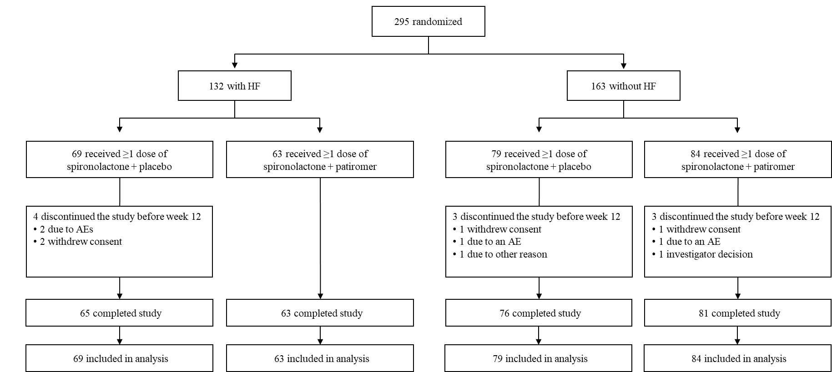

Supplemental Figure 2. Mean (SE) central laboratory serum potassium during active treatment in patients A) with heart failure, and
B) without heart failure.

A)
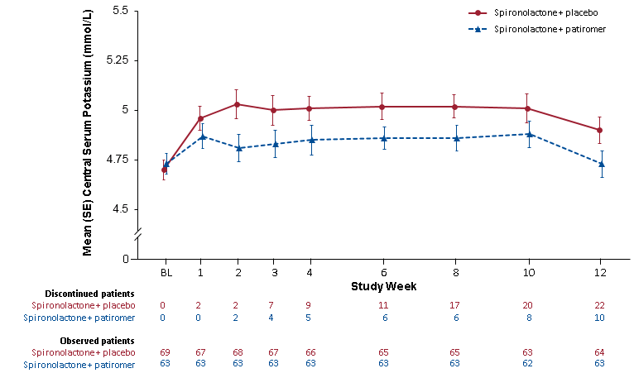

B)
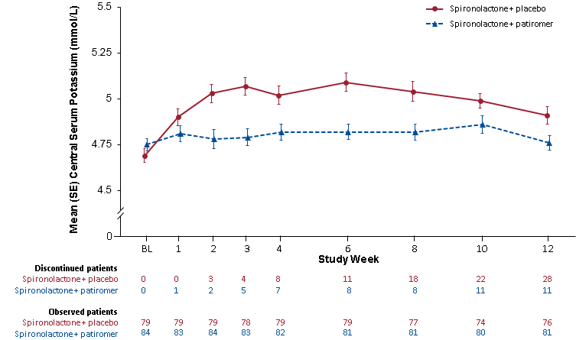

Supplemental Figure 3. NT-proBNP levels at baseline and Week 12 in A) the overall population, B) patients with atrial fibrillation, and C) patients without atrial fibrillation.

A)
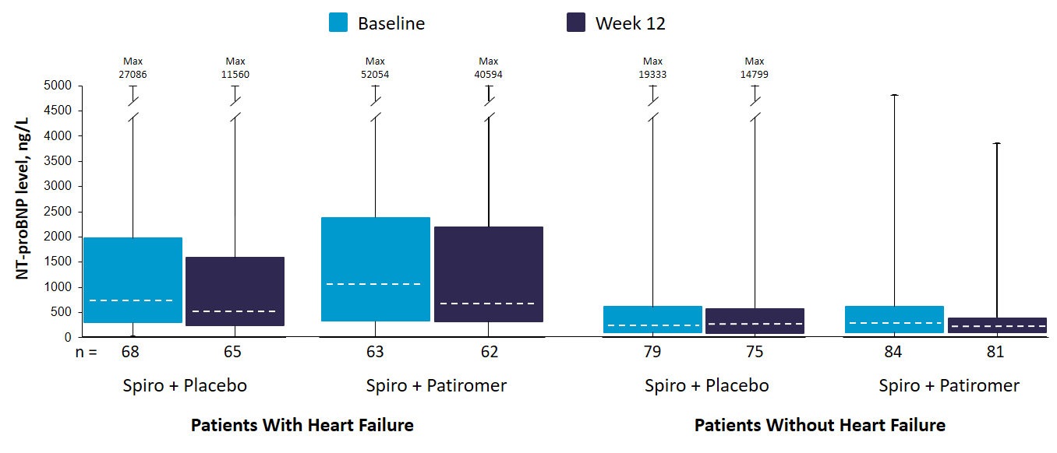
Boxes represent median (dashed center line), Q1 (lower bound), and Q3 (upper bound). Whiskers represent minimum and maximum values.

B)
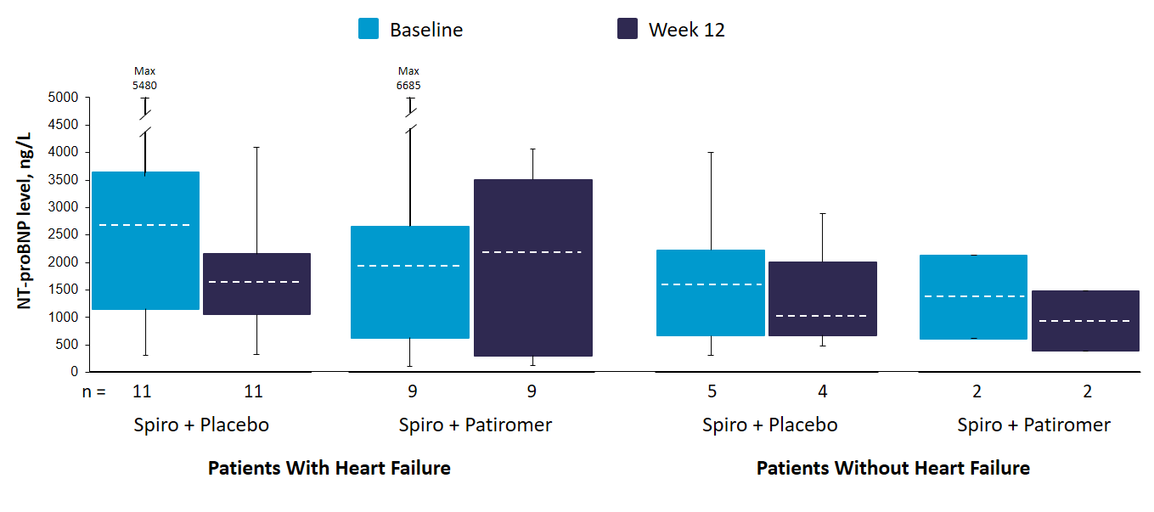

C)
