Head-to-head comparison of clustering methods for heterogeneous data
A simulation-driven benchmark
SUPPLEMENTARY FIGURES AND TABLE

Supplementary Figure 1: Introduction of controlled noise in a simulated categorical variable with three levels (A: pink, B: green and C: blue) as performed in the present analysis (left panel: 0% noise, right panel: 20% noise).
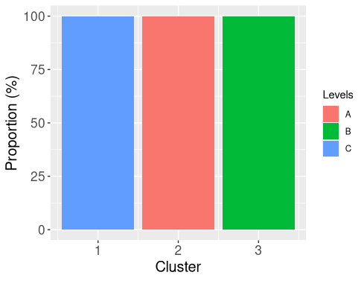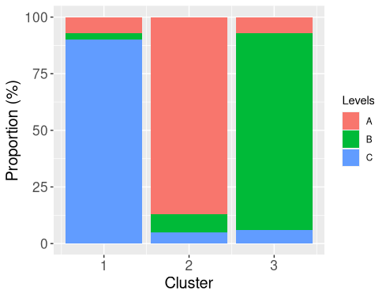

Supplementary figure 2: 2D projections of numerical variables for datasets created from the simulation scenarios using t-SNE.
Cluster memberships are denoted by their color.

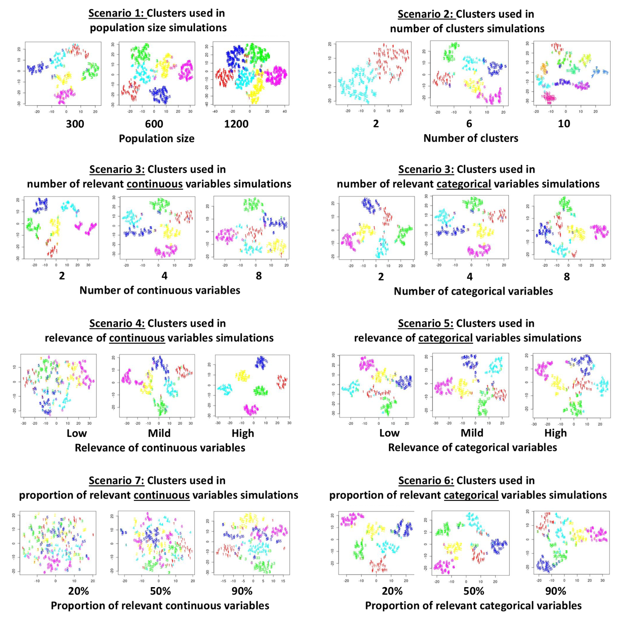

Supplementary table 1: Comparison of methods using ARI metric for each condition presented in figures 1 and 2
Figure | Condition |  | Overall  comparison* | Comparison among  distance-based  methods* | Comparison among  model-based  methods* | Comparison  model-based vs.  distance-based**
1 | Population size | 300 | <0.0001 | <0.0001 | <0.0001 | <0.0001
1 |  | 600 | <0.0001 | <0.0001 | <0.0001 | <0.0001
1 |  | 1200 | <0.0001 | <0.0001 | <0.0001 | <0.0001
1 | Number of clusters | 2 | <0.0001 | <0.0001 | <0.0001 | <0.0001
1 |  | 4 | <0.0001 | <0.0001 | <0.0001 | <0.0001
1 |  | 6 | <0.0001 | <0.0001 | <0.0001 | <0.0001
2 | Number of  continuous variables | 2 | <0.0001 | <0.0001 | <0.0001 | <0.0001
2 |  | 4 | <0.0001 | <0.0001 | <0.0001 | <0.0001
2 |  | 6 | <0.0001 | <0.0001 | <0.0001 | <0.0001
2 | Number of  categorical variables | 2 | <0.0001 | <0.0001 | <0.0001 | <0.0001
2 |  | 4 | <0.0001 | <0.0001 | <0.0001 | <0.0001
2 |  | 6 | <0.0001 | <0.0001 | <0.0001 | <0.0001
2 | Relevance of  continuous variables | low | <0.0001 | <0.0001 | <0.0001 | <0.0001
2 |  | mild | <0.0001 | <0.0001 | <0.0001 | <0.0001
2 |  | high | <0.0001 | <0.0001 | <0.0001 | <0.0001
2 | Relevance of  categorical variables | low | <0.0001 | <0.0001 | <0.0001 | <0.0001
2 |  | mild | <0.0001 | <0.0001 | <0.0001 | <0.0001
2 |  | high | <0.0001 | <0.0001 | <0.0001 | <0.0001
2 | Number of relevant  continuous variables | 2/10 | <0.0001 | <0.0001 | <0.0001 | <0.0001
2 |  | 5/10 | <0.0001 | <0.0001 | <0.0001 | <0.0001
2 |  | 9/10 | <0.0001 | <0.0001 | <0.0001 | <0.0001
2 | Number of relevant  categorical variables | 2/10 | <0.0001 | <0.0001 | <0.0001 | <0.0001
2 |  | 5/10 | <0.0001 | <0.0001 | <0.0001 | <0.0001
2 |  | 9/10 | <0.0001 | <0.0001 | <0.0001 | <0.0001
*p-value from Kruskal-Wallis test. **p-value from Wilcoxon test.

Supplementary table 2: Runtimes of the examined method for the conditions presented in figure 1 (average runtimes are presented in seconds).
Experiments were run on a computer with an Intel i7-4600U processor running at 2.10 GHz (x4) using 11.1 GiB of RAM, running Linux: Ubuntu 20.04 LTS.

 | Population size |  |  | Number of clusters
Methods | 300 | 600 | 1200 | 2 | 6 | 10
HC+Tradi | 0.021 | 0.089 | 0.433 | 0.024 | 0.030 | 0.021
HC+UET | 0.633 | 2.292 | 7.715 | 0.753 | 0.841 | 0.785
Kproto | 5.846 | 9.696 | 13.805 | 1.338 | 5.941 | 9.612
PAM+Tradi | 0.071 | 0407 | 1.524 | 0.040 | 0.080 | 0.107
PAM+UET | 0.662 | 2.420 | 8.602 | 0.759 | 0.875 | 0.864
Kamila | 0.715 | 1.065 | 1.443 | 0.327 | 0.837 | 0.724
LCA | 3.611 | 11.437 | 19.894 | 0.947 | 4.201 | 7.778
LCM | 4.564 | 7.863 | 14.318 | 0.891 | 4.438 | 10.161
Mixmod | 0.265 | 0.167 | 0.309 | 0.182 | 0.080 | 0.177

