Supplemental Table 1: list of the 24 SNPs included in the NPPB – NPPA gene candidate analysis
Rs name | chr | pos | A1 | A2 | N0 | N1 | N2 | NAs | callrate | maf | hz
rs2272803 | 1 | 11898789 | T | G | 3 | 130 | 1442 | 0 | 1.000 | 0.043 | 0.083
rs1023252* | 1 | 11899033 | T | G | 128 | 603 | 844 | 0 | 1.000 | 0.273 | 0.383
rs198415 | 1 | 11901592 | C | T | 23 | 348 | 1201 | 3 | 0.998 | 0.125 | 0.221
rs61764042 | 1 | 11905059 | G | A | 3 | 76 | 1496 | 0 | 1.000 | 0.026 | 0.048
rs5065 | 1 | 11906068 | G | A | 27 | 364 | 1184 | 0 | 1.000 | 0.133 | 0.231
rs198370 | 1 | 11906981 | C | T | 8 | 234 | 1327 | 6 | 0.996 | 0.080 | 0.149
rs61757261 | 1 | 11907430 | G | T | 0 | 4 | 1571 | 0 | 1.000 | 0.001 | 0.003
rs5063 | 1 | 11907648 | T | C | 4 | 141 | 1430 | 0 | 1.000 | 0.047 | 0.090
rs198372 | 1 | 11909514 | A | G | 20 | 358 | 1197 | 0 | 1.000 | 0.126 | 0.227
rs149772863 | 1 | 11917720 | A | G | 0 | 5 | 1570 | 0 | 1.000 | 0.002 | 0.003
rs35640285 | 1 | 11918379 | A | C | 0 | 8 | 1567 | 0 | 1.000 | 0.003 | 0.005
rs5229 | 1 | 11918519 | T | C | 0 | 13 | 1562 | 0 | 1.000 | 0.004 | 0.008
rs198389* | 1 | 11919271 | G | A | 295 | 786 | 493 | 1 | 0.999 | 0.437 | 0.499
rs79712000 | 1 | 11924030 | C | T | 2 | 112 | 1461 | 0 | 1.000 | 0.037 | 0.071
rs6676300* | 1 | 11925300 | G | A | 224 | 751 | 599 | 1 | 0.999 | 0.381 | 0.477
rs4846061 | 1 | 11926350 | A | C | 4 | 165 | 1405 | 1 | 0.999 | 0.055 | 0.105
rs74714707 | 1 | 11926758 | T | C | 2 | 111 | 1462 | 0 | 1.000 | 0.037 | 0.070
rs12562952 | 1 | 11927056 | C | T | 11 | 288 | 1276 | 0 | 1.000 | 0.098 | 0.183
rs9661078 | 1 | 11936324 | C | A | 209 | 805 | 559 | 2 | 0.999 | 0.389 | 0.512
rs11804222 | 1 | 11936514 | A | G | 14 | 320 | 1240 | 1 | 0.999 | 0.111 | 0.203
rs79593079 | 1 | 11936644 | T | C | 2 | 129 | 1444 | 0 | 1.000 | 0.042 | 0.082
rs7554327 | 1 | 11937404 | T | C | 375 | 829 | 371 | 0 | 1.000 | 0.499 | 0.526
rs4846066 | 1 | 11938050 | A | G | 208 | 803 | 560 | 4 | 0.997 | 0.388 | 0.511
rs72864766 | 1 | 11938399 | A | G | 4 | 145 | 1426 | 0 | 1.000 | 0.049 | 0.092
SNP, single nucleotide polymorphism; Chr, chromosome; pos, position; A1, allele 1; A2, allele 2; N0, number of homozygotes for A1; N1, number of heterozygotes; N2, number of homozygotes for A2, NAs, number of missing data; MAF, minor allele frequency; hz, heterozygosity, * these SNPs were also identified in the GWAS.
Supplemental Table 2 : Characteristics of the subjects not included in the study (n=150)
Characteristics | Mean ± sd / n (%)
Age (years) | 49.77 ± 13.54
Sex female | 78 (52.00%)
Current smoker | 38 (25.50%)
BMI (kg/m²) | 26.85 ± 5.41
Diabetes | 2 (1.40%)
Fasting glycemia (g/L) | 0.88 ± 0.11
Glycated hemoglobin (%) | 5.57 ± 0.36
eGFR (mL/min/1.73m²) | 96.38 ± 13.44
Urinary sodium (mmol/L) | 109.31 ± 43.59
Heart Rate (bpm) | 62.70 ± 9.91
SBP (mmHg) | 121.04 ± 11.03
DBP (mmHg) | 74.66 ± 8.27
Hypertension | 62 (41.33%)
Any CV conditions* | 4 (2.67%)
Heart failure | 1 (0.67%)
Myocardial infarction | 0 (0.00%)
Stroke | 2 (1.33%)
Valvular disease | 2 (1.33%)
Septal e’ (cm/s) | 9.61 ± 2.79
Lateral e’ (cm/s) | 12.74 ± 4.11
e/a | 1.19 ± 0.44
e/e' | 6.55 ±1.65
LAVI (mL) | 23.34 ± 7.68
Deceleration time | 204.31 ± 53.56
NT-proBNP levels according to category of subjects (arbitrary PEA units)
Healthy (n=87) | 3.54 ± 1.00
Hypertension (n=59) | 3.74 ± 1.08
Any CV conditions* (n=4) | 4.11 ± 1.07
*Any CV conditions included Heart failure, Myocardial infarction, Stroke and Valvular diseases.
Supplemental Table 3: Covariate effects in the linear model for plasma NT-proBNP levels
 | Univariate model |  |  | Multivariate model
 | Estimate | SD | P value | Estimate | SD | P value
Sex (female) | 0.536 | 0.044 | <0.001 | 0.026 | 0.002 | <0.001
Age | 0.028 | 0.002 | <0.001 | 0.556 | 0.0504 | <0.001
BMI | -0.011 | 0.008 | 0.025 | -0.006 | 0.005 | 0.224
eGFR | -0.006 | 0.002 | 0.003 | -0.006 | 0.002 | 0.003
HR | -0.016 | 0.002 | <0.001 | -0.015 | 0.002 | <0.001
SBP | -0.005 | 0.002 | 0.056 | -0.003 | 0.002 | 0.220
Urinary Na | 0.00087 | 0.00050 | 0.08 | 0.0015 | 0.0005 | 0.005
SD, standard deviation; BMI, Body Mass Index; eGFR, estimated Glomerular Filtration Rate; SBP, Systolic Blood Pressure; Urinary Na, urinary sodium
Supplemental Table 4: Variance decomposition for plasma NT-proBNP levels for all included subjects
 | Heritability | Common environmental effect | Covariate effects | Residual variance
Model 1 | 16.31 | 1.64 | 19.83 | 62.20
Model 2 | 15.11 | 0.65 | 22.97 | 61.27
Model 1, covariates are age and sex; Model 2, covariates are age, sex, eGFR, heart rate and urinary sodium
Supplemental Table 5: Variance decomposition for plasma NT-proBNP levels among healthy subjects
 | Heritability | Common environmental effect | Covariate effects | Residual variance
Model 1 | 16.23 | 0.00 | 20.66 | 63.10
Model 2 | 15.95 | 0.00 | 23.31 | 60.73
Model 1, covariates are age and sex; Model 2, covariates are age, sex, eGFR, heart rate and urinary sodium

Supplemental table 6: Correlations between the gene expressions of the gene cluster.
 |  | Correlation Coefficient
 |  | NPPB | NPPA | MTHFR | CLCN6 | C1orf167
P value | NPPB |  | 0.049 | -0.016 | 5.10-4 | 0.090
 | NPPA | 0.25 |  | -0.030 | -0.062 | 0.167
 | MTHFR | 0.71 | 0.49 |  | 0.073 | -0.026
 | CLCN6 | 0.99 | 0.14 | 0.08 |  | 0.065
 | C1orf167 | 0.06 | <0.001 | 0.54 | 0.13

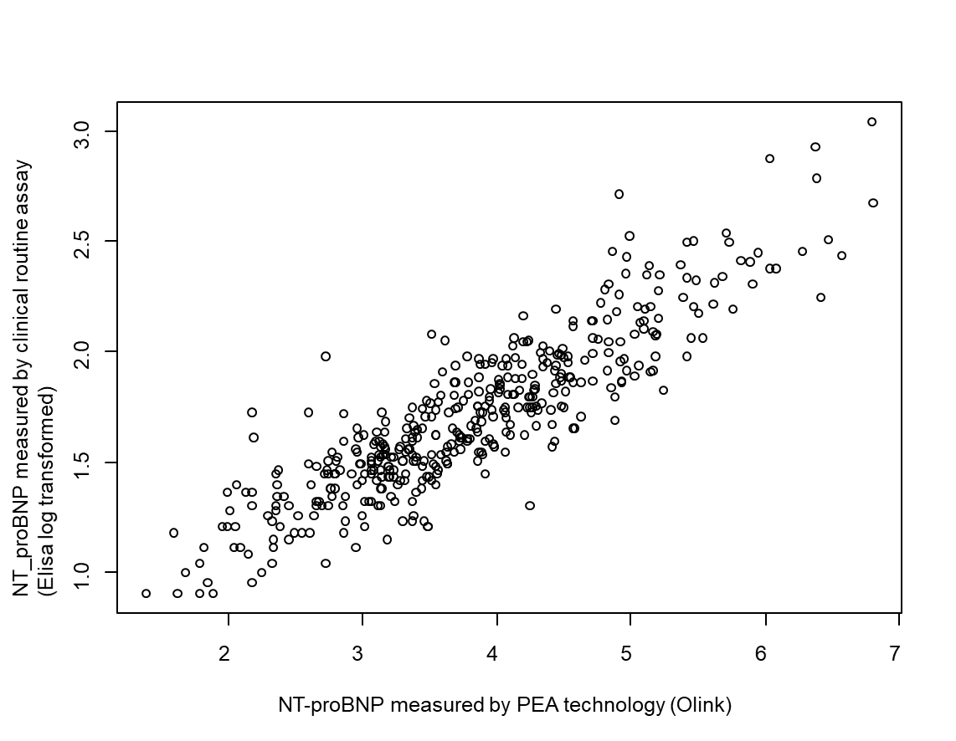
Supplemental Figure 1: Comparison between measured by clinical routine assays and the PEA technology

