Supplemental Material

Supplemental Table 1. Adjusted mean changes of uric acid levels (mg/dL) over time (on-treatment) in the Empagliflozin (pooled) vs. Placebo group
Week (n/o patients analyzed) | UA level change Empagliflozin (n=4516) | UA level change Placebo (n=2260) | Adjusted mean (95%-CI) treatment difference Empagliflozin vs. Placebo | p-value
Baseline mean (SD) | 5.93 (0.02) | 6.01 (0.03) | - | -
Week 12 (n=6728) | -0.32 (0.02) | 0.03 (0.02) | -0.35 (-0.40, -0.30) | <0.0001
Week 28 (n=6506) | -0.34 (0.02) | 0.06 (0.02) | -0.40 (-0.45, -0.34) | <0.0001
Week 52 (n=6226) | -0.34 (0.02) | 0.02 (0.02) | -0.37 (-0.42, -0.31) | <0.0001
Week 66 (n=6055) | -0.30 (0.02) | 0.04 (0.02) | -0.34 (-0.40, -0.28) | <0.0001
Week 80 (n=5885) | -0.28 (0.02) | 0.03 (0.03) | -0.31 (-0.37, -0.25) | <0.0001
Week 94 (n=5731) | -0.31 (0.02) | 0.04 (0.03) | -0.35 (-0.41, -0.29) | <0.0001
Week 108 (n=5067) | -0.29 (0.02) | 0.06 (0.03) | -0.35 (-0.41, -0.28) | <0.0001
Week 122 (n=4243) | -0.26 (0.02) | 0.08 (0.03) | -0.34 (-0.41, -0.27) | <0.0001
Week 136 (n=3627) | -0.28 (0.02) | 0.03 (0.03) | -0.31 (-0.38, -0.23) | <0.0001
Week 150 (n=3218) | -0.30 (0.02) | 0.02 (0.03) | -0.32 (-0.39, -0.24) | <0.0001
Week 164 (n=2800) | -0.29 (0.02) | 0.03 (0.04) | -0.32 (-0.41, -0.24) | <0.0001
Week 178 (n=2049) | -0.31 (0.03) | -0.02 (0.04) | -0.30 (-0.39, -0.20) | <0.0001
Week 192 (n=1272) | -0.33 (0.03) | -0.10 (0.05) | -0.24 (-0.34, -0.13) | <0.0001
Week 206 (n=463) | -0.31 (0.05) | 0.10 (0.07) | -0.42 (-0.59, -0.24) | <0.0001

UA level changes are presented as adjusted mean (SE) changes from baseline based on MMRM analyses, that included continuous fixed effects of baseline uric acid and baseline HbA1c at each visit and discrete fixed effects for treatment at each visit, region, baseline eGFR, baseline BMI and last projected visit.
BMI=body-mass-index; eGFR=estimated glomerular filtration rate; HbA1c=glycated hemoglobin A1c; UA=uric acid.

Supplemental Table 2. Adjusted mean changes of uric acid levels (mg/dL) over time (on-treatment) in the Empagliflozin (10 mg and 25 mg separately) vs. Placebo group
Week (n/o patients analyzed) | UA level change Empagliflozin 10 mg (n=2266) | UA level change Empagliflozin 25 mg (n=2250) | UA level change Placebo (n=2260) | Adjusted mean (95%-CI) treatment difference Empagliflozin 10mg vs. Placebo | Adjusted mean (95%-CI) treatment difference Empagliflozin 25 mg vs. Placebo
Baseline mean (SD) | 5.91 (0.03) | 5.96 (0.03) | 6.01 (0.03) | - | -
Week 12 (n=6728) | -0.32 (0.02) | -0.32 (0.02) | 0.03 (0.02) | -0.35 (-0.41, -0.29) | -0.36 (-0.41, -0.30)
Week 28 (n=6506) | -0.32 (0.02) | -0.35 (0.02) | 0.06 (0.02) | -0.38 (-0.44, -0.32) | -0.41 (-0.47, -0.35)
Week 52 (n=6226) | -0.35 (0.02) | -0.33 (0.02) | 0.02 (0.02) | -0.38 (-0.44, -0.31) | -0.35 (-0.42, -0.29)
Week 66 (n=6055) | -0.28 (0.02) | -0.32 (0.02) | 0.04 (0.02) | -0.32 (-0.39, -0.25) | -0.35 (-0.42, -0.29)
Week 80 (n=5885) | -0.29 (0.03) | -0.27 (0.03) | 0.03 (0.03) | -0.33 (-0.40, -0.26) | -0.30 (-0.37, -0.23)
Week 94 (n=5731) | -0.31 (0.03) | -0.31 (0.03) | 0.04 (0.03) | -0.34 (-0.41, -0.27) | -0.35 (-0.42, -0.28)
Week 108 (n=5067) | -0.28 (0.03) | -0.30 (0.03) | 0.06 (0.03) | -0.33 (-0.41, -0.26) | -0.36 (-0.43, -0.29)
Week 122 (n=4243) | -0.28 (0.03) | -0.24 (0.03) | 0.08 (0.03) | -0.36 (-0.44, -0.28) | -0.32 (-0.40, -0.24)
Week 136 (n=3627) | -0.30 (0.03) | -0.27 (0.03) | 0.03 (0.03) | -0.32 (-0.41, -0.24) | -0.29 (-0.38, -0.21)
Week 150 (n=3218) | -0.31 (0.03) | -0.29 (0.03) | 0.02 (0.03) | -0.33 (-0.42, -0.24) | -0.31 (-0.39, -0.22)
Week 164 (n=2800) | -0.29 (0.03) | -0.29 (0.03) | 0.03 (0.04) | -0.32 (-0.42, -0.23) | -0.33 (-0.42, -0.23)
Week 178 (n=2049) | -0.32 (0.04) | -0.31 (0.04) | -0.02 (0.04) | -0.30 (-0.41, -0.20) | -0.29 (-0.40, -0.18)
Week 192 (n=1272) | -0.38 (0.04) | -0.29 (0.04) | -0.10 (0.05) | -0.29 (-0.41, -0.16) | -0.19 (-0.31, -0.07)
Week 206 (n=463) | -0.36 (0.07) | -0.27 (0.06) | 0.10 (0.07) | -0.47 (-0.66, -0.27) | -0.38 (-0.57, -0.18)
Adjusted mean (SE) changes from baseline based on MMRM analyses, that included continuous fixed effects of baseline uric acid and baseline HbA1c at each visit and discrete fixed effects for treatment at each visit, region, baseline eGFR, baseline BMI and last projected visit.
BMI=body-mass-index; eGFR=estimated glomerular filtration rate; HbA1c=glycated hemoglobin A1c; UA=uric acid

Supplemental Table 3. Adjusted mean changes of uric acid levels (mg/dL) over time (on-treatment) in the Empagliflozin (10 mg and 25 mg pooled) vs. Placebo group in patients with UA levels < vs. ≥6.0 mg/dL and < vs. ≥7.0 mg/dL at baseline and by prevalent CKD at baseline
Week (n/o patients analyzed) | Adjusted mean (95%-CI) treatment difference Empagliflozin vs. Placebo in participants with UA level <6.0 mg/dL at BL  (n=3679) | Adjusted mean (95%-CI) treatment difference Empagliflozin vs. Placebo in participants with UA level ≥6.0 mg/dL at BL  (n=3097) | Adjusted mean (95%-CI) treatment difference Empagliflozin vs. Placebo in participants with UA level <7.0 mg/dL at BL  (n=5218) | Adjusted mean (95%-CI) treatment difference Empagliflozin vs. Placebo in participants with UA level ≥7.0 mg/dL at BL  (n=1558) | Adjusted mean (95%-CI) treatment difference Empagliflozin vs. Placebo in participants without prevalent CKD at BL  (n=4580) | Adjusted mean (95%-CI) treatment difference Empagliflozin vs. Placebo in participants with prevalent CKD at BL  (n=2146)
Week 12 | -0.26 (-0.34, -0.19) | -0.45 (-0.53, -0.37) | -0.31 (-0.37, -0.25) | -0.48 (-0.59; -0.37) | -0.41 (-0.47, -0.35) | -0.23 (-0.32, -0.14)
Week 28 | -0.28 (-0.36, -0.21) | -0.52 (-0.60, -0.44) | -0.33 (-0.39, -0.26) | -0.61 (-0.72; -0.50) | -0.44 (-0.50, -0.37) | -0.32 (-0.42, -0.23)
Week 52 | -0.28 (-0.36, -0.20) | -0.46 (-0.55, -0.38) | -0.30 (-0.37, -0.24) | -0.56 (-0.68; -0.43) | -0.38 (-0.45, -0.31) | -0.34 (-0.44, -0.23)
Week 66 | -0.24 (-0.33, -0.16) | -0.44 (-0.53, -0.35) | -0.28 (-0.35, -0.21) | -0.51 (-0.63, -0.38) | -0.37 (-0.44, -0.30) | -0.28 (-0.38, -0.17)
Week 80 | -0.25 (-0.33, -0.16) | -0.38 (-0.47, -0.29) | -0.27 (-0.34, -0.19) | -0.45 (-0.58, -0.32) | -0.33 (-0.41, -0.26) | -0.28 (-0.39, -0.17)
Week 94 | -0.26 (-0.35, -0.18) | -0.44 (-0.54, -0.35) | -0.30 (-0.38, -0.23) | -0.47 (-0.61, -0.34) | -0.33 (-0.41, -0.26) | -0.40 (-0.52, -0.29)
Week 108 | -0.28 (-0.38, -0.19) | -0.41 (-0.51, -0.31) | -0.31 (-0.38, -0.23) | -0.46 (-0.59, -0.32) | -0.36 (-0.44, -0.28) | -0.34 (-0.45, -0.22)
Week 122 | -0.23 (-0.33, -0.13) | -0.46 (-0.57, -0.35) | -0.28 (-0.37, -0.20) | -0.51 (-0.66, -0.36) | -0.35 (-0.43, -0.26) | -0.32 (-0.45, -0.20)
Week 136 | -0.24 (-0.34, -0.13) | -0.38 (-0.49, -0.27) | -0.28 (-0.37, -0.20) | -0.37 (-0.52, -0.21) | -0.34 (-0.42, -0.25) | -0.25 (-0.39, -0.12)
Week 150 | -0.29 (-0.40, -0.18) | -0.34 (-0.45, -0.22) | -0.30 (-0.38, -0.21) | -0.37 (-0.53, -0.20) | -0.33 (-0.42, -0.24) | -0.29 (-0.43, -0.15)
Week 164 | -0.32 (-0.44, -0.20) | -0.31 (-0.44, -0.18) | -0.32 (-0.42, -0.22) | -0.30 (-0.49, -0.12) | -0.34 (-0.44, -0.24) | -0.30 (-0.46, -0.15)
Week 178 | -0.24 (-0.37, -0.11) | -0.35 (-0.49, -0.21) | -0.26 (-0.36, -0.15) | -0.43 (-0.63, -0.22) | -0.32 (-0.43, -0.21) | -0.24 (-0.42, -0.07)
Week 192 | -0.23 (-0.37, -0.08) | -0.23 (-0.39, -0.07) | -0.21 (-0.33, -0.09) | -0.30 (-0.53, -0.07) | -0.25 (-0.37, -0.12) | -0.22 (-0.42, -0.03)
Week 206 | -0.39 (-0.63, -0.14) | -0.43 (-0.67, -0.19) | -0.40 (-0.60, -0.20) | -0.42 (-0.78, -0.07) | -0.48 (-0.69, -0.27) | -0.25 (-0.56, 0.05)
Adjusted mean treatment difference based on MMRM analyses, that included continuous fixed effects of baseline uric acid (only if not subgroup) and baseline HbA1c at each visit and discrete fixed effects for treatment at each visit, region, baseline eGFR (only if not subgroup), baseline BMI, last projected visit and subgroup-by-treatment-by visit interaction. Prevalent CKD defined by an eGFR <60 ml/min/1.73m² or UACR >300 mg/g creatinine at baseline.
BMI=body-mass-index; BL=baseline; CKD=chronic kidney disease; eGFR=estimated glomerular filtration rate; HbA1c=glycated hemoglobin A1c; UA=uric acid; UACR=urinary-albumin-creatinine ratio

Supplemental Table 4. Effects of empagliflozin on new onset of gout or initiation of anti-gout medication during follow-up (on-treatment) by baseline UA level
 | UA <6.0 mg/dL at baseline |  |  |  |  | UA ≥6.0 mg/dL at baseline
 | Placebo |  | Empagliflozin (10 and 25 mg pooled) |  |  | Placebo |  | Empagliflozin (10 and 25 mg pooled)
 | n/N (%) | Rate | n/N (%) | Rate | HR (95%CI) | n/N (%) | Rate | n/N (%) | Rate | HR (95%CI) | Interaction P value
New onset of gout or initiation of anti-gout medication† | 16/1172 (1.4) | 5.5 | 28/2440 (1.1) | 4.4 | 0.82 (0.44, 1.51) | 98/1015 (9.7) | 41.8 | 129/1977 (6.5) | 26.9 | 0.66 (0.51, 0.86) | 0.5282
New onset of gout‡ | 1/1231 (0.1) | 0.3 | 9/2565 (0.4) | 1.3 | NC | 46/1100 (4.2) | 17.4 | 68/2121 (3.2) | 12.9 | NC | -
Initiation of anti-gout medication† | 16/1172 (1.4) | 5.5 | 26/2440 (1.1) | 4.1 | 0.76 (0.41, 1.41) | 88/1015 (8.7) | 37.3 | 109/1977 (5.5) | 22.6 | 0.62 (0.47, 0.82) | 0.5621
 | UA <7.0 mg/dL at baseline |  |  |  |  | UA ≥7.0 mg/dL at baseline
 | Placebo |  | Empagliflozin (10 and 25 mg pooled) |  |  | Placebo |  | Empagliflozin (10 and 25 mg pooled)
 | n/N (%) | Rate | n/N (%) | Rate | HR (95%CI) | n/N (%) | Rate | n/N (%) | Rate | HR (95%CI) | Interaction P value
New onset of gout or initiation of anti-gout medication† | 36/1678 (2.1) | 8.7 | 50/3444 (1.5) | 5.6 | 0.66 (0.43, 1.02) | 78/509 (15.3) | 7.05 | 107/973 (11.0) | 48.3 | 0.68 (0.51, 0.91) | 0.9377
New onset of gout‡ | 9/1768 (0.5) | 2.0 | 22/3630 (0.6) | 2.3 | 1.18 (0.54, 2.56) | 38 /563 (6.7) | 29.1 | 55/1056 (5.2) | 21.8 | 0.73 (0.48, 1.11) | 0.2905
Initation of anti-gout medication† | 33/1678 (2.0) | 7.9 | 43/3444 (1.2) | 4.8 | 0.62 (0.40, 0.98) | 71/509 (13.9) | 63.6 | 92/973 (9.5) | 41.1 | 0.64 (0.47, 0.88) | 0.9127
Rate is expressed in events per 1000 person-years. †Analysis performed in patients not on anti-gout medication at baseline (n=6607); ‡Analysis performed in all patients (n=7020). HR for pooled empagliflozin versus placebo based on Cox proportional hazards regression analysis adjusting for baseline age, HbA1c, eGFR, sex, BMI, geographic region, treatment group, subgroup and treatment-by-subgroup interaction.
NC=not calculated due to <14 number of patients with events in one subgroup; UA=uric acid; HR=Hazard Ratio, CI=Confidence Interval
Supplemental Table 5. Mediation analysis to study the influence of new initiation of diuretics on the treatment effect of empagliflozin on new onset of gout or initiation of anti-gout medication during follow-up (on-treatment)
Time to new onset of gout or initiation of anti-gout medication | HR (95% CI) for use of diuretics (yes vs. no) | HR (95%CI) for empagliflozin (10 and 25 mg pooled) vs. placebo | % of treatment effect mediated by diuretic use
Cox regression model |  | 0.67 (0.53,0.85) | -
Cox regression model with additional covariate for time-dependent use of loop diuretics | 2.52 (1.95,3.26) | 0.70 (0.55,0.89) | 10.9%
Cox regression model with additional covariate for time-dependent use of thiazide diuretics | 1.27 (0.98,1.65) | 0.67 (0.53,0.86) | 0.0%
Cox regression model with additional covariate for time-dependent use of loop or thiazide diuretics | 2.14 (1.66,2.76) | 0.69 (0.54,0.88) | 7.3%
Analysis performed in patients not on anti-gout medication at baseline (n=6607). Hazard ratio (95 % CI) based on Cox proportional hazards regression analysis (primary model) adjusting for baseline age, HbA1c, eGFR, sex, BMI, geographic region and treatment group without and with time-dependent covariate for loop/thiazide diuretics use, respectively.
Percentage mediation was estimated as (ln(HR)-ln(HRc))/ln(HR)*100%, where HR is the is the HR for the comparison of the treatment groups in the primary model, and HRc is the HR for the comparison of the treatment groups in the model adjusting for the time-dependent covariate of diuretics.
Time to new onset of loop diuretics on-treatment in empa vs. placebo: HR 0.56, 95% CI (0.46,0.67), Time to new onset of thiazides on-treatment in empa vs. placebo: HR 0.65, 95% CI (0.52,0.81), both in patients not on anti-gout medication at baseline and not on loop diuretics resp. thiazides at baseline.
BMI=Body-mass-index; eGFR=estimated glomerular filtration rate; HR=Hazard Ratio, CI=Confidence Interval.

Supplemental Figure 1. Effect of Empagliflozin (10 and 25 mg) vs. placebo on uric acid levels (mg/dl) over time (on-treatment)

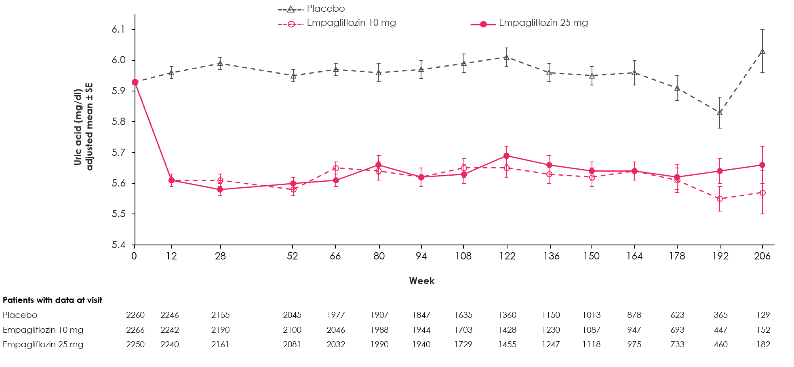
Legend: MMRM analyses, that included continuous fixed effects of baseline uric acid and baseline HbA1c at each visit and discrete fixed effects for treatment at each visit, region, baseline eGFR, baseline BMI and last projected visit. BMI=body-mass-index; eGFR=estimated glomerular filtration rate; HbA1c=glycated hemoglobin A1c; HR=hazard ratio; CI=confidence interval.

Supplemental Figure 2. Effect of Empagliflozin (10 and 25 mg pooled) vs. placebo on uric acid levels (mg/dl) over time (on-treatment) in participants with baseline UA ≥6.0 mg/dL vs. <6.0 mg/dL

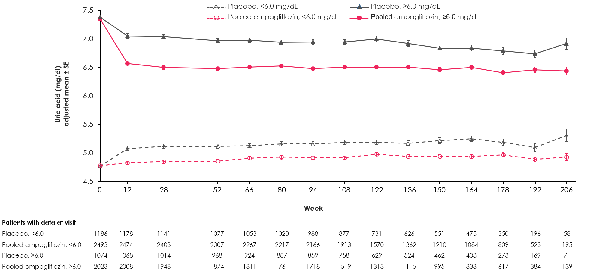

Legend: MMRM analyses, that included continuous fixed effects of baseline HbA1c at each visit and discrete fixed effects for treatment at each visit, region, baseline eGFR, baseline BMI, last projected visit and subgroup-by-treatment-by visit interaction. BMI=body-mass-index; eGFR=estimated glomerular filtration rate; HbA1c=glycated hemoglobin A1c; HR=hazard ratio; CI=confidence interval.

Supplemental Figure 3. Effect of Empagliflozin (10 and 25 mg pooled) vs. placebo on uric acid levels (mg/dl) over time (on-treatment) in participants with baseline UA ≥7.0 mg/dL vs. <7.0 mg/dL
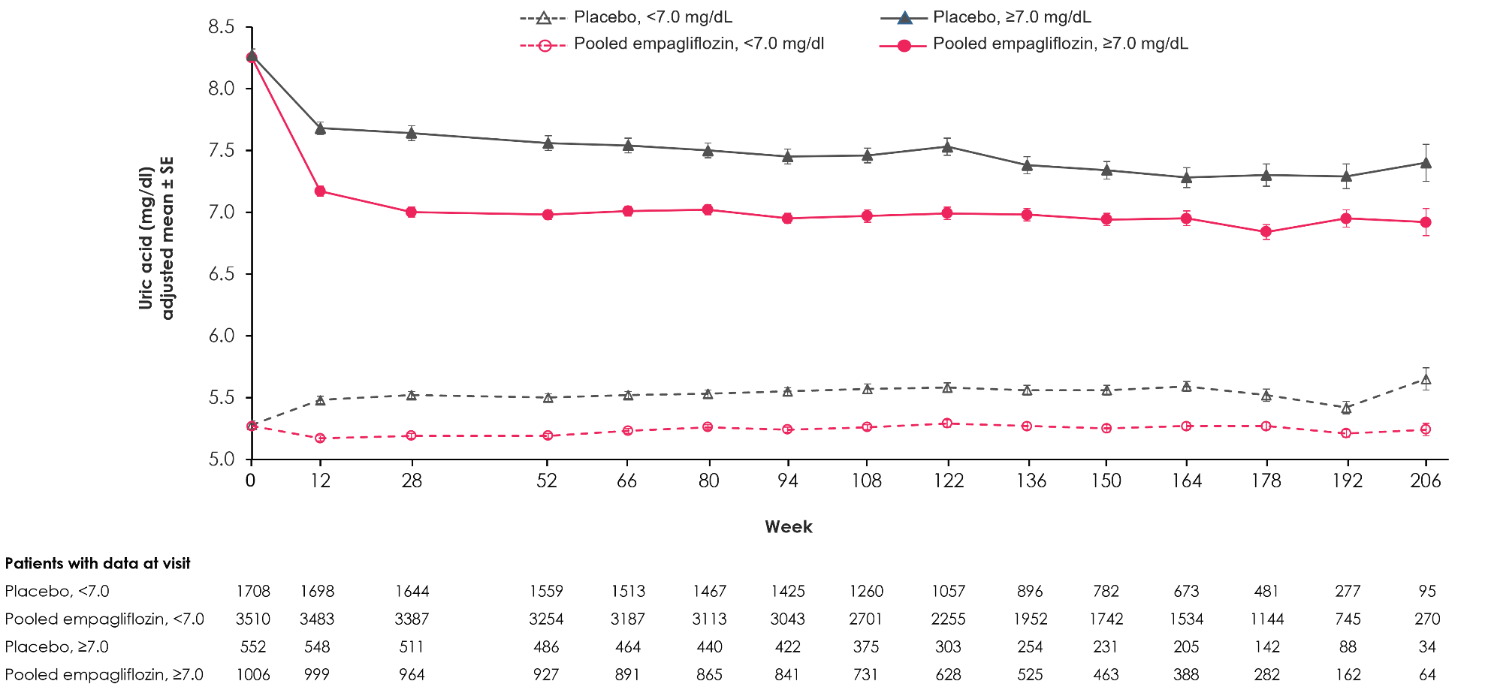

Legend: MMRM analyses, that included continuous fixed effects of baseline HbA1c at each visit and discrete fixed effects for treatment at each visit, region, baseline eGFR, baseline BMI, last projected visit and subgroup-by-treatment-by visit interaction.
BMI=body-mass-index; eGFR=estimated glomerular filtration rate; HbA1c=glycated hemoglobin A1c; HR=hazard ratio; CI=confidence interval.

Supplemental Figure 4. Proportion of patients with serum uric acid levels <6.0 mg/dl (left panel) and <7.0 mg/dl (right panel) during on treatment phase
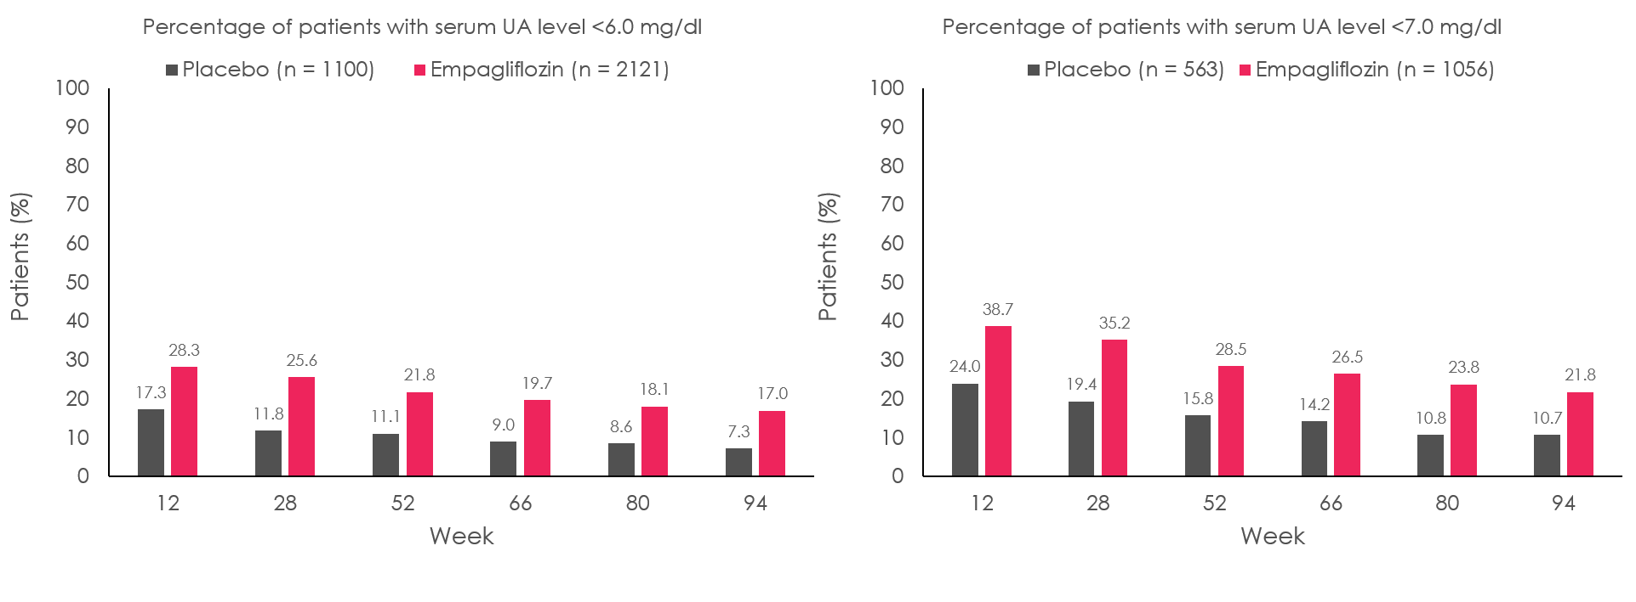
Legend: Data are presented up to week 94 visit, which could be reached by all patients. Patients with missing serum UA are considered not meeting the criterion. UA=uric acid.

Supplemental Figure 5. Time to new onset of gout or anti-gout medication during on-treatment phase (for patients not on anti-gout medication at baseline) in patients with UA levels < vs. ≥6.0 mg/dL at baseline
Legend: Cox proportional hazards models with terms for age, sex, geographic region, baseline HbA1c, baseline eGFR, baseline BMI, treatment, subgroups of participants based on baseline UA level < vs. ≥6 mg/dL and subgroup-by-treatment interaction (p=0.5282).
BMI=body-mass-index; eGFR=estimated glomerular filtration rate; HbA1c=glycated hemoglobin A1c, HR=hazard ratio, CI=confidence interval.

Supplemental Figure 6. Time to new onset of gout or anti-gout medication during on-treatment phase (for patients not on anti-gout medication at baseline) in patients with UA levels < vs. ≥7.0 mg/dL at baseline
Legend: Cox proportional hazards models with terms for age, sex, geographic region, baseline HbA1c, baseline eGFR, baseline BMI, treatment, subgroups of participants based on baseline UA level < vs. ≥7 mg/dL and subgroup-by-treatment interaction (p=0.9377).
BMI=body-mass-index; eGFR=estimated glomerular filtration rate; HbA1c=glycated hemoglobin A1c; HR=Hazard Ratio, CI=Confidence Interval.

