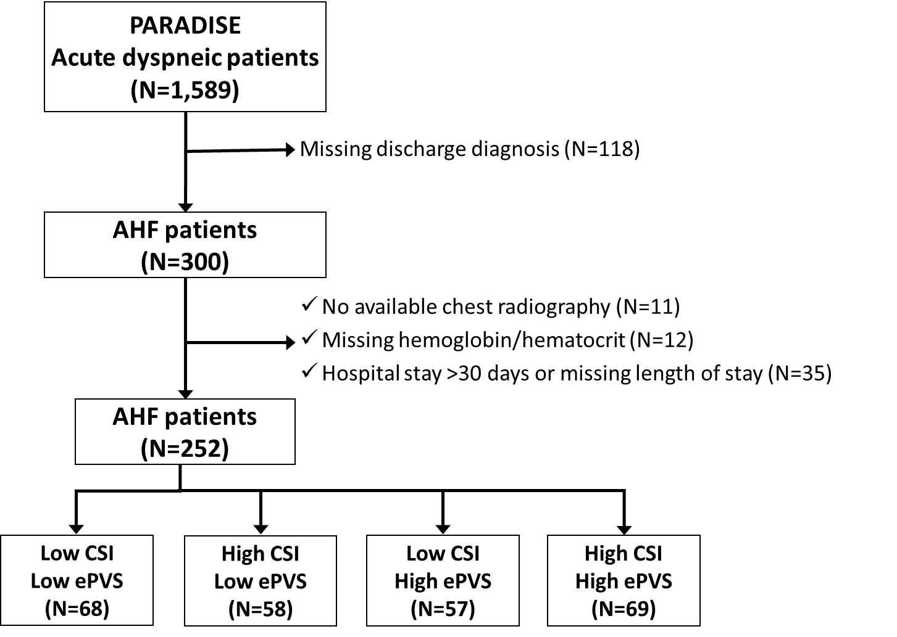
Supplementary figure 1. Study flow chart

Supplementary figure 2. Survival curve for the inhospital mortality according to ePVS/CSI categories

Supplementary table 1. Interaction between CSI/ePVS and baseline factors on in-hospital mortality
 | p-value for interaction
Age >80 years | 0.98
Sex | 0.09
Hypertension | 0.21
Coronary artery disease | 0.78
COPD | 0.45
Pneumonia | 0.88
Pleural effusion in chest radiogram | 0.18
Quality of chest radiogram | 0.07

Supplementary table 2. Cox proportional hazard model for in-hospital mortality before and after 7 days following emergency department admission
 | <7 days |  |  | ≥7 days
 | HR | 95% CI | p-value | HR | 95% CI | p-value
CSI continuous (per 0.1) | 0.99 | 0.99-1.24 | 0.92 | 1.11 | 0.99-1.24 | 0.07
High CSI vs Low CSI | 1.01 | 0.48-2.12 | 0.98 | 4.30 | 1.23-15.10 | 0.02
ePVS continuous | 0.94 | 0.70-1.26 | 0.68 | 1.40 | 1.04-1.88 | 0.03
High ePVS vs Low ePVS | 1.18 | 0.56-2.49 | 0.66 | 1.80 | 0.62-5.21 | 0.28
Low CSI & Low ePVS |  | (reference) |  |  | (reference)
High CSI & Low ePVS | 0.74 | 0.24-2.27 | 0.60 | 3.75 | 0.14-16.97 | 0.24
Low CSI & High ePVS | 0.90 | 0.31-2.61 | 0.85 | 1.52 | 0.41-33.93 | 0.73
High CSI & High ePVS | 1.16 | 0.45-3.01 | 0.76 | 6.81 | 0.86-53.90 | 0.07

