Heart Failure Treatment Uptitration and Outcome and Age: An Analysis of BIOSTAT-CHF
Ify R Mordi MD¹, Wouter Ouwerkerk^{2,3}, Stefan D. Anker MD PhD⁴, John G. Cleland MD⁵, Kenneth Dickstein MD PhD^{6, 7}, Marco Metra MD⁸, Leong L. Ng MD⁹, Nilesh J. Samani MD⁹, Dirk J. van Veldhuisen MD PhD¹⁰, Faiez Zannad MD PhD¹¹, Adriaan A. Voors MD PhD¹⁰, Chim C Lang MD¹
1. Division of Molecular and Clinical Medicine, University of Dundee, Dundee, United Kingdom
2. National Heart Centre Singapore, Hospital Drive, Singapore 169659
3. Dept of Dermatology, Amsterdam UMC, University of Amsterdam, Amsterdam Infection & Immunity Institute, Amsterdam, The Netherlands
4. Department of Cardiology (CVK); and Berlin Institute of Health Center for Regenerative Therapies (BCRT); German Centre for Cardiovascular Research (DZHK) partner site Berlin; Charité Universitätsmedizin Berlin, Germany
5. National Heart & Lung Institute, Royal Brompton & Harefield Hospitals, Imperial College, London, United Kingdom.
6. University of Bergen, Bergen, Norway
7. Stavanger University Hospital, Stavanger, Norway
8. Institute of Cardiology, Department of medical and surgical specialties, radiological sciences and public health; University of Brescia, Italy
9. Department of Cardiovascular Sciences, University of Leicester and NIHR Leicester Biomedical Research Centre, Glenfield Hospital, Groby Road Leicester, LE3 9QP, UK
10. University of Groningen, University Medical Center Groningen, Department of Cardiology, Groningen, the Netherlands
11. Inserm CIC-P 1433, Université de Lorraine, CHRU de Nancy, FCRIN INI-CRCT, Nancy, France
Word Count 2,866
Abstract Word Count 250
Corresponding Author
Chim C Lang, Division of Molecular and Clinical Medicine, University of Dundee, Dundee, United Kingdom, DD1 9SY
c.c.lang@dundee.ac.uk
Telephone: +44 (0)1382 383013; Fax: +44(0)1382 383259
Aims
Several studies have shown that older patients with heart failure with reduced ejection fraction (HFrEF) are under-treated. The aim of this study was to evaluate the association of uptitration of angiotensin-converting enzyme inhibitors (ACEI) angiotensin-receptor blockers (ARB) and beta-blockers on outcome across the age spectrum in HFrEF patients.
Methods and Results
We analysed HFrEF patients on sub-optimal doses of ACEI/ARB and/or beta-blockers from the BIOSTAT-CHF study stratified by age. Patients underwent a 3-month uptitration period. We used inverse probability weighting to adjust for the likelihood of successful uptitration to determine the association of achieved dose with mortality and/or HF hospitalisation, testing for an interaction with age.
Over the median follow-up of 21 months in 1,720 HFrEF patients (mean age 76.5% male, mean age 67 years) the primary outcome occurred in 558 patients. Increased percentage of target dose of ACEI/ARB and beta-blocker achieved at 3 months were both significantly associated with reduced incidence of the primary outcome, (ACEI-ARB: HR per 12.5% increase in dose 0.92; 95% CI 0.91-0.94, p<0.001; beta-blocker HR 0.98; 95% CI 0.95-1.00, p=0.046), with a significant interaction with age seen for beta-blockers but not ACEI/ARB (p=0.034 and 0.22 respectively)..
Conclusions
Achieving higher doses of ACEI/ARB was associated with improved outcome regardless of age, however achieving higher doses of beta-blockers was only associated with improved outcome in younger, but not in older patients.

Increased life expectancy and improved management of acute cardiology conditions and comorbidities mean that the age of patients with heart failure with reduced ejection fraction (HFrEF) is steadily increasing ¹. With this has come a rise in the complexity of HFrEF patients. Particularly in more developed countries, HFrEF is becoming a disease of the older, frailer patient, and these factors combine to increase mortality risk ²⁻⁴.
As well as having worse outcomes, older HFrEF patients are frequently undertreated compared to younger patients, often being on none or sub-optimal doses of angiotensin-converting enzyme inhibitors (ACEI), angiotensin-II receptor blockers (ARB) and beta-blockers ⁵⁻⁹. Major HFrEF clinical trials from which guidelines are derived have often included few elderly patients, with the mean age in almost all landmark studies being <70 years, with some trials excluding older patients altogether ². Although post-hoc analyses of these trials have not reported significant treatment interactions with age for ACEI ¹⁰, ARB ^{11, 12} or beta-blockers ¹³⁻¹⁵, there have been very few trials specifically including older populations with HFrEF.¹⁶ In particular, there is very little information on the relationship between achieving target doses of HF medications and clinical outcomes. Clinicians may be particularly reluctant to uptitrate HF therapies to the maximally tolerated dose in older patients due to concerns varying from side-effects and polypharmacy to patient preference, cost and even “therapeutic inertia”.
The aim of this study was to evaluate whether achieving target doses of ACEI/ARB and beta-blockers after a period of uptitration was associated with similar outcome in HFrEF patients who were undertreated at baseline regardless of age.
METHODS
Study Design
The cohort and study design of the BIOSTAT-CHF study have been described in detail previously¹⁷. Briefly, an index cohort of 2,516 patients with new-onset or worsening heart failure (left ventricular ejection fraction ≤40% or elevated natriuretic peptides) on loop diuretics and on ≤50% of target dose of ACEI/ARB and/or beta-blocker were recruited from 11 European countries between December 2010 and December 2012. Median follow-up was 21 months. Patients underwent a 3-month uptitration period where the treating clinicians were encouraged to uptitrate ACEI/ARB and beta-blockers to guideline-recommended target doses (Supplementary Table 1).¹⁸ Following this period no further medication changed were mandated unless clinically indicated. Information on ACEI/ARB and beta-blocker doses were collected at 3 months. Patients attended for a visit at 9 months where clinical examination and electrocardiogram (ECG) was performed.
For this analysis, we only included patients meeting the current definition of HFrEF (LVEF <40%) and surviving the initial 3-month uptitration period. Patients were stratified into older (≥70 years) and younger (<70 years) age groups. Target doses of ACEI/ARB and beta-blocker were taken from the European Society of Cardiology guidelines at the time the study was designed.¹⁹ Outcomes assessed were all-cause mortality and/or HF hospitalisation combined and mortality alone.
Statistical Analysis
Normally-distributed continuous data are reported as mean ± standard deviation, while non-parametric data are reported as median with interquartile range in brackets. Categorical data are reported as number with percentage in brackets. Comparisons between continuous variables were made using independent t-tests, while chi-square tests were made for comparisons between categorical variables, with post-hoc correction for tests including more than two groups.
Multivariable linear regression was used to determine associations between baseline variables including age and percentage of target dose achieved at the end of the uptitration period. All variables significantly associated (p<0.05) with successful uptitration in univariable analysis were included in a multivariable model. Pearson correlation and linear regression were used to evaluate the association between heart rate at 9 months with dose of beta-blocker achieved adjusted for baseline heart rate. The primary analysis was the association between the percentage of target dose achieved (per 12.5% dose increase) and the primary outcome of mortality and/or HF hospitalisation and its interaction with age as a continuous variable in a model adjusted for the likelihood of uptitration using inverse probability weighting (IPW) as described previously.²⁰ Multivariable analyses were also performed using age as a categorical variable with cut-offs of above and below 70. Finally, patients were stratified into 4 groups according to percentage of target dose achieved (0%, 1-49%, 50-99% and ≥100%) and associations with the primary outcome assessed in patients above and below 70 years old assessed using Kaplan-Meier models. Sensitivity analyses were performed adjusting for the BIOSTAT risk prediction model, a validated model developed within this cohort which includes variables most strongly associated with outcome including age²¹. All tests were two-sided and a p value <0.05 was considered significant throughout. All tests were performed using R version 3.5.1.
RESULTS
Baseline Characteristics
In total 1,720 patients with HFrEF surviving to the end of the 3-month uptitration period were included (76.5% male, mean age 67.2 ± 11.9 years). 765 patients (44.5%) were aged ≥70 years. Baseline characteristics are summarised in Table 1. Older patients were more likely to be female and had a higher prevalence of comorbidities such as myocardial infarction, atrial fibrillation and hypertension. Older patients were less likely to have had HF device therapy. Older patients had higher systolic blood pressure but lower diastolic blood pressure, heart rate and body mass index, worse renal function and higher NT-proBNP.
Heart Failure Treatment at Baseline
Dosages of ACEI/ARB and beta-blockers at baseline are summarised in Figure 1. As per design of the BIOSTAT-CHF study, the majority of patients were receiving less than 50% of target dose of ACEI/ARB and beta-blocker at baseline. Older patients were significantly more likely than younger patients to not be prescribed any dose of ACEI/ARB (28.9% vs. 23.3%, p=0.007) or beta-blocker (17.8% vs. 13.5%, p=0.021) at baseline.
Uptitration of Heart Failure Therapies at Follow-Up
ACEI/ARB and beta-blocker dosage data were obtained at 3 months. For both groups of medications there were significant differences in dosages attained at follow-up (Figure 1). Older patients were significantly less likely to achieve ≥50% of target dose of ACEI/ARB than younger patients (51.6% vs. 57.6%, p=0.016). There was no significant difference in the likelihood of achieving ≥50% of target dose of beta-blocker between older and younger patients (37.0% vs. 35.4%). Reasons for failure to reach target dose were broadly similar between the two age groups and are reported in Supplementary Table 2.
Baseline variables associated with achieved dose are reported in Supplementary Table 3. Increased age was significantly associated with lower achieved dose of beta-blocker (OR per 10-year increase in age 0.98; 95% CI 0.97-0.99, p<0.001) but not ACEI/ARB (OR 0.98; 95% CI 0.97-1.00, p=0.07). Other baseline variables significantly associated with treatment uptitration were body mass index, systolic blood pressure and serum creatinine (ACEI/ARB), country of recruitment and baseline heart rate (beta-blocker). Estimated glomerular filtration rate was more strongly associated with achieved dose in older patients, though the association remained significant in younger patients also (≥70 years: OR 1.03; 95% CI 1.02-1.04, p<0.001, <70 years: OR 1.01 per 10 ml/min/1.73m² increase; 95% CI 1.00-1.02, p=0.042). All other variables showed no interaction with age.
ECG heart rate data was available at 9 months in 1,345 individuals (769 <70 years, 576 ≥70 years). There was no significant difference in achieved heart rate between older and younger patients (<70 years: 72.5±14.6 bpm, ≥70 72.0±14.6 bpm, p=0.51). There was however a significant difference in the relationship between achieved dose of beta-blocker and achieved heart rate at 9 months between older and younger patients. As a continuous variable, in younger patients, each 12.5% of target dose of beta-blocker achieved was associated with a 0.7 bpm decrease in ECG heart rate (p<0.001), whereas in older patients there was no significant association between achieved dose and achieved ECG heart rate (0.004 bpm decrease per 12.5% of target dose of beta-blocker, p=0.99; interaction p value between older and younger patients 0.018) (Supplementary Figure 1).
Association between Achieved Dose and Outcome and Interaction with Age
Over the median follow-up period of 21 months, the primary outcome occurred in 558 patients (273 patients <70 years old (28.6%) and in 285 patients ≥70 years old (37.3%)).
Increased percentage of target dose of ACEI/ARB achieved at 3 months was significantly associated with reduced incidence of the primary outcome (HR per 12.5% increase in dose 0.92; 95% CI 0.91-0.94, p<0.001) and mortality alone (ACEI/ARB HR per 12.5% increase in dose 0.89; 95% CI 0.86-0.92, p<0.001). There was no significant interaction with age (primary endpoint interaction p value 0.22, mortality p=0.054) (Figure 2 and Supplementary Figure 2).
Increased percentage of target dose of beta-blocker achieved at 3 months was also associated with reduced incidence of both the primary outcome (HR per 12.5% increase in dose 0.98; 95% CI 0.95-1.00, p=0.046) and mortality alone (HR per 12.5% increase in dose 0.92; 95% CI 0.89-0.96, p<0.001), however in contrast to ACEI/ARB, there was a significant interaction between age and the percentage of target dose of beta-blocker achieved for both the primary outcome (p=0.034) and mortality (p<0.001) (Figure 2 and Supplementary Figure 2).
A similar pattern was also seen when the cohort was dichotomised according to age. Each 12.5% increase in ACEI/ARB dose achieved at 3 months was associated with a reduced incidence of the primary outcome in patients <70 (HR 0.91; 95% CI 0.88-0.94, p<0.001) and ≥70 (HR 0.94; 95% CI 0.92-0.97, p<0.001, interaction p value 0.07). In contrast, increased achieved dose of beta-blocker was only associated with reduced incidence of the primary outcome in younger patients (<70: HR 0.95; 95% CI 0.92-0.98, p=0.003; ≥70: HR 1.01; 95% CI 0.98-1.04, p=0.65, interaction p value=0.014). Similar results were found when mortality was analysed alone (Figure 3).
The association between target dose achieved after the uptitration period and outcomes are summarised in Table 2 and Figure 4. After adjustment for likelihood of uptitration using inverse probability weighting, there was a similar relationship between dose of ACEI/ARB achieved and outcomes across age groups, higher achieved dose being associated with reduced incidence of the primary outcome (interaction p value 0.20). While an association between higher achieved beta-blocker dose and lower risk of the primary outcome was also seen in younger patients, with achieving target dose not being associated with improved outcome compared to lower doses (interaction p value 0.009). Similar patterns were seen for mortality alone (Supplementary Table 4).
These also patterns remained when adjusted for the BIOSTAT risk prediction model (Supplementary Tables 5 and 6).
DISCUSSION
The most important finding of this study is that while higher achieved doses of ACEI/ARB were associated with similarly improved outcome in HFrEF patients regardless of age, there appeared to be an interaction with age in the relationship between achieved beta-blocker dose and outcome. While there was a clear association between achieving target dose of beta-blocker and improved outcome in younger patients, there did not appear to be any incremental benefit in attaining target dose of beta-blockers in older patients compared to intermediate doses. We also showed, as has been previously reported, that older patients had a higher prevalence of comorbidities and were less likely to be established on guideline-recommended HF treatment. Additionally, despite encouragement to uptitrate HF medications in all patients, older patients remained less likely to be prescribed optimal doses of ACEI/ARB.
There have been few randomised trials in HFrEF specifically focusing on the elderly, and there are very few reports of the association between dose achieved and outcomes. There have been no trials using ACEI/ARB specifically in older HFrEF patients, however subgroup analyses of the pivotal randomised trials did not demonstrate any interaction with age. Our finding that ACEI/ARB are associated with improved outcome in older patients is also consistent with other observational studies ^{7, 22}. In the two largest randomised trials comparing low versus high-dose of ACEI/ARB, patients assigned to higher doses had significantly improved outcome compared to those with lower dose, and there was no interaction with age, with older patients (>65 years) having similar outcome to younger patients ^{23, 24}. Our findings are consistent with these results.
Although randomised trials have not clearly shown an interaction between HF treatment and age, most trials have included very few patients over 70, and most subgroup analyses have a younger age stratification (e.g. 65 years). The key point for our study was therefore to examine patients over 70 years old, and also to specifically study uptitration of medications. There have been specific beta-blocker trials in elderly HFrEF patients. In SENIORS nebivolol caused a significant reduction in the primary outcome in patients ≥70 years old ¹⁶. In clinical trials of older HFrEF patients however, there has been some evidence to suggest that there may not be incremental benefit from achieving target doses of beta-blocker compared to intermediate doses. In SENIORS, patients reaching 50% of target dose of nebivolol (5mg) had a similar outcome to those reaching the target dose of 10mg ²⁵. Other beta-blocker trials in general HFrEF populations have demonstrated a similar lack of dose-response relationship. In MERIT-HF outcomes were similar between patients reaching low or high-dose beta-blockers compared to placebo ²⁶, while in CIBIS-II, the greatest benefit vs. placebo was seen in the mid-dose bisoprolol group ²⁷. In HF-ACTION, the best outcomes were at intermediate beta-blocker doses, with more events at lower or target doses ²⁸. Although these were post-hoc analyses, they do suggest that attainment of target doses of beta-blocker may not provide incremental benefit over mid-range doses.
Our finding that the association between achieving target dose and outcome was different in older patients compared to younger is intriguing, particularly given the small magnitude of effect that age had on likelihood of achieving target dose. Although trials in HFrEF patients have not clearly demonstrated this, it has been postulated that mid-range beta-blocker doses might be optimal in older patients because they typically have a decrease in cardiovascular responsiveness to β-adrenergic stimulation, acting as an intrinsic beta-blockade, reflected by lower resting heart rate in older patients ²⁹⁻³¹. This might explain why we did not find a consistent association in our study between achieved beta-blocker dose and heart rate in older patients, in contrast to younger patients. It has been suggested that heart rate reduction might be more important than achieved beta-blocker dose in HFrEF. In CIBIS-ELD, achieved heart rate rather than beta-blocker dose (carvedilol or bisoprolol) was significantly associated with outcome ³². A separate post-hoc analysis of CIBIS-ELD suggested that reaching target dose may simply be a reflection of patients who have failed to respond to beta-blocker treatment (i.e. no heart rate reduction) and will continue to do so ³³. These findings have been replicated in other HFrEF studies and it is suggested that achieved heart rate has more influence on prognosis than dose ^{34, 35}. The higher prevalence of atrial fibrillation ^{7, 36, 37} may also diminish any beneficial effects of beta-blockers in older patients – several large studies have established that beta-blockers may not be as effective in patients in atrial fibrillation ³⁸.
Despite the increasing age of HF patients, individuals included in the most recent large HFrEF outcome trials are still relatively young, with a mean age <65 years ^{39, 40}. In practice, “real-world” HF patients often differ from those in trials, being older with more comorbidities ⁴¹, and our study provides important information on older patients that may be more reflective of clinical practice. Several studies have previously shown that as one might expect, older HFrEF patients are frailer, sicker and have more comorbidities than younger patients ^{41, 42}. Our study parallels these results in a multi-national, European setting.
We also found that older patients were less likely to be on guideline-recommended treatments at baseline. This has been reported previously in older studies ^{6, 43}, and would appear to remain the case despite the increasing management of HF patients by specialists.^{9, 44} By design, patients included in BIOSTAT-CHF were undertreated at baseline, and perhaps more interestingly, despite the protocol encouraging treating clinicians to uptitrate ACEI/ARB and beta-blocker therapy, older patients remained less likely to be on ACEI/ARB following the uptitration period. This is similar to the analysis from CHAMP-HF, which reported that older age was significantly associated with reduced likelihood of uptitration of HF therapies⁴⁵. Given that we found a strong association between achieved dose of ACEI/ARB and improved outcome, clinicians should look to take advantage of opportunities to uptitrate these therapies wherever possible, even in older individuals.
Limitations
Our study does have some limitations. This is a post-hoc analysis of a non-randomised study. It is important to note that although BIOSTAT was an observational study, it did include a 3-month uptitration period, which did therefore provide an extra stimulus to uptitrate therapy which may not have been completely reflective of “real-world” practice. Despite our use of inverse probability weighting, the study design does not permit definitive determination of causality. Our use of inverse probability weighting and a sensitivity analysis using the BIOSTAT risk score does provide some further confidence in the results. We could not completely account for changes in medications between visits, and did not collect data on non-CV hospitalisations during which medications might have changed. Although we analysed drugs according to their class, each drug has its own specific pharmacokinetic and pharmacodynamic profile which might provide unique results. At the time the BIOSTAT-CHF study was designed, MRA use was only recommended in the guidelines for “severely symptomatic HF” ¹⁹, and so the majority of patients were not on an MRA at baseline and uptitration was not mandated ⁴⁶. Similarly, the study time period pre-dated the introduction of newer therapies such as sacubitril/valsartan and ivabradine into HF treatment guidelines. Finally, we did not collect any more detailed information on reasons for failure to achieve target doses which could provide more granularity on this issue.
CONCLUSION
In this multi-centre European cohort study, we found that older HFrEF patients were significantly less likely to be prescribed guideline-recommended HF therapies, and despite encouragement to uptitrate treatment, were less likely to attain optimal doses of ACEI/ARB compared to younger patients. There was a similar association with improved outcome with attaining target dose of ACEI/ARB in older and younger patients, however, the association of achieving target dose of beta-blocker and improved outcome appeared to reduce with age. Clinicians should continue to use opportunities to uptitrate HF therapies to their patients’ maximally-tolerated doses.
Sources of Funding
This project was funded by a grant from the European Commission: FP7-242209-BIOSTAT-CHF. IRM is supported by a NHS Education for Scotland/Chief Scientist Office Postdoctoral Clinical Lectureship (PCL/17/07).
Conflicts of Interest: We report no specific conflict of interest related to this paper. SDA has received research support from Abbott Vascular and Vifor International, and personal fees from Boehringer Ingelheim, Bayer, Astra Zeneca, Vifor International, Impulse Dynamics, Novartis, Respicardia and St. Jude Medical. AAV reports personal fees from Amgen, personal fees from cytokinetics, personal fees from Boehringer Ingelheim, personal fees from Vifor, grants and personal fees from Roche , personal fees from Novartis, personal fees from Servier, personal fees from AstraZeneca, personal fees from Bayer, personal fees from GSK, personal fees from Myokardia, personal fees from Merck, outside the submitted work. LLN and DJV report grants from EU FP7 Program during the conduct of the study. C.C.L. received fees and/or research grants from Novartis, Astra Zenenca and MSD. M.M. received consulting or speaker fees from Amgen, AstraZeneca, Bayer, Novartis, Relypsa, Servier, Stealth Therapeutics, Trevena, Abbott Vascular. The remaining authors have nothing to disclose.

REFERENCES
1. Conrad N, Judge A, Tran J, Mohseni H, Hedgecott D, Crespillo AP, Allison M, Hemingway H, Cleland JG, McMurray JJV, Rahimi K. Temporal trends and patterns in heart failure incidence: a population-based study of 4 million individuals. Lancet 2018;391(10120):572-580.
2. Lazzarini V, Mentz RJ, Fiuzat M, Metra M, O'Connor CM. Heart failure in elderly patients: distinctive features and unresolved issues. Eur J Heart Fail 2013;15(7):717-23.
3. Murad K, Goff DC, Jr., Morgan TM, Burke GL, Bartz TM, Kizer JR, Chaudhry SI, Gottdiener JS, Kitzman DW. Burden of Comorbidities and Functional and Cognitive Impairments in Elderly Patients at the Initial Diagnosis of Heart Failure and Their Impact on Total Mortality: The Cardiovascular Health Study. JACC Heart Fail 2015;3(7):542-550.
4. Chaudhry SI, Wang Y, Gill TM, Krumholz HM. Geriatric conditions and subsequent mortality in older patients with heart failure. J Am Coll Cardiol 2010;55(4):309-16.
5. Forman DE, Cannon CP, Hernandez AF, Liang L, Yancy C, Fonarow GC. Influence of age on the management of heart failure: findings from Get With the Guidelines-Heart Failure (GWTG-HF). Am Heart J 2009;157(6):1010-7.
6. Havranek EP, Abrams F, Stevens E, Parker K. Determinants of mortality in elderly patients with heart failure: the role of angiotensin-converting enzyme inhibitors. Arch Intern Med 1998;158(18):2024-8.
7. Komajda M, Hanon O, Hochadel M, Lopez-Sendon JL, Follath F, Ponikowski P, Harjola VP, Drexler H, Dickstein K, Tavazzi L, Nieminen M. Contemporary management of octogenarians hospitalized for heart failure in Europe: Euro Heart Failure Survey II. Eur Heart J 2009;30(4):478-86.
8. Barywani SB, Ergatoudes C, Schaufelberger M, Petzold M, Fu ML. Does the target dose of neurohormonal blockade matter for outcome in Systolic heart failure in octogenarians? Int J Cardiol 2015;187:666-72.
9. Greene SJ, Butler J, Albert NM, DeVore AD, Sharma PP, Duffy CI, Hill CL, McCague K, Mi X, Patterson JH, Spertus JA, Thomas L, Williams FB, Hernandez AF, Fonarow GC. Medical Therapy for Heart Failure With Reduced Ejection Fraction: The CHAMP-HF Registry. J Am Coll Cardiol 2018;72(4):351-366.
10. Flather MD, Yusuf S, Kober L, Pfeffer M, Hall A, Murray G, Torp-Pedersen C, Ball S, Pogue J, Moye L, Braunwald E. Long-term ACE-inhibitor therapy in patients with heart failure or left-ventricular dysfunction: a systematic overview of data from individual patients. ACE-Inhibitor Myocardial Infarction Collaborative Group. Lancet 2000;355(9215):1575-81.
11. Cohn JN, Tognoni G. A randomized trial of the angiotensin-receptor blocker valsartan in chronic heart failure. N Engl J Med 2001;345(23):1667-75.
12. Young JB, Dunlap ME, Pfeffer MA, Probstfield JL, Cohen-Solal A, Dietz R, Granger CB, Hradec J, Kuch J, McKelvie RS, McMurray JJ, Michelson EL, Olofsson B, Ostergren J, Held P, Solomon SD, Yusuf S, Swedberg K. Mortality and morbidity reduction with Candesartan in patients with chronic heart failure and left ventricular systolic dysfunction: results of the CHARM low-left ventricular ejection fraction trials. Circulation 2004;110(17):2618-26.
13. Kotecha D, Manzano L, Krum H, Rosano G, Holmes J, Altman DG, Collins PD, Packer M, Wikstrand J, Coats AJ, Cleland JG, Kirchhof P, von Lueder TG, Rigby AS, Andersson B, Lip GY, van Veldhuisen DJ, Shibata MC, Wedel H, Bohm M, Flather MD. Effect of age and sex on efficacy and tolerability of beta blockers in patients with heart failure with reduced ejection fraction: individual patient data meta-analysis. BMJ 2016;353:i1855.
14. Eschalier R, McMurray JJ, Swedberg K, van Veldhuisen DJ, Krum H, Pocock SJ, Shi H, Vincent J, Rossignol P, Zannad F, Pitt B. Safety and efficacy of eplerenone in patients at high risk for hyperkalemia and/or worsening renal function: analyses of the EMPHASIS-HF study subgroups (Eplerenone in Mild Patients Hospitalization And SurvIval Study in Heart Failure). J Am Coll Cardiol 2013;62(17):1585-93.
15. Pitt B, Zannad F, Remme WJ, Cody R, Castaigne A, Perez A, Palensky J, Wittes J. The effect of spironolactone on morbidity and mortality in patients with severe heart failure. Randomized Aldactone Evaluation Study Investigators. N Engl J Med 1999;341(10):709-17.
16. Flather MD, Shibata MC, Coats AJ, Van Veldhuisen DJ, Parkhomenko A, Borbola J, Cohen-Solal A, Dumitrascu D, Ferrari R, Lechat P, Soler-Soler J, Tavazzi L, Spinarova L, Toman J, Bohm M, Anker SD, Thompson SG, Poole-Wilson PA. Randomized trial to determine the effect of nebivolol on mortality and cardiovascular hospital admission in elderly patients with heart failure (SENIORS). Eur Heart J 2005;26(3):215-25.
17. Voors AA, Anker SD, Cleland JG, Dickstein K, Filippatos G, van der Harst P, Hillege HL, Lang CC, Ter Maaten JM, Ng L, Ponikowski P, Samani NJ, van Veldhuisen DJ, Zannad F, Zwinderman AH, Metra M. A systems BIOlogy Study to TAilored Treatment in Chronic Heart Failure: rationale, design, and baseline characteristics of BIOSTAT-CHF. Eur J Heart Fail 2016;18(6):716-26.
18. Ponikowski P, Voors AA, Anker SD, Bueno H, Cleland JG, Coats AJ, Falk V, Gonzalez-Juanatey JR, Harjola VP, Jankowska EA, Jessup M, Linde C, Nihoyannopoulos P, Parissis JT, Pieske B, Riley JP, Rosano GM, Ruilope LM, Ruschitzka F, Rutten FH, van der Meer P. 2016 ESC Guidelines for the diagnosis and treatment of acute and chronic heart failure: The Task Force for the diagnosis and treatment of acute and chronic heart failure of the European Society of Cardiology (ESC)Developed with the special contribution of the Heart Failure Association (HFA) of the ESC. Eur Heart J 2016;37(27):2129-200.
19. Dickstein K, Cohen-Solal A, Filippatos G, McMurray JJ, Ponikowski P, Poole-Wilson PA, Stromberg A, van Veldhuisen DJ, Atar D, Hoes AW, Keren A, Mebazaa A, Nieminen M, Priori SG, Swedberg K. ESC Guidelines for the diagnosis and treatment of acute and chronic heart failure 2008: the Task Force for the Diagnosis and Treatment of Acute and Chronic Heart Failure 2008 of the European Society of Cardiology. Developed in collaboration with the Heart Failure Association of the ESC (HFA) and endorsed by the European Society of Intensive Care Medicine (ESICM). Eur Heart J 2008;29(19):2388-442.
20. Ouwerkerk W, Voors AA, Anker SD, Cleland JG, Dickstein K, Filippatos G, van der Harst P, Hillege HL, Lang CC, Ter Maaten JM, Ng LL, Ponikowski P, Samani NJ, van Veldhuisen DJ, Zannad F, Metra M, Zwinderman AH. Determinants and clinical outcome of uptitration of ACE-inhibitors and beta-blockers in patients with heart failure: a prospective European study. Eur Heart J 2017;38(24):1883-1890.
21. Voors AA, Ouwerkerk W, Zannad F, van Veldhuisen DJ, Samani NJ, Ponikowski P, Ng LL, Metra M, Ter Maaten JM, Lang CC, Hillege HL, van der Harst P, Filippatos G, Dickstein K, Cleland JG, Anker SD, Zwinderman AH. Development and validation of multivariable models to predict mortality and hospitalization in patients with heart failure. Eur J Heart Fail 2017;19(5):627-634.
22. Pedone C, Pahor M, Carosella L, Bernabei R, Carbonin P. Use of angiotensin-converting enzyme inhibitors in elderly people with heart failure: prevalence and outcomes. J Gerontol A Biol Sci Med Sci 2004;59(7):716-21.
23. Packer M, Poole-Wilson PA, Armstrong PW, Cleland JG, Horowitz JD, Massie BM, Ryden L, Thygesen K, Uretsky BF. Comparative effects of low and high doses of the angiotensin-converting enzyme inhibitor, lisinopril, on morbidity and mortality in chronic heart failure. ATLAS Study Group. Circulation 1999;100(23):2312-8.
24. Konstam MA, Neaton JD, Dickstein K, Drexler H, Komajda M, Martinez FA, Riegger GA, Malbecq W, Smith RD, Guptha S, Poole-Wilson PA. Effects of high-dose versus low-dose losartan on clinical outcomes in patients with heart failure (HEAAL study): a randomised, double-blind trial. Lancet 2009;374(9704):1840-8.
25. Dobre D, van Veldhuisen DJ, Mordenti G, Vintila M, Haaijer-Ruskamp FM, Coats AJ, Poole-Wilson PA, Flather MD. Tolerability and dose-related effects of nebivolol in elderly patients with heart failure: data from the Study of the Effects of Nebivolol Intervention on Outcomes and Rehospitalisation in Seniors with Heart Failure (SENIORS) trial. Am Heart J 2007;154(1):109-15.
26. Wikstrand J, Hjalmarson A, Waagstein F, Fagerberg B, Goldstein S, Kjekshus J, Wedel H. Dose of metoprolol CR/XL and clinical outcomes in patients with heart failure: analysis of the experience in metoprolol CR/XL randomized intervention trial in chronic heart failure (MERIT-HF). J Am Coll Cardiol 2002;40(3):491-8.
27. Simon T, Mary-Krause M, Funck-Brentano C, Lechat P, Jaillon P. Bisoprolol dose-response relationship in patients with congestive heart failure: a subgroup analysis in the cardiac insufficiency bisoprolol study(CIBIS II). Eur Heart J 2003;24(6):552-9.
28. Fiuzat M, Wojdyla D, Kitzman D, Fleg J, Keteyian SJ, Kraus WE, Pina IL, Whellan D, O'Connor CM. Relationship of beta-blocker dose with outcomes in ambulatory heart failure patients with systolic dysfunction: results from the HF-ACTION (Heart Failure: A Controlled Trial Investigating Outcomes of Exercise Training) trial. J Am Coll Cardiol 2012;60(3):208-15.
29. Grossman E, Messerli FH. Why beta-blockers are not cardioprotective in elderly patients with hypertension. Curr Cardiol Rep 2002;4(6):468-73.
30. Lakatta EG, Gerstenblith G, Angell CS, Shock NW, Weisfeldt ML. Diminished inotropic response of aged myocardium to catecholamines. Circ Res 1975;36(2):262-9.
31. Feldman RD, Limbird LE, Nadeau J, Robertson D, Wood AJ. Alterations in leukocyte beta-receptor affinity with aging. A potential explanation for altered beta-adrenergic sensitivity in the elderly. N Engl J Med 1984;310(13):815-9.
32. Dungen HD, Musial-Bright L, Inkrot S, Apostolovic S, Edelmann F, Lainscak M, Sekularac N, Stork S, Tahirovic E, Tscholl V, Krackhardt F, Loncar G, Trippel TD, Gelbrich G. Heart rate following short-term beta-blocker titration predicts all-cause mortality in elderly chronic heart failure patients: insights from the CIBIS-ELD trial. Eur J Heart Fail 2014;16(8):907-14.
33. Gelbrich G, Edelmann F, Inkrot S, Lainscak M, Apostolovic S, Neskovic AN, Waagstein F, Loeffler M, Anker SD, Dietz R, Dungen HD. Is target dose the treatment target? Uptitrating beta-blockers for heart failure in the elderly. Int J Cardiol 2012;155(1):160-6.
34. McAlister FA, Wiebe N, Ezekowitz JA, Leung AA, Armstrong PW. Meta-analysis: beta-blocker dose, heart rate reduction, and death in patients with heart failure. Ann Intern Med 2009;150(11):784-94.
35. Cullington D, Goode KM, Clark AL, Cleland JG. Heart rate achieved or beta-blocker dose in patients with chronic heart failure: which is the better target? Eur J Heart Fail 2012;14(7):737-47.
36. Zafrir B, Lund LH, Laroche C, Ruschitzka F, Crespo-Leiro MG, Coats AJS, Anker SD, Filippatos G, Seferovic PM, Maggioni AP, De Mora Martin M, Polonski L, Silva-Cardoso J, Amir O. Prognostic implications of atrial fibrillation in heart failure with reduced, mid-range, and preserved ejection fraction: a report from 14 964 patients in the European Society of Cardiology Heart Failure Long-Term Registry. Eur Heart J 2018;39(48):4277-4284.
37. Sartipy U, Dahlstrom U, Fu M, Lund LH. Atrial Fibrillation in Heart Failure With Preserved, Mid-Range, and Reduced Ejection Fraction. JACC Heart Fail 2017;5(8):565-574.
38. Kotecha D, Holmes J, Krum H, Altman DG, Manzano L, Cleland JG, Lip GY, Coats AJ, Andersson B, Kirchhof P, von Lueder TG, Wedel H, Rosano G, Shibata MC, Rigby A, Flather MD. Efficacy of beta blockers in patients with heart failure plus atrial fibrillation: an individual-patient data meta-analysis. Lancet 2014;384(9961):2235-43.
39. Swedberg K, Komajda M, Bohm M, Borer JS, Ford I, Dubost-Brama A, Lerebours G, Tavazzi L. Ivabradine and outcomes in chronic heart failure (SHIFT): a randomised placebo-controlled study. Lancet 2010;376(9744):875-85.
40. McMurray JJ, Packer M, Desai AS, Gong J, Lefkowitz MP, Rizkala AR, Rouleau JL, Shi VC, Solomon SD, Swedberg K, Zile MR. Angiotensin-neprilysin inhibition versus enalapril in heart failure. N Engl J Med 2014;371(11):993-1004.
41. Maggioni AP, Orso F, Calabria S, Rossi E, Cinconze E, Baldasseroni S, Martini N. The real-world evidence of heart failure: findings from 41 413 patients of the ARNO database. Eur J Heart Fail 2016;18(4):402-10.
42. Sze S, Pellicori P, Zhang J, Weston J, Clark AL. Identification of Frailty in Chronic Heart Failure. JACC Heart Fail 2019;7(4):291-302.
43. Gustafsson F, Torp-Pedersen C, Seibaek M, Burchardt H, Kober L. Effect of age on short and long-term mortality in patients admitted to hospital with congestive heart failure. Eur Heart J 2004;25(19):1711-7.
44. Peri-Okonny PA, Mi X, Khariton Y, Patel KK, Thomas L, Fonarow GC, Sharma PP, Duffy CI, Albert NM, Butler J, Hernandez AF, McCague K, Williams FB, DeVore AD, Patterson JH, Spertus JA. Target Doses of Heart Failure Medical Therapy and Blood Pressure: Insights From the CHAMP-HF Registry. JACC Heart Fail 2019;7(4):350-358.
45. Greene SJ, Fonarow GC, DeVore AD, Sharma PP, Vaduganathan M, Albert NM, Duffy CI, Hill CL, McCague K, Patterson JH, Spertus JA, Thomas L, Williams FB, Hernandez AF, Butler J. Titration of Medical Therapy for Heart Failure With Reduced Ejection Fraction. J Am Coll Cardiol 2019;73(19):2365-2383.
46. Ferreira JP, Rossignol P, Machu JL, Sharma A, Girerd N, Anker SD, Cleland JG, Dickstein K, Filippatos G, Hillege HL, Lang CC, Ter Maaten JM, Metra M, Ng L, Ponikowski P, Samani NJ, van Veldhuisen DJ, Zwinderman AH, Voors A, Zannad F. Mineralocorticoid receptor antagonist pattern of use in heart failure with reduced ejection fraction: findings from BIOSTAT-CHF. Eur J Heart Fail 2017;19(10):1284-1293.

FIGURE LEGEND
- Dosages of Heart Failure Therapies Achieved at Baseline and at Follow-up.
Percentages of patients prescribed no (white), 1-49% (orange) and ≥50% of target dose (blue) of ACEI/ARB and beta-blocker at baseline and follow-up.
- Association between Achieved ACEI/ARB and Beta-Blocker Dose and the Primary Outcome across the Age Spectrum.
The adjusted hazard ratio (red line) and 95% CI (shaded area) for incidence of the primary outcome per 12.5% increase in ACEI/ARB and beta-blocker dose and the interaction with age as a continuous variable.
- Association between Achieved ACEI/ARB and Beta-Blocker Dose and the Primary Outcome Stratified by Age.
The adjusted hazard ratio and 95% CI for outcomes per 12.5% increase in ACEI/ARB and beta-blocker dose in patients <70 and ≥70 years old.
- Percentage of Target Dose Achieved and the Primary Outcome.
Kaplan-Meier Curves showing the association between achieved dose of ACEI/ARB and beta-blocker and the primary outcome in patients <70 and ≥70 years old. Curves include the initial 3-month uptitration period.

Table 1. Baseline Data.
 | <70 years (n=955) | ≥70 years (n=765) | p value
Age (years) | 58.7 ± 8.5 | 77.8 ± 5.2 | <0.001
Male | 789 (82.6) | 527 (68.9) | <0.001
Ischaemic Cardiomyopathy | 404 (42.3) | 385 (50.3) | <0.001
HF Hospitalisation within last 12 months | 309 (32.4) | 263 (34.4) | 0.40
Previous MI | 340 (35.6) | 328 (42.9) | 0.002
Previous CABG | 127 (13.3) | 151 (19.7) | <0.001
History of Atrial Fibrillation | 339 (35.5) | 377 (49.3) | <0.001
Diabetes | 286 (29.9) | 258 (33.7) | 0.10
Previous Stroke | 67 (7.0) | 73 (9.5) | 0.07
History of Hypertension | 525 (55.0) | 493 (64.4) | 0.001
Device Therapy |  |  | <0.001
Pacemaker | 19 (2.0) | 80 (10.5)
ICD | 115 (12.0) | 46 (6.0)
CRT | 91 (9.5) | 76 (9.9)
BMI | 28.6 ± 5.7 | 26.7 ± 4.7 | <0.001
Heart Rate (bpm) | 81 ± 20 | 78 ± 17 | <0.001
Systolic Blood Pressure (mmHg) | 122 ± 21 | 126 ± 21 | 0.001
Diastolic Blood Pressure (mmHg) | 81 ± 13 | 78 ± 12 | <0.001
Dyspnoea VAS Score | 50.8 ± 22.7 | 46.1 ± 23.3 | 0.026
NYHA Class 3-4 | 288 (30.1) | 268 (35.0) | 0.52
QRS Duration (ms) | 112 ± 30 | 125 ± 35 | <0.001
LVEF (%) | 26.4 ± 6.9 | 28.6 ± 6.5 | <0.001
Urea (mmol/L) | 14.6 ± 12.3 | 16.3 ± 11.2 | 0.006
Creatinine (μmol/L) | 105 ± 52 | 120 ± 48 | <0.001
Median NT-proBNP (ng/L) | 3772 (938-6606) | 4805 (1354-8256) | <0.001
ACEI/ARB (any dose) | 733 (76.8) | 544 (71.1) | 0.007
Beta-blocker (any dose) | 826 (96.5) | 629 (82.2) | 0.021
MRA | 608 (63.7) | 364 (47.6) | <0.001
Loop Diuretic | 955 (100) | 764 (99.9) | 0.91
MI – myocardial infarction; CABG – coronary artery bypass graft; ICD – implantable cardioverter-defibrillator; CRT – cardiac resynchronisation therapy; BMI – body mass index; VAS – visual analogue scale; LVEF – left ventricular ejection fraction; ACEI – angiotensin-converting enzyme inhibitor; ARB – angiotensin-II receptor blocker; MRA – mineralocorticoid receptor antagonist
Bold indicates p<0.05

Table 2. Association Between Achieved Dose Following Uptitration and Mortality and/or Heart Failure Hospitalisation (adjusted for likelihood of uptitration using inverse probability treatment weighting).
 |  | Age <70 |  |  | Age ≥70
 | Number of Patients | Hazard Ratio | p value | Number of Patients | Hazard Ratio | p value | Interaction p value
ACEI/ARB
>100% | 239 | ref |  | 166 | ref |  | 0.20
50-99% | 311 | 1.23 (0.97-1.56) | 0.09 | 229 | 0.99 (0.78-1.26) | 0.96
1-49% | 338 | 1.61 (1.29-2.01) | <0.001 | 279 | 1.44 (1.16-1.78) | <0.001
0 | 67 | 2.62 (1.94-3.55) | <0.001 | 91 | 1.78 (1.35-2.34) | <0.001
Beta-blocker
>100% | 106 | ref |  | 86 | ref |  | 0.009
50-99% | 247 | 0.98 (0.72-1.32) | 0.89 | 185 | 0.81 (0.61-1.06) | 0.13
1-49% | 551 | 1.24 (0.96-1.60) | 0.10 | 437 | 0.84 (0.67-1.07) | 0.16
0 | 51 | 1.68 (1.12-2.52) | 0.012 | 57 | 0.93 (0.63-1.38) | 0.72
ACEI – angiotensin-converting enzyme inhibitor; ARB – angiotensin-II receptor blocker.
Bold indicates p<0.05.

Figure 1. Dosages of Heart Failure Therapies Achieved at Baseline and at Follow-up.
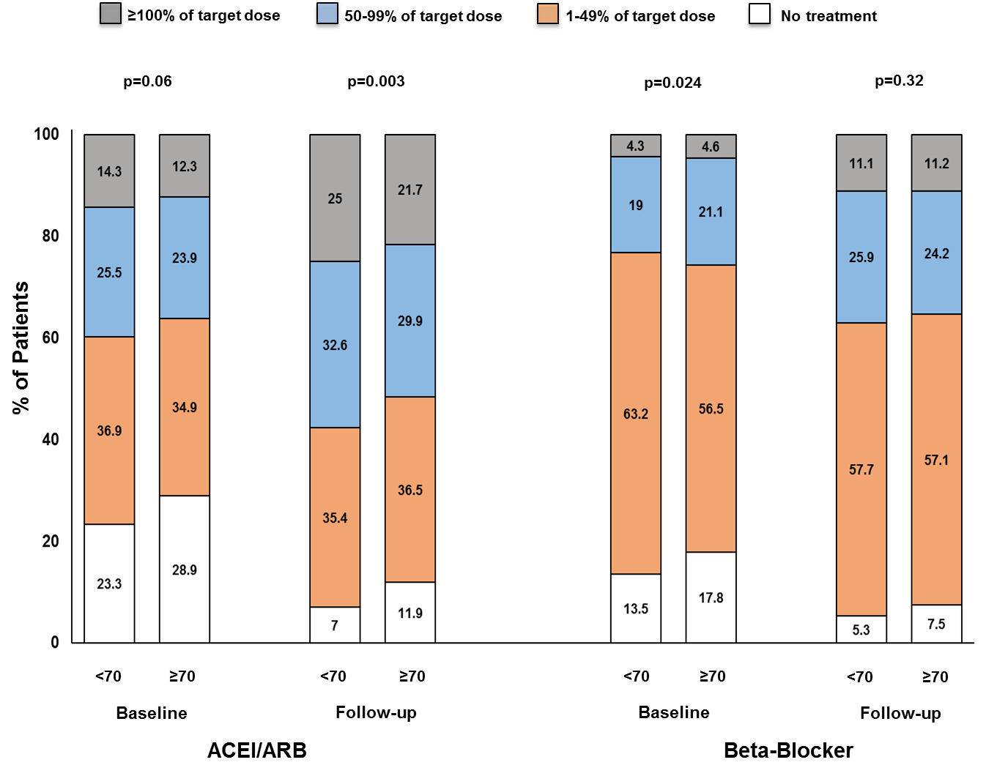

Figure 2. Association between Achieved ACEI/ARB and Beta-Blocker Dose and the Primary Outcome across the Age Spectrum.
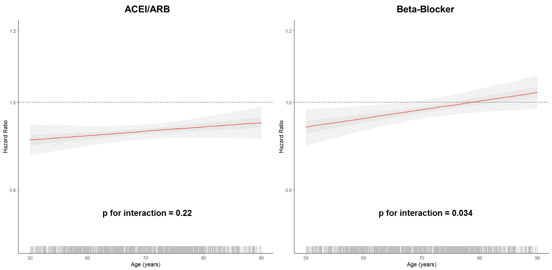
Figure 3. Association between Achieved ACEI/ARB and Beta-Blocker Dose and the Primary Outcome Stratified by Age.

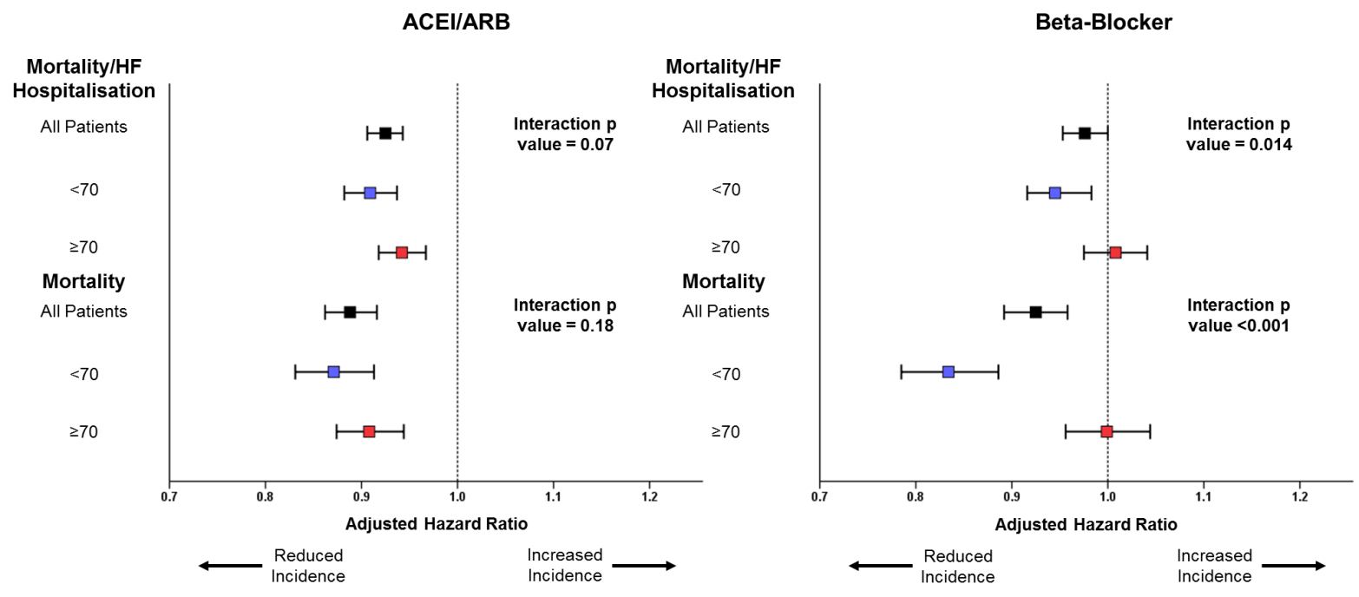
Figure 4. Percentage of Target Dose Achieved and the Primary Outcome.
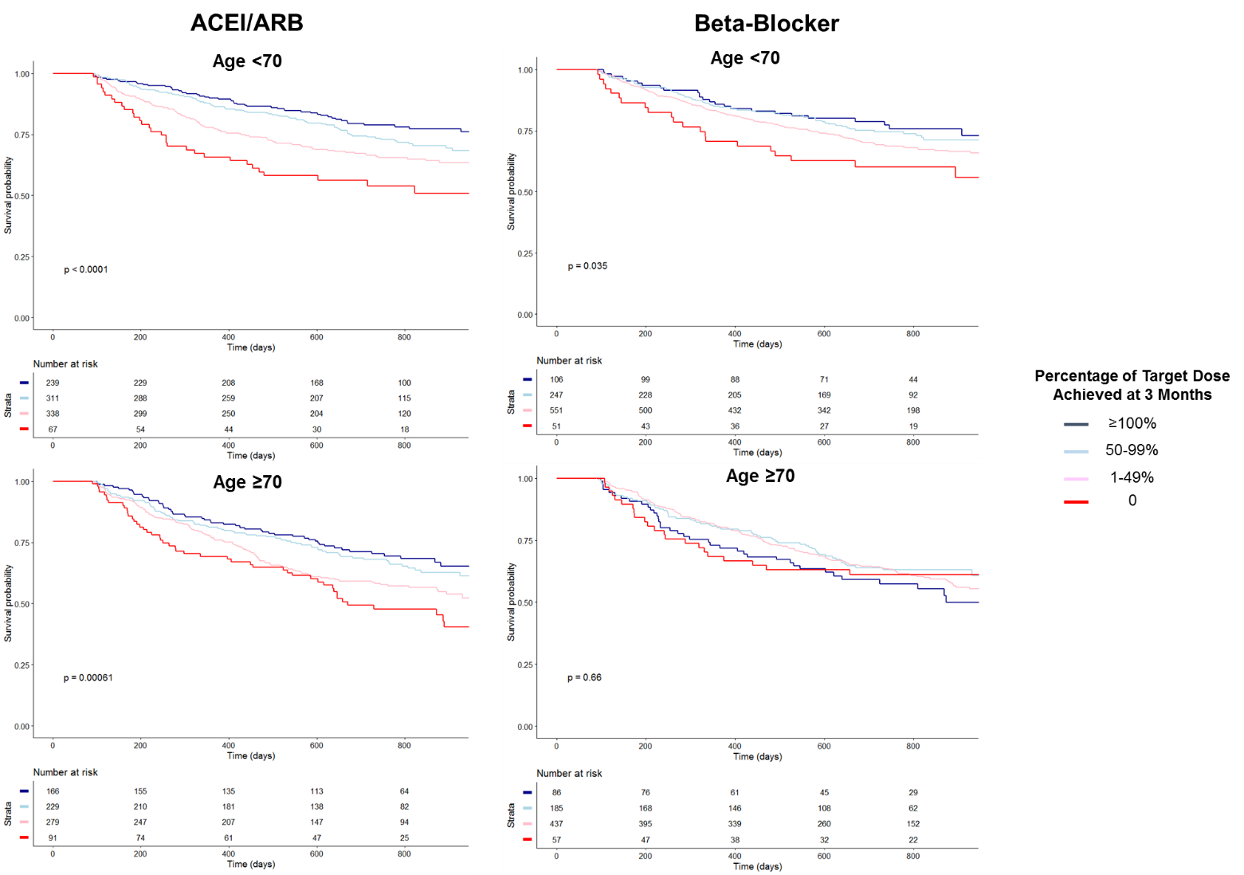

Supplementary Table 1. Target Doses from European Society of Cardiology Heart Failure Guidelines at Time of Study Design (2008).
Drug | Target Dose | Total Daily Dose
ACE Inhibitors
Captopril | 50 mg t.i.d. | 150mg
Enalapril | 10 mg b.i.d. | 20mg
Lisinopril | 35 mg q.d. | 35mg
Ramipril | 5 mg b.i.d. or 10 mg q.d. | 10mg
Trandolapril | 4 mg q.d. | 4mg
Perindopril | 8 mg q.d. | 8mg
ARBs
Candesartan | 32 mg q.d. | 32 mg
Valsartan | 160 mg b.i.d. | 320 mg
Losartan | 150 mg q.d. | 150 mg
Beta-blockers
Bisoprolol | 10 mg q.d. | 10 mg
Carvedilol | 25–50 mg b.i.d. | 50–100 mg
Metoprolol CR/XL | 200 mg q.d | 200 mg
Nebivolol | 10 mg | 10 mg

Supplementary Table 2. Reasons for Failure to Achieve Target Dose.
 | Age <70 | Age ≥70
ACEI/ARB
Achieved Target Dose | 239 (25.0) | 166 (21.7)
Symptoms, side-effects or non-cardiac organ dysfunction | 212 (22.2) | 198 (25.9)
Other | 504 (52.8) | 401 (52.4)
Beta-blocker
Achieved Target Dose | 106 (11.1) | 86 (11.2)
Symptoms, side-effects or non-cardiac organ dysfunction | 183 (19.2) | 173 (22.6)
Other | 666 (69.7) | 506 (66.1)

Supplementary Table 3. Variables Significantly Associated with Percentage Achieved Dose of ACE-Inhibitor/Angiotensin II Receptor Blocker and Beta-Blocker in Multivariable Analysis.
 | Estimate | SE | OR (95% CI) | p value | Interaction p value with age
ACEI/ARB
Intercept | -0.30 | 0.10 |  | 0.004
Age (per 10 year increase) | -0.015 | 0.009 | 0.98 (0.97-1.00) | 0.07 | n/a
BMI (per 5kg/m² increase) | 0.049 | 0.009 | 1.05 (1.03-1.07) | <0.001 | 0.76
Systolic Blood Pressure (per 10mmHg increase) | 0.043 | 0.005 | 1.04 (1.03-1.05) | <0.001 | 0.80
Estimated GFR (per 10 ml/min/1.73m² increase) | 0.016 | 0.004 | 1.02 (1.01-1.02) | <0.001 | 0.046
Country
Netherlands | Baseline
France | 0.057 | 0.038 | 1.06 (0.98-1.14) | 0.13 | 0.76
Germany | 0.024 | 0.056 | 1.02 (0.92-1.14) | 0.66 | 0.72
Serbia | 0.024 | 0.056 | 1.03 (0.97-1.10) | 0.33 | 0.44
Slovenia | 0.040 | 0.084 | 1.04 (0.88-1.23) | 0.64 | 0.76
Greece | -0.12 | 0.034 | 0.89 (0.83-0.95) | <0.001 | 0.49
Italy | -0.073 | 0.034 | 0.93 (0.87-0.99) | 0.031 | 0.89
Norway | 0.14 | 0.047 | 1.15 (1.05-1.27) | 0.003 | 0.43
Sweden | 0.21 | 0.050 | 1.24 (1.12-1.37) | <0.001 | 0.16
Poland | -0.058 | 0.036 | 0.94 (0.88-1.01) | 0.11 | 0.64
United Kingdom | 0.019 | 0.062 | 1.02 (0.90-1.15) | 0.75 | 0.45
Beta-Blocker
Intercept | 0.51 | 0.058
Age (per 10 year increase) | -0.012 | 0.007 | 0.98 (0.97-0.99) | <0.001 | n/a
Heart Rate (per 10 bpm increase) | 0.013 | 0.004 | 1.01 (1.01-1.02) | <0.001 | 0.23
Country
Netherlands | Baseline
France | -0.022 | 0.029 | 0.98 (0.92-1.04) | 0.45 | 0.97
Germany | 0.031 | 0.042 | 1.03 (0.95-1.12) | 0.46 | 0.92
Serbia | -0.17 | 0.025 | 0.84 (0.80-0.88) | <0.001 | 0.43
Slovenia | 0.14 | 0.066 | 1.16 (1.02-1.32) | 0.028 | 0.34
Greece | -0.27 | 0.026 | 0.76 (0.72-0.80) | <0.001 | 0.86
Italy | -0.077 | 0.026 | 0.93 (0.88-0.97) | 0.003 | 0.60
Norway | 0.005 | 0.037 | 1.01 (0.94-1.08) | 0.89 | 0.59
Sweden | 0.19 | 0.038 | 1.21 (1.12-1.30) | <0.001 | 0.026
Poland | -0.13 | 0.027 | 0.88 (0.84-0.93) | <0.001 | 0.54
United Kingdom | -0.22 | 0.048 | 0.80 (0.73-0.88) | <0.001 | 0.99
ACEI – angiotensin-converting enzyme inhibitor; ARB – angiotensin-II receptor blocker; BMI – body mass index; SE – standard error; OR – odds ratio
Bold indicates p<0.05. All baseline variables in Table 1 were tested for univariable significance and if significantly associated with successful uptitration in a multivariable model. For clarity only variables showing significant association and age are presented here.
Supplementary Table 4. Association Between Achieved Dose Following Uptitration and Mortality only (adjusted for likelihood of uptitration using inverse probability treatment weighting).
 |  | Age <70 |  |  | Age ≥70
 | Number of Patients | Hazard Ratio | p value | Number of Patients | Hazard Ratio | p value | Interaction p value
ACEI/ARB
>100% | 239 | ref |  | 166 | ref |  | 0.40
50-99% | 311 | 1.20 (0.83-1.73) | 0.34 | 229 | 1.22 (0.86-1.72) | 0.50
1-49% | 338 | 1.97 (1.40-2.76) | <0.001 | 279 | 1.86 (1.36-2.55) | <0.001
0 | 67 | 3.34 (2.17-5.12) | <0.001 | 91 | 2.58 (1.77-3.76) | <0.001
Beta-blocker
>100% | 106 | ref |  | 86 | ref |  | <0.001
50-99% | 247 | 2.39 (1.30-4.41) | 0.005 | 185 | 0.54 (0.37-0.81) | 0.002
1-49% | 551 | 3.94 (2.26-6.85) | <0.001 | 437 | 0.83 (0.61-1.12) | 0.21
0 | 51 | 5.65 (2.84-11.23) | <0.001 | 57 | 0.88 (0.53-1.45) | 0.62
ACEI – angiotensin-converting enzyme inhibitor; ARB – angiotensin-II receptor blocker.
Bold indicates p<0.05.

Supplementary Table 5. Association Between Achieved Dose Following Uptitration and Mortality/Heart Failure Hospitalisation (adjusted for likelihood of uptitration using inverse probability treatment weighting and BIOSTAT risk model).
 | Age <70 |  | Age ≥70 |  | Interaction p value
 | Hazard Ratio (95% CI) | p value | Hazard Ratio (95% CI) | p value
ACEI/ARB
>100% | ref |  | ref |  | 0.014
50-99% | 0.94 (0.74-1.19) | 0.61 | 0.91 (0.72-1.15) | 0.44
1-49% | 1.17 (0.93-1.47) | 0.17 | 1.09 (0.87-1.35) | 0.46
0 | 1.30 (0.95-1.78) | 0.11 | 1.02 (0.77-1.37) | 0.87
Beta-blocker
>100% | ref |  | ref |  | 0.029
50-99% | 0.94 (0.70-1.27) | 0.70 | 0.74 (0.56-0.98) | 0.034
1-49% | 0.95 (0.73-1.23) | 0.69 | 0.73 (0.58-0.93) | 0.010
0 | 1.17 (0.78-1.76) | 0.44 | 0.67 (0.45-1.00) | 0.048
ACEI – angiotensin-converting enzyme inhibitor; ARB – angiotensin-II receptor blocker.
Bold indicates p<0.05.

Supplementary Table 6. Association Between Achieved Dose Following Uptitration and Mortality only (adjusted for likelihood of uptitration using inverse probability treatment weighting and the BIOSTAT risk score for prediction of mortality).
 | Age <70 |  | Age ≥70 |  | Interaction p value
 | Hazard Ratio (95% CI) | p value | Hazard Ratio (95% CI) | p value
ACEI/ARB
>100% | ref |  | ref |  | 0.15
50-99% | 0.87 (0.60-1.26) | 0.45 | 1.08 (0.77-1.54) | 0.64
1-49% | 1.34 (0.94-1.89) | 0.10 | 1.44 (1.04-1.97) | 0.026
0 | 1.33 (0.83-2.12) | 0.23 | 1.51 (1.02-2.23) | 0.041
Beta-blocker
>100% | ref |  | ref |  | <0.001
50-99% | 2.61 (1.41-4.81) | 0.002 | 0.53 (0.36-0.78) | 0.001
1-49% | 3.19 (1.83-5.57) | <0.001 | 0.73 (0.54-0.99) | 0.040
0 | 4.99 (2.51-9.92) | <0.001 | 0.58 (0.35-0.96) | 0.035
ACEI – angiotensin-converting enzyme inhibitor; ARB – angiotensin-II receptor blocker.
Bold indicates p<0.05.

Supplementary Figure 1.
Association Between Achieved Beta-Blocker Dose and Achieved Heart Rate in Older vs. Younger Patients.
Mean heart rate (and standard error) at follow-up stratified by percentage of target dose of beta-blocker achieved and age. There was a significant correlation between beta-blocker dose and achieved heart rate in younger but not older patients.

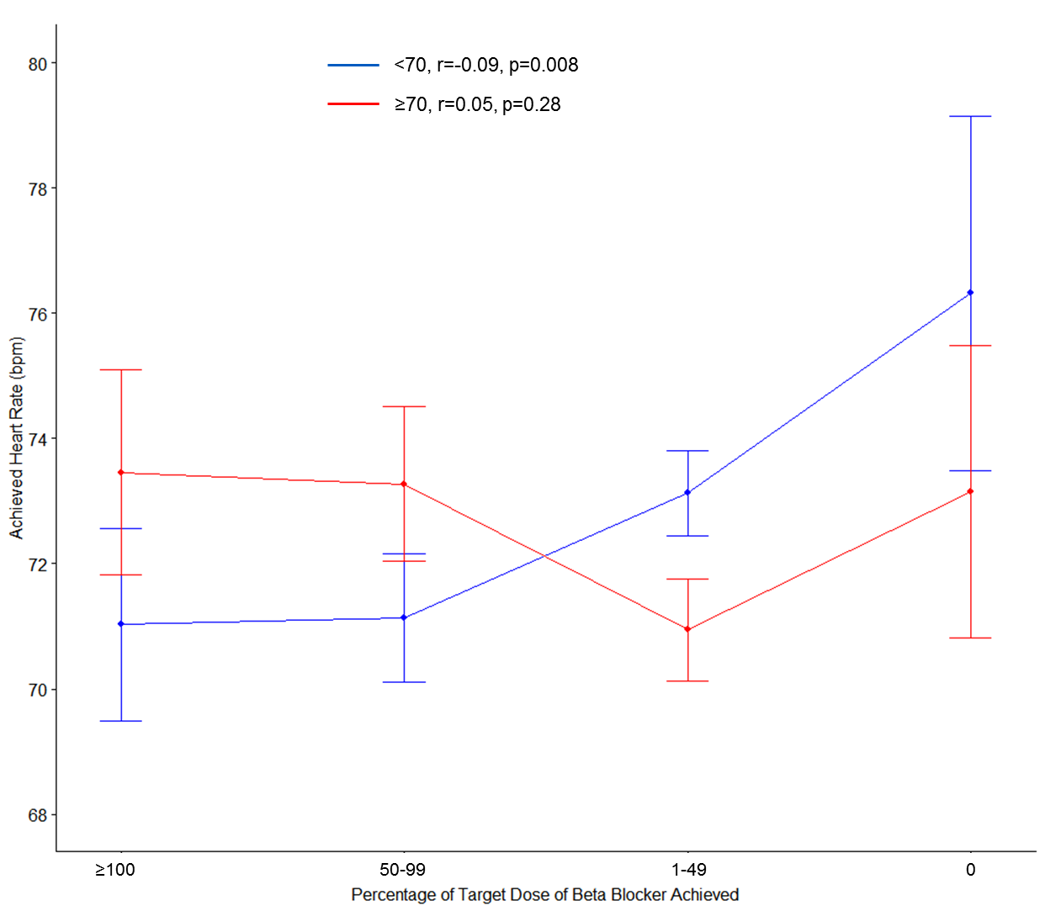

Supplementary Figure 2. Association between Achieved ACEI/ARB and Beta-Blocker Dose and the Primary Outcome across the Age Spectrum.
