Global Representation of Heart Failure Clinical Trial Leaders, Collaborators, and
Enrolled Participants:
A Bibliometric Review 2000-2020

Jie Wei Zhu, BHSc 1; NhatChinh Le, BSc1#; Sunny Wei, MD, CM, MSc1#; Liesl Zühlke,
MBChB, PhD2; Renato Lopes, MD, PhD3; Faiez Zannad, MD, PhD4; Harriette GC Van Spall,
MD, MPH1,5,6
# denotes shared 2nd authorship

Author Affiliations
1 Department of Medicine, McMaster University, Hamilton, Ontario, Canada
2 The Cardiac Clinic, Department of Medicine, Groote Schuur Hospital and University of Cape
Town, J Floor Old Groote Schuur Hospital, Groote Schuur Drive, Observatory 7925, Cape
Town, South Africa
3 Duke Clinical Research Institute, Duke University Medical Center, Durham, North Carolina.
4 Universite de Lorraine, Inserm, Centre d'Investigations Cliniques-1433 and Inserm U1116,
CHRU Nancy, France
5 Department of Health Research Methods, Evidence, and Impact, McMaster University,
Hamilton, Ontario, Canada
6 Population Health Research Institute, Hamilton, Ontario, Canada

Funding
Dr Zannad reports steering committee personal fees from Applied Therapeutics, Amgen, Bayer,
Boehringer, Novartis, Janssen, Cellprothera and CVRx, advisory board personal fees from,
AstraZeneca, Vifor Fresenius, Cardior, Cereno pharmaceutical, Corvidia, Merck, Myokardia,
NovoNordisk and Owkin, stock options at Cereno and G3Pharmaceutical, and being the founder
of the Global Cardiovascular Clinical Trialist Forum.
Dr Van Spall is supported by the Canadian Institutes of Health Research and the Heart and
Stroke Foundation of Canada

Conflict of Interest: none declared

Data availability statement
The data underlying this article will be shared on reasonable request to the corresponding author.

Corresponding author:
Dr. Harriette Gillian Christine Van Spall
20 Copeland Avenue, David Braley Research Building, Suite C3-117
Hamilton, Ontario L8L 0A3, Canada.
E-mail: Harriette.VanSpall@phri.ca. Twitter: @hvanspall

Manuscript word count: 3509

ABSTRACT
Background: The geographic representation of investigators and participants in heart failure
(HF) randomized clinical trials (RCTs) may not reflect the global burden of disease.
Aims: We assessed the geographic diversity of RCT leaders and explored associations with
geographic representation of enrolled participants among impactful HF RCTs.
Methods and Results: We searched MEDLINE, EMBASE, and CINAHL for HF RCTs
published in journals with impact factor ≥ 10 between January 2000 and June 2020. We used the Jonckheere-Terpstra test to assess temporal trends and multivariable logistic regression models to explore associations between predictors and outcomes. There were 414 eligible RCTs. Only 80 of 828 trial leaders (9.7%; 95% CI: 7.8% to 11.8%), and 453 of 4656 collaborators (9.7%; 95% CI: 8.8% to 10.6%) were from outside Europe and North America, with no change in temporal trends and greater disparities in large RCTs. The adjusted odds of trial leadership
outside Europe and North America were lower with industry funding (aOR: 0.33; 95% CI: 0.15
to 0.75; P = 0.008). Among 157,416 participants in whom geography was reported, only 14.5%
(95% CI: 14.3% to 14.7%) were enrolled outside Europe and North America, but odds of
enrolment were ten-fold greater with trial leadership outside Europe and North America (aOR:
10.0; 95% CI 5.6-19.0; P < 0.001).
Conclusions: Regions disproportionately burdened with HF are under-represented in HF trial
leadership, collaboration, and enrolment. RCT leadership outside Europe and North America is
independently associated with participant enrolment in under-represented regions. Increasing
research capacity outside Europe and North America could enhance trial diversity and generalizability.
Keywords: Randomized Controlled Trials, Authorship, Collaboration, Diversity, Geography
Abbreviations:
HF = heart failure
LMIC = low- and middle- income countries
PPR Participation-to-Prevalence ratios
RCT = randomized control trial

Introduction
Heart failure (HF) is a global epidemic with a disproportionate burden in low and middle
income countries (LMIC).1,2 Clinical trials have the potential to impact practice, but when trial
populations do not include regions of the world in which a majority of patients are suffering from
the disease, generalizability is limited.3 While geographic representation of patients is important
to ensure external validity of trial results, geographic representation of researchers can ensure
that HF is tackled with insight into the local epidemiology and the context that influence
outcomes.
Primary research on diversity among cardiovascular clinical trial leaders has focused
almost exclusively on gender,4-6 with little discussion about geographic diversity. Clinical trials
led by women are associated with enrolment of more diverse participants.4,5,7 Indeed, leadership
diversity – in its many forms - may broaden the focus of research questions, employ novel trial
designs matched to the needs of patients and local healthcare systems, and address unique
concerns of participants who may be historically under-represented in clinical trials.8-10 On a
global level, geographic diversity of clinical trial leaders may enhance geographic diversity
among trial participants, build research capacity in under-represented regions, and increase
academic output and research impact in research-poor settings. For example, international
collaborations are associated with a greater number of publications and a higher citation count
than single-country authorship teams.11-13
In this bibliometric review, we evaluated temporal trends in the geographic representation
of leaders and collaborators of HF trials published in high-impact medical journals, defining trial
leaders as first and last authors and collaborators as authors in any other position. We focused on
high impact-factor journals to capture trials with the potential to inform practice on a global
scale. We explored trial characteristics independently associated with trial leadership in countries
outside Europe and North America and assessed whether geographic representation of trial
leaders was independently associated with geographic representation of participants enrolled in
the trial.

Methods
Search strategy and data sources
We conducted a systematic search of Embase, MEDLINE and CINAHL with the
assistance of a professional information specialist. Our search strategy comprised variations of
the key terms heart failure and randomized controlled trial (see Supplemental Appendix). Our
search was limited to human studies published in English up until June 2020. We manually
searched citations of included studies and relevant review articles for additional studies not
included in our original search. The study protocol was registered in the International
Prospective Register of Systematic Reviews (PROSPERO).

Study selection
The authors independently screened all titles and abstracts against pre-determined
eligibility criteria in duplicate (J.Z., N.L. and S.W). Discrepancies between reviewers were
resolved via consensus. Studies were included if they satisfied the following criteria: i) published
in English between January 1, 2000 and June 17, 2020, ii) included adults aged 18 years or older
with HF and iii) were published in a medical journal with an impact factor of ≥ 10 in 2020. The
impact factor of 10 was chosen empirically to include publications with highest likelihood of
impacting clinical practice.14 The year 2000 was arbitrarily chosen to include a representative
sample of contemporary clinical trials. Full-text manuscripts reporting primary outcomes were
included, while protocols and publications following the initial manuscript that reported primary
outcomes were excluded. As such, we excluded post hoc, intermediate or secondary analyses.

Data extraction
We independently extracted the following data in duplicate (J.Z., N.L. and S.W.) from
individual studies using a standardized form: trial characteristics (publication year, journal of
publication, journal impact factor, funding, level of randomization, type of intervention, national
or international trial and number of centres); bibliometric characteristics (journal of publication,
total number of authors, gender and geography of authors in lead/first, middle, senior/last and
corresponding positions, and location of the trial coordinating centre); and participant
characteristics, including geographic region of enrolment.
We included individual authors listed in the paper and documented shared authorship
roles in the first or last positions, where applicable. We defined trial leaders as first or last
authors and collaborators as authors in any position. We did not include individuals in trial
investigator committees or consortia groups. We regarded trials as having international
collaborations when two or more authors had primary institutional affiliations in different
countries. Geographic information for authors was established using the address of the primary
institutional affiliation of each author in the paper. We used World Bank data to classify
countries by income.15

Outcomes
The primary outcome was trial leadership outside Europe and North America. The
secondary outcome was the enrolment of trial patients outside Europe and North America.

Analytic Plan
We performed a descriptive analysis on the characteristics of trials and the geography and
gender of authors, with continuous variables presented as median and interquartile range (IQR)
and categorical variables as numbers and percentages. We conducted a sensitivity analysis,
repeating this descriptive analysis in trials that included >500 participants. Temporal trends in
geographic representation of lead, senior, and any author between 2000 and 2020 were analyzed
using the Jonckheere-Terpstra proportion trend test. We used multivariable logistic regression to
determine RCT characteristics independently associated with trial leadership outside Europe and
North America. Trial characteristics under consideration as predictor variables included scope of
the trial (national versus international), type of funding (industry versus public), type of
intervention (drug, surgical or device versus other), trial size (<500 versus > 500 participants).
We assessed country of enrolment among those participants in whom geography data
were reported. We estimated trial participant-to-prevalence ratio in regions across the world
using the Global Health Data Exchange registry.16 Participant-to-Prevalence ratios (PPR) were
calculated from the regional contribution of participants to the total RCTs divided by the regional
contribution of patients with HF relative to the global population with HF. In secondary analysis,
we used multivariable logistic regression to determine the independent association between trial
leadership outside Europe and North America and enrolment of patients outside Europe and
North America. Results were reported as odds ratio (ORs) with corresponding 95% confidence
interval (CI) and associated P values. All P values were 2-tailed, and the level of significance
was set at alpha = 0.05. Data were analyzed using SPSS version 27.0 (IBM Corporation,
Armonk, New York).

Results
Our systematic search yielded a total of 10 596 articles, of which 8278 were excluded
following title and abstract screening. Among the remaining 2318 full-text articles that were
assessed, 414 satisfied eligibility criteria and were included (Figure 1).
Baseline characteristics of patients and RCTs
A total of 234 287 participants with a mean age of 66.3 years were enrolled across all
studies (median 120 participants; IQR: 40-389). Most trial participants were male (71.7%) and
had an ischemic etiology of heart failure (53.4%).
A majority of the 414 RCTs had trial coordinating centres located in Europe or North
America (53.1% and 37.4%, respectively, for a total of 90.5%), tested a drug intervention
(65.5%), were conducted in a single country (74.9%) and involved multiple centres (58.7%)
(Table 1). Informed consent was obtained in all trials.

Geographic representation of trial leaders and collaborators
Only 80 of 828 trial leaders (9.7%; 95% CI: 7.8% to 11.8%) were from regions outside
Europe and North America. The United Kingdom (10.2%) and United States (34.4%) were the
most frequently represented countries among trial leaders. The trials included a total of 4656
collaborators (median 10 authors; IQR: 7 to 14 authors per trial), most (90.1%) of whom had
primary institutional affiliations in Europe (49.2%) and North America (40.9%). Among the
4656 trial collaborators, 453 (9.7%; 95% CI: 8.8% to 10.6%) were from countries outside Europe
and North America. Africa was the least represented continent among trial leaders (0.1%) and all
collaborators (0.3%) (Figure 2A). Low- and middle-income countries were particularly underrepresented among trial leaders and collaborators. A breakdown of trial leaders and collaborators by country is provided in Table 2.
The median number of collaborators per trial increased from 8 (IQR: 5 to 11) in 2001-
2003 to 15 (IQR: 12 to 19) in 2016-2020. While there was a numeric decrease in the proportion
of European collaborators and an increase in North American, Central / South American, and
African collaborators since 2012 (Figure 2A), there was no significant change in the in the
proportion of trial leaders (first author, P = 0.75; last author, P = 0.64) or trial collaborators from
countries outside Europe and North America between 2000 and 2020 (P = 0.17) (Figure 2B).

Sensitivity analysis
Among international trials conducted in two or more countries, there were no significant
temporal changes in trial leadership outside Europe and North America (P = 0.65). Among the
79 RCTs that included >500 participants, 77 (97.5%; 95% CI: 91.2% to 99.7%) were led by
authors from Europe or North America and 2 were led by authors from Asia (n = 1 [1.3%; 95%
CI: 0.3% to 7.0%]) and Oceania (n = 1 [1.3%; 95% CI: 0.3% to 7.0%]), respectively. Among the
79 RCTs, 57 (72.2%; 95% CI: 60.9% to 81.7%) were international and 22 (27.8%; 95% CI: 18.4% to 39.1%) were national.

International collaboration between trial leaders
Of 167 trials with international collaboration between trial leaders, 125 represented
European or North American countries (74.9%; 95% CI: 67.6% to 81.2%) (Table 2). The most
frequent type of international collaboration was between countries in Europe (n= 79 [47.3%;
95% CI: 39.5% to 55.2%]); then between countries in North America (n = 42 [25.1%; 95% CI:
18.8% to 32.4%]); and finally, between countries in Europe and North America (n = 31 [18.6%;
95% CI: 13.0% to 25.3%]). Only 15 of 167 trials (9.0%; 95% CI: 5.1% to 14.4%) with
international collaborations between trial leaders involved a country outside Europe and North
America.

Multivariable analysis of RCT characteristics associated with trial leadership outside Europe
and North America
The odds of trial leadership outside Europe and North America were significantly lower
in trials with industry funding compared to public funding (OR: 0.33; 95% CI: 0.15 to 0.75; P =
0.008) (Table 3). Scope of trial (national versus international), intervention type (drug or device /
surgery versus other), and size of trial (> 500 participants versus < 500 participants) had no
signification association with trial leadership outside Europe and North America (Table 3).

Geographic representation of trial participants
Of the 414 RCTs, a total of 97 (23.4%) recruited participants outside Europe and North
America, and only 2.9% recruited participants from Africa (Table 1). Participant level data on
region of enrolment was available for 157,416 (67.2%; 95% CI: 67.0% to 67.4%) trial
participants. Among these participants, 54.9% (95% CI: 54.7% to 55.2%) were enrolled in
Europe; 30.6% (95% CI: 30.4% to 30.8%) in North American; 5.8% (95% CI: 5.7% to 5.9%) in
Asia; 5.8% (95% CI: 5.7% to 5.9%) in Central and South America; 1.94% (95% CI: 1.9% to
2.0%) in Oceania; and 0.95% (95% CI: 0.9% to 1.0%) in Africa (Figure 3). The trial participant-
to-prevalence ratio was highest in North America (3.3) and Europe (2.8) and lowest in Asia (0.1)
and Africa (0.1) (Figure 3).
Trial leadership outside Europe and North America was independently associated with
recruitment of patients outside Europe and North America (OR: 10.0; 95% CI 5.6-19.0; P <
0.001.

Trial leadership and journal of publication
The studies included in this analysis were published in 14 medical journals
(Supplemental Table 1). Most of the 414 trials were published in the European Journal of Heart
Failure (n = 109 [26.3%]), followed by Journal of the American College of Cardiology (n = 87
[21.0]) and Circulation (n = 63 [15.2%]). Among trials with first or last study authors outside
Europe and North America, most were published in the European Journal of Heart Failure (n = 8
[53.3%; 95% CI: 26.6% to 78.7%]) and Journal of the American College of Cardiology (n = 5
[33.3%; 95% CI: 11.8% to 61.6%]).

Discussion
This bibliometric review of 414 HF RCTs published between 2000 and 2020 in high-impact medical journals is the first to rigorously examine the geographic representation of HF clinical trial leaders, collaborators, and participants. We found that countries outside Europe and North America – which bear the greatest burden of HF on a global scale16 – were under-represented among trial leaders (9.7%), collaborators (9.7%), and participants (14.5%), with no change in temporal trends over the past 20 years. The gaps in geographic representation of trial leaders and collaborators was even more pronounced in large trials. International collaborations were primarily between or within Europe and North America, and Africa was the least represented continent. Industry funding was independently associated with lower odds of trial leadership outside Europe or North America. The geographic location of trial enrolment reflected
that of trial leadership, with the adjusted odds of enrolling trial participants outside Europe and
North America ten-fold greater in trials with leaders outside Europe and North America
(Graphical Abstract).
The under-representation of clinical trial leaders and collaborators from regions outside
Europe and North America was even more marked in large trials, and may reflect systemic
barriers to trial coordination in these regions, particularly in LMIC. Barriers beyond what can be
addressed by the research community in some LMIC include social and political instability,
economic deprivation, and suboptimal healthcare systems for the reliable delivery of an
intervention. Research-specific barriers include limited trial coordination centers, advanced
research education, research infrastructure, grant funds, and human capacity for research.17 In
addition, ethical and regulatory challenges may hinder the efficient implementation of
multicentre trials in Africa, Asia, South America and the Caribbean.17 Thus, while the global
maldistribution of trial activity decreases the generalizability of results, it can increase efficiency
by concentrating resources in regions with established research capacity and rigor; however,
without broadening this capacity across regions, the cycle is expected to self-perpetuate.
Our findings that African researchers were the least represented globally in HF RCT
authorship - comprising 1 first author, 0 last authors, and 0.3% of middle authors - highlight the
potential that the cardiovascular research community has lost in harnessing research ideas,
answering research questions, and designing pragmatic trials to respond to the healthcare needs
of African patients. Prior studies have demonstrated a substantial predominance of non-African co-authors in cardiovascular research,20 and reported that Africa produced 0.3% of the total
cardiovascular research output from 1995 to 2002 with an average of 27 publications per year.21
Although we found that the proportion of RCTs with African authors has increased in recent
years (Figure 2A), there will need to be marked global funding investment and collaboration
efforts to improve capacity and realize the research potential that lies in African countries.22
Although there are international initiatives that provide grant funding to African-based
organizations, these are not specific to the healthcare sector and funds for cardiovascular
research remain limited.23 African academic institutions continue to have limited research
resources, fewer research institutes, and little government support.22
Over half the RCTs in this study were industry sponsored and industry funding was
associated with lower odds of trial leadership outside Europe or North America. Industry
sponsors typically select trial leaders from a small pool of clinician researchers who lend their
credentials and scientific influence to the trial.24 There are no open processes by which leaders
and executive committees are selected in industry-initiated trials, which likely disadvantages
women4 and those from LMIC. Indeed, industry-funded trials are not conducted with diversity
and inclusion as a goal, but rather for commercial reasons and profit-generation in high income
countries.24 Although there has been a shift towards conducting industry-initiated trials in
regions outside Europe and North America, ethical, legislative, and regulatory barriers persist in
some LMIC,25 and the geographic composition of trial leaders has not changed.
Trial enrolment was largely in North American and Europe, and the HF participant-prevalence ratio was highest in these regions, suggesting geographic over-representation in trials. The participant-prevalence ratio was lowest in Asia and Africa, consistent with marked underrepresentation of participants in these regions. LMIC include a majority of the global population living with HF, and the etiology, access to care, and burden of HF in these countries differ from those of high-income countries.26 HF patients from countries with greater income inequality, including LMIC, have the highest mortality rates,25 and income inequality of countries has a prognostic impact similar to those of major HF comorbidities.27 Similarly, Africa and other LMICs are underrepresented in authorship of endemic diseases such as HIV, despite the steady temporal increase in international research collaboration and more than two thirds of HIV infected individuals living in Africa.28,29 The impact of research-driven solutions could
potentially produce the greatest mortality benefit in the poorest regions of the world that are
largely under-represented in research.30,31 This could come from direct benefits of trial
participation – closer monitoring and care for those enrolled - and also from healthcare research
investments that could potentially improve healthcare processes and infrastructure,32 and
expedite knowledge translation – including drug commercialization - in LMIC.
The adjusted odds of trial recruitment outside Europe and North America were ten-fold
greater in trials led outside Europe and North America. The benefits of trial leadership from
LMIC extend beyond devising research questions, designing trial protocols, and recruiting trial
populations to meet the health care needs of their local populations. Trial leadership in these
countries can provide opportunities to expand institutional capacity, improve infrastructure, train
junior researchers, and advance the careers of able scientists through publications, citations, and
name recognition. Benefits can also extend to collaborators from high-income countries, as
publications involving multinational authorship tend to have greater academic impact than
single-country publications.33,34 Several trials led in the USA and Europe have outsourced their
research to LMIC to manage costs and regulatory requirements, which may result not only in
greater research capacity but also more collaborator roles for researchers in these countries.18,19
There are several multi-level strategies that may address current challenges and promote
geographic diversity among leaders of HF RCTs (Table 4). Research teams from high-income
countries can engage in more frequent international collaborations, relatively easily in the current
era of digital communications and virtual meetings.35 Industry and grant funding agencies such
as the National Heart, Lung, and Blood Institute (NHLBI) and Global Alliance for Chronic
Disease (GACD) can stipulate that studies conducted in LMIC include researchers from these
countries as collaborators. GACD can also broaden the current scope of funding for
implementation science to heart failure, which would be an important opportunity to reduce the
gap in HF research output from LMICs.32 Increasing emphasis should also be placed on adequate
early research training, fellowships, exchange programs, and visiting professorships to foster the
growth and development of future human capital, which is key to scientific success. Increasing
effort by both low- and high-income countries therefore should be directed towards providing
training in an equitable, respectful way to establish long-lasting, sustainable partnerships. Lastly,
to address the ethical and regulatory approval system obstacles, capacity strengthening activities
initiated through grants from high-income countries (at the level of the World Health
Organization, pharmaceutical and device companies, and professional societies) have been
previously proposed as a promising strategy.36
Study strengths and limitations
Methodological strengths of our study included the comprehensive search strategy,
duplicate extraction, large sample size and temporal range (20-year time span) of RCTs
published in high-impact factor journals. Limitations should be noted. First, we focussed on
English language studies published in high impact factor medical journals to capture the most
widely-read trials with the potential to impact clinical practice. We recognize that the geographic
representation of authors and participants reported in this study may not apply to RCTs published
in lower-impact, non-English journals or adequately capture the growth in cardiovascular
research in non-English countries.37 Furthermore, this may contribute to reinforcing the researchcenteredness around English-language publications from North America and Europe. Second, the trials were specific to HF and results may not be generalizable to trials in other cardiovascular diseases. Indeed, HF is a younger discipline and the organization of HF care in low-income countries is less developed than that of other cardiovascular diseases like coronary artery disease.38 Third, some authors may have had a primary or secondary institution affiliation
outside their current country of residence and the institutional addresses may not accurately
reflect their geographic location. Fourth, we used first and last authorship status as surrogates for
leadership of RCTs, although we acknowledge that some trials are led by industry partners. Fifth,
while our geographic classification was continent-based, we recognize the inter-country variation
in research contribution, as outlined in Table 2. Sixth, our multivariable analysis is exploratory in
nature and the results should be interpreted with caution.

Conclusion
Among the 414 HF RCTs published between 2000 and 2020, researchers outside Europe and
North America were under-represented as trial leaders and collaborators in high-impact HF
RCTs, with no significant temporal changes in representation over time. Trial participants in
regions outside Europe and North America were grossly under-represented relative to HF
prevalence, particularly in Africa and Asia. Trial leadership outside Europe and North Americal
was less likely in industry-funded trials, but associated with ten-fold greater odds of participant enrolment outside Europe and North America. Building research capacity in under-represented
regions has the potential to increase the diversity and external validity of clinical trials.

Acknowledgments
The authors thank Mohammad Alruwayeh, Yousif Eliya, Kristen Sullivan, and Sera Whitelaw,
for their assistance with data extraction.

References
[1] Callender T, Woodward M, Roth G, Farzadfar F, Lemarie JC, et al. (2014) Heart Failure Care
in Low- and Middle-Income Countries: A Systematic Review and Meta-Analysis. PLOS
Medicine 11(8): e1001699. https://doi.org/10.1371/journal.pmed.1001699

[2] Harikrishnan S, Sanjay G, Anees T, et al. Clinical presentation, management, in-hospital and
90-day outcomes of heart failure patients in Trivandrum, Kerala, India: the Trivandrum Heart
Failure Registry. Eur J Heart Fail. 2015;17(8):794-800. doi:10.1002/ejhf.283

[3] Van Spall HG, Toren A, Kiss A, Fowler RA. Eligibility criteria of randomized controlled
trials published in high-impact general medical journals: a systematic sampling review. JAMA.
2007;297(11):1233-40. doi: 10.1001/jama.297.11.1233. PMID: 17374817.

[4] Denby KJ, Szpakowski N, Silver J, Walsh MN, Nissen S, Cho L. Representation of Women
in Cardiovascular Clinical Trial Leadership. JAMA Intern Med. 2020;180(10):1382-1383.
doi:10.1001/jamainternmed.2020.2485

[5] Whitelaw S, Sullivan K, Eliya Y, et al. Trial characteristics associated with under-enrolment
of females in randomized controlled trials of heart failure with reduced ejection fraction: a
systematic review [published online ahead of print, 2020 Oct 29]. Eur J Heart Fail.
2020;10.1002/ejhf.2034. doi:10.1002/ejhf.2034

[6] Whitelaw S, Thabane L, Mamas MA, et al. Characteristics of Heart Failure Trials Associated
With Under-Representation of Women as Lead Authors. J Am Coll Cardiol. 2020;76(17):1919-
1930. doi:10.1016/j.jacc.2020.08.062

[7] Wei S, Le N, Zhu, J, et al. Racial reporting and diversity among heart failure clinical trial
participants 2000-2020: a systematic review. Manuscript under review.

[8] Sliwa K, Azibani F, Baard J, et al. Reducing late maternal death due to cardiovascular disease
- A pragmatic pilot study. Int J Cardiol. 2018;272:70-76. doi:10.1016/j.ijcard.2018.07.140

[9] Van Spall HGC, Lee SF, Xie F, et al. Effect of Patient-Centered Transitional Care Services
on Clinical Outcomes in Patients Hospitalized for Heart Failure: The PACT-HF Randomized
Clinical Trial. JAMA. 2019;321(8):753-761. doi:10.1001/jama.2019.0710

[10] Bernabe-Ortiz A, Sal Y Rosas VG, Ponce-Lucero V, et al. Effect of salt substitution on
community-wide blood pressure and hypertension incidence. Nat Med. 2020;26(3):374-378.
doi:10.1038/s41591-020-0754-2

[11] Abramo G, D'Angelo CA, Solazzi M. The relationship between scientists' research
performance and the degree of internationalization of their research. Scientometrics [Internet].
2011 Mar 29. Available at: http://link.springer.com/10.1007/s11192-010-0284-7. Accessed Oct
26, 2020.

[12] F. Narin and E.S. Whitlow, 1990, Measurement of Scientific Cooperation and Coauthorship
in CEC-related Areas of Science (Report EUR 12900, Office for Official Publications of the
European Communities, Luxembourg).

[13] Gal D, Glänzel W, Sipido KR. Mapping cross-border collaboration and communication in
cardiovascular research from 1992 to 2012. Eur Heart J. 2017;38(16):1249-1258.
doi:10.1093/eurheartj/ehw459

[14] Collier C. Announcing the 2019 journal citation reports. Available at: https://clarivate.com/
webofsciencegroup/article/announcing-the-2019-journal-citation-reports/. Accessed Jan 20,
2021.

[15] Institute of Medicine (US) Committee on Preventing the Global Epidemic of Cardiovascular
Disease: Meeting the Challenges in Developing Countries; Fuster V, Kelly BB, editors.
Promoting Cardiovascular Health in the Developing World: A Critical Challenge to Achieve
Global Health. Washington (DC): National Academies Press (US); 2010. E, World Bank Income
Classifications July 2009. Available from: https://www.ncbi.nlm.nih.gov/books/NBK45682/

[16] GHDx - Global Health Data Exchange (Institute for Health Metrics and Evaluation – IHME.
Available at: http://www.healthdata.org/gbd/2019. Accessed April 27, 2021.

[17] Ndebele P, Blanchard-Horan C, Shahkolahi A, et al. Regulatory challenges associated with
conducting multi-country clinical trials in resource-limited settings. J. Acquir. Immune Defic.
Syndr. (1999) 2014;65:S29. doi: 10.1097/QAI.0000000000000037

[18] Homedes N, Ugalde A. Health and Ethical Consequences of Outsourcing Pivotal Clinical
Trials to Latin America: A Cross-Sectional, Descriptive Study. PLOS One.
2016;11(6):e0157756. doi:10.1371/journal.pone.0157756

[19] Belforti RK, Wall MS, Lindenauer PK, et al. International outsourcing of medical research
by high-income countries: changes from 1995 to 2005. J Investig Med. 2010;58(2):287-294.
doi:10.2310/JIM.0b013e3181ca72e2

[20] Adams J, Gurney K, Hook D. et al. International collaboration clusters in Africa.
Scientometrics. 2014;98(1):547–556.
[21] Adams J, Gurney K, Hook D. et al. International collaboration clusters in Africa.
Scientometrics. 2014;98(1):547–556.

[22] Zannad, F., Sobhy, M., Almahmeed, W., et al. Clinical research in Africa and middle East:
roadmap for reform and harmonisation of the regulatory framework and sustainable capacity
development. Journal of Global Health Reports. 2019. 3, p.e2019082.

[23] Gaziano TA, Bitton A, Anand S, et al. Growing epidemic of coronary heart disease in low-and middle-income countries. Curr Probl Cardiol. 2010;35(2):72-115. doi:10.1016/j.cpcardiol.2009.10.002

[24] Chopra SS. Industry Funding of Clinical Trials: Benefit or Bias? JAMA. 2003;290(1):113–
114. doi:10.1001/jama.290.1.113

[25] Marzouk D, Abd El Aal W, Saleh A, et al. Overview on health research ethics in Egypt and
North Africa. The European Journal of Public Health. 2014;24(suppl 1):87-91.
doi:10.1093/eurpub/cku110

[26] Gaziano TA, Bitton A, Anand S, et al. Growing epidemic of coronary heart disease in lowandmiddle-income countries. Curr Probl Cardiol. 2010;35(2):72-115.
doi:10.1016/j.cpcardiol.2009.10.002

[27] Ferreira JP, Rossignol P, Dewan P, Lamiral Z, White WB, Pitt B, McMurray JJV,
Zannad F. Income level and inequality as complement to geographical differences
in cardiovascular trials. Am Heart J. 2019 Dec;218:66-74. doi:10.1016/j.ahj.2019.08.019

[28] Nye J, D'Souza MP, Hu D, Ghosh D. Research productivity and collaboration of the NIHfunded HIV vaccine trials network: A bibliometric analysis. Heliyon. 2021;7(1):e06005.
Published 2021 Jan 22. doi:10.1016/j.heliyon.2021.e06005

[29] Sweileh WM. Bibliometric analysis of literature in AIDS-related stigma and discrimination.
Transl Behav Med. 2019;9(4):617-628. doi:10.1093/tbm/iby072

[30] Alemayehu C, Mitchell G, Nikles J. Barriers for conducting clinical trials in developing
countries- a systematic review. Int J Equity Health. 2018;17(1):37. Published 2018 Mar 22.
doi:10.1186/s12939-018-0748-6

[31] Murray CJ, Lopez AD. Global comparative assessments in the health sector: disease burden,
expenditures and intervention packages. 1994.

[32] Davies J. Collaborative funding for NCDs-a model of research funding. Lancet Diabetes
Endocrinol. 2016;4(9):725-727. doi:10.1016/S2213-8587(16)30184-X

[33] Lopes RD, Macedo AVS, de Barros E Silva PGM, et al. Continuing versus suspending
angiotensin-converting enzyme inhibitors and angiotensin receptor blockers: Impact on adverse
outcomes in hospitalized patients with severe acute respiratory syndrome coronavirus 2 (SARSCoV-2)--The BRACE CORONA Trial. Am Heart J. 2020;226:49-59.
doi:10.1016/j.ahj.2020.05.002

[34] Ettarh R. Patterns of international collaboration in cardiovascular research in sub-Saharan
Africa. Cardiovasc J Afr. 2016;27(3):194-200. doi:10.5830/CVJA-2015-082

[35] Kyvik S. Changing trends in publishing behaviour among university faculty, 1980–2000.
Scientometrics. 2003;58:35–48.

[36] The African Network for Drugs and Diagnostics Innovation. Mboya-Okeyo T, Ridley RG,
Nwaka S, ANDI Task Force. Lancet. 2009 May 2; 373(9674):1507-8.

[37] Huffman MD, Baldridge A, Bloomfield GS, et al. Global cardiovascular research output,
citations, and collaborations: a time-trend, bibliometric analysis (1999-2008). PLoS One.
2013;8(12):e83440. Published 2013 Dec 31. doi:10.1371/journal.pone.0083440\

[38] Ferreira JP, Kraus S, Mitchell S, Perel P, et al. World Heart Federation Roadmap for Heart
Failure. Glob Heart. 2019 Sep;14(3):197-214. doi: 10.1016/j.gheart.2019.07.004

Figure Legends
Figure 1. PRISMA Flow Diagram
Systematic search strategy conducted in MEDLINE, EMBASE, and CINAHL to identify all
randomized controlled trials (RCTs) published in medical journals with an impact factor ≥10 and
recruited adults with heart failure (HF).
Figure 2. Geographic representation of Heart Failure Randomzied Controlled Trial
participants compared to world prevalence of Heart Failure
Prevalence of adults from each region enrolled in HF RCTs between 2000-2020 (left) and
worldwide adult prevalence of HF by region (right). Detailed region data not available for 76,871
(32.8%) out of a total 234,287 enrolled participants; they were excluded from the analysis. Adult
global prevalence of HF from the Global Health Data Exchange registry.
Figure 3. Geographic representation of trial leaders and collaborators among 414 Heart
Failure Randomized Controlled Trials published in high impact factor journals 2000-2020.
(A) Geographic representation of 4656 collaborators from each continent by year.
(B) Temporal trends in the proportion of trial leaders (first or last authors) and collaborators
(authors in any position) outside Europe and North America. There were 828 trial leaders and
4656 trial collaborators represented in the sample. Trends were analyzed using the Jonckheere-
Terpstra proportion trend test (2-tailed test, α = 0.05). Error bars represent 95% CI.
Graphical Abstract. Temporal trends and factors associated with geographic representation
among leaders and collaborators of Heart Failure (HF) (top) and participant-to-prevalence ratio
from each region (bottom) for randomized controlled trials (RCTs) published in high impact
journals between 2000 and 2020.

Table 1. Baseline Characteristics of Heart Failure Randomized Controlled Trials Published in
High Impact Factor Journals Between 2000 and 2020
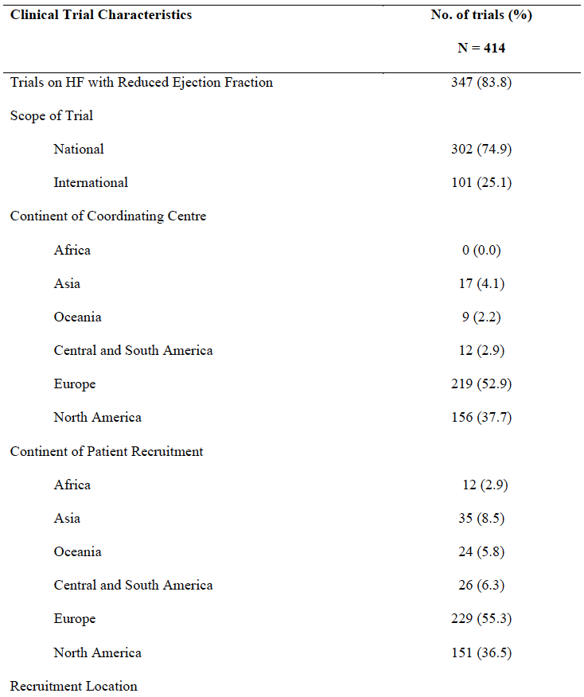
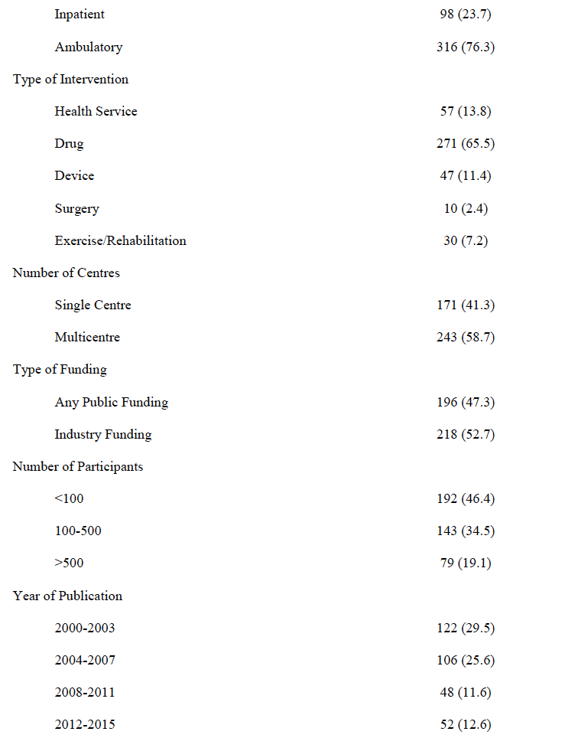

Table 2. Geographic Representation of Authors of HF RCTs Published in High Impact Factor
Journals Between 2000 and 2020
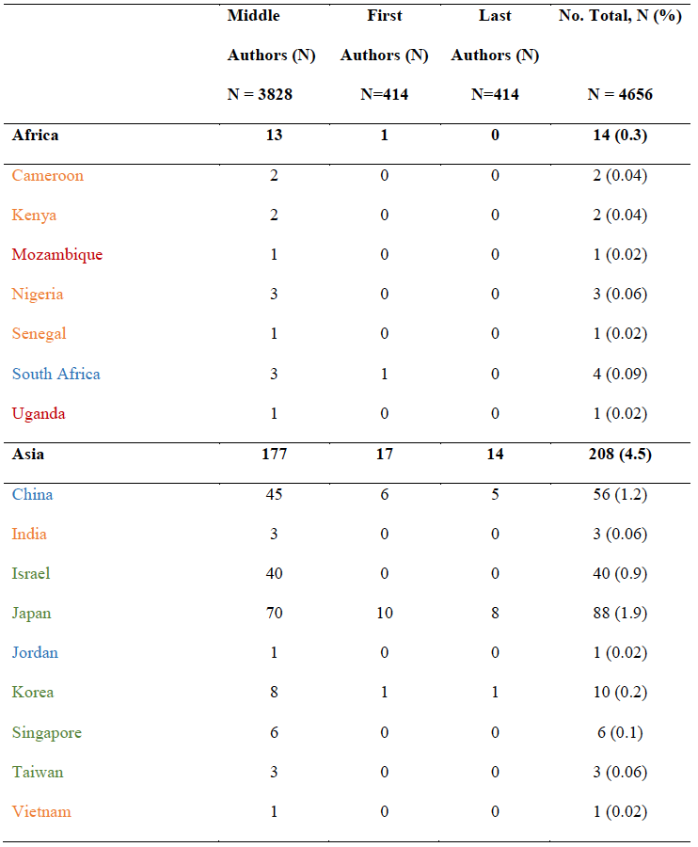
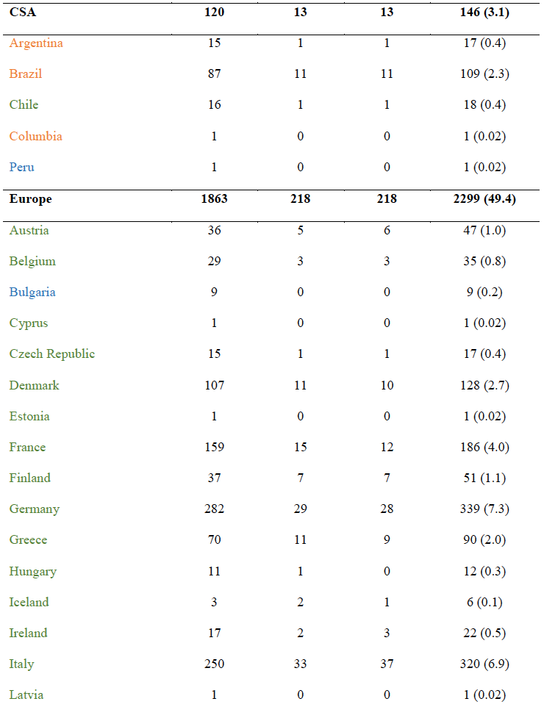
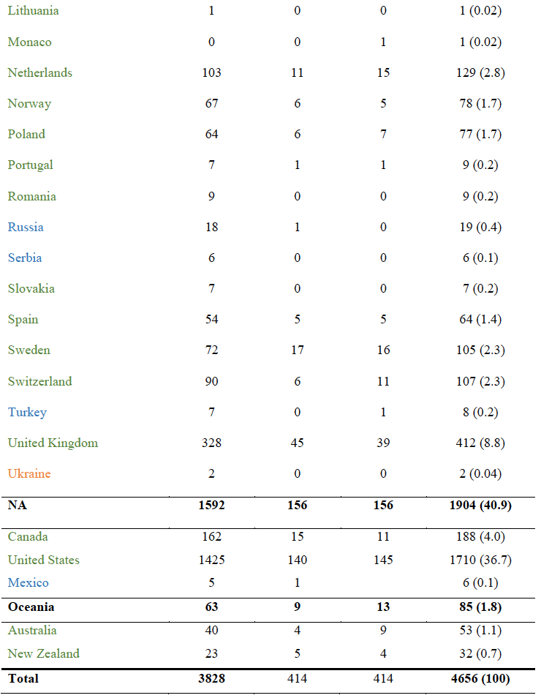
Legend: red represents low income; orange represents lower-middle income; blue represents
upper-middle; green represents high income (World Bank, 2021)

Table 3. Multivariable Analysis of Trial Characteristics Associated with Leadership Outside
Europe and North America Among Heart Failure Randomized Controlled Trials (n = 414)
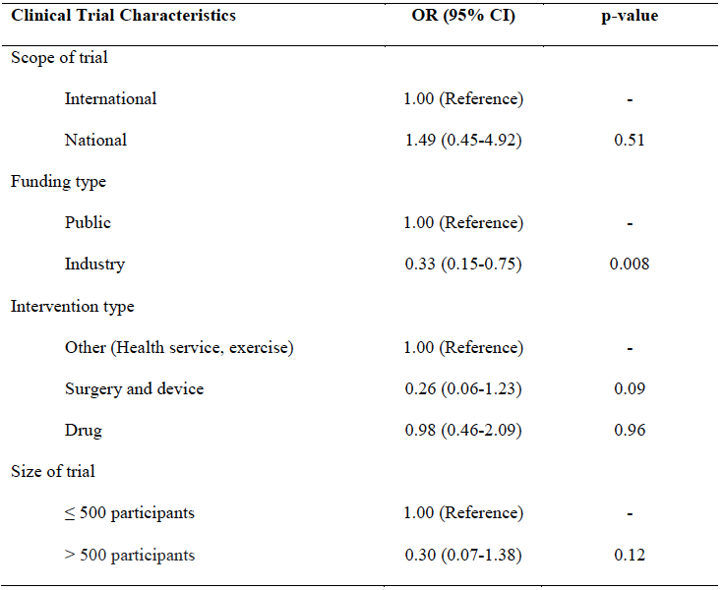

Table 4. Recommendations to Close Geographic Gaps in RCT Leadership and Collaborations
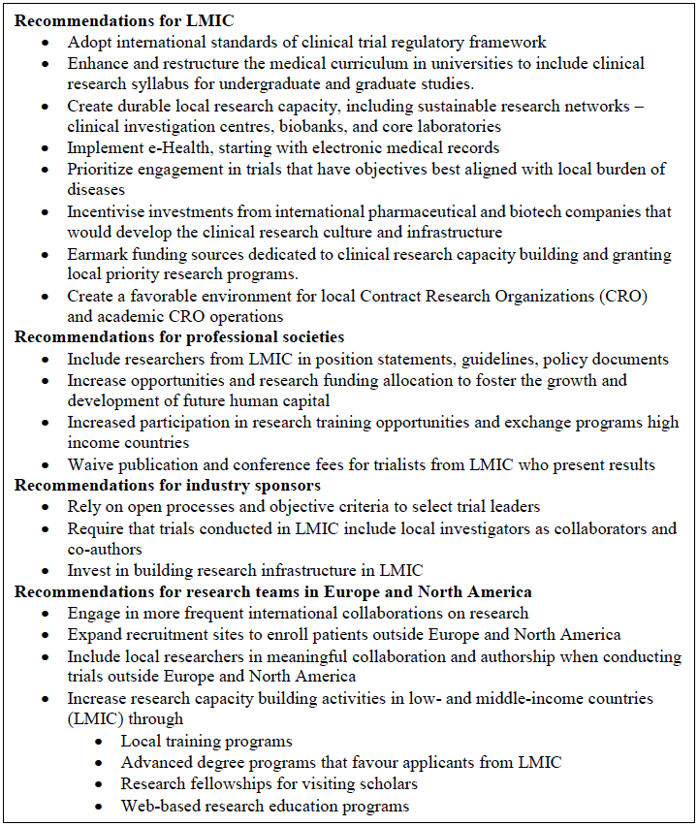
Figure 1
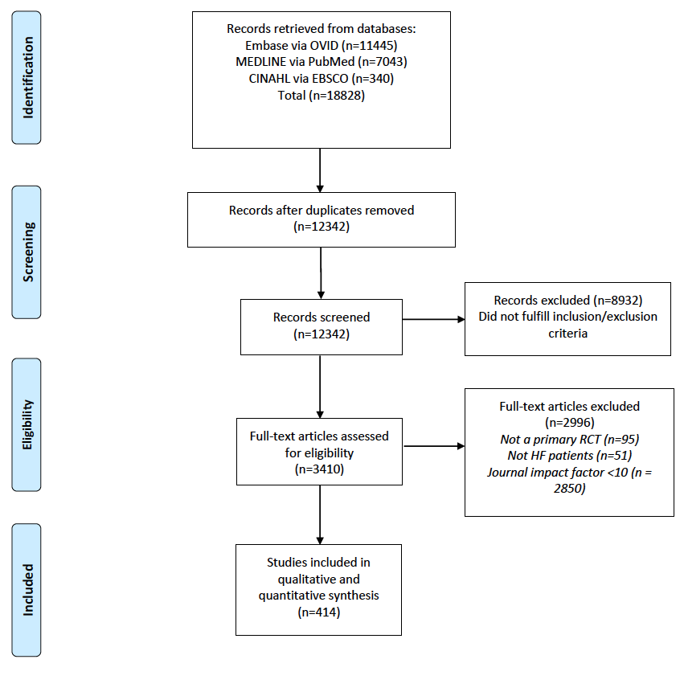

Figure 2
A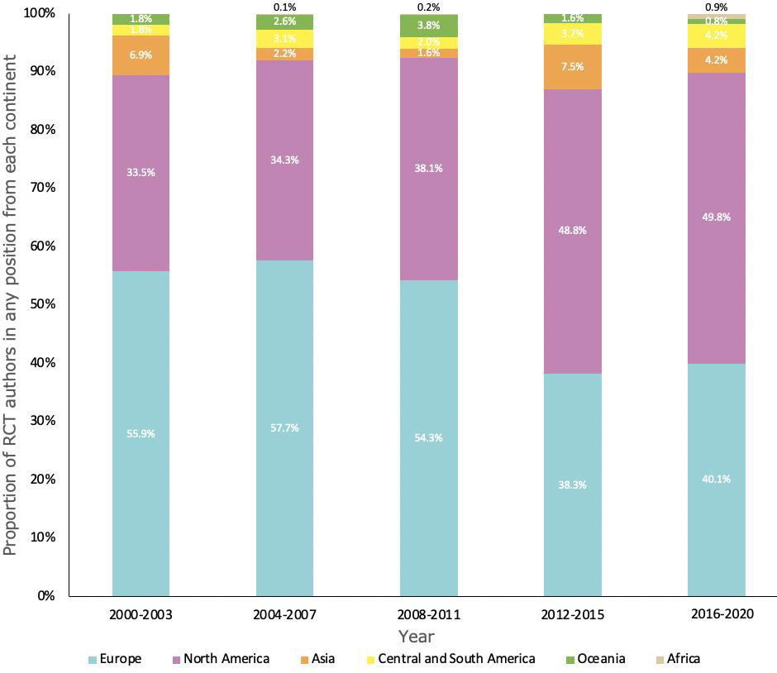
B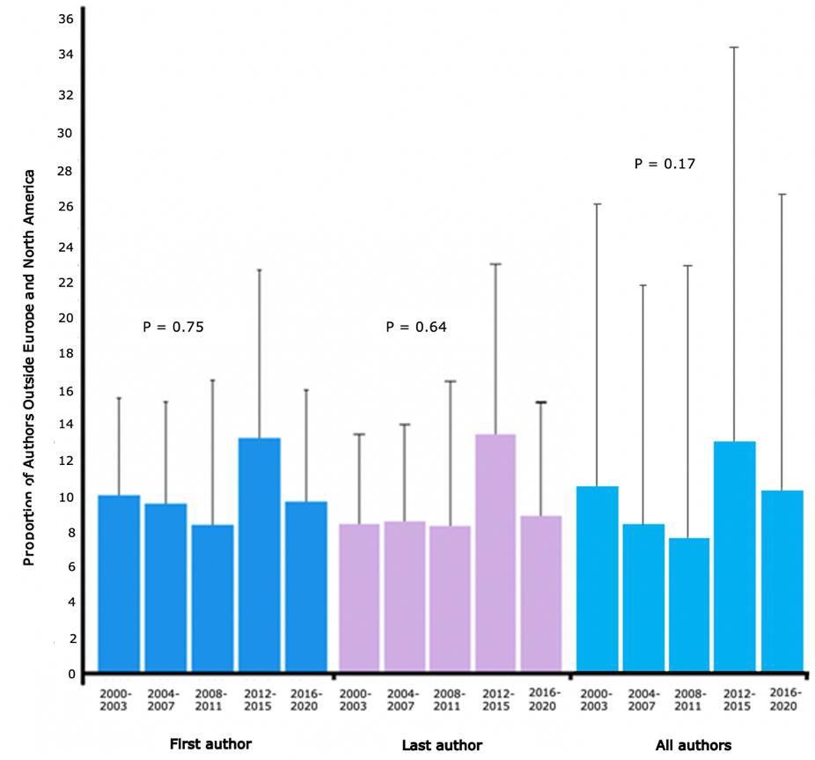
Figure 3
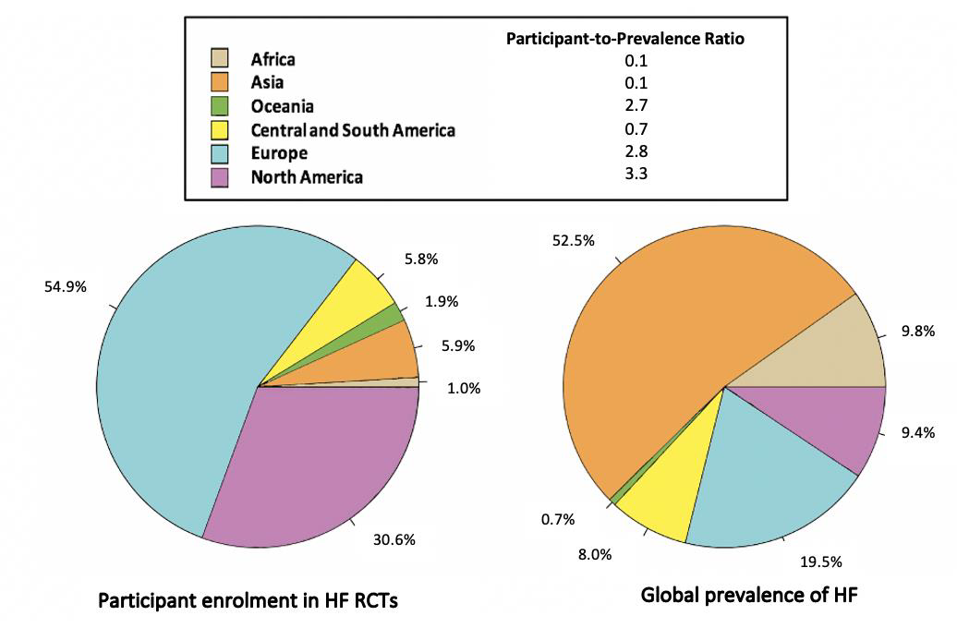

Graphical Abstract
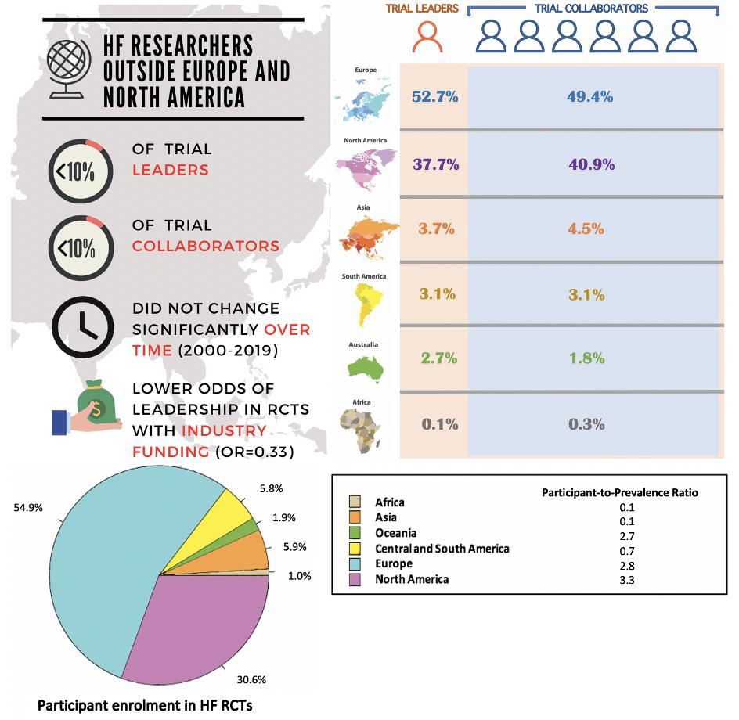

SUPPLEMENTARY MATERIAL
Supplemental Methods: Search strategy
1. Heart failure.mp or Heart Failure/
2. Limit 1 to (english language or humans)
3. Limit 2 to yr =*2000 – Current*
4. Limit 3 to randomized controlled trial
5. Limit 4 to (meta-analysis or “review” or systematic reviews)
6. 4 not 5

Supplemental Table 1. Journal of Publication and Geographic Representation of Leaders of
Heart Failure Randomized Controlled Trials published in Major Medical Journals (N=414)
