Supplementary Data

Methods

Study population
The Atherosclerosis Risk in Communities (ARIC) Study is a population-based study that recruited residents aged 45–65 years in 1987–1989 from 4 communities in North Carolina, Mississippi, Minnesota, and Maryland. A detailed description of the design and objectives of the ARIC Study has been published.¹ The study protocol was approved by each field center's institutional review board, and all participants provided written informed consent.
Participants underwent 7 examinations during 25 years of follow‐up (i.e., visit 1, 2, 3, 4, 5, 6, and 7 examinations), with an annual contact by telephone. In the current analysis, we used high-sensitivity cardiac troponin I (hs-cTnI), high-sensitivity cardiac troponin T (hs-cTnT), N-terminal pro–B-type natriuretic peptide (NT-proBNP), soluble angiotensin-converting enzyme 2 (sACE2) and other biomarkers measured at visit 5 (2011–2013; Supplementary Figure 1).

Ascertainment of clinical covariates
Prevalent coronary heart disease (CHD), stroke, and heart failure (HF) were defined as self-reported myocardial infarction, ischemic stroke, or HF (signs or symptoms) before ARIC visit 1 or adjudicated myocardial infarction (including silent myocardial infarction), coronary revascularization, stroke, or HF hospitalization between ARIC visits 1 and 5.²⁻⁴ Medical history, demographic data, anthropometric data, blood pressure measurements, and fasting lipid assessments were obtained during ARIC visit 5 at the same time as the blood draw for the biomarker measurements. Diabetes mellitus was defined as a fasting glucose level ≥126 mg/dL, a self-reported physician diagnosis of diabetes, or use of diabetes medications. Hypertension in the ARIC study is defined as systolic blood pressure ≥140 mm Hg or diastolic blood pressure ≥90 mm Hg or use of blood pressure–lowering therapies.

Biomarker measurements and analyses
hs-cTnI was measured using a highly sensitive chemiluminescent immunoassay (Architect Stat Troponin-I; Abbott, Abbott Park, IL) on an automated chemistry analyzer (Architect i 2000sr; Abbott) in plasma samples that were collected at visit 5 (2011–2013), and stored at -80°C. The hs-cTnI assay has a limit of detection of 1.2 ng/L (range 0–50,000 ng/L) and an interassay coefficient of variation (CV) of 10% at 3 ng/L.^{5.}
hs-cTnT was measured using a highly sensitive assay (Elecsys Troponin T Gen 5 STAT; Roche Diagnostics, Indianapolis, IN) in plasma samples that were collected at visit 5 (2011–2013), stored at -80°C. As per the manufacturer's package insert, the lower limit of detection of this assay is 5 ng/L and the limit of quantification is 6 ng/L. The interassay CVs were 6.9% and 2.6% at mean hs-cTnT concentrations of 29 ng/L and 2378 ng/L, respectively.⁶
We modeled hs-cTnT and hs-cTnI as both continuous and categorical variables. For the continuous analyses, hs-cTnT and hs-cTnI values were natural log transformed. For hs-cTnT, individuals were classified according to prespecified cutpoints of <6 ng/L (low), 6 to <14 ng/L (intermediate), and ≥14 ng/L (high) The level of 6 ng/L was chosen as it is the limit of quantification for the assay in the manufacturer's package insert, and 14 ng/L represents the 90th percentile in ARIC⁷ and also reflects the 99th percentile upper reference recommended by the Joint European Society of Cardiology/American College of Cardiology Foundation/American Heart Association/World Heart Federation Task Force for the Universal Definition of Myocardial Infarction.⁸
For the hs-cTnI categorical analysis, individuals were classified according to prespecified cutpoint of <2 ng/L (low), 2 to <10 ng/L (intermediate), and ≥10 ng/L (high). The limit of detection is 1.2 ng/L, and the lower cutpoint of 2 ng/L was based on rounding up to the nearest integer. The higher cutpoint was based on a previously published study.⁵
NT-proBNP was measured using an electrochemiluminescent immunoassay (proBNP II assay; Roche Diagnostics) on an automated Cobas e411 analyzer (Roche Diagnostics) in plasma samples that were collected at visit 5 (2011–2013), and stored at -80°C. The assay has a measurement range of 5–35,000 pg/mL, a lower limit of detection of 5 pg/mL, and a limit of quantification of 35 pg/mL.⁹
NT-proBNP was natural log transformed (for continuous analyses) or transformed to a categorical variable according to prespecified reference cutpoints of <100 pg/mL (labeled as low risk), ≥100 to <300 pg/mL (labeled as intermediate risk), and ≥300 pg/mL (labeled as high risk). These cutpoints were chosen based on previous a ARIC study evaluating cardiovascular (CVD) risk prediction with NT-proBNP.¹⁰
Participants with hs-cTnI, hs-cTnT, or NT-proBNP levels below the lower limits of detection were assigned values equal to half the lower limits of detection.
Soluble ACE2 was measured using Olink assay. Olink assay is based on proximity extension assay technology, which uses pairing of target proteins to 2 specific oligonucleotide-labeled antibodies and involves real-time polymerase chain reaction, to detect and quantify target proteins. Results are expressed in normalized protein expression units (NPX), which are relative units, expressed on a log2 scale, where 1 unit higher represents a doubling of the measured protein concentrations.
Plasma levels of hs-CRP were measured using an immunoturbidimetric assay on a Beckman Coulter AU480 analyzer (Beckman Coulter Inc, Brea, CA).

Cardiovascular outcomes
Clinical endpoints included CHD, ischemic stroke, HF hospitalization and all-cause mortality events. All outcomes were assessed after ARIC visit 5 with follow-up through December 31, 2018. The methods of assessing incident CHD, stroke, and HF hospitalizations in the ARIC study have been described previously.²⁻⁴ Briefly, incident CHD events were adjudicated by an ARIC endpoint committee and defined as fatal CHD, definite or probable myocardial infarction, silent myocardial infarction between examinations as determined by electrocardiography, and coronary revascularization.² For incident stroke events, any definite or probable hospitalization for stroke signs/symptoms with neuroimaging (computed tomography or magnetic resonance imaging) and other diagnostic reports were recorded if the list of discharge diagnoses included cerebrovascular disease code (ICD-9 code), if a cerebrovascular condition or procedure was mentioned in the discharge summary, or if cerebrovascular finding was noted on a computed tomography or magnetic resonance imaging scan.³ Each eligible case was classified as ischemic per criteria adapted from the National Survey of Stroke.¹¹ HF hospitalization consisted of definite and probable acute decompensated HF based on medical chart review of signs and symptoms of decompensation, elevation of natriuretic peptides, cardiac systolic and/or diastolic dysfunction, and HF-specific therapy by certified physicians.⁴ Deaths were ascertained through the review of hospital discharge records and death certificates, supplemented by informant interviews or physician questionnaires for out-of-hospital deaths along with linkage to State and National Death Index records.
Incident global CVD was defined as a composite of incident CHD, incident stroke, and incident HF hospitalization. Incident atherosclerotic CVD (ASCVD) was defined as a composite of incident CHD and incident stroke.

References
1. ARIC Investigators. The Atherosclerosis Risk in Communities (ARIC) Study: design and objectives. Am J Epidemiol 1989;129:687-702.
2. White AD, Folsom AR, Chambless LE, Sharret AR, Yang K, Conwill D, Higgins M, Williams OD, Tyroler HA. Community surveillance of coronary heart disease in the Atherosclerosis Risk in Communities (ARIC) Study: methods and initial two years' experience. J Clin Epidemiol 1996;49:223-233.
3. Rosamond WD, Folsom AR, Chambless LE, Wang CH, McGovern PG, Howard G, Copper LS, Shahar E. Stroke incidence and survival among middle-aged adults: 9-year follow-up of the Atherosclerosis Risk in Communities (ARIC) cohort. Stroke 1999;30:736-743.
4. Rosamond WD, Chang PP, Baggett C, Johnson A, Bertoni AG, Shahar E, Deswal A, Heiss G, Chambless LE. Classification of heart failure in the Atherosclerosis Risk in Communities (ARIC) study: a comparison of diagnostic criteria. Circ Heart Fail 2012;5:152-159.
5. Jia X, Sun W, Hoogeveen RC, Nambi V, Matsushita K, Folsom AR, Heiss G, Couper DJ, Solomon SD, Boerwinkle E, Shah A, Selvin E, de Lemos JA, Ballantyne CM. High-sensitivity troponin I and incident coronary events, stroke, heart failure hospitalization, and mortality in the ARIC Study. Circulation 2019;139:2642-2653.
6. McEvoy JW, Chen Y, Ndumele CE, Solomon SD, Nambi V, Ballantyne CM, Blumenthal RS, Coresh J, Selvin E. Six-year change in high-sensitivity cardiac troponin T and risk of subsequent coronary heart disease, heart failure, and death. JAMA Cardiol 2016;1:519-528.
7. Saunders JT, Nambi V, de Lemos JA, Chambless LE, Virani SS, Boerwinkle E, Hoogeveen RC, Liu X, Astor BC, Mosley TH, Folsom AR, Heiss G, Coresh J, Ballantyne CM. Cardiac troponin T measured by a highly sensitive assay predicts coronary heart disease, heart failure, and mortality in the Atherosclerosis Risk in Communities Study. Circulation 2011;123:1367-1376.
8. Thygesen K, Alpert JS, Jaffe AS, Simoons ML, Chaitman BR, White HD, on behalf of the Joint ESC/ACCF/AHA/WHF Task Force for the Universal Definition of Myocardial Infarction. Third universal definition of myocardial infarction. J Am Coll Cardiol 2012;60:1581-1598.
9. Ndumele CE, Matsushita K, Sang Y, Lazo M, Agarwal SK, Nambi V, Deswal A, Blumenthal RS, Ballantyne CM, Coresh J, Selvin E. N-terminal pro-brain natriuretic peptide and heart failure risk among individuals with and without obesity: the Atherosclerosis Risk in Communities (ARIC) Study. Circulation 2016;133:631-638.
10. Saeed A, Nambi V, Sun W, Virani SS, Taffet GE, Deswal A, Selvin E, Matsushita K, Wagenknecht LE, Hoogeveen R, Coresh J, de Lemos JA, Ballantyne CM. Short-term global cardiovascular disease risk prediction in older adults. J Am Coll Cardiol 2018;71:2527-2536.
11. National Institute of Neurological and Communicative Disorders and Stroke. The National Survey of Stroke. Stroke 1981;12:I1-91.

Supplementary Figure 1S. Flow diagram for eligible cohort selection from Atherosclerosis Risk in Communities (ARIC) visit 5
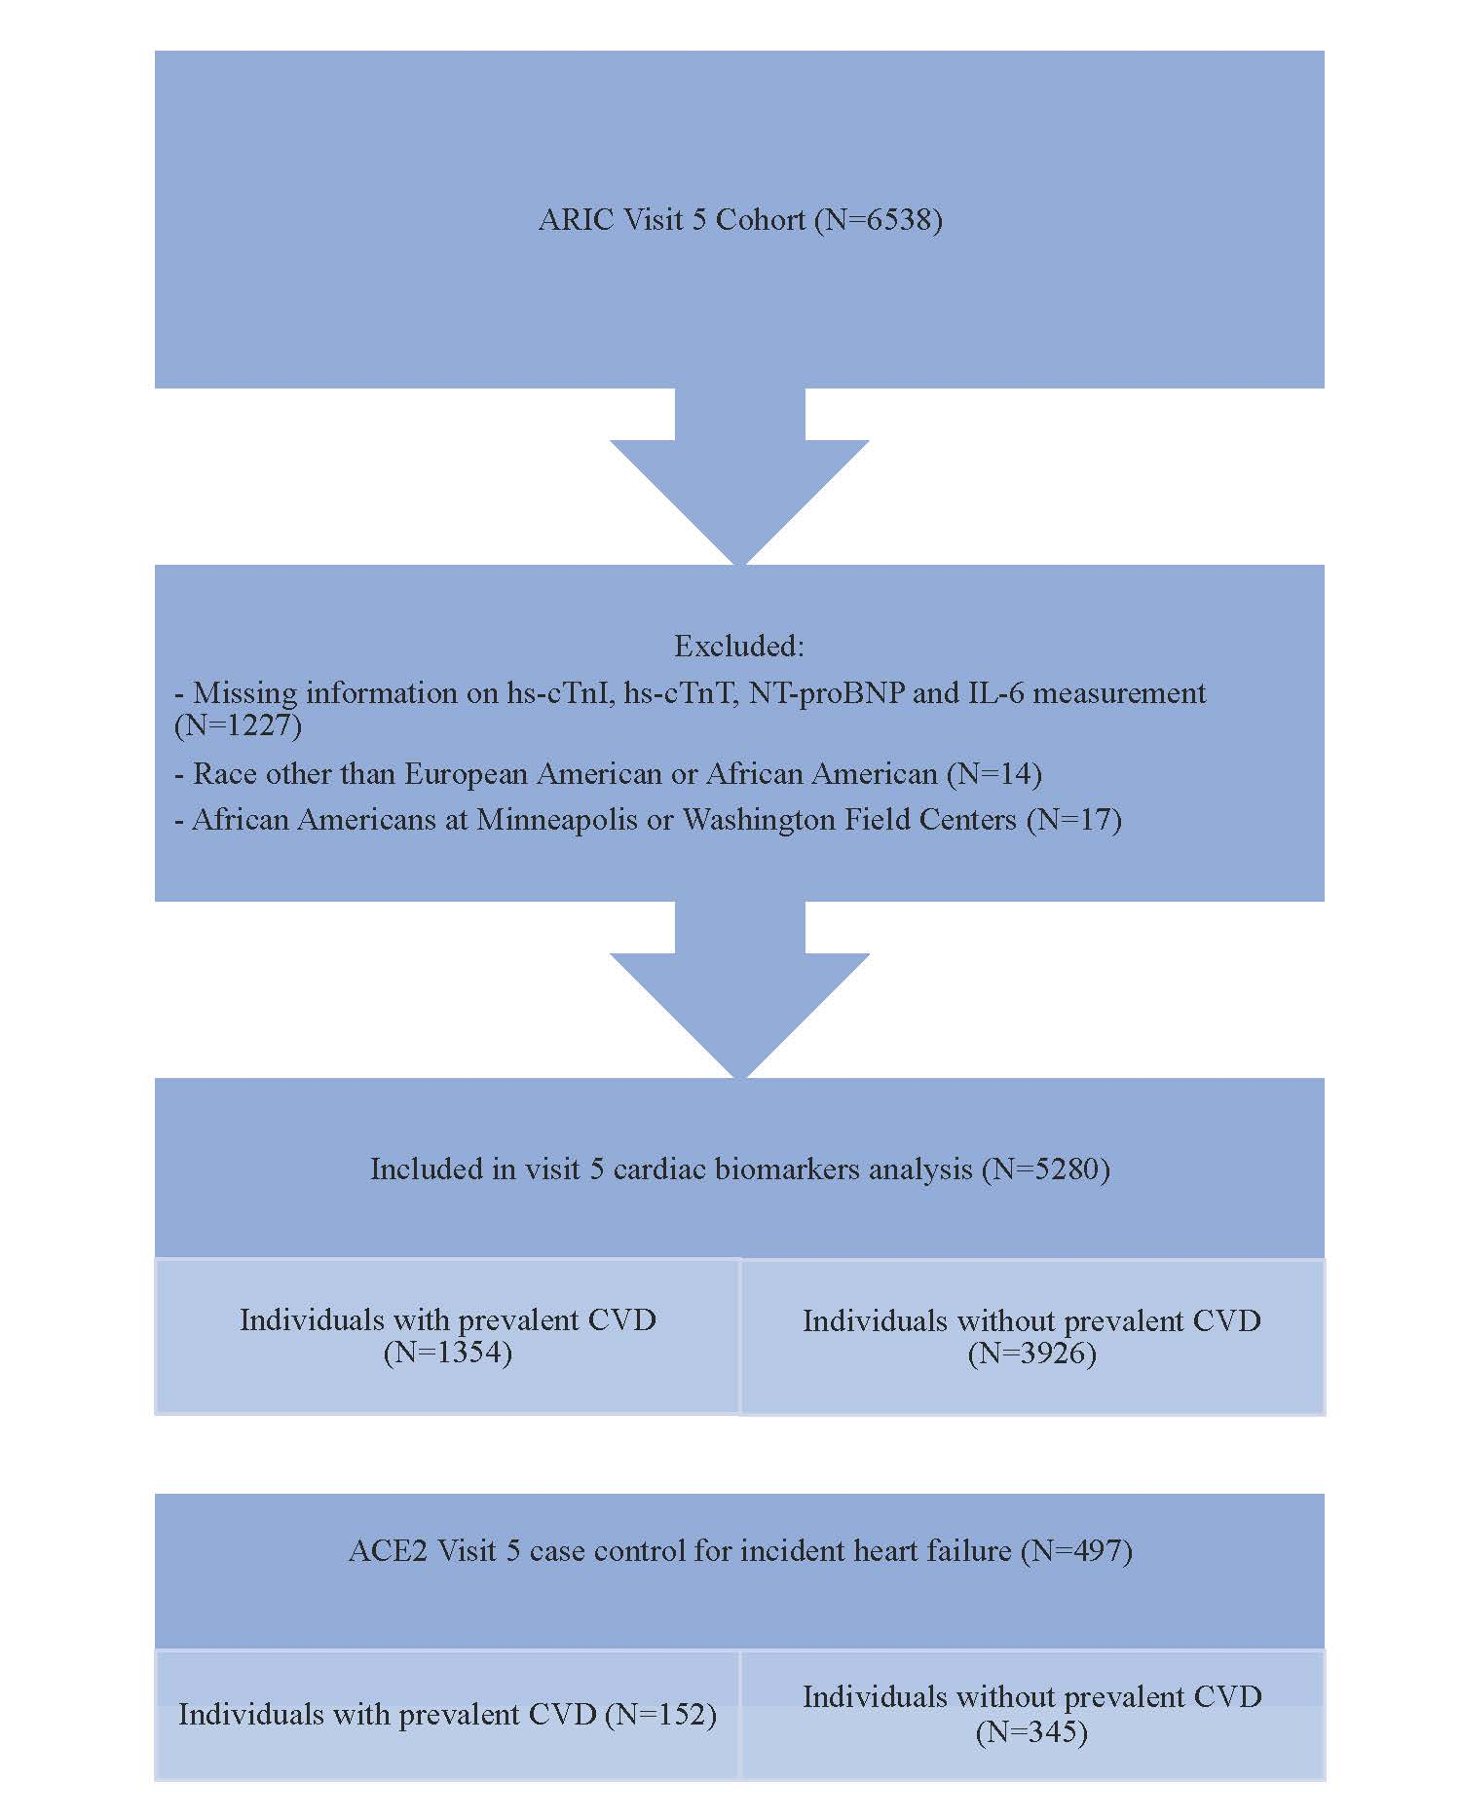

Abbreviations: ACE2: angiotensin-converting enzyme 2; CVD=cardiovascular disease; sACE2: soluble angiotensin-converting enzyme 2; hs-cTnI: high-sensitivity cardiac troponin I; hs-cTnT: high-sensitivity cardiac troponin T; NT-proBNP: N-terminal pro–B-type natriuretic peptide.

Supplementary Table 1S: Spearman’s correlation among cardiovascular biomarkers and soluble ACE2 at visit 5 (n=496)

 | hs-cTnI | hs-cTnT | NT-proBNP
hs-cTnT | R = 0.62,  P < 0.0001
NT-proBNP | R = 0.47  P < 0.0001 | R=0.36,  P <0.0001
sACE2 | R = 0.27,  P < 0.0001 | R = 0.27,  P < 0.0001 | R=0.18,  P=0.0001

Abbreviations: sACE2: soluble angiotensin-converting enzyme 2; hs-cTnI: high-sensitivity cardiac troponin I; hs-cTnT: high-sensitivity cardiac troponin T; NT-proBNP: N-terminal pro–B-type natriuretic peptide.
Supplementary Table 2S. Median sACE2 levels in individuals with or without use of different classes of antihypertensive therapies

 | sACE2 levels, median (25th, 75th percentiles)
 | Yes | No | P-value
ACEi or ARB | 70.0 (52.2, 113.6) | 65.9 (48.5, 98.6) | 0.1397
MRA | 95.0 (74.8, 119.1) | 66.0 (50.4, 106.3) | 0.1574
Loop diuretic | 83.9 (53.3, 138.4) | 65.1 (50.1, 98.8) | 0.0407
Beta blockers | 72.6 (53.6, 135.9) | 63.8 (47.7, 93.0) | 0.0008
Abbreviations: ACEi=angiotensin-converting enzyme inhibitor; ARB=angiotensin receptor blocker; MRA=mineralocorticoid receptor antagonist; sACE2=soluble angiotensin-converting enzyme 2.

Supplementary Table 3S: Adjusted odds ratios (95% confidence intervals) for baseline cardiac biomarkers categories and sACE2 as a continuous variable (natural log transformed)

Cardiac biomarker | Low | Intermediate | High
hs-cTnI (ng/L) | <2 (n=44) | 2–<10 (n=338) | ≥10 (n=114)
Model 1 | 1 (reference) | 1.39 (0.80-2.39) | 2.31 (1.27-4.18)
Model 2 | 1 (reference) | 1.33 (0.75-2.37) | 2.14 (1.13-4.08)
hs-cTnT (ng/L) | <6 (n=30) | 6–13 (n=201) | ≥14 (n=266)
Model 1 | 1 (reference) | 2.08 (0.95-4.52) | 3.17 (1.42-7.06)
Model 2 | 1 (reference) | 2.16 (0.84-5.51) | 3.46 (1.31-9.13)
NT-proBNP (pg/mL) | <100 (n=125) | 100–<300 (n=168) | ≥300 (n=204)
Model 1 | 1 (reference) | 1.29 (0.87-1.91) | 1.92 (1.31-2.83)
Model 2 | 1 (reference) | 1.32 (0.87-2.01) | 1.89 (1.23-2.92)
Data are presented as odds ratio (95% confidence interval).

Model 1 is adjusted by age, sex, and race; model 2 is model 1 plus total cholesterol, high-density lipoprotein cholesterol, current smoking, systolic blood pressure, antihypertensive medication use, diabetic status, lipid-lowering medication use, history of CVD (stroke, total CHD, and HF), estimated glomerular filtration rate.

Supplementary Table 4S: Association of sACE2 as a continuous variable (natural log transformed [ln]) and echocardiographic parameters in participants without prevalent CVD

Echocardiographic parameter | Model | Beta-coefficient | 95% confidence interval | p-value
ln-LVEF | Model 1 | -0.03 | -0.05, -0.01 | 0.010
 | Model 2 | -0.03 | -0.06, -0.01 | 0.007
 | Model 3 | -0.02 | -0.04, 0.003 | 0.10
ln-LVMi | Model 1 | 0.08 | 0.04, 0.12 | <0.001
 | Model 2 | 0.06 | 0.02, 0.11 | 0.005
 | Model 3 | 0.02 | -0.02, 0.05 | 0.44
ln-LAVi | Model 1 | 0.10 | 0.04, 0.15 | 0.001
 | Model 2 | 0.09 | 0.03, 0.14 | 0.003
 | Model 3 | 0.04 | -0.02, 0.09 | 0.18
ln-septal e′ | Model 1 | -0.06 | -0.10, -0.01 | 0.01
 | Model 2 | -0.05 | -0.10, -0.002 | 0.04
 | Model 3 | -0.02 | -0.07, 0.03 | 0.36
ln-septal E/e′ | Model 1 | 0.11 | 0.05, 0.17 | <0.001
 | Model 2 | 0.09 | 0.02, 0.15 | 0.007
 | Model 3 | 0.04 | -0.02, 0.10 | 0.17
GLS | Model 1 | 0.65 | 0.18, 1.12 | 0.006
 | Model 2 | 0.51 | 0.04, 0.98 | 0.04
 | Model 3 | 0.19 | -0.26, 0.63 | 0.41
Data are presented as adjusted beta-coefficients and 95% confidence intervals. Significant values in bold

Model 1 is adjusted by age, sex, and race; model 2 is model 1 plus total cholesterol, high-density lipoprotein cholesterol, current smoking, systolic blood pressure, antihypertensive medication use, diabetes status, lipid-lowering medication use, history of CVD (stroke, total CHD, and HF), and eGFR; model 3 is model 2 plus ln–hs-cTnI, ln–hs-cTnT, and ln–NT-proBNP.

Abbreviations: GLS: global longitudinal strain; LAVi: left atrial volume index; LVEF: left ventricular ejection fraction, LVMi= left ventricular mass index.
Supplementary Table 5S. Hazards ratios (HRs) and 95% confidence intervals (CIs) for cardiovascular events and all-cause death with sACE2 levels as a continuous variable (natural log transformed) in individuals without prevalent CVD

Event | Model | HR | 95% CI | P value
Global CVD  171/345, 49.6% | Model 1 | 1.41 | 1.15-1.73 | 0.001
 | Model 2 | 1.32 | 1.05-1.66 | 0.02
 | Model 3 | 1.14 | 0.89-1.45 | 0.29
HF hospitalization  157/345, 45.5% | Model 1 | 1.44 | 1.16-1.78 | 0.001
 | Model 2 | 1.33 | 1.05-1.69 | 0.02
 | Model 3 | 1.12 | 0.86-1.45 | 0.40
ASCVD  64/345, 18.6% | Model 1 | 1.09 | 0.76-1.58 | 0.63
 | Model 2 | 0.92 | 0.61-1.37 | 0.67
 | Model 3 | 0.83 | 0.54-1.27 | 0.38
All-cause mortality  117/345, 33.9% | Model 1 | 1.33 | 1.03-1.71 | 0.03
 | Model 2 | 1.33 | 1.00-1.77 | 0.05
 | Model 3 | 1.10 | 0.81-1.49 | 0.56

Data are presented as number of events [n] / number at risk [N] (percent) and HR per natural log unit increase for sACE2 with 95% CI.

Model 1 is adjusted by visit 5 age, sex, and race; model 2 is model 1 plus visit 5 total cholesterol, high-density lipoprotein cholesterol, current smoking, systolic blood pressure, antihypertensive medication use, diabetic status, and lipid-lowering medication use; model 3 is model 2 plus ln–hs-cTnI, ln–hs-cTnT, and ln–NT-proBNP.

Abbreviations: ASCVD=atherosclerotic cardiovascular disease; CI=confidence interval; CVD=cardiovascular disease; eGFR=estimated glomerular filtration rate; HDL-C=high-density lipoprotein cholesterol; HF=heart failure; HR=hazard ratio; n=number of events; N=number at risk; sACE2=soluble angiotensin-converting enzyme 2.

