**SUPPLEMENTARY APPENDIX**

Ravera A, Santema BT, Sama IE, et al. – **Quality of life in men and women with heart failure: association with outcome, and comparison of the Kansas City Cardiomyopathy Questionnaire and the EuroQol 5 dimensions questionnaire.**

**TABLE OF CONTENTS**

**1. SUPPLEMENTARY METHODS** ........................................................................................ p.4

**2. TABLES**

**Table S1.** Recommended doses of angiotensin-converting enzyme inhibitors (ACEi), angiotensin receptor blockers (ARB) and beta-blockers in European Society of Cardiology (ESC) guidelines† for patients with left ventricular ejection fraction (LVEF) <40%. .................................................................................................. p.6

**Table S2.** Baseline characteristics stratified by sex. ...................................................................................... p.7

**Table S3.** Variation in quality of life summary scores between baseline and nine months in the total population (a), and in men (b) and women (c) separately, who received 0, 1–49%, 50–99%, or 100% or more of guideline-recommended β blocker dose. .................................................................................................. p.8

**Table S4.** Variation in quality of life summary scores between baseline and nine months in the total population (a), and in men (b) and women (c) separately, who received 0, 1–49%, 50–99%, or 100% or more of guideline-recommended angiotensin-converting enzyme inhibitors (ACEi) or angiotensin receptor blockers (ARB) dose. ................................................................................................................................... p.10

**Table S5.** Variation of parameters of functional capacity between baseline and 9 months in the total study population and in men and women separately, median (interquartile range). ............................................. p.12

**Table S6.** Unadjusted and adjusted association of 6MWT distance at baseline with outcome................... p.13

**Table S7.** Comparison between time-dependent receiver operating characteristic (ROC) curves’ area under the curve (AUC) for different quality of life measures-based models (unadjusted) for predicting mortality (a), heart failure hospitalization (b), and the composite mortality and/or heart failure hospitalization. ...... p.14

**Table S8.** Reclassification among people who experienced or did not experience each studied outcome at one year, comparing different quality of life measures (**A-C-E**) or the use of quality of life measures on top of the BIOSTAT risk model for each explored outcome (**B-D-F**). **(A-B)** all-cause death; **(C-D)** heart failure hospitalization; **(E-F)** all-cause death and/or heart failure hospitalization. ................................................. p.16

**3. FIGURES**

**Figure S1.** Study flow diagram. .................................................................................................................. p.18

**Figure S2.** Sex differences in the answers to the items of Kansas City Cardiomyopathy Questionnaire at baseline. ........................................................................................................................................................ p.19

**Figure S3.** Sex differences in the answers to the items of Kansas City Cardiomyopathy Questionnaire at nine months .......................................................................................................................................................... p.20

**Figure S4.** Sex differences in the answers to the items of EuroQol 5 dimensions questionnaire at nine months .......................................................................................................................................................... p.21

**Figure S5**. Shift analysis showing sex differences in fraction target dose of angiotensin-converting enzyme inhibitors (ACEi) or angiotensin receptor blockers (ARB) and β-blockers at baseline. ..............................p.22

**Figure S6.** Shift analysis showing sex differences in achieved fraction target dose of angiotensin-converting enzyme inhibitors (ACEi) or angiotensin receptor blockers (ARB) and β-blockers at three months. ..........p.24

**Figure S7.** Shift analysis showing sex differences between the quantiles of Kansas City Cardiomyopathy Questionnaire change (Delta KCCQ-OS) from baseline to 9 months, at varying levels of achieved fraction target dose of angiotensin-converting enzyme inhibitors (ACEi) or angiotensin receptor blockers (ARB) and β-blockers. . ................................................................................................................................................. p.26

**Figure S8.** Effect plots for all-cause mortality by (a) Kansas City Cardiomyopathy Questionnaire overall score, EuroQoL 5 dimensions (b) visual analogue scale and (c) utility score at baseline, using adjusted Cox model with the corresponding median quality of life measure as reference. .............................................. p.28

**Figure S9.** Effect plots for heart failure hospitalization by (a) Kansas City Cardiomyopathy Questionnaire Overall Score, EuroQoL 5 dimensions (b) visual analogue scale and (c) utility score at baseline, using adjusted Cox model with the corresponding median quality of life measure as reference. ......................... p.30

**Figure S10.** Effect plots for all-cause mortality and/or heart failure hospitalization by (a) Kansas City Cardiomyopathy Questionnaire overall score, EuroQoL 5 dimensions (b) visual analogue scale and (c) utility score at baseline, using adjusted Cox model with the corresponding quality of life measure as reference. p.32**Supplementary methods**

*Kansas City Cardiomyopathy Questionnaire (KCCQ)*

KCCQ is a validated tool to measure health-related quality of life (QoL) in heart failure (HF) patients consisting of 23 questions exploring the patients’s quality of life in the 2 weeks before completion. The results of these questions that can be summarized in seven domains (physical limitations due to HF, symptom stability, symptom severity, symptom frequency, self-efficacy, quality of life, and social limitation) as well as into an overall summary score (KCCQ-OS) [Green CP, Porter CB, Bresnahan DR, Spertus JA. Development and evaluation of the Kansas City Cardiomyopathy Questionnaire: a new health status measure for heart failure. J Am Coll Cardiol 2000;35(5):1245-55]. Missing values within each domain are assigned the average of the answered items within that same domain [Green CP, Porter CB, Bresnahan DR, Spertus JA. Development and evaluation of the Kansas City Cardiomyopathy Questionnaire: a new health status measure for heart failure. J Am Coll Cardiol 2000;35(5):1245-55]. Overall and domain-specific scores range from 0 to 100, with 100 representing the best possible QoL status. A difference ≥5 points between mean scores is traditionally considered clinically meaningful, although recent evidence pointed out that even smaller differences may be relevant [Butler J, Khan MS, Mori C, Filippatos GS, Ponikowski P, Comin-Colet J, Roubert B, Spertus JA, Anker SD. Minimal clinically important difference in quality of life scores for patients with heart failure and reduced ejection fraction. Eur J Heart Fail 2020].

*EuroQol 5 dimensions questionnaire (EQ-5D)*

EQ-5D is a standardized measure of health status developed by the EuroQol Group to provide a simple, generic and generalizable measure of QoL [Dyer MT, Goldsmith KA, Sharples LS, Buxton MJ. A review of health utilities using the EQ-5D in studies of cardiovascular disease. Health Qual Life Outcomes 2010;8:13]. The EQ-5D explores the patients’ quality of life in the day of questionnaire completion and includes a descriptive part, consisting of five dimensions (mobility, self-care, usual activity, pain/discomfort and anxiety/depression), with three possible levels each. Two hundred and forty-three possible health states can be defined that represent all the combinations of individual answers to these five questions, and each health state can be converted into a single summary index called ‘utility score’ (EQ-5D US) based on country-specific value sets . In this study, the United Kingdom value set, obtained with the time trade-off method, was used [Dolan P. Modeling valuations for EuroQol health states. Med Care 1997;35(11):1095-108]. EQ-5D US is measured on a cardinal scale of 0–1: 1 indicates perfect health, 0 indicates a QoL status comparable to death, negative values of EQ-5D US are possible and suggest states considered to be worse than death. A distinct part of the EQ-5D is the visual analogue scale (VAS). Respondents are asked to mark a single point on a vertical scale that represents their health status on the day of completion. The scale extends from 0 to 100, with 100 representing the best possible QoL status.

*BIOSTAT-CHF risk models*

The BIOSTAT-CHF model for all-cause death at one year includes age, blood urea nitrogen, N-terminal pro-B-type natriuretic peptide (NT-proBNP), hemoglobin, and the use of β-blockers at baseline; the BIOSTAT-CHF model for HF hospitalization at one year includes age, HF hospitalization in previous year, systolic blood pressure, presence of peripheral edema, and glomerular filtration rate at baseline; the BIOSTAT-CHF model for all-cause death and/or HF hospitalization at one year includes age, HF hospitalization in previous year, systolic blood pressure, presence of peripheral edema, NT-proBNP, hemoglobin, sodium, high-density lipoprotein, and the use of β-blockers at baseline [Voors AA, Ouwerkerk W, Zannad F, van Veldhuisen DJ, Samani NJ, Ponikowski P, Ng LL, Metra M, Ter Maaten JM, Lang CC, Hillege HL, van der Harst P, Filippatos G, Dickstein K, Cleland JG, Anker SD, Zwinderman AH. Development and validation of multivariable models to predict mortality and hospitalization in patients with heart failure. Eur J Heart Fail 2017;19(5):627-634].

*Shift analysis*

Distributions of baseline and three-months angiotensin-converting enzyme inhibitors (ACEi) or angiotensin receptor blockers (ARB) and beta-blockers doses, and of baseline-to-nine-months variation in KCCQ-OS were also computed using the Harrell–Davis estimate of the deciles and compared using the Kolmogorov-Smirnov test. A shift function (shifthd) was used to quantify sex differences between deciles of these distributions, along with 95% percentile bootstrap confidence intervals (CI) with 200 samples [Wilcox RR. Introduction to robust estimation and hypothesis testing. 3rd ed. Amsterdam ; Boston: Academic Press; 2012].

*Net reclassification improvement (NRI)*

We analysed reclassification improvement with categorical NRI, defining the risk categories as tertiles of annual risk of each event (i.e. mortality, HF hospitalization and the composite endpoint) in our population.

**Table S1.** Recommended doses of angiotensin-converting enzyme inhibitors (ACEi), angiotensin receptor blockers (ARB) and beta-blockers in European Society of Cardiology (ESC) guidelines† for patients with left ventricular ejection fraction (LVEF) <40%.

|  |  |  |  |
| --- | --- | --- | --- |
| Drug | Class | Target dose | Total daily dose |
| Captopril | ACEi | 50 mg tid | 150 mg |
| Enalapril | ACEi | 10 mg bid | 20 mg |
| Lisinopril | ACEi | 35 mg qd | 35 mg |
| Ramipril | ACEi | 5 mg bid or 10 mg qd | 10 mg |
| Trandolapril | ACEi | 4 mg qd | 4 mg |
| Perindopril | ACEi | 8 mg qd | 8 mg |
| Candesartan | ARB | 32 mg qd | 32 mg |
| Valsartan | ARB | 160 mg bid | 320 mg |
| Losartan | ARB | 150 mg qd | 150 mg |
| Bisoprolol | Beta-blocker | 10 mg qd | 10 mg |
| Carvedilol | Beta-blocker | 25 - 50 mg bid* | 50-100 mg* |
| Metoprolol CR/XL | Beta-blocker | 200 mg qd | 200 mg |
| Nebivolol | Beta-blocker | 10 mg qd | 10 mg |

* 25 mg bid for patients weighing < 75 kg and 50 mg bid for patients weighting > 75 Kg

† Dickstein K, Cohen-Solal A, Filippatos G, McMurray JJ, Ponikowski P, Poole-Wilson PA, Strömberg A, van Veldhuisen DJ, Atar D, Hoes AW, Keren A, Mebazaa A, Nieminen M, Priori SG, Swedberg K. ESC guidelines for the diagnosis and treatment of acute and chronic heart failure 2008: the Task Force for the diagnosis and treatment of acute and chronic heart failure 2008 of the European Society of Cardiology. Developed in collaboration with the Heart Failure Association of the ESC (HFA) and endorsed by the European Society of Intensive Care Medicine (ESICM). Eur J Heart Fail 2008;10(10):933-89.

McMurray JJ, Adamopoulos S, Anker SD, Auricchio A, Böhm M, Dickstein K, Falk V, Filippatos G, Fonseca C, Gomez-Sanchez MA, Jaarsma T, Køber L, Lip GY, Maggioni AP, Parkhomenko A, Pieske BM, Popescu BA, Rønnevik PK, Rutten FH, Schwitter J, Seferovic P, Stepinska J, Trindade PT, Voors AA, Zannad F, Zeiher A, Bax JJ, Baumgartner H, Ceconi C, Dean V, Deaton C, Fagard R, Funck-Brentano C, Hasdai D, Hoes A, Kirchhof P, Knuuti J, Kolh P, McDonagh T, Moulin C, Popescu BA, Reiner Z, Sechtem U, Sirnes PA, Tendera M, Torbicki A, Vahanian A, Windecker S, McDonagh T, Sechtem U, Bonet LA, Avraamides P, Ben Lamin HA, Brignole M, Coca A, Cowburn P, Dargie H, Elliott P, Flachskampf FA, Guida GF, Hardman S, Iung B, Merkely B, Mueller C, Nanas JN, Nielsen OW, Orn S, Parissis JT, Ponikowski P. ESC guidelines for the diagnosis and treatment of acute and chronic heart failure 2012: The Task Force for the Diagnosis and Treatment of Acute and Chronic Heart Failure 2012 of the European Society of Cardiology. Developed in collaboration with the Heart Failure Association (HFA) of the ESC. Eur J Heart Fail 2012;14(8):803-69.

**Table S2.** Baseline characteristics stratified by sex.

|  |  |  |  |
| --- | --- | --- | --- |
|  | Men | Women | p-value |
| No. of subjects | 1276 | 373 |  |
| Clinical profile |  |  |  |
| Pulmonary rales (%) |  |  | 0.856 |
| No | 626 (50.0) | 177 (48.5) |  |
| Single base | 166 (13.2) | 48 (13.2) |  |
| Bi-basilar | 461 (36.8) | 140 (38.4) |  |
| Oedema (%) |  |  | 0.254 |
| Not Present | 479 (45.4) | 137 (44.5) |  |
| Ankle | 302 (28.6) | 88 (28.6) |  |
| Below Knee | 226 (21.4) | 60 (19.5) |  |
| Above Knee | 49 (4.6) | 23 (7.5) |  |
| Jugular venous pressure (%) | 268 (30.9) | 67 (28.6) | 0.547 |
| Hepatomegaly (%) | 213 (16.7) | 42 (11.3) | 0.014 |
| Orthopnea (%) | 383 (30.0) | 125 (33.6) | 0.213 |
| Heart failure history |  |  |  |
| Heart failure etiology |  |  |  |
| Hypertensive (%) | 625 (50) | 200 (53.6) | <0.001 |
| Cardiomyopathy (%) | 582 (45.6) | 179 (48) | 0.608 |
| Other (%) | 129 (10.1) | 48 (12.9) | 0.437 |
| Medical history |  |  |  |
| PCI (%) | 304 (23.8) | 59 (15.8) | 0.001 |
| CABG (%) | 228 (17.9) | 39 (10.5) | 0.001 |
| Device (%) |  |  | <0.001 |
| None | 916 (72.0) | 305 (82.2) |  |
| Pacemaker | 71 (5.6) | 29 (7.8) |  |
| ICD | 141 (11.1) | 15 (4.0) |  |
| CRT | 26 (2.0) | 4 (1.1) |  |
| CRT and ICD | 118 (9.3) | 18 (4.9) |  |
| Medication |  |  |  |
| Loop diuretics (%) | 1270 (99.5) | 373 (100.0) | 0.402 |
| Digoxin (%) | 267 (20.9) | 50 (13.4) | 0.002 |
| 6MWT |  |  |  |
| MWT6 V1 (m) | 281.00 [100.00, 385.00] | 180.00 [0.00, 310.00] | <0.001 |

Legend: 6MWT= 6-min walk test, CABG=coronary artery by-pass graft, CRT=cardiac resynchronization therapy, ICD=implantable cardioverter defibrillator, PCI=percutaneous coronary intervention.

Continuous variables are presented either as means ± standard deviation when normally distributed, or median (interquartile range) for non-normally distributed variables. Categorical variables are shown as numbers (percentages).

**Table S3.** Variation in quality of life summary scores between baseline and nine months in the total population (a), and in men (b) and women (c) separately, who received 0, 1–49%, 50–99%, or 100% or more of guideline-recommended β blocker dose, median [interquartile range].

(a)

|  |  |  |  |  |  |  |
| --- | --- | --- | --- | --- | --- | --- |
| **HFrEF Total population** | | **Fraction target dose β blockers after up-titration phase** | | | | p |
| **0%** | **1-49%** | **50-99%** | **≥ 100%** |
| n | | 69 | 704 | 327 | 142 |  |
| **QoL variation between baseline and nine months** | **KCCQ overall score** | 7.29 [0.00, 30.21] | 10.94 [1.04, 26.04] | 10.42 [0.00, 25.00] | 18.23 [0.00, 35.42] | 0.468 |
| **EQ-5D utility score** | 0.07 [-0.05, 0.19] | 0.03 [-0.05, 0.20] | 0.00 [-0.05, 0.15] | 0.00 [-0.07, 0.19] | 0.201 |
| **EQ-5D VAS** | 5.00 [0.00, 20.00] | 9.00 [0.00, 20.00] | 5.00 [-5.00, 20.00] | 5.00 [-5.00, 20.00] | 0.104 |

(b)

|  |  |  |  |  |  |  |
| --- | --- | --- | --- | --- | --- | --- |
| **HFrEF Men** | | **Fraction target dose β blockers after up-titration phase** | | | | p |
| **0%** | **1-49%** | **50-99%** | **≥ 100%** |
| n | | 51 | 543 | 260 | 110 |  |
| **QoL variation between baseline and nine months** | **KCCQ overall score** | 6.25 [-0.52, 30.21] | 11.46 [0.00, 26.04] | 10.42 [0.00, 24.22] | 16.15 [-3.65, 34.64] | 0.954 |
| **EQ-5D utility score** | 0.07 [-0.04, 0.19] | 0.00 [-0.05, 0.19] | 0.00 [-0.04, 0.15] | 0.00 [-0.11, 0.17] | 0.189 |
| **EQ-5D VAS** | 5.00 [-2.50, 20.00] | 10.00 [0.00, 20.00] | 5.00 [-5.50, 20.00] | 5.00 [-8.75, 15.75] | 0.043 |

(c)

|  |  |  |  |  |  |  |
| --- | --- | --- | --- | --- | --- | --- |
| **HFrEF Women** | | **Fraction target dose β blockers after up-titration phase** | | | | p |
| **0%** | **1-49%** | **50-99%** | **≥ 100%** |  |
| n | | 18 | 161 | 67 | 32 |  |
| **QoL variation between baseline and nine months** | **KCCQ overall score** | 10.42 [2.60, 30.47] | 10.42 [2.08, 28.12] | 10.42 [-1.04, 27.08] | 21.35 [8.07, 35.68] | 0.126 |
| **EQ-5D utility score** | 0.08 [-0.06, 0.19] | 0.05 [-0.04, 0.22] | 0.00 [-0.11, 0.12] | 0.10 [0.00, 0.43] | 0.014 |
| **EQ-5D VAS** | 5.00 [0.00, 25.00] | 5.00 [-4.00, 20.00] | 7.00 [-1.00, 20.00] | 11.00 [0.00, 20.00] | 0.734 |

Legend: EQ-5D= EuroQoL 5 dimensions; HFrEF= heart failure with reduced left ventricular ejection fraction; KCCQ= Kansas City Cardiomyopathy Questionnaire; QoL= quality of life; VAS= visual analogue scale.

**Table S4.** Variation in quality of life summary scores between baseline and nine months in the total population (a), and in men (b) and women (c) separately, who received 0, 1–49%, 50–99%, or 100% or more of guideline-recommended angiotensin-converting enzyme inhibitors (ACEi) or angiotensin receptor blockers (ARB) dose median [interquartile range].

(a)

|  |  |  |  |  |  |  |
| --- | --- | --- | --- | --- | --- | --- |
| **HFrEF Total population** | | **Fraction target dose ACEi/ARB after up-titration phase** | | | | p |
| **0%** | **1-49%** | **50-99%** | **≥ 100%** |  |
| n | | 87 | 447 | 389 | 319 |  |
| **HRQoL variation between baseline and nine months** | **KCCQ overall score** | 14.58 [3.12, 31.25] | 9.38 [-1.04, 26.04] | 13.54 [2.08, 27.08] | 9.38 [0.00, 27.08] | 0.054 |
| **EQ-5D utility score** | 0.04 [-0.05, 0.23] | 0.00 [-0.04, 0.19] | 0.00 [-0.07, 0.19] | 0.00 [-0.04, 0.15] | 0.774 |
| **EQ-5D VAS** | 9.00 [-5.00, 20.00] | 5.00 [-5.00, 20.00] | 10.00 [0.00, 20.00] | 5.00 [-4.00, 20.00] | 0.296 |

(b)

|  |  |  |  |  |  |  |
| --- | --- | --- | --- | --- | --- | --- |
| **HFrEF Men** | | **Fraction target dose ACEi/ARB after up-titration phase** | | | | p |
| **0%** | **1-49%** | **50-99%** | **≥ 100%** |  |
| n | | 70 | 351 | 301 | 242 |  |
| **HRQoL variation between baseline and nine months** | **KCCQ overall score** | 14.06 [3.12, 30.21] | 9.38 [-1.04, 25.00] | 13.54 [2.08, 27.08] | 8.33 [0.00, 24.74] | 0.034 |
| **EQ-5D utility score** | 0.05 [-0.03, 0.24] | 0.00 [-0.05, 0.18] | 0.00 [-0.05, 0.19] | 0.00 [-0.07, 0.14] | 0.225 |
| **EQ-5D VAS** | 9.00 [-5.00, 20.00] | 5.00 [-5.00, 20.00] | 10.00 [0.00, 20.00] | 5.00 [-5.00, 20.00] | 0.252 |

(c)

|  |  |  |  |  |  |  |
| --- | --- | --- | --- | --- | --- | --- |
| **HFrEF Women** | | **Fraction target dose ACEi/ARB after up-titration phase** | | | | p |
| **0%** | **1-49%** | **50-99%** | **≥ 100%** |  |
| n | | 17 | 96 | 88 | 77 |  |
| **HRQoL variation between baseline and nine months** | **KCCQ overall score** | 20.83 [4.17, 36.46] | 9.90 [1.04, 28.12] | 10.94 [1.82, 28.13] | 12.50 [5.21, 30.21] | 0.654 |
| **EQ-5D utility score** | 0.00 [-0.12, 0.12] | 0.05 [-0.03, 0.23] | 0.00 [-0.13, 0.12] | 0.10 [0.00, 0.20] | 0.065 |
| **EQ-5D VAS** | 2.00 [0.00, 20.00] | 5.00 [-5.50, 25.00] | 8.50 [0.00, 20.00] | 5.00 [-1.00, 20.00] | 0.989 |

Legend: ACEi= Angiontensin converting enzyme inhibitors; ARB= Angiotensin receptor blockers; EQ-5D= EuroQoL 5 dimensions; HFrEF= heart failure with reduced left ventricular ejection fraction; KCCQ= Kansas City Cardiomyopathy Questionnaire; QoL= quality of life; VAS= visual analogue scale

**Table S5.** Variation of parameters of functional capacity between baseline and 9 months in the total study population and in men and women separately, median (interquartile range).

|  |  |  |  |  |  |  |
| --- | --- | --- | --- | --- | --- | --- |
|  | Total population | P value | Men | P value | Women | P value |
| KCCQ Overall score | 13.8 (12.6-15.1) | < 0.001 | 13.4 (11.9-14.8) | < 0.001 | 15.4 (13.0-17.9) | < 0.001 |
| *KCCQ Clinical summary score* | 14.5 (13.1-15.8) | < 0.001 | 14.0 (12.4-15.6) | < 0.001 | 16.1 (13.4-18.7) | < 0.001 |
| *KCCQ Functional status score* | 14.1 (12.8-15.5) | < 0.001 | 13.8 (12.2-15.4) | < 0.001 | 15.4 (12.7-18.2) | < 0.001 |
| KCCQ domain, Physical limitation | 8.9 (7.4-10.3) | < 0.001 | 8.4 (6.7-10.1) | < 0.001 | 10.6 (7.7-13.5) | < 0.001 |
| KCCQ domain, Symptom frequency | 18.7 (17.0-20.3) | < 0.001 | 18.4 (16.5-20.3) | < 0.001 | 19.5 (16.1-23.0) | < 0.001 |
| KCCQ domain, Symptom severity | 17.2 (15.5-18.8) | < 0.001 | 17.0 (15.1-18.8) | < 0.001 | 17.8 (14.4-21.2) | < 0.001 |
| KCCQ domain, Symptom change over time | 6.9 (4.8-9.1) | < 0.001 | 7.5 (5.1-10.0) | < 0.001 | 4.9 (0.2-9.5) | 0,041 |
| KCCQ domain, Self-efficacy | 10.7 (9.1-12.2) | < 0.001 | 9.7 (8.0-11.5) | < 0.001 | 14.0 (10.6-17.4) | < 0.001 |
| KCCQ domain, Social limitation | 13.6 (11.8-15.4) | < 0.001 | 12.7 (10.6-14.8) | < 0.001 | 16.9 (13.1-20.6) | < 0.001 |
| KCCQ domain, Quality of life | 17.0 (15.4-18.6) | < 0.001 | 16.7 (14.9-18.5) | < 0.001 | 18.0 (15.0-21.1) | < 0.001 |
| EQ-5D VAS | 8.0 (6.7-9.3) | < 0.001 | 7.9 (6.4-9.3) | < 0.001 | 8.4 (5.7-11.1) | < 0.001 |
| EQ-5D Utility score | 0.06 (0.05-0.08) | < 0.001 | 0.06 (0.04-0.08) | < 0.001 | 0.07 (0.03-0.10) | < 0.001 |
| 6MWT (m) | 69 (59-79) | <0.001 | 69 (57-81) | <0.001 | 69 (50-89) | <0.001 |

Legend: 6MWT= 6-min walk test; EQ-5D= EuroQoL 5 dimensions; KCCQ= Kansas City Cardiomyopathy Questionnaire; US= utility score; VAS= visual analogue scale.

**Table S6.** Unadjusted and adjusted association of 6MWT distance at baseline with outcome.

|  |  |  |  |  |  |  |
| --- | --- | --- | --- | --- | --- | --- |
|  | Outcome | n | Unadjusted  HR (95% CI) | p-value | Adjusted*  HR (95% CI) | p-value |
| Total population | Mortality | 1611 | 0.997 (0.997-0.998) | <0.001 | 0.999 (0.998-0.999) | <0.001 |
| HF Hospitalization | 1611 | 0.999 (0.998-0.999) | <0.001 | 1.0 (0.999-1.0) | 0.193 |
| Composite | 1611 | 0.998 (0.998-0.999) | <0.001 | 0.999 (0.999-0.999) | 0.036 |
| Men | Mortality | 1243 | 0.997 (0.997-0.998) | <0.001 | 0.998 (0.998-0.999) | <0.001 |
| HF Hospitalization | 1243 | 0.998 (0.998-0.999) | <0.001 | 0.999 (0.999-1.0) | 0.251 |
| Composite | 1243 | 0.998 (0.998-0.999) | <0.001 | 0.999 (0.999-1.0) | 0.051 |
| Women | Mortality | 368 | 0.997 (0.995-0.999) | <0.001 | 0.999 (0.997-1.0) | 0.118 |
| HF Hospitalization | 368 | 0.999 (0.997-1.0) | 0.105 | 1.0 (0.998-1.0) | 0.543 |
| Composite | 368 | 0.998 (0.997-0.999) | 0.001 | 0.999 (0.998-1.0) | 0.201 |

*= for the appropriate BIOSTAT-CHF risk model

Legend: 6MWT= 6-min walk test; BIOSTAT-CHF= BIOlogy Study to TAilored Treatment in Chronic Heart Failure; CI= confidence interval; HF= heart failure; HR= hazard ratio.

**Table S7**. Comparison between time-dependent receiver operating characteristic (ROC) curves’ area under the curve (AUC) for different quality of life measures-based models (unadjusted) for predicting mortality (a), heart failure hospitalization (b), and the composite mortality and/or heart failure hospitalization.

**(a)**

|  |  |  |  |  |  |
| --- | --- | --- | --- | --- | --- |
| T  (years) |  | AUC | SE | P for comparison with KCCQ overall score | P for comparison with EQ-5D utility score |
| 0.5 | KCCQ overall score | 0.69 | 0.023 | - | - |
| EQ-5D utility score | 0.65 | 0.026 | 0.042 | - |
| EQ-5D VAS score | 0.61 | 0.025 | 0.001 | 0.122 |
| 1 | KCCQ overall score | 0.70 | 0.019 | - | - |
| EQ-5D utility score | 0.66 | 0.020 | 0.014 | - |
| EQ-5D VAS score | 0.63 | 0.020 | <0.001 | 0.110 |
| 1.5 | KCCQ overall score | 0.66 | 0.018 | - | - |
| EQ-5D utility score | 0.64 | 0.019 | 0.188 | - |
| EQ-5D VAS score | 0.61 | 0.018 | 0.005 | 0.086 |
| 2 | KCCQ overall score | 0.65 | 0.019 | - | - |
| EQ-5D utility score | 0.65 | 0.019 | 0.738 | - |
| EQ-5D VAS score | 0.59 | 0.019 | 0.001 | 0.002 |
| 2.5 | KCCQ overall score | 0.61 | 0.025 | - | - |
| EQ-5D utility score | 0.66 | 0.023 | 0.055 | - |
| EQ-5D VAS score | 0.60 | 0.024 | <0.001 | 0.025 |
| 3 | KCCQ overall score | 0.55 | 0.059 | - | - |
| EQ-5D utility score | 0.61 | 0.068 | 0.417 | - |
| EQ-5D VAS score | 0.51 | 0.065 | 0.609 | 0.118 |

**(b)**

|  |  |  |  |  |  |
| --- | --- | --- | --- | --- | --- |
| T  (years) |  | AUC | SE | P for comparison with KCCQ overall score | P for comparison with EQ-5D utility score |
| 0.5 | KCCQ overall score | 0.60 | 0.019 | - | - |
| EQ-5D utility score | 0.58 | 0.023 | <0.001 | - |
| EQ-5D VAS score | 0.58 | 0.022 | 0.002 | 0.833 |
| 1 | KCCQ overall score | 0.61 | 0.016 | - | - |
| EQ-5D utility score | 0.58 | 0.020 | <0.001 | - |
| EQ-5D VAS score | 0.59 | 0.019 | 0.001 | 0.606 |
| 1.5 | KCCQ overall score | 0.60 | 0.016 | - | - |
| EQ-5D utility score | 0.57 | 0.019 | <0.001 | - |
| EQ-5D VAS score | 0.58 | 0.018 | <0.001 | 0.621 |
| 2 | KCCQ overall score | 0.60 | 0.017 | - | - |
| EQ-5D utility score | 0.58 | 0.020 | <0.001 | - |
| EQ-5D VAS score | 0.57 | 0.020 | <0.001 | 0.808 |
| 2.5 | KCCQ overall score | 0.62 | 0.023 | - | - |
| EQ-5D utility score | 0.60 | 0.026 | 0.473 | - |
| EQ-5D VAS score | 0.59 | 0.027 | 0.453 | 0.849 |
| 3 | KCCQ overall score | 0.56 | 0.066 | - | - |
| EQ-5D utility score | 0.58 | 0.075 | 0.945 | - |
| EQ-5D VAS score | 0.59 | 0.065 | 0.804 | 0.836 |

**(c)**

|  |  |  |  |  |  |
| --- | --- | --- | --- | --- | --- |
| T  (years) |  | AUC | SE | P for comparison with KCCQ overall score | P for comparison with EQ-5D utility score |
| 0.5 | KCCQ overall score | 0.66 | 0.017 | - | - |
| EQ-5D utility score | 0.60 | 0.019 | <0.001 | - |
| EQ-5D VAS score | 0.59 | 0.019 | <0.001 | 0.366 |
| 1 | KCCQ overall score | 0.68 | 0.015 | - | - |
| EQ-5D utility score | 0.61 | 0.016 | <0.001 | - |
| EQ-5D VAS score | 0.60 | 0.016 | <0.001 | 0.680 |
| 1.5 | KCCQ overall score | 0.66 | 0.015 | - | - |
| EQ-5D utility score | 0.59 | 0.016 | <0.001 | - |
| EQ-5D VAS score | 0.59 | 0.016 | <0.001 | 0.676 |
| 2 | KCCQ overall score | 0.65 | 0.017 | - | - |
| EQ-5D utility score | 0.60 | 0.017 | 0.002 | - |
| EQ-5D VAS score | 0.58 | 0.017 | 0.002 | 0.177 |
| 2.5 | KCCQ overall score | 0.62 | 0.025 | - | - |
| EQ-5D utility score | 0.62 | 0.023 | 0.795 | - |
| EQ-5D VAS score | 0.60 | 0.025 | 0.504 | 0.356 |
| 3 | KCCQ overall score | 0.59 | 0.065 | - | - |
| EQ-5D utility score | 0.60 | 0.078 | 0.898 | - |
| EQ-5D VAS score | 0.59 | 0.069 | 0.947 | 0.828 |

Legend: AUC= area under the curve; EQ-5D= EuroQoL 5 dimensions; KCCQ= Kansas City Cardiomyopathy Questionnaire; ROC= receiver operating characteristic; SE= standard error; VAS= visual analogue scale.

**Table S8.** Reclassification among people who experienced or did not experience each studied outcome at one year, comparing different quality of life measures (**A-C-E**) or the use of quality of life measures on top of the BIOSTAT risk model for each explored outcome (**B-D-F**). **(A-B)** all-cause death; **(C-D)** heart failure hospitalization; **(E-F)** all-cause death and/or heart failure hospitalization; net reclassification improvement, NRI (95% confidence interval).

**(A)**

|  |  |  |  |
| --- | --- | --- | --- |
| **NRI (95% CI)** | | Old model | |
| EQ-5D utility score | EQ-5D VAS |
| New model | KCCQ overall score | 0.089 (-0.023 - 0.224 ) | 0.268 (0.123-0.383) |
| EQ-5D utility score | - | 0.146 ( 0.002-0.281) |

**(B)**

|  |  |  |
| --- | --- | --- |
| **NRI (95% CI)** | | Old model |
| BIOSTAT risk model |
| New model | KCCQ overall score + BIOSTAT risk model | 0.053 (-0.013 – 0.124) |
| EQ-5D utility score+ BIOSTAT risk model | 0.028 ( -0.028 – 0.088) |
| EQ-5D VAS + BIOSTAT risk model | 0.016 (-0.026 – 0.080) |

**(C)**

|  |  |  |  |
| --- | --- | --- | --- |
| **NRI (95% CI)** | | Old model | |
| EQ-5D utility score | EQ-5D VAS |
| New model | KCCQ overall score | 0.230 (0.091-0.328) | 0.272 (0.137-0.370) |
| EQ-5D utility score | - | 0.058 (-0.166 – 0.059) |

**(D)**

|  |  |  |
| --- | --- | --- |
| **NRI (95% CI)** | | Old model |
| BIOSTAT risk model |
| New model | KCCQ overall score + BIOSTAT risk model | 0.059 (- 0.0001 – 0.111) |
| EQ-5D utility score+ BIOSTAT risk model | 0.008 ( -0.025 – 0.057) |
| EQ-5D VAS + BIOSTAT risk model | 0.002 (-0.035 – 0.042) |

**(E)**

|  |  |  |  |
| --- | --- | --- | --- |
| **NRI (95% CI)** | | Old model | |
| EQ-5D utility score | EQ-5D VAS |
| New model | KCCQ overall score | 0.246 (0.111-0.350) | 0.212 (0.088-0.364) |
| EQ-5D utility score | - | 0.001 (-0.125 – 0.138) |

**(F)**

|  |  |  |
| --- | --- | --- |
| **NRI (95% CI)** | | Old model |
| BIOSTAT risk model |
| New model | KCCQ overall score + BIOSTAT risk model | 0.060 (-0.033 – 0.130) |
| EQ-5D utility score+ BIOSTAT risk model | 0.007 (-0.041 – 0.063) |
| EQ-5D VAS + BIOSTAT risk model | 0.009 (-0.058 – 0.068). |

Legend: BIOSTAT-CHF= BIOlogy Study to TAilored Treatment in Chronic Heart Failure; EQ-5D= EuroQoL 5 dimensions; KCCQ= Kansas City Cardiomyopathy Questionnaire; VAS= visual analogue scale.

**Figure S1.** Study flow diagram. HFrEF= heart failure with reduced ejection fraction; LVEF= left ventricular ejection fraction; QoL= quality of life; V1= visit 1(baseline); V2= visit 2 (nine months).

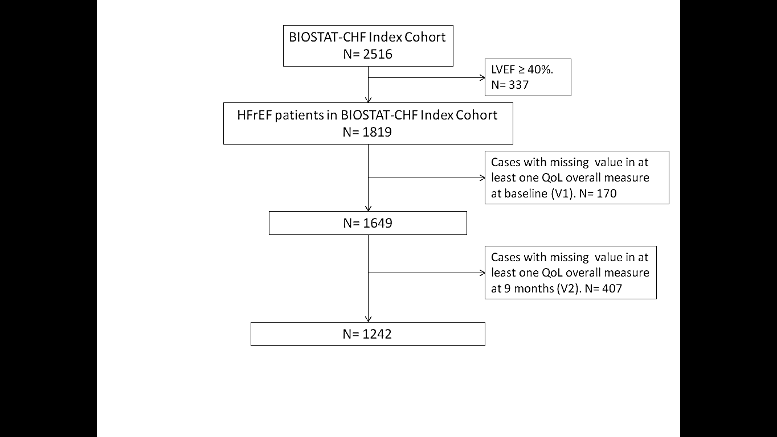

**Figure S2.** Sex differences in the answers to the items of Kansas City Cardiomyopathy Questionnaire at baseline. HF= heart failure; KCCQ= Kansas City Cardiomyopathy Questionnaire; M= men; Q= question; W= women.

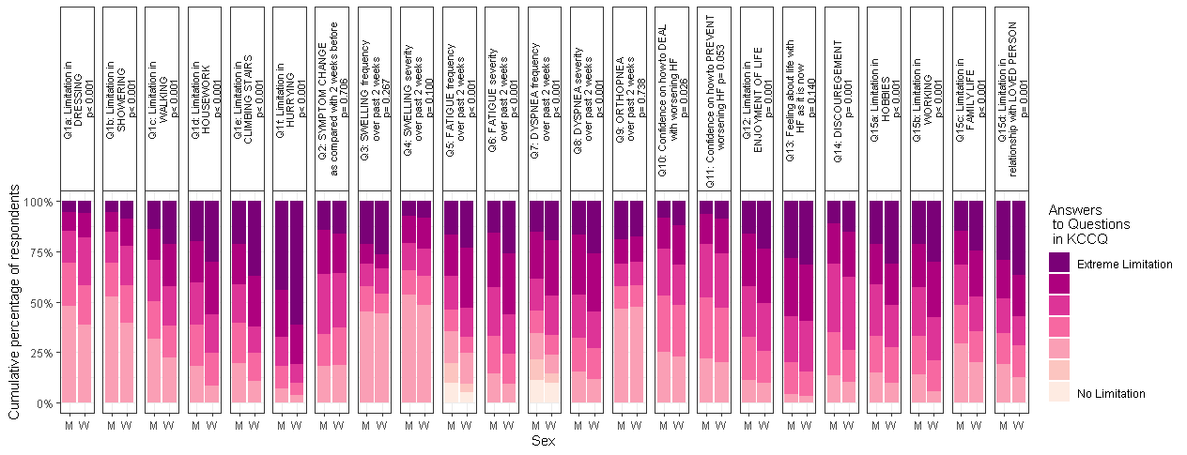

**Figure S3.** Sex differences in the answers to the items of Kansas City Cardiomyopathy Questionnaire at nine months. HF= heart failure; KCCQ= Kansas City Cardiomyopathy Questionnaire; M= men; Q= question; W= women.

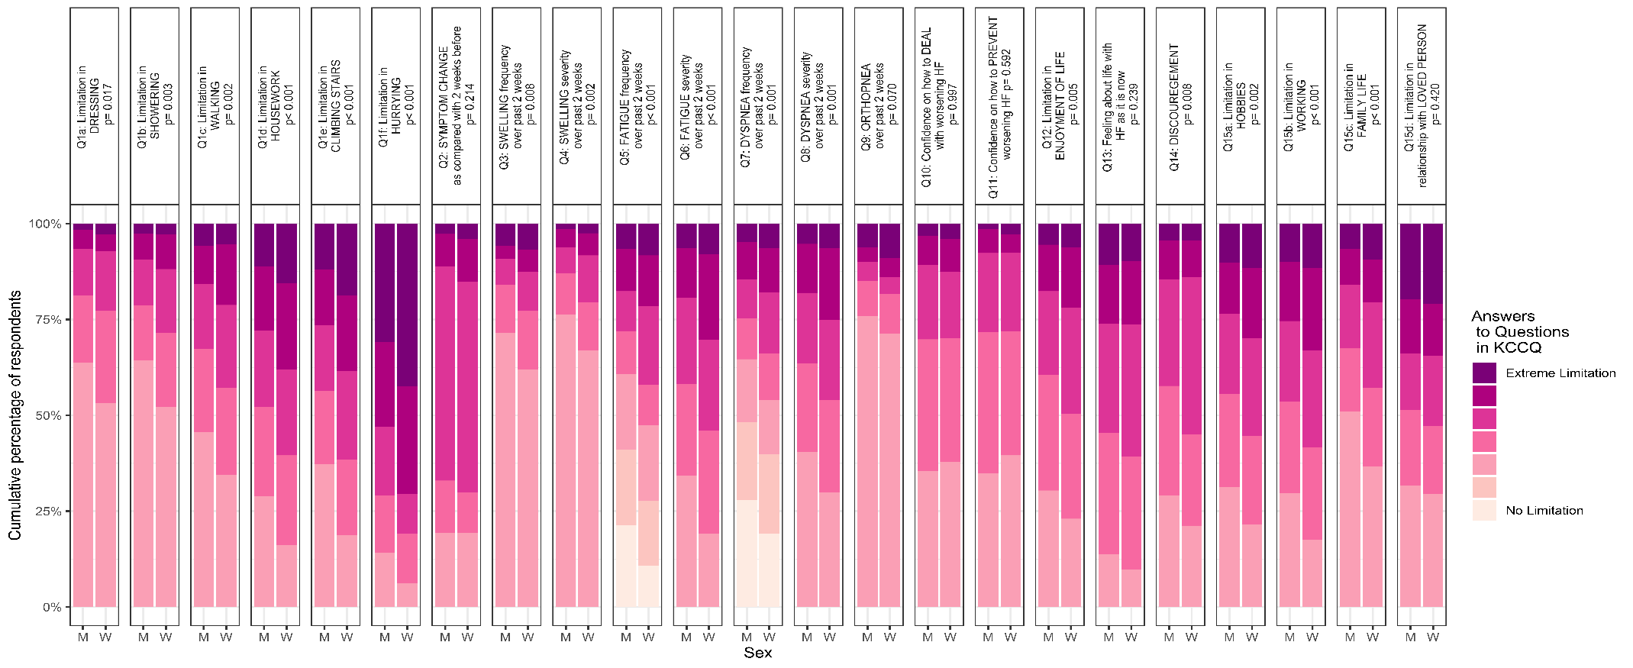

**Figure S4.** Sex differences in the distribution of the answers to EuroQol 5 dimensions items at nine months (cumulative percentages). EQ-5D= EuroQoL 5 dimensions.

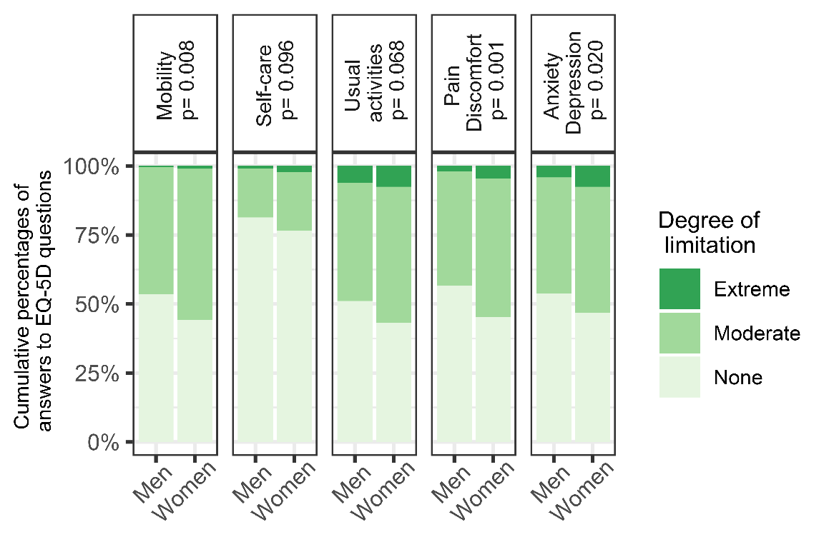

**Figure S5.** Shift analysis showing sex differences in fraction target dose of angiotensin-converting enzyme inhibitors (ACEi) or angiotensin receptor blockers (ARB) and β-blockers at baseline. Within each drug category: panel (A) show 1D scatterplots, with the deciles marked by grey vertical lines, sex groups are plotted along the y-axis; panel (B) depicts the shift function, differences in the distributions for men and women are plotted along the y-axis for each decile (white dots), as a function of women deciles. For each decile difference, the vertical line indicates its 95% bootstrap confidence interval. Overall p-values are obtained comparing each pair of distributions (women vs. men) with the Kolmogorov-Smirnov test. ACEi= angiotensin-converting enzyme inhibitors; ARB= angiotensin receptor blockers; CI= confidence interval.

**ACEi/ARB**

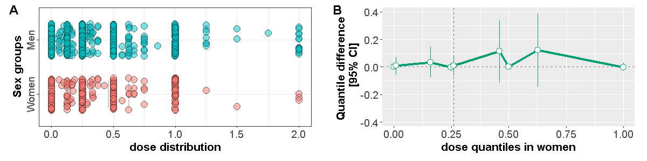 p = 0.534

**β-blockers**

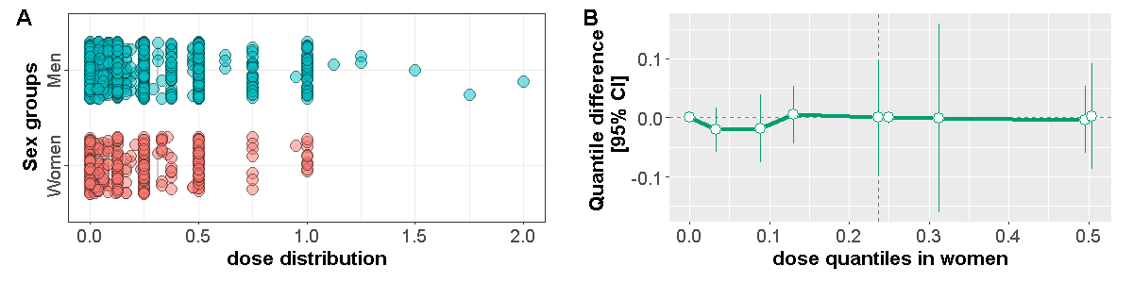 p = 0.638

**Figure S6.** Shift analysis showing sex differences in achieved fraction target dose of angiotensin-converting enzyme inhibitors (ACEi) or angiotensin receptor blockers (ARB) and β-blockers. Within each drug category: panel (A) show 1D scatterplots, with the deciles marked by grey vertical lines, sex groups are plotted along the y-axis; panel (B) depicts the shift function, differences in the distributions for men and women are plotted along the y-axis for each decile (white dots), as a function of women deciles. For each decile difference, the vertical line indicates its 95% bootstrap confidence interval. Overall p-values are obtained comparing each pair of distributions (women vs. men) with the Kolmogorov-Smirnov test. ACEi= angiotensin-converting enzyme inhibitors; ARB= angiotensin receptor blockers; CI= confidence interval.

**ACEi/ARB**

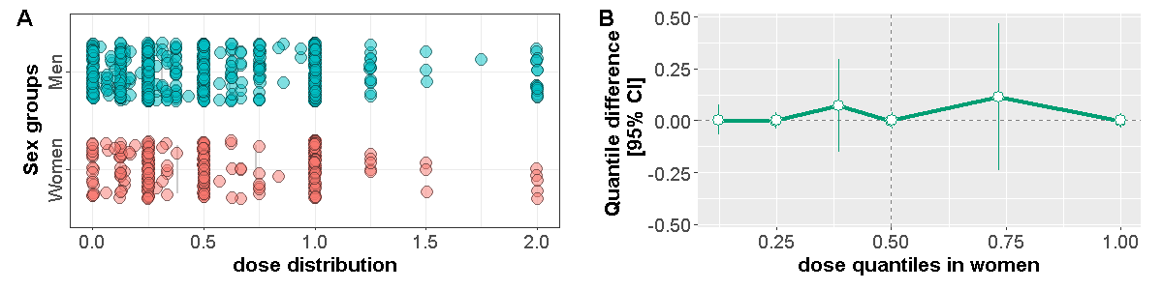 p = 0.989

**β-blockers**

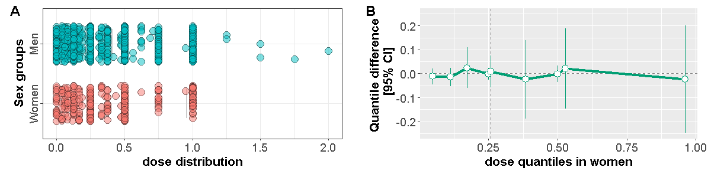 p = 0.992

**Figure S7.** Shift analysis showing sex differences between the quantiles of Kansas City Cardiomyopathy Questionnaire change (Delta KCCQ-OS) from baseline to 9 months, at varying levels of achieved fraction target dose of angiotensin-converting enzyme inhibitors (ACEi) or angiotensin receptor blockers (ARB) and β-blockers. Within each dose level: panel (A) show 1D scatterplots, with the deciles marked by grey vertical lines; panel (B) depicts the shift function, differences in the distributions for men and women are plotted along the y-axis for each decile (white dots), as a function of women deciles. For each decile difference, the vertical line indicates its 95% bootstrap confidence interval. Overall p-values are obtained comparing each pair of distributions (women vs. men) with the Kolmogorov-Smirnov test. ACEi= angiotensin-converting enzyme inhibitors; ARB= angiotensin receptor blockers; CI= confidence interval; delta KCCQ-OS= Kansas City Cardiomyopathy Questionnaire change from baseline to 9 months; V1= baseline visit; V2= 9 months visit.

|  |  |  |  |  |
| --- | --- | --- | --- | --- |
| Drug  Frac.  target dose 3 months | **ACEi/ARB** | p | **β-Blockers** | p |
| **0%** |  | 0.935 |  | 0.745 |
| **1-49%** |  | 0.700 |  | 0.887 |
| **50-99%** |  | 0.923 |  | 0.862 |
| **≥ 100%** |  | 0.036 |  | 0.019 |

**Figure S8.** Effect plots for all-cause mortality by (a) Kansas City Cardiomyopathy Questionnaire overall score, EuroQoL 5 dimensions (b) visual analogue scale and (c) utility score at baseline, using adjusted Cox model with the corresponding median quality of life measure as reference. Men subset is represented in blue, women subset in red. Data density across quality of life spectrum is plotted in grey. EQ-5D= EuroQoL 5 dimensions; KCCQ= Kansas City Cardiomyopathy Questionnaire; VAS= visual analogue scale.

|  |  |
| --- | --- |
| **a)** |  |
| **b)** |  |
| **c)** |  |

**Figure S9.** Effect plots for heart failure hospitalization by (a) Kansas City Cardiomyopathy Questionnaire Overall Score, EuroQoL 5 dimensions (b) visual analogue scale and (c) utility score at baseline, using adjusted Cox model with the corresponding median quality of life measure as reference. Men subset is represented in blue, women subset in red. Data density across quality of life spectrum is plotted in grey. EQ-5D= EuroQoL 5 dimensions; KCCQ= Kansas City Cardiomyopathy Questionnaire; VAS= visual analogue scale.

|  |  |
| --- | --- |
| **a)** |  |
| **b)** |  |
| **c)** |  |

**Figure S10.** Effect plots for all-cause mortality and/or heart failure hospitalization by (a) Kansas City Cardiomyopathy Questionnaire overall score, EuroQoL 5 dimensions (b) visual analogue scale and (c) utility score at baseline, using adjusted Cox model with the corresponding quality of life measure as reference. Men subset is represented in blue, women subset in red. Data density across quality of life spectrum is plotted in grey. EQ-5D= EuroQoL 5 dimensions; KCCQ= Kansas City Cardiomyopathy Questionnaire; VAS= visual analogue scale.

|  |  |
| --- | --- |
| **a)** |  |
| **b)** |  |
| **c)** |  |