Supplementary table 1. Baseline characteristics of the validation cohort

|  |  |  |  |
| --- | --- | --- | --- |
|  | **Con. hyp.** (N=108) | **Ecc. hyp.** (N=164) | p value |
| **Age, yrs** | 74.0 (10.8) | 69.2 (11.4) | < 0.001 |
| **Female** | 32 (29.6%) | 56 (34.1%) | 0.436 |
| **BMI, kg/m2** | 29.0 (6.2) | 28.0 (6.1) | 0.192 |
| **SBP, mm Hg** | 129.6 (23.7) | 120.9 (21.0) | 0.002 |
| **DBP, mm Hg** | 71.7 (13.1) | 69.6 (12.0) | 0.178 |
| **NYHA class** |  |  | 0.125 |
| Class I | 0 (0.0%) | 3 (1.8%) |  |
| Class II | 50 (46.3%) | 89 (54.3%) |  |
| Class III | 46 (42.6%) | 63 (38.4%) |  |
| Class IV | 12 (11.1%) | 9 (5.5%) |  |
|  |  |  |  |
| **Heart rate, beats/min** | 73.7 (14.0) | 74.6 (17.3) | 0.629 |
|  |  |  |  |
| **Medical history** |  |  |  |
| Myocardial infarction | 52 (48.1%) | 75 (46.0%) | 0.730 |
| PCI | 20 (18.7%) | 23 (14.1%) | 0.314 |
| CABG | 21 (19.4%) | 33 (20.1%) | 0.891 |
| Valvular surgery | 5 (4.6%) | 6 (3.7%) | 0.691 |
| Atrial fibrillation (ECG) | 26 (25.5%) | 45 (28.5%) | 0.597 |
| Hypertension | 61 (57.0%) | 72 (44.2%) | 0.039 |
| Diabetes | 31 (28.7%) | 47 (28.7%) | 0.994 |
| COPD | 7 (6.6%) | 25 (15.3%) | 0.031 |
| Renal disease | 50 (47.2%) | 71 (43.8%) | 0.591 |
| Current malignancy | 5 (4.7%) | 12 (7.3%) | 0.380 |
|  |  |  |  |
| **Smoking history** |  |  | 0.719 |
| None | 50 (46.7%) | 68 (42.0%) |  |
| Past | 37 (34.6%) | 63 (38.9%) |  |
| Current | 20 (18.7%) | 31 (19.1%) |  |
|  |  |  |  |
| **Urea, mmol/l** | 9.6 | 8.6 | 0.118 |
|  |  |  |  |
| **ACEi/ARB use** | 77 (71.3%) | 130 (79.3%) | 0.131 |
| **Betablocker use** | 88 (81.5%) | 128 (78.0%) | 0.493 |
| **MRA use** | 37 (34.3%) | 74 (45.1%) | 0.074 |
| **Diuretic use** | 108 (100.0%) | 164 (100.0%) | 1.000 |
|  |  |  |  |
| **Primary etiology** |  |  |  |
| Ischemic heart disease | 69 (64.4%) | 98 (60.0%) | 0.746 |
| Hypertension | 11 (10.2%) | 14 (8.6%) | 0.690 |
| Cardiomyopathy | 7 (6.5%) | 22 (13.5%) | 0.267 |
| Valvular heart disease | 7 (6.5%) | 10 (6.1%) | 0.934 |
| Other | 15 (14.0%) | 23 (14.1%) | 1.000 |
|  |  |  |  |
| **LVEF (%)** | 31.2 (7.1) | 27.6 (7.5) | < 0.001 |
| **Mitral valve regurgitation (moderate-severe)** | 44 (41.1%) | 96 (59.3%) | 0.004 |
| **E/A ratio** | 0.9 (0.6, 1.4) | 1.3 (0.7, 2.2) | 0.042 |

Supplementary table 2. Measurements using Olink Proseek® data are presented as arbitrary units (AU) on a log2 scale.

|  |  |  |  |  |
| --- | --- | --- | --- | --- |
|  | Con. hyp. (N=142) | Ecc. hyp. (N=873) | Below limit of detection | p value |
| ALCAM | 4.1 (3.7, 4.5) | 4.1 (3.7, 4.4) | 0,07% | 0.898 |
| AP-N | 4.2 (3.8, 4.7) | 4.2 (3.8, 4.6) | 0,05% | 0.736 |
| AXL | 7.1 (6.8, 7.5) | 7.0 (6.6, 7.5) | 0,05% | 0.044 |
| AZU1 | 1.8 (1.5, 2.6) | 1.9 (1.5, 2.6) | 24,98% | 0.27 |
| BLM hydrolase | 4.6 (4.1, 5.0) | 4.5 (4.1, 4.9) | 7,22% | 0.537 |
| CASP-3 | 6.6 (5.4, 8.3) | 6.7 (5.7, 8.1) | 0,05% | 0.975 |
| CCL15 | 6.6 (6.2, 7.0) | 6.5 (6.0, 6.9) | 0,05% | 0.089 |
| CCL16 | 5.4 (4.9, 5.8) | 5.3 (4.8, 5.8) | 0,05% | 0.18 |
| CCL22 | 1.4 (0.8, 1.8) | 1.4 (0.9, 2.0) | 1,25% | 0.036 |
| CCL24 | 4.9 (4.0, 5.6) | 4.8 (4.1, 5.5) | 0,05% | 0.957 |
| CD163 | 6.7 (6.3, 7.3) | 6.7 (6.2, 7.2) | 0,05% | 0.32 |
| CD93 | 9.0 (8.5, 9.3) | 8.8 (8.4, 9.2) | 0,05% | 0.139 |
| CDH5 | 2.7 (2.3, 3.1) | 2.7 (2.3, 3.1) | 0,27% | 0.7 |
| CHI3L1 | 5.8 (5.1, 6.5) | 5.4 (4.6, 6.3) | 0,32% | 0.005 |
| CHIT1 | 2.3 (1.6, 3.1) | 2.3 (1.5, 2.9) | 3,66% | 0.859 |
| CNTN1 | 1.8 (1.4, 2.3) | 1.9 (1.4, 2.2) | 0,15% | 0.88 |
| COL1A1 | 1.6 (1.2, 2.0) | 1.5 (1.1, 2.0) | 0,07% | 0.288 |
| CPA1 | 3.6 (3.2, 4.3) | 3.6 (3.0, 4.2) | 0,20% | 0.259 |
| CPB1 | 3.4 (2.9, 3.9) | 3.3 (2.7, 3.9) | 0,07% | 0.536 |
| CSTB | 4.5 (3.9, 5.0) | 4.3 (3.8, 4.9) | 14,81% | 0.38 |
| CTSD | 3.2 (2.7, 3.7) | 3.1 (2.6, 3.6) | 3,98% | 0.205 |
| CTSZ | 4.1 (3.7, 4.7) | 4.1 (3.6, 4.5) | 0,05% | 0.188 |
| CXCL16 | 5.5 (5.1, 5.9) | 5.5 (5.0, 5.8) | 0,05% | 0.394 |
| DLK-1 | 4.3 (3.7, 4.7) | 4.0 (3.5, 4.6) | 0,05% | 0.031 |
| EGFR | 0.6 (0.2, 0.8) | 0.6 (0.3, 0.9) | 0,81% | 0.334 |
| Ep-CAM | 2.7 (2.1, 3.4) | 2.7 (2.2, 3.4) | 0,22% | 0.733 |
| EPHB4 | 1.5 (1.1, 1.8) | 1.4 (1.1, 1.7) | 2,87% | 0.11 |
| FABP4 | 5.4 (4.7, 6.2) | 5.0 (4.2, 5.9) | 0,05% | 0.004 |
| FAS | 4.2 (3.8, 4.5) | 4.0 (3.7, 4.4) | 0,05% | 0.3 |
| Gal-3 | 4.3 (3.8, 4.8) | 4.4 (3.9, 4.8) | 0,52% | 0.391 |
| Gal-4 | 3.0 (2.6, 3.4) | 2.9 (2.4, 3.4) | 0,12% | 0.229 |
| GDF-15 | 4.9 (4.4, 5.6) | 4.7 (4.1, 5.4) | 0,05% | 0.019 |
| GRN | 3.0 (2.5, 3.3) | 3.0 (2.6, 3.3) | 0,05% | 0.648 |
| ICAM-2 | 4.3 (3.8, 4.7) | 4.2 (3.8, 4.6) | 0,05% | 0.699 |
| IGFBP-1 | 4.8 (4.1, 5.6) | 4.7 (3.8, 5.5) | 0,10% | 0.288 |
| IGFBP-2 | 7.9 (7.2, 8.3) | 7.5 (6.9, 8.1) | 0,05% | 0.012 |
| IGFBP-7 | 3.7 (3.1, 4.1) | 3.6 (3.1, 4.1) | 0,05% | 0.312 |
| IL-17RA | 3.2 (2.8, 3.7) | 3.2 (2.8, 3.7) | 0,12% | 0.789 |
| IL-18BP | 5.7 (5.2, 6.1) | 5.6 (5.1, 6.0) | 0,05% | 0.142 |
| IL-1RT1 | 5.9 (5.5, 6.2) | 5.8 (5.4, 6.2) | 0,05% | 0.299 |
| IL-1RT2 | 4.0 (3.5, 4.4) | 4.0 (3.6, 4.4) | 0,07% | 0.943 |
| IL2-RA | 3.6 (3.1, 4.2) | 3.5 (3.1, 4.0) | 0,10% | 0.048 |
| IL-6RA | 10.0 (9.6, 10.4) | 10.1 (9.6, 10.4) | 0,05% | 0.689 |
| ITGB2 | 4.4 (4.0, 4.8) | 4.4 (4.0, 4.9) | 0,07% | 0.943 |
| JAM-A | 4.4 (3.8, 5.7) | 4.5 (3.9, 5.3) | 0,10% | 0.517 |
| KLK6 | 2.5 (2.4, 2.9) | 2.5 (2.4, 2.9) | 23,02% | 0.666 |
| LDL receptor | 2.9 (2.3, 3.6) | 3.0 (2.5, 3.5) | 0,12% | 0.941 |
| LTBR | 3.0 (2.6, 3.4) | 2.8 (2.4, 3.3) | 0,10% | 0.037 |
| MB | 6.2 (5.6, 7.0) | 6.0 (5.5, 6.6) | 0,05% | 0.02 |
| MCP-1 | 2.2 (1.8, 2.5) | 2.2 (1.8, 2.5) | 0,07% | 0.784 |
| MEPE | 2.2 (1.8, 2.6) | 2.1 (1.7, 2.6) | 0,32% | 0.453 |
| MMP-2 | 2.8 (2.2, 3.3) | 2.7 (2.3, 3.3) | 0,05% | 0.437 |
| MMP-3 | 6.8 (6.1, 7.5) | 6.7 (6.1, 7.3) | 0,05% | 0.03 |
| MMP-9 | 3.2 (2.3, 3.8) | 3.1 (2.5, 3.8) | 1,72% | 0.817 |
| MPO | 3.5 (2.9, 3.9) | 3.5 (3.1, 4.0) | 0,93% | 0.168 |
| Notch 3 | 3.2 (2.6, 3.6) | 3.2 (2.7, 3.6) | 0,49% | 0.596 |
| NT-pro BNP | 3.4 (2.4, 4.1) | 2.8 (2.0, 3.8) | 5,85% | 0.028 |
| OPG | 2.7 (2.2, 3.2) | 2.5 (2.1, 2.9) | 0,10% | 0.061 |
| OPN | 4.9 (4.4, 5.5) | 4.7 (4.1, 5.3) | 0,05% | 0.005 |
| PAI | 5.2 (4.4, 6.0) | 5.1 (4.2, 6.0) | 0,05% | 0.691 |
| PCSK9 | 1.8 (1.5, 2.1) | 1.8 (1.4, 2.2) | 1,06% | 0.758 |
| PDGF subunit A | 1.9 (1.1, 2.8) | 2.0 (1.1, 2.9) | 0,81% | 0.882 |
| PECAM-1 | 4.2 (3.7, 5.0) | 4.2 (3.7, 4.8) | 1,13% | 0.511 |
| PGLYRP1 | 6.7 (6.0, 7.2) | 6.5 (5.9, 7.0) | 0,05% | 0.052 |
| PI3 | 3.2 (2.7, 3.8) | 2.9 (2.5, 3.5) | 17,02% | 0.013 |
| PLC | 6.5 (5.9, 6.9) | 6.3 (5.9, 6.8) | 0,05% | 0.037 |
| PON3 | 4.2 (3.4, 4.8) | 4.3 (3.6, 4.9) | 0,10% | 0.325 |
| PRTN3 | 3.9 (3.4, 4.3) | 3.9 (3.4, 4.4) | 6,90% | 0.514 |
| PSP-D | 2.1 (1.4, 2.7) | 2.0 (1.4, 2.5) | 6,85% | 0.243 |
| RARRES2 | 11.0 (10.6, 11.4) | 11.0 (10.6, 11.3) | 0,05% | 0.595 |
| RETN | 6.1 (5.5, 6.5) | 5.9 (5.4, 6.4) | 0,05% | 0.271 |
| SCGB3A2 | 2.3 (1.5, 2.9) | 2.0 (1.4, 2.6) | 0,25% | 0.127 |
| SELE | 1.5 (0.9, 2.1) | 1.5 (0.9, 1.9) | 0,15% | 0.486 |
| SELP | 8.2 (7.5, 9.1) | 8.2 (7.5, 8.9) | 0,05% | 0.578 |
| SHPS-1 | 2.9 (2.6, 3.3) | 2.8 (2.5, 3.3) | 0,17% | 0.203 |
| SPON1 | 1.7 (1.3, 2.1) | 1.6 (1.2, 1.9) | 5,60% | 0.038 |
| ST2 | 3.8 (3.0, 4.7) | 3.5 (2.9, 4.3) | 0,15% | 0.016 |
| TFF3 | 5.2 (4.6, 5.7) | 5.0 (4.5, 5.6) | 0,05% | 0.029 |
| TFPI | 7.8 (7.2, 8.2) | 7.7 (7.3, 8.2) | 0,05% | 0.699 |
| TIMP4 | 4.5 (4.0, 5.1) | 4.4 (3.9, 4.9) | 0,05% | 0.062 |
| TLT-2 | 3.5 (3.1, 4.0) | 3.5 (3.0, 3.9) | 0,12% | 0.459 |
| TNF-R1 | 4.9 (4.3, 5.4) | 4.6 (4.1, 5.2) | 10,86% | 0.044 |
| TNF-R2 | 4.4 (3.9, 4.9) | 4.2 (3.7, 4.7) | 0,05% | 0.015 |
| TNFRSF10C | 5.3 (4.8, 5.8) | 5.2 (4.7, 5.7) | 0,05% | 0.198 |
| TNFRSF14 | 4.2 (3.7, 4.8) | 4.0 (3.6, 4.5) | 0,07% | 0.019 |
| TNFSF13B | 5.4 (4.8, 5.8) | 5.3 (4.8, 5.8) | 0,05% | 0.849 |
| t-PA | 4.8 (4.0, 5.7) | 4.9 (4.1, 5.9) | 0,05% | 0.082 |
| TR | 5.0 (4.4, 5.6) | 5.0 (4.4, 5.5) | 0,05% | 0.536 |
| TR-AP | 4.2 (3.8, 4.8) | 4.2 (3.8, 4.7) | 0,17% | 0.266 |
| uPA | 3.8 (3.3, 4.2) | 3.9 (3.4, 4.2) | 0,05% | 0.388 |
| U-PAR | 4.1 (3.7, 4.6) | 4.0 (3.5, 4.4) | 0,07% | 0.034 |
| vWF | 5.7 (4.9, 6.7) | 5.9 (5.1, 7.0) | 0,05% | 0.167 |

Supplementary table 3. Baseline characteristics (index cohort) including patients with normal geometry and concentric remodeling

|  |  |  |  |  |  |
| --- | --- | --- | --- | --- | --- |
|  | **Normal**  (N=263) | **Con. rem.** (N=26) | **Con. hyp.** (N=142) | **Ecc. hyp.** (N=873) | p value |
| **Age, yrs** | 65.2 (12.9) | 69.2 (14.0) | 69.7 (11.4) | 66.5 (11.8) | 0.003 |
| **Female** | 35 (13.3%) | 7 (26.9%) | 43 (30.3%) | 220 (25.2%) | <0.001 |
| **BMI, kg/m2** | 28.0 (5.7) | 26.6 (5.5) | 28.4 (5.3) | 27.5 (4.9) | 0.121 |
| **SBP, mm Hg** | 123.0 (20.6) | 128.4 (23.5) | 129.4 (21.1) | 123.9 (21.3) | 0.014 |
| **DBP, mm Hg** | 76.5 (13.1) | 74.0 (12.7) | 78.3 (12.9) | 75.7 (12.7) | 0.110 |
| **NYHA class** |  |  |  |  | 0.007 |
| Class I | 26 (9.9%) | 1 (3.8%) | 12 (8.5%) | 65 (7.4%) |  |
| Class II | 116 (44.1%) | 12 (64.2%) | 62 (43.7%) | 419 (48.0%) |  |
| Class III | 67 (25.5%) | 4 (15.4%) | 51 (35.9%) | 266 (30.5%) |  |
| Class IV | 7 (2.7%) | 0 (0.0%) | 4 (2.8%) | 25 (2.9%) |  |
| Not assessed | 47 (17.9%) | 9 (34.6%) | 13 (9.2%) | 98 (11.2%) |  |
| **Heart rate, beats/min** | 81.9 (22.4) | 85.6 (20.6) | 80.5 (18.0) | 80.1 (17.7) | 0.288 |
|  |  |  |  |  |  |
| **Medical history** |  |  |  |  |  |
| Myocardial infarction | 115 (43.7%) | 10 (38.5%) | 44 (31.0%) | 332 (38.0%) | 0.090 |
| PCI | 64 (24.3%) | 4 (15.4%) | 31 (21.8%) | 176 (20.2%) | 0.445 |
| CABG | 44 (16.7%) | 1 (3.8%) | 22 (15.5%) | 138 (15.8%) | 0.395 |
| Valvular surgery | 18 (6.8%) | 2 (7.7%) | 11 (7.7%) | 55 (6.3%) | 0.918 |
| Moderate-severe mitral valve regurgitation | 115 (43.9%) | 7 (29.2%) | 59 (41.5%) | 504 (57.9%) |  |
| Atrial fibrillation (History) | 117 (44.5%) | 14 (53.8%) | 64 (45.1%) | 353 (40.4%) | 0.309 |
| Atrial fibrillation (ECG) | 77 (29.4%) | 12 (46.2%) | 48 (33.8%) | 258 (29.7%) | 0.242 |
| Hypertension | 133 (50.6%) | 17 (65.4%) | 109 (76.8%) | 526 (60.3%) | <0.001 |
| Diabetes | 83 (31.6%) | 10 (38.5%) | 48 (33.8%) | 259 (29.7%) | 0.592 |
| COPD | 32 (12.2%) | 6 (23.1%) | 29 (20.4%) | 148 (17.0%) | 0.106 |
| Renal disease | 52 (19.8%) | 12 (46.2%) | 44 (31.0%) | 203 (23.3%) | 0.003 |
| Current malignancy | 9 (3.4%) | 1 (3.8%) | 5 (3.5%) | 16 (1.8%) | 0.335 |
|  |  |  |  |  |  |
| **Smoking history** |  |  |  |  | 0.141 |
| None | 74 (28.1%) | 7 (26.9%) | 56 (39.4%) | 318 (36.5%) |  |
| Past | 148 (56.3%) | 14 (53.8%) | 63 (44.4%) | 413 (47.4%) |  |
| Current | 41 (15.6%) | 5 (19.2%) | 23 (16.2%) | 141 (16.2%) |  |
|  |  |  |  |  |  |
| **NT-proBNP, ng/l** | 2627 | 4127 | 3862 | 2493 | <0.001 |
| **eGFR, ml/min/1.73 m2** | 66.4 | 46.6 | 57.7 | 61.9 | 0.001 |
| **Urea, mmol/l** | 10.3 | 12.3 | 12.4 | 11.6 | 0.238 |
| **Hemoglobin, g/dl** | 13.7 (1.8) | 12.7 (2.3) | 13.4 (2.0) | 13.4 (1.8) | 0.033 |
|  |  |  |  |  |  |
| **ACEi/ARB use** | 197 (74.9%) | 15 (57.7%) | 99 (69.7%) | 649 (74.3%) | 0.174 |
| **Beta-blocker use** | 227 (86.3%) | 19 (17.3%) | 111 (78.2%) | 742 (85.0%) | 0.055 |
| **MRA use** | 147 (55.9%) | 9 (34.6%) | 71 (50.0%) | 524 (60.0%) | 0.010 |
| **Diuretic use** | 263 (100.0%) | 26 (100.0%) | 142 (100.0%) | 872 (99.9%) | 0.920 |
|  |  |  |  |  |  |
| **LVEF (%)** | 27.9 (6.7) | 31.8 (5.7) | 30.2 (6.2) | 26.5 (7.0) | <0.001 |
| **LVEDD (mm)** | 57.0 | 45.0 | 56.0 | 65.0 | <0.001 |
| **LVMI (g/m2)** | 96.9 | 91.8 | 157.1 | 147.8 | <0.001 |
| **RWT** | 0.30 | 0.58 | 0.47 | 0.31 | <0.001 |
| **E/A ratio** | 1.9 (0.9, 2.6) | 0.8 (0.6, 1.4) | 1.0 (0.7, 2.0) | 1.4 (0.7, 2.3) | 0.980 |

Supplementary figure 1. Overall survival in index cohort stratified by left ventricular geometry

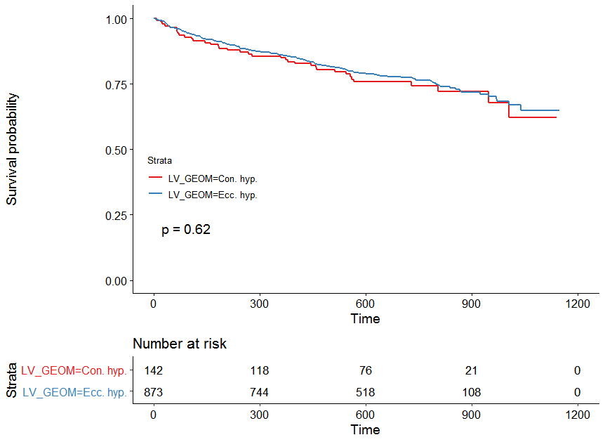

Supplementary figure 2. Overall survival in validation cohort stratified by left ventricular geometry

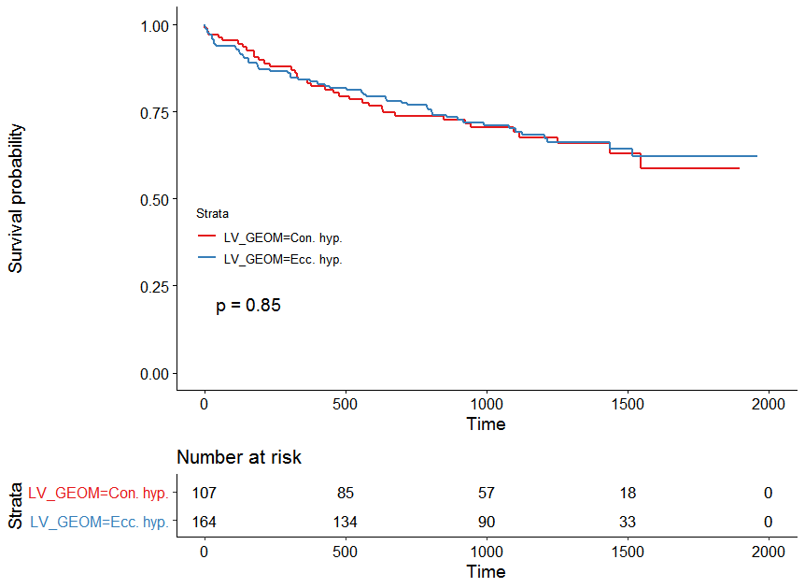

Supplementary figure 3. Unweighted Kaplan Meier curves for <50% uptitration versus >50% uptitration of ACEi/ARBs and betablockers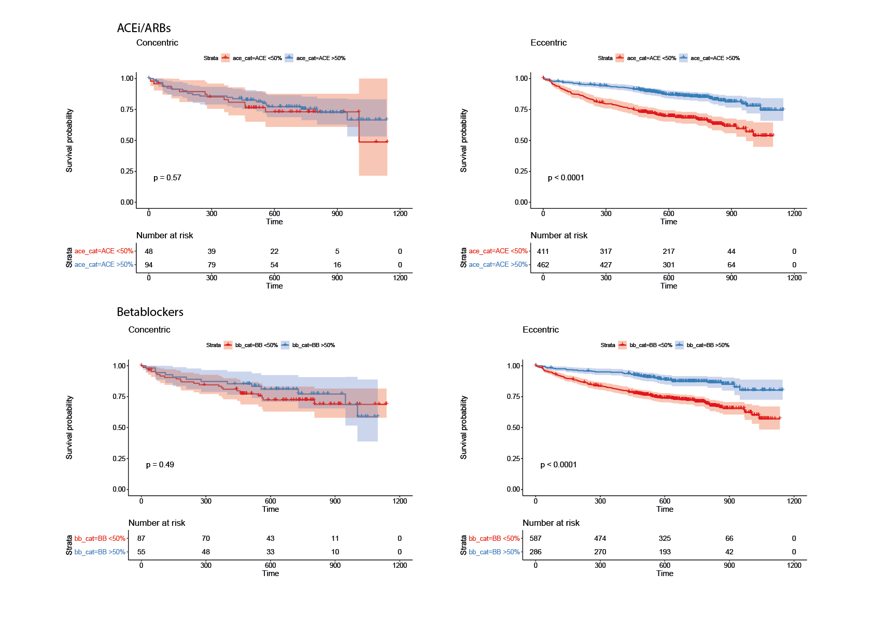

Supplementary figure 4. Heatmap of protein-protein correlations in concentric hypertrophy

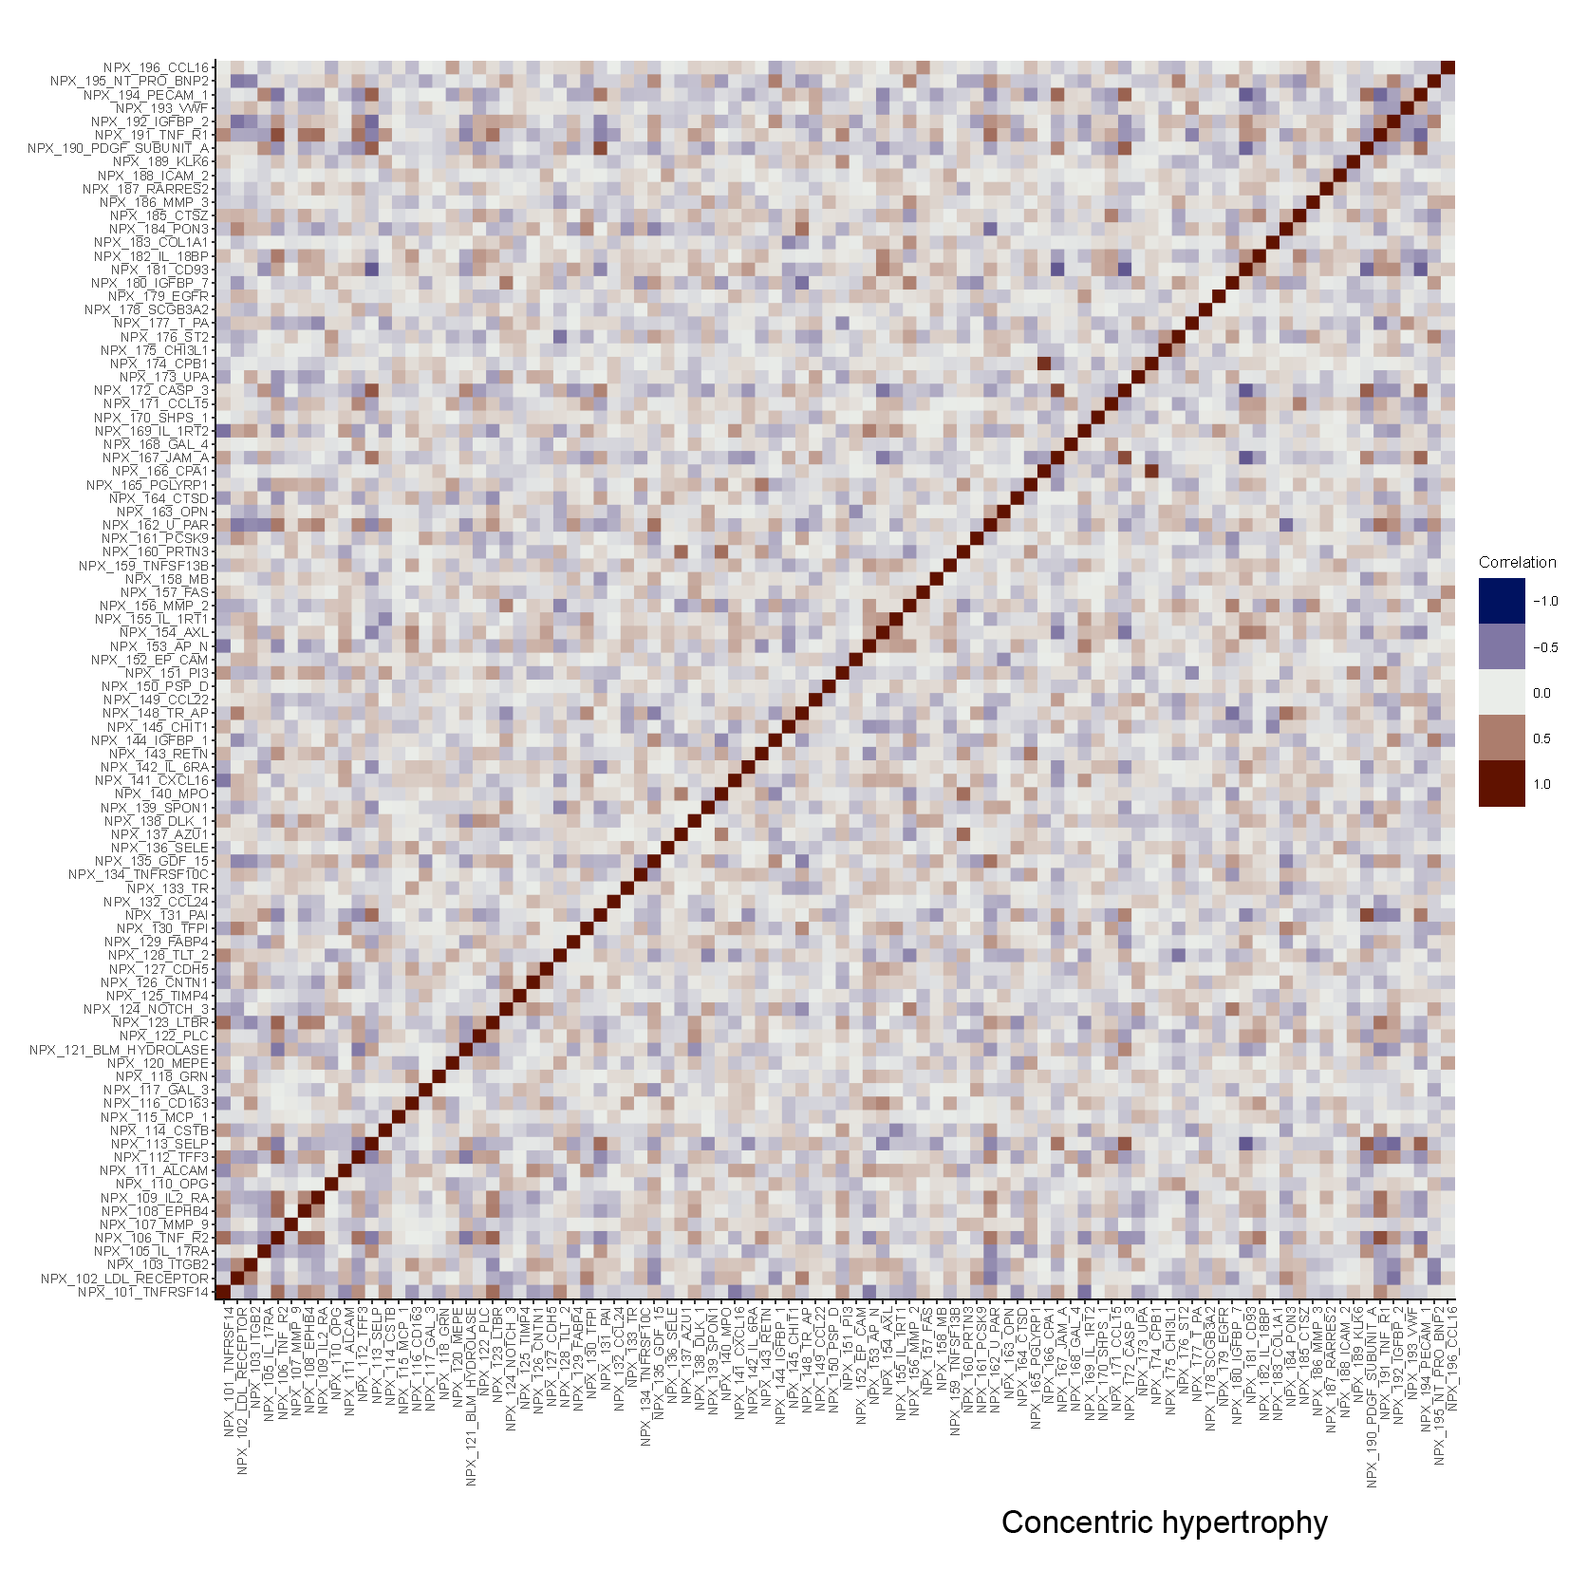

Supplementary figure 5. Heatmap of protein-protein correlations in eccentric hypertrophy

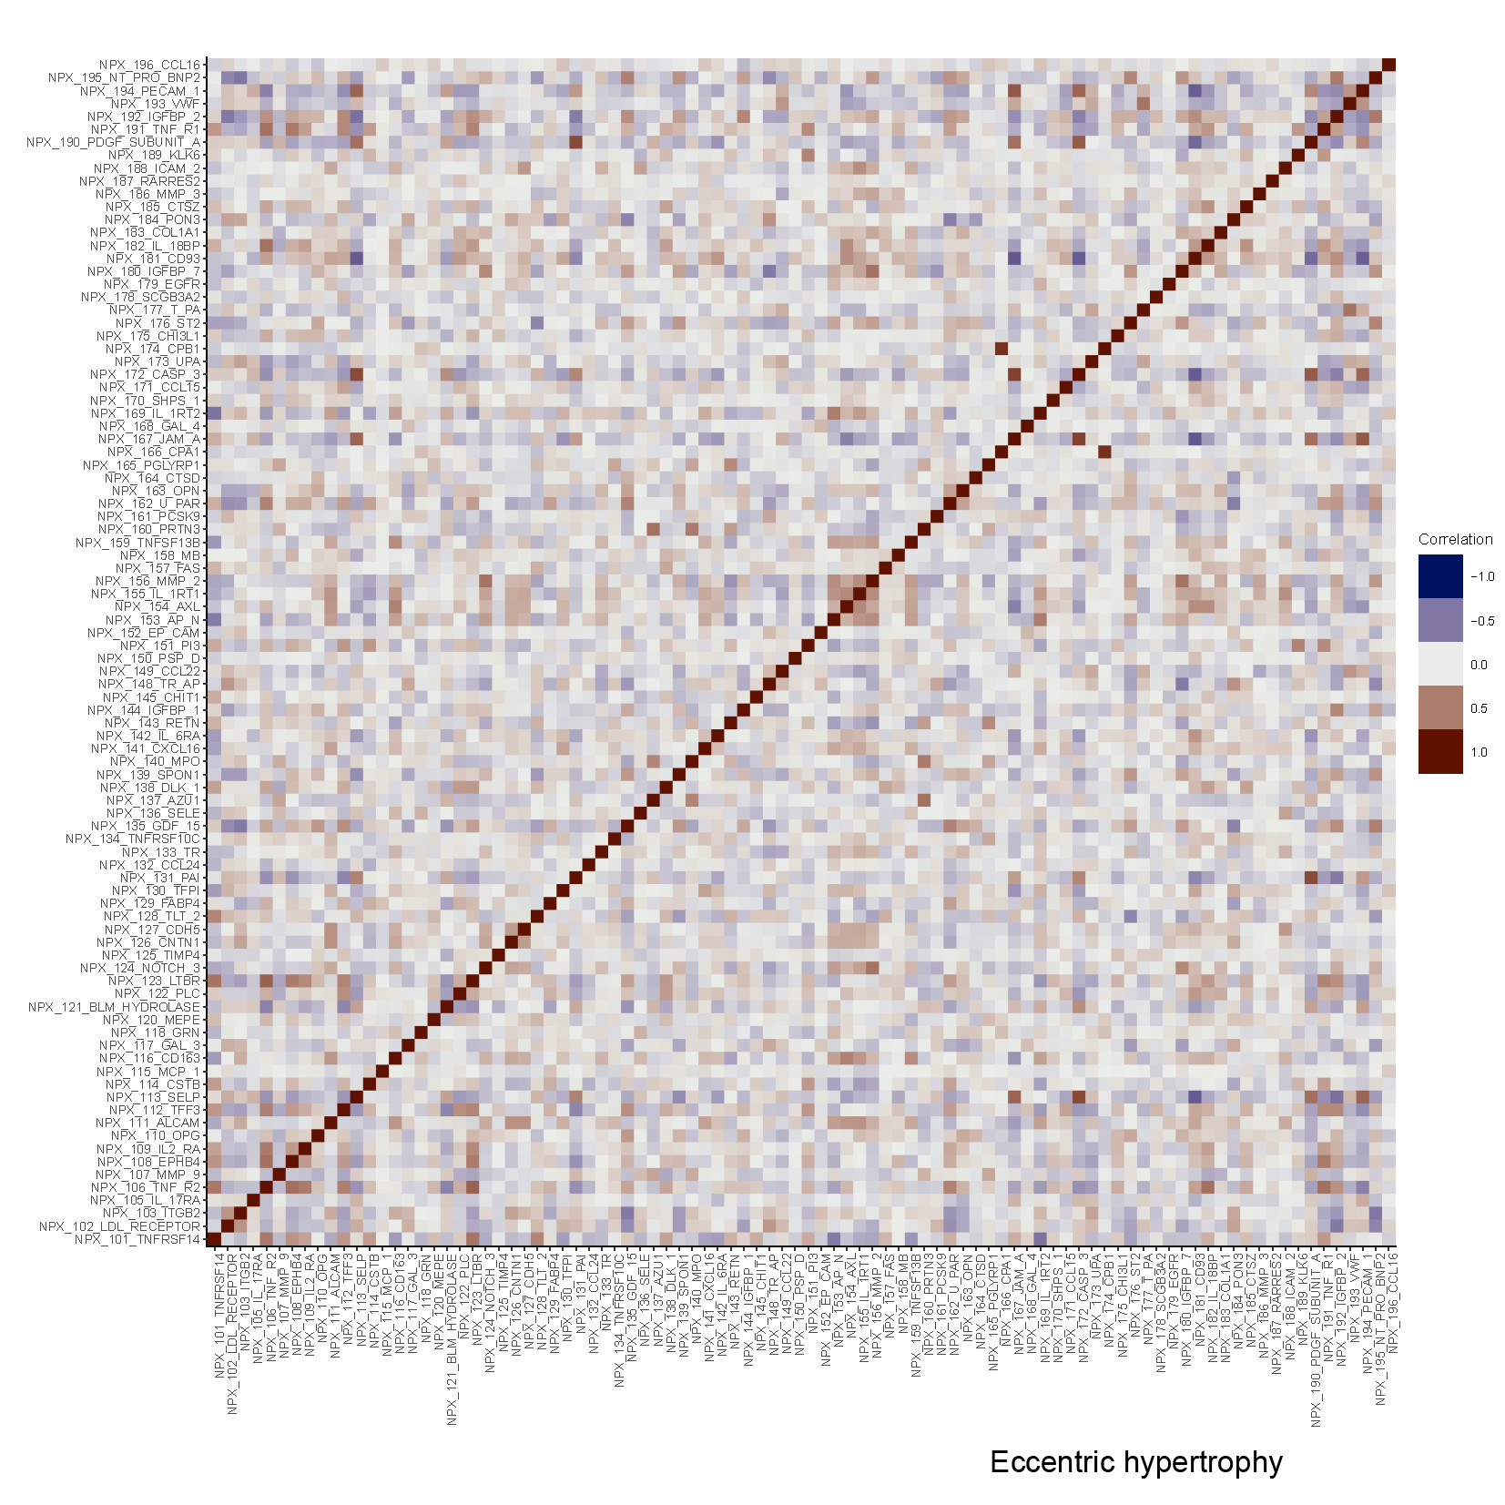

Supplementary figure 6. Flow-chart of patient selection

