Supplemental Material
Risk of Adverse Events with Liraglutide in HFrEF: A Total Event Re-analysis of the FIGHT
João Sérgio Neves, MD^{1,2}; Francisco Vasques-Nóvoa, MD^{1,3}; Marta Borges-Canha, MD^{1,2}; Ana Rita Leite, MD¹; Abhinav Sharma, MD, PhD⁴; Davide Carvalho, MD, PhD^{2,5}; Milton Packer, MD^{6,7}; Faiez Zannad, MD, PhD⁸; Adelino Leite-Moreira, MD, PhD^{1,9}; João Pedro Ferreira, MD, PhD^{1,8}

1. Cardiovascular R&D Centre - UnIC@RISE, Department of Surgery and Physiology, Faculty of Medicine of the University of Porto, Porto, Portugal.
2. Department of Endocrinology, Diabetes and Metabolism, Centro Hospitalar Universitário de São João, Porto, Portugal.
3. Department of Internal Medicine, Centro Hospitalar Universitário de São João, Porto, Portugal.
4. Division of Cardiology, DREAM-CV Lab, McGill University Health Centre, Montreal, Canada.
5. Instituto de Investigação e Inovação em Saúde, Universidade do Porto, Porto 4200-135, Portugal.
6. Baylor University Medical Center, Dallas, Texas, USA;
7. Imperial College, London, United Kingdom.
8. Université de Lorraine, Inserm, Centre d'Investigations Cliniques, - Plurithématique 14-33, and Inserm U1116, CHRU Nancy, F-CRIN INI-CRCT (Cardiovascular and Renal Clinical Trialists), Nancy, France.
9. Department of Cardiothoracic Surgery, Centro Hospitalar Universitário São João, Porto, Portugal
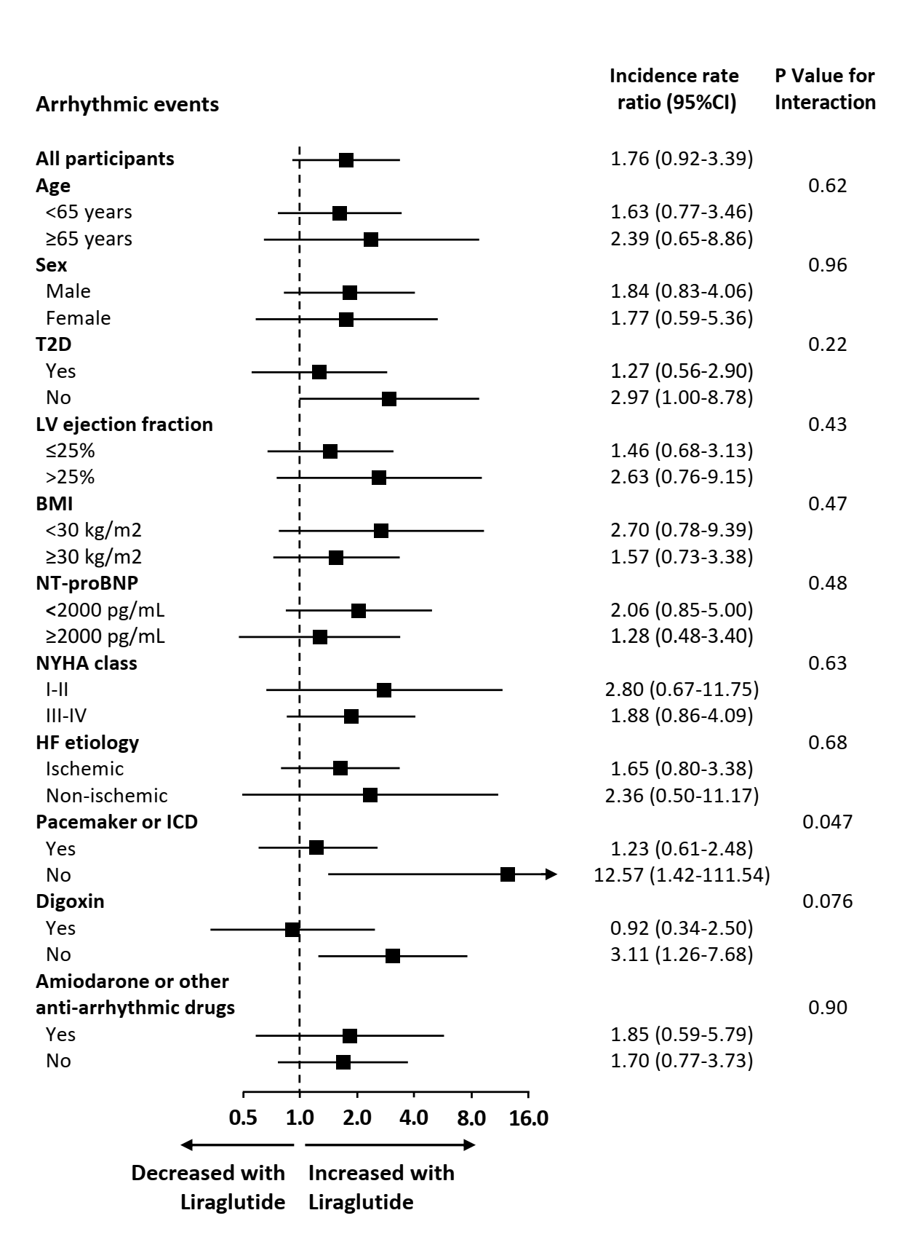
Supplemental Figure 1. Subgroup analyses for the total arrhythmic events. HF, heart failure; CI, confidence interval; T2D, type 2 diabetes; LV, left ventricle; BMI, body mass index; NYHA New York Heart Association; ICD, implantable cardioverter-defibrillator.
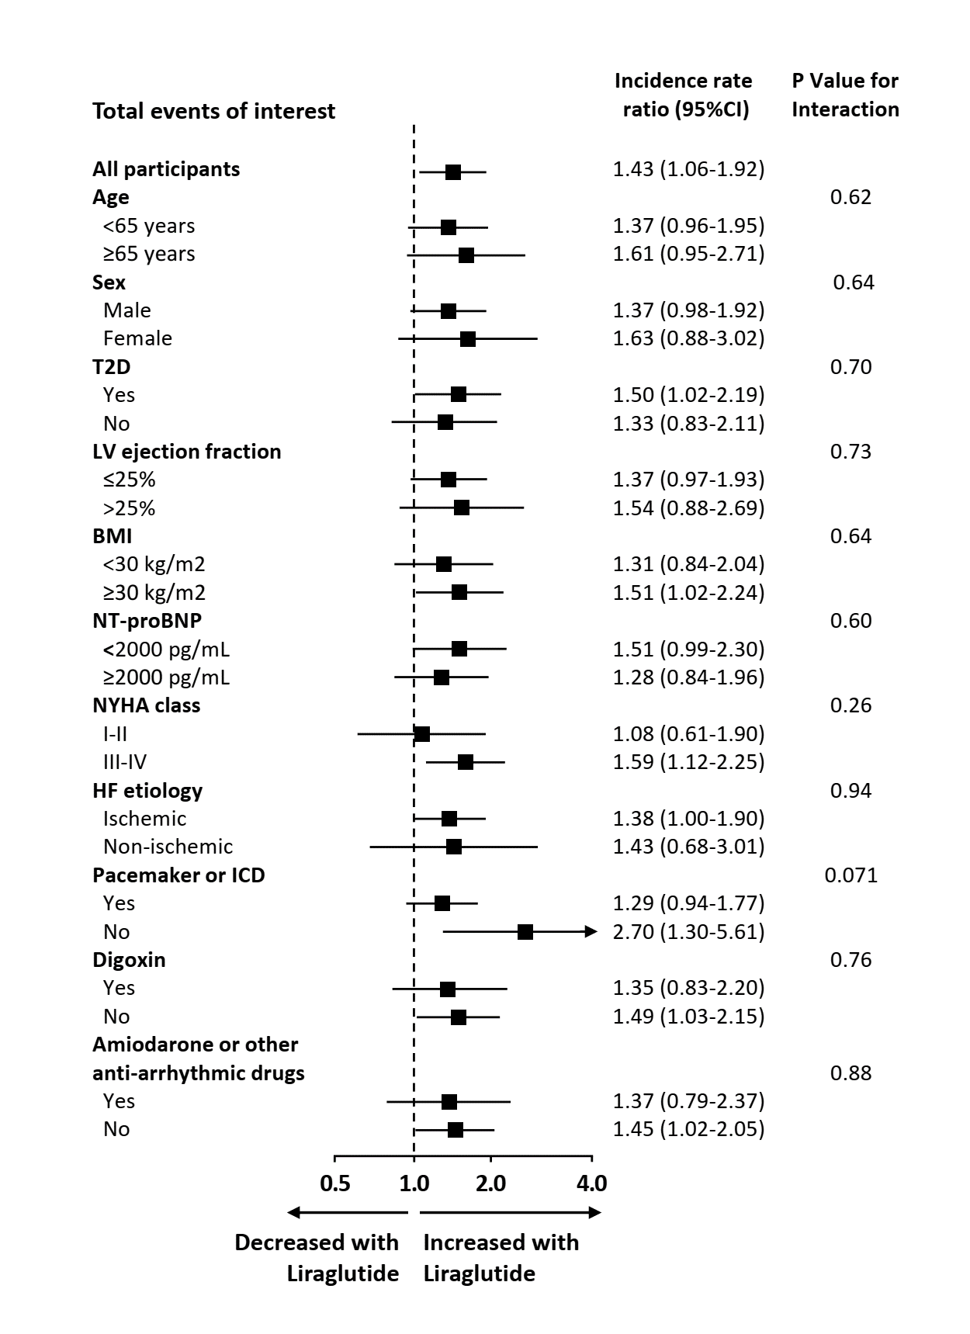
Supplemental Figure 2. Subgroup analyses for the total events of interest - predefined by the study investigators as any of the following: arrhythmias, sudden cardiac death, acute coronary syndrome, worsening heart failure, cerebrovascular event, venous thromboembolism, lightheadedness, presyncope or syncope, or worsening renal function. HF, heart failure; CI, confidence interval; T2D, type 2 diabetes; LV, left ventricle; BMI, body mass index; NYHA New York Heart Association; ICD, implantable cardioverter-defibrillator.

 | Original analysis (time-to-first-event analysis)  Cox regression |  |  |  | Post-hoc analysis (based on totality of events)  Negative binomial regression
Outcome | Placebo  (N =146) | Liraglutide  (N =154) | Hazard ratio (95%CI) | P-value | Placebo  (N =146) | Liraglutide  (N =154) | Incidence rate ratio (95%CI) | P-value
Mean Global Rank Scoreª | 156 | 146 | - | 0.31 | - | - | - | -
HFH or death | 57 | 72 | 1.30 (0.92-1.84) | 0.14 | 96 | 143 | 1.41 (0.98-2.04) | 0.064
HFH | 50 | 63 | 1.30 (0.89-1.88) | 0.17 | 80 | 124 | 1.47 (0.98-2.20) | 0.061
Death | 16 | 19 | 1.10 (0.57-2.14) | 0.78 | 16 | 19 | 1.13 (0.58-2.19) | 0.72
HFH, ED visit or death^{b} | 72 | 89 | 1.36 (0.99-1.85) | 0.05 | - | - | - | -
HFH, urgent HF visit or death^{b} | - | - | - | - | 102 | 153 | 1.48 (1.00-2.19) | 0.056
ED visit^{b} | 28 | 39 | 1.41 (0.87-2.30) | 0.16 | - | - | - | -
Urgent HF visits^{b} | - | - | - | - | 6 | 10 | 1.58 (0.52-4.81) | 0.42
Arrhythmic events^{c} | 16 | 26 | - | - | 21 | 39 | 1.76 (0.92-3.37) | 0.088
Events of interest^{d} | 82 | 97 | - | - | 196 | 295 | 1.43 (1.06-1.92) | 0.018

Supplemental Table 1. Comparison of the results of the original analysis (based on time-to-event analysis) and this post-hoc analysis (based on totality of events). ED, emergency department; HF, heart failure; HHF, heart failure hospitalizations. a. Ranked across 3 hierarchical tiers: time to death, time to rehospitalization for heart failure, and time-averaged proportional change in N-terminal pro-B-type natriuretic peptide level from baseline to 180 days. Higher values indicate better health (range, 1 [an early death] to 300 [a patient who survived free from rehospitalization and had an improvement in N-terminal pro-B-type natriuretic peptide level]). Analysis of the global rank end point was based on the Wilcoxon test statistic. b. In the original analysis all ED visits were included, while in the current post-hoc analysis only urgent HF visits requiring intravenous diuretic treatment were counted. c. Investigator-reported; hazard ratio and p-value were not calculated in the original analysis. d. Events of interest, predefined by the study investigators as any of the following: arrhythmias, sudden cardiac death, acute coronary syndrome, worsening heart failure, cerebrovascular event, venous thromboembolism, lightheadedness, presyncope or syncope, or worsening renal function; hazard ratio and p-value were not calculated in the original analysis.

