Supplemental Material

Supplemental Table 1. Patient’s characteristics by heart failure history status and randomized treatment
Characteristic | HF |  | No HF
 | Placebo | Albiglutide | Placebo | Albiglutide
N. | 968 | 954 | 3764 | 3776
Age, years | 65.0 (58.0, 70.0) | 65.0 (59.0, 71.0) | 65.0 (58.0, 70.0) | 64.0 (58.0, 70.0)
Women | 352 (36.4%) | 319 (33.4%) | 1115 (29.6%) | 1108 (29.3%)
NYHA I/II | 820 (86.3%) | 815 (87.4%) | 0 (0.0%) | 0 (0.0%)
Asian | 42 (4.3%) | 46 (4.8%) | 200 (5.3%) | 182 (4.8%)
Hispanic | 93 (9.6%) | 78 (8.2%) | 895 (23.8%) | 927 (24.5%)
Black or African American | 21 (2.2%) | 14 (1.5%) | 93 (2.5%) | 97 (2.6%)
White | 798 (82.4%) | 805 (84.4%) | 2490 (66.2%) | 2489 (65.9%)
Other | 14 (1.4%) | 11 (1.2%) | 86 (2.3%) | 81 (2.1%)
Asia Pacific | 33 (3.4%) | 41 (4.3%) | 158 (4.2%) | 144 (3.8%)
Eastern Europe | 464 (47.9%) | 466 (48.8%) | 546 (14.5%) | 571 (15.1%)
Latin America | 62 (6.4%) | 49 (5.1%) | 783 (20.8%) | 809 (21.4%)
North America | 152 (15.7%) | 131 (13.7%) | 826 (21.9%) | 835 (22.1%)
Western Europe | 257 (26.5%) | 267 (28.0%) | 1451 (38.5%) | 1417 (37.5%)
Current Smoker | 125 (12.9%) | 133 (13.9%) | 626 (16.6%) | 604 (16.0%)
CAD | 790 (81.6%) | 774 (81.1%) | 2555 (67.9%) | 2558 (67.7%)
CABG | 208 (21.5%) | 225 (23.6%) | 634 (16.8%) | 665 (17.6%)
PAD | 192 (19.8%) | 203 (21.3%) | 967 (25.7%) | 992 (26.3%)
Cerebrovascular disease | 250 (25.8%) | 249 (26.1%) | 921 (24.5%) | 922 (24.4%)
Atrial fibrillation/flutter | 188 (19.4%) | 186 (19.5%) | 233 (6.2%) | 235 (6.2%)
Weight, kg | 92.3 (80.9, 105.6) | 93.9 (81.9, 109.0) | 89.9 (78.2, 103.0) | 89.5 (78.0, 102.2)
BMI, Kg/m² | 32.4 (29.0, 36.7) | 32.7 (29.1, 37.1) | 31.2 (28.0, 35.2) | 31.2 (28.0, 35.1)
Heart rate, bpm | 72.0 (65.0, 78.0) | 72.0 (66.0, 79.0) | 72.0 (65.0, 79.0) | 72.0 (65.0, 79.0)
Systolic BP. mmHg | 134.0 (122.0, 143.0) | 134.0 (123.0, 144.0) | 135.0 (124.0, 145.0) | 134.0 (124.0, 145.0)
Diastolic BP, mmHg | 78.0 (70.0, 85.0) | 79.0 (70.0, 85.0) | 78.0 (70.0, 83.0) | 77.0 (70.0, 83.0)
HbA1c, % | 8.4 (7.7, 9.5) | 8.5 (7.7, 9.6) | 8.3 (7.6, 9.4) | 8.3 (7.6, 9.5)
eGFR, ml/min/1.73m² | 72.0 (57.0, 88.0) | 71.0 (55.0, 89.0) | 79.0 (62.0, 95.0) | 78.0 (63.0, 95.0)
eGFR <60 ml/min/1.73m² | 286 (29.5%) | 307 (32.2%) | 806 (21.4%) | 758 (20.1%)
Diabetic eye disease | 300 (31.0%) | 315 (33.0%) | 655 (17.4%) | 667 (17.7%)
Diabetes duration, years | 12.2 (6.9, 18.1) | 12.6 (7.4, 18.7) | 13.1 (7.8, 19.7) | 13.0 (7.9, 19.3)
Insulin | 565 (58.4%) | 611 (64.0%) | 2172 (57.7%) | 2248 (59.5%)
Metformin | 658 (68.0%) | 651 (68.2%) | 2848 (75.7%) | 2811 (74.4%)
DPP4i | 115 (11.9%) | 116 (12.2%) | 624 (16.6%) | 582 (15.4%)
Sulfonylureas | 325 (33.6%) | 283 (29.7%) | 1054 (28.0%) | 1063 (28.2%)
SGLT2i | 37 (3.8%) | 50 (5.2%) | 228 (6.1%) | 260 (6.9%)
Thiazolidinediones | 13 (1.3%) | 7 (0.7%) | 89 (2.4%) | 85 (2.3%)
ACEi/ARBs | 830 (85.7%) | 817 (85.6%) | 2937 (78.0%) | 2940 (77.9%)
Beta-blockers | 806 (83.3%) | 766 (80.3%) | 2376 (63.1%) | 2362 (62.6%)
MRAs | 188 (19.4%) | 206 (21.6%) | 207 (5.5%) | 207 (5.5%)
CCBs | 308 (31.8%) | 316 (33.1%) | 1123 (29.8%) | 1112 (29.4%)
Nitrates | 222 (22.9%) | 195 (20.4%) | 568 (15.1%) | 570 (15.1%)
Thiazides | 200 (20.7%) | 225 (23.6%) | 837 (22.2%) | 864 (22.9%)
Loop diuretics | 378 (39.0%) | 350 (36.7%) | 521 (13.8%) | 545 (14.4%)
Statins | 851 (87.9%) | 841 (88.2%) | 3137 (83.3%) | 3126 (82.8%)
Fibrates | 62 (6.4%) | 62 (6.5%) | 283 (7.5%) | 308 (8.2%)
Ezetimibe | 36 (3.7%) | 42 (4.4%) | 255 (6.8%) | 283 (7.5%)
Antiplatelet agents | 768 (79.3%) | 753 (78.9%) | 2871 (76.3%) | 2898 (76.7%)
Anticoagulants | 147 (15.2%) | 144 (15.1%) | 267 (7.1%) | 239 (6.3%)
Legend: CAD, coronary artery disease; CABG, coronary artery bypass grafting; PAD, peripheral artery disease; BMI, body mass index; HbA1c, glycated hemoglobin; eGFR, estimated glomerular filtration rate; DPP4i, dipeptidyl peptidase 4 inhibitors; SGLT2i, sodium glucose co-transporter 2 inhibitors; ACEi/ARBs, angiotensin converting enzyme inhibitors/angiotensin receptor blockers; MRAs, mineralocorticoid receptor antagonists; CCBs, calcium channel blockers.
Continuous variables are reported as medians and respective 25th to 75th percentiles.

Supplemental Table 2. Associations of NYHA class with cardiovascular events and mortality
Event | NYHA III/IV  n. (%)  IR 100py | NYHA I/II  n. (%)  IR 100py | No HF  n. (%)  IR 100py | HR (95%CI) *  P-value  NYHA I/II vs. No HF | HR (95%CI) *  P-value  NYHA III/IV vs. No HF
Cardiovascular death or HF hospitalization | 46/248 (18.5)  IR=12.7 | 123/1635 (7.5)  IR=4.7 | 227/7540 (3.0)  IR=1.9 | 2.16 (1.72-2.70)  P <0.001 | 5.08 (3.65-7.06)  P <0.001
Cardiovascular death, MI, or stroke | 51/248 (20.6)  IR =14.4 | 184/1635 (11.3)  IR=7.2 | 512/7540 (6.8)  IR =4.4 | 1.46 (1.23-1.74)  P <0.001 | 2.67 (1.98-3.60)  P <0.001
All-cause mortality | 33/248 (13.3)  IR=8.5 | 103/1635 (6.3)  IR=3.8 | 260/7540 (3.4)  IR =2.2 | 1.65 (1.31-2.09)  P <0.001 | 3.63 (2.49-5.29)  P <0.001
*Hazard ratio adjusted for age, sex, race, coronary artery disease, body mass index, systolic blood pressure, HbA1c, and eGFR.
Legend: IR, incidence-rate per 100 person-years; HF, heart failure; MI, myocardial infarction.

Supplemental Table 3. Effect of albiglutide vs. placebo on the study outcomes by HF history among patients who received at least one dose of the study drug
Outcome/HF history status | Albiglutide  n. (%) | Placebo  n. (%) | HR (95%CI) | Inter.P
Cardiovascular death or HF hospitalization
No HF | 97/3764 (2.6) | 130/3749 (3.5) | 0.73 (0.56-0.95) | 0.063
HF | 91/952 (9.6) | 88/966 (9.1) | 1.06 (0.79-1.42)
Cardiovascular death
No HF | 74/3764 (2.0) | 82/3749 (2.2) | 0.89 (0.65-1.21) | 0.54
HF | 48/952 (5.0) | 48/966 (5.0) | 1.04 (0.70-1.55)
HF hospitalization (first)
No HF | 29/3764 (0.8) | 58/3749 (1.5) | 0.49 (0.31-0.77) | 0.025
HF | 50/952 (5.3) | 53/966 (5.5) | 0.96 (0.66-1.42)
Cardiovascular death, MI, or stroke
No HF | 234/3764 (6.2) | 277/3749 (7.4) | 0.83 (0.69-0.98) | 0.29
HF | 101/952 (10.6) | 145/966 (15.0) | 0.70 (0.54-0.90)
All-cause mortality
No HF | 123/3764 (3.3) | 135/3749 (3.6) | 0.90 (0.70-1.14) | 0.43
HF | 71/952 (7.5) | 70/966 (7.2) | 1.06 (0.76-1.47)
Legend: HF, heart failure; MI, myocardial infarction.

Supplemental Figure 1. Kaplan-Meier curves for the composite outcomes of cardiovascular death or heart failure hospitalization and cardiovascular death, myocardial infarction, or stroke
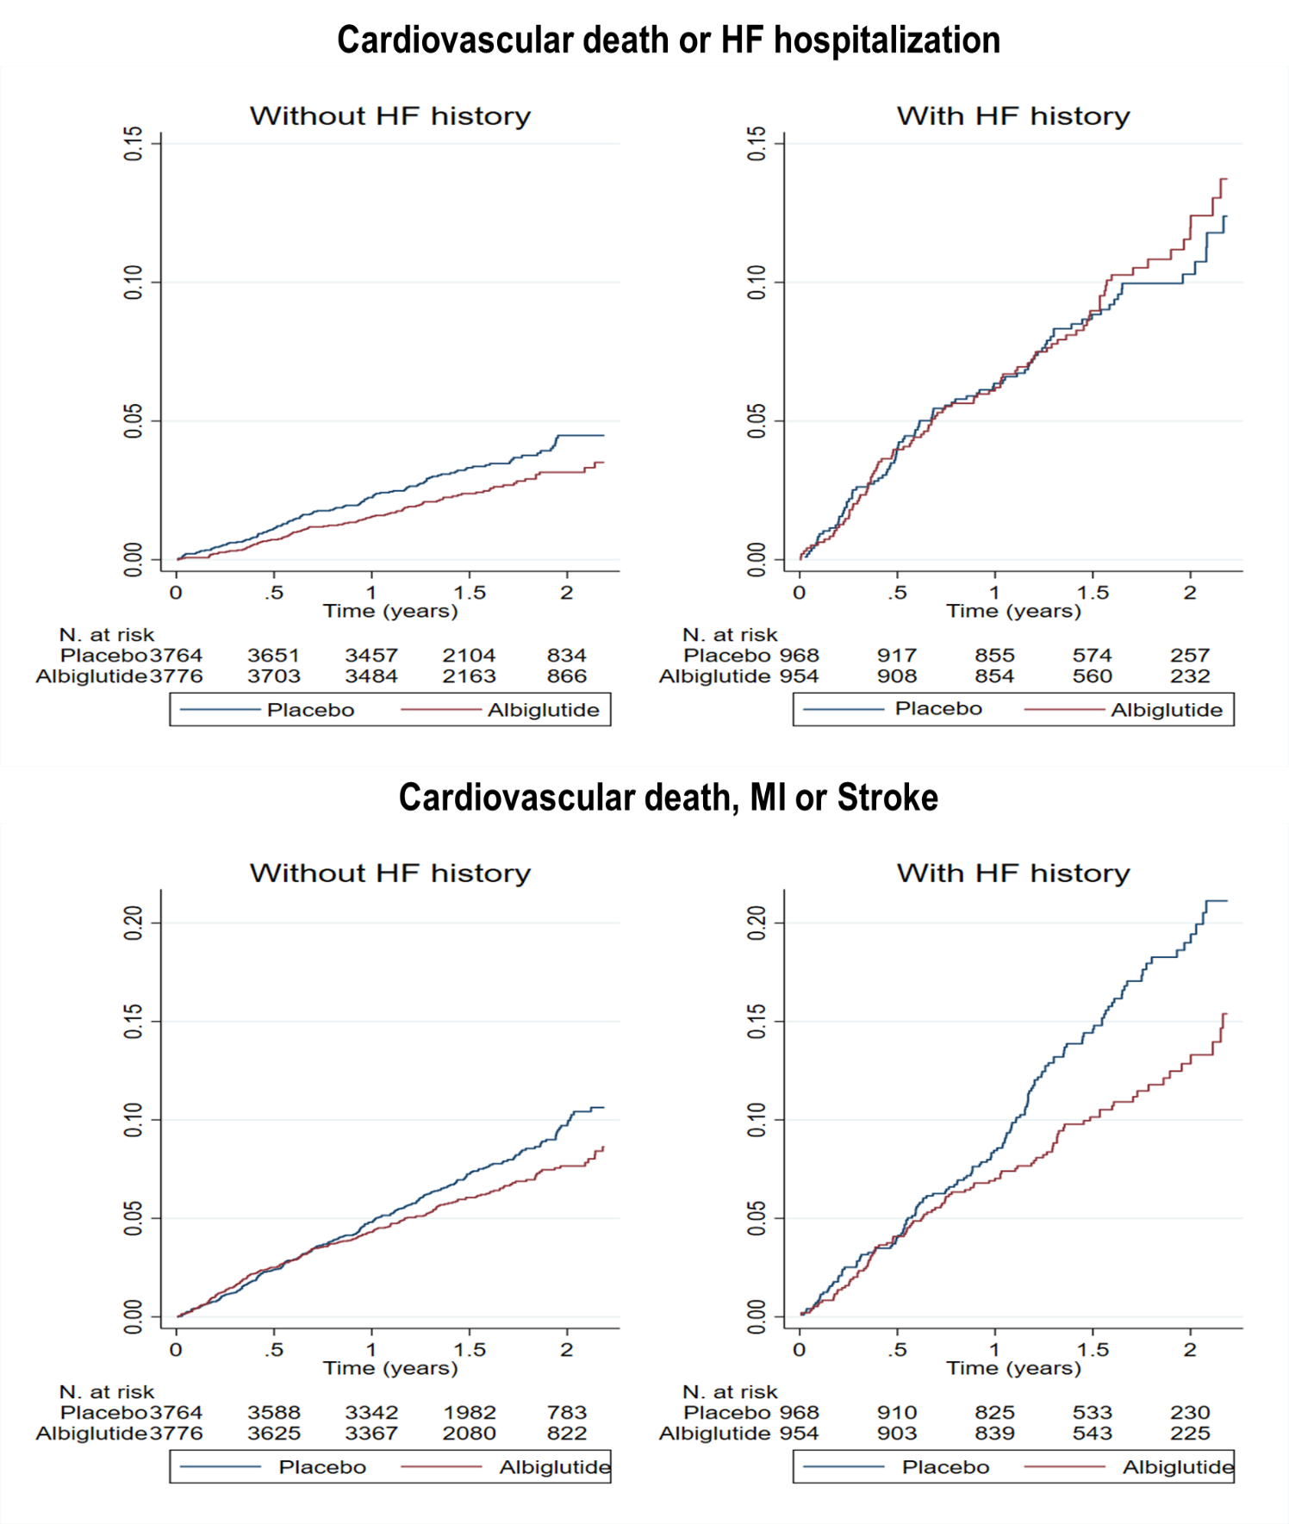
Legend: HF, heart failure; MI, myocardial infarction.

