Supplemental Table 1: Baseline Characteristics Based on First Adjudication Committee Confirmed HHF
 | Adjudicated HHF  N=588 |  | No adjudicated HHF  N=3142
Age, years | 67.0±11.2 |  | 66.8±11.0
Female sex | 126 (21.4) |  | 767 (24.4)
Race
White | 382 (65.0) |  | 2247 (71.5)
Black/African American | 59 (10.0) |  | 198 (6.3)
Asian | 122 (20.7) |  | 550 (17.5)
Other including mixed races | 10 (1.7) |  | 104 (3.3)
Missing | 15 (2.6) |  | 43 (1.4)
Region
North America | 97 (16.5) |  | 328 (10.4)
Latin America | 168 (28.6) |  | 1118 (35.6)
Europe | 201 (34.2) |  | 1152 (36.7)
Asia | 105 (17.9) |  | 388 (12.3)
Other | 17 (2.9) |  | 156 (5.0)
NYHA class
II | 372 (63.3) |  | 2428 (77.3)
III | 210 (35.7) |  | 700 (22.3)
IV | 6 (1.0) |  | 14 (0.4)
Body mass index, kg/m² | 28.2±5.7 |  | 27.8±5.3
Heart rate, beats/min | 73.6±11.8 |  | 70.8±11.7
Systolic blood pressure, mmHg | 118.8±15.4 |  | 122.6±15.6
Diastolic blood pressure, mmHg | 73.2±10.7 |  | 74.0±10.8
NT-proBNP, pg/mL, median, (IQR) | 3090.5  (1709.0 – 5853.0) |  | 1762.0  (1039.0 – 3095.0)
Cause of heart failure
Ischemic |  | 302 ( 51.4) | 1627 (51.8)
Medical history
DM at baseline |  | 341 (58.0) | 1515 (48.2)
Atrial fibrillation |  | 249 (42.3) | 1120 (35.6)
Hypertension |  | 455 (77.4) | 2243 (71.4)
History of HHF in the last 12 months |  | 251 (42.7) | 900 (28.6)
eGFR
mL/min/1.73 m² |  | 58.3±22.2 | 62.7±21.4
<60 mL/min/1.73 m² |  | 324 (55.1) | 1475 (46.9)
Device therapy
ICD or CRT-D |  | 227 (38.6) | 944 (30.0)
CRT |  | 88 (15.0) | 354 (11.3)
Heart failure medication
ACE inhibitor |  | 241 (41.0) | 1462 (46.5)
ARB |  | 151 (25.7) | 757 (24.1)
ARNi |  | 116 (19.7) | 611 (19.4)
Diuretic other than MRA |  | 554 (94.2) | 2694 (85.7)
MRA |  | 400 (68.0) | 2261 (72.0)
Beta blocker |  | 549 (93.4) | 2984 (95.0)
Data are n (%) or mean +/-SD, unless otherwise stated.
ACE, angiotensin-converting enzyme; ARB, angiotensin receptor blocker; ARNI, angiotensin receptor neprilysin inhibitor; CRT-D, cardiac resynchronization therapy defibrillator; DM, diabetes mellitus; eGFR, estimated glomerular filtration rate; HHF, hospitalization for heart failure; ICD, implantable cardioverter defibrillator; MRA, mineralocorticoid receptor antagonist; NYHA, New York Heart Association; NT-proBNP, N-terminal-prohormone brain natriuretic peptide.
Supplemental Table 2: Baseline Characteristics Based on First Adjudication Committee Confirmed HHF
 | First HHF – SCTI  N=520 | First HHF – non-SCTI  N=68
Age, years | 67.1±11.2 | 66.3±11.5
Female sex | 109 (21.0) | 17 (25.0)
Race
White | 332 (63.8) | 50 (73.5)
Black/African American | 52 (10.0) | 7 (10.3)
Asian | 113 (21.7) | 9 (13.2)
Other including mixed races | 8 (1.5) | 2 (2.9)
Missing | 15 (2.9) | 0
Region
North America | 89 (17.1) | 8 (11.8)
Latin America | 142 ( 27.3) | 26 ( 38.2)
Europe | 176 ( 33.8) | 25 ( 36.8)
Asia | 97 ( 18.7) | 8 ( 11.8)
Other | 16 ( 3.1) | 1 ( 1.5)
NYHA class
II | 330 (63.5) | 42 (61.8)
III | 185 (35.6) | 25 (36.8)
IV | 5 (1.0) | 1 (1.5)
Body mass index, kg/m² | 28.2±5.8 | 27.8±5.1
Heart rate, beats/min | 73.7±11.9 | 73.1±11.0
Systolic blood pressure, mmHg | 118.3±15.1 | 122.6±17.3
Diastolic blood pressure, mmHg | 73.0±10.6 | 74.7±11.1
NT-proBNP, pg/mL, median, (IQR) | 3264.0  (1806.5–5878.5) | 2330.0  (1470.5–4575.0)
Cause of heart failure
Ischemic | 270 (51.9) | 32 (47.1)
Medical history
DM at baseline | 302 (58.1) | 39 (57.4)
Atrial fibrillation | 225 (43.3) | 24 (35.3)
Hypertension | 402 (77.3) | 53 (77.9)
History of HHF in the last 12 months | 226 (43.5) | 25 (36.8)
eGFR
mL/min/1.73 m² | 58.3±21.9 | 58.7±24.4
<60 mL/min/1.73 m² | 290 (55.8) | 34 (50.0)
Device therapy
ICD or CRT-D | 204 (39.2) | 23 (33.8)
CRT | 81 (15.6) | 7 (10.3)
Heart failure medication
ACE inhibitor | 211 (40.6) | 30 (44.1)
ARB | 132 (25.4) | 19 (27.9)
ARNi | 109 (21.0) | 7 (10.3)
Diuretic other than MRA | 489 (94.0) | 65 (95.6)
MRA | 349 (67.1) | 51 (75.0)
Beta blocker | 482 (92.7) | 67 (98.5)
Duration of HHF stay*, median (IQR) | 9 (6–16) | 8 (5–12)
Data are n (%) or mean +/-SD, unless otherwise stated.
*Duration of HHF stay calculation is based on all HHF events and not restricted to first event.
ACE indicates angiotensin-converting enzyme; ARB, angiotensin receptor blocker; ARNI, angiotensin receptor neprilysin inhibitor; CRT-D, cardiac resynchronization therapy defibrillator; diabetes mellitus; eGFR, estimated glomerular filtration rate; HHF, hospitalization for heart failure; ICD, implantable cardioverter defibrillator; MRA, mineralocorticoid receptor antagonist; NYHA, New York Heart Association; NT-proBNP, N-terminal-prohormone brain natriuretic peptide; and SCTI, Standardized Data Collection for Cardiovascular Trials Initiative.

Supplemental Table 3: Efficacy Outcomes Based on SCTI criteria and no-SCTI criteria
Endpoint | Placebo  N=1867 |  | Empagliflozin  N=1863 |  | HR (95% CI) | p-value
 | N (%) | Inc. rate per 100pt  years (95% CI) | N (%) | Inc. rate per 100pt  years (95% CI)
Time to first HHF or CV death, incl. non-SCTI | 462 (24.7) | 21.00 (19.13, 22.96) | 361 (19.4) | 15.77 (14.19, 17.44) | 0.75 (0.65, 0.86) | <0.0001
Time to first HHF or CV death, excl. non-SCTI | 427 (22.9) | 19.08 (17.32, 20.94) | 351 (18.8) | 15.22 (13.67, 16.85) | 0.79 (0.69, 0.91) | 0.0013
First and recurrent HHF, incl. non-SCTI | 553 | - | 388 | - | 0.70 (0.58, 0.85) | 0.0003
First and recurrent HHF, excl. non-SCTI | 487 | - | 361 | - | 0.74 (0.61, 0.91) | 0.0039

CV, cardiovascular; HHF, hospitalization for heart failure; pt, patient; SCTI, Standardized Data Collection for Cardiovascular Trials Initiative.

Supplemental Table 4: Event Accumulation Based on Investigator vs. CEC assessment

Month of accrualª | Adjudicated  primary endpoint  events  N | Investigator-reported primary endpoint  events  N | Additional  events  N (%)
1 | 1 | 1 | 0 (0)
2 | 1 | 1 | 0 (0)
3 | 1 | 2 | 1 (100)
4 | 5 | 8 | 3 (60)
5 | 12 | 16 | 4 (33)
6 | 22 | 29 | 7 (32)
7 | 33 | 40 | 7 (21)
8 | 51 | 60 | 9 (18)
9 | 65 | 77 | 12 (18)
10 | 80 | 100 | 20 (25)
11 | 101 | 124 | 23 (23)
12 | 123 | 147 | 24 (20)
13 | 137 | 166 | 29 (21)
14 | 162 | 195 | 33 (20)
15 | 182 | 218 | 36 (20)
16 | 209 | 242 | 33 (16)
17 | 249 | 286 | 37 (15)
18 | 284 | 332 | 48 (17)
19 | 316 | 364 | 48 (15)
20 | 354 | 412 | 58 (16)
21 | 396 | 467 | 71 (18)
22 | 436 | 513 | 77 (18)
23 | 476 | 555 | 79 (17)
24 | 528 | 613 | 85 (16)
25 | 269 | 665 | 96 (17)
26 | 614 | 719 | 105 (17)
27 | 657 | 766 | 109 (17)
28 | 690 | 804 | 114 (17)
29 | 718 | 840 | 122 (17)
30 | 760 | 876 | 116 (15)
31 | 795 | 919 | 124 (16)
32^{b} | 815 | 945 | 130 (16)
33 | 821 | 949 | 128 (16)
34 | 822 | 950 | 128 (16)
35 | 823 | 951 | 128 (16)

ª Relative to trial start
^{b} Start of trial close-out

CEC, clinical events committee.
Supplemental Figure 1: Data Process Flow Chart for Fatal Events

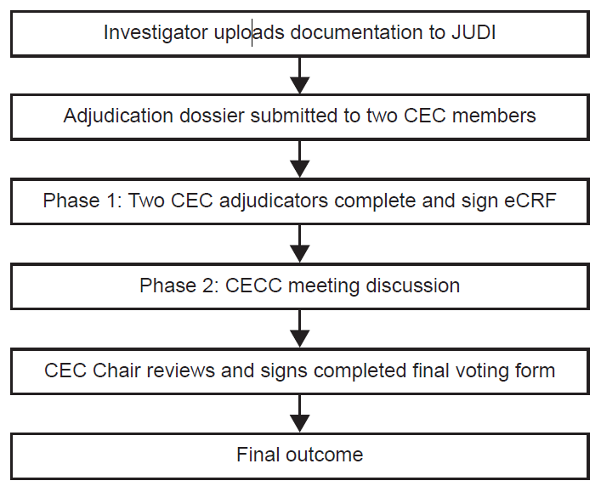

CEC, clinical events committee; CECC, clinical events committee cardiology; eCRF, electronic clinical report form; JUDI, the electronic adjudication platform used (AG Mednet).

Supplemental Figure 2: Data Process Flow Chart for Heart Failure Hospitalization

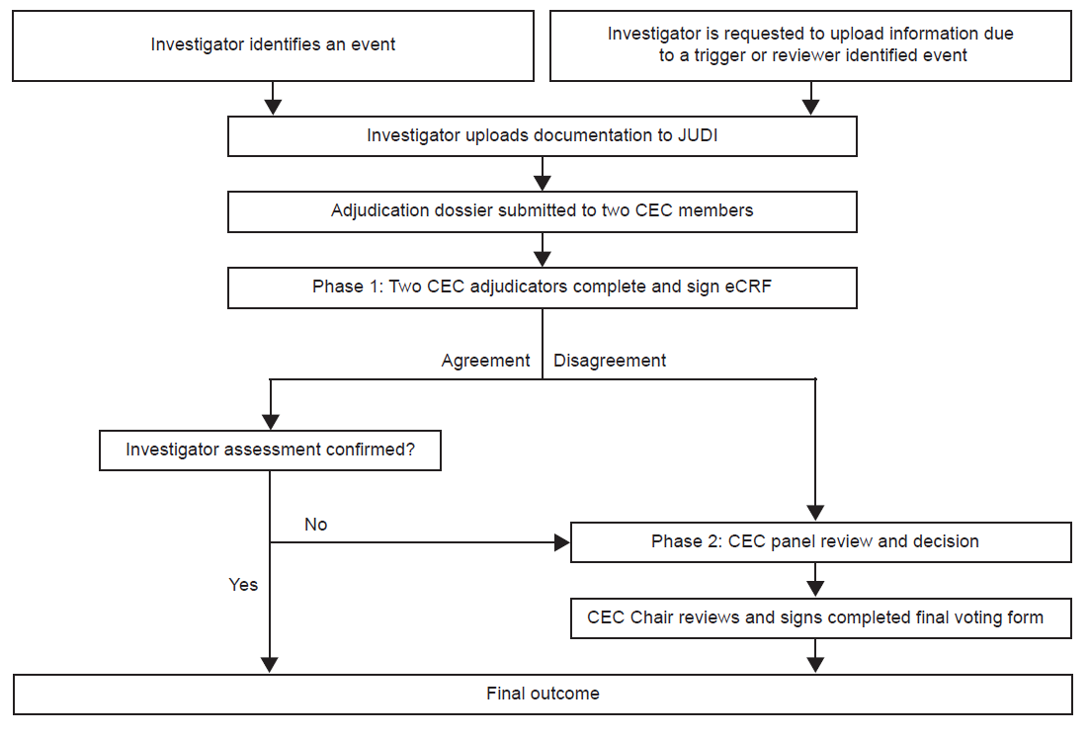

CEC, clinical events committee; CECC, clinical events committee cardiology; eCRF, electronic clinical report form; JUDI, the electronic adjudication platform used (AG Mednet).

Supplemental Methods

Adjudicated outcome event definitions: Hospitalization for heart FAilure and Cause of Death

All cardiovascular endpoint definitions were modifications based on draft recommendations for CDISC August 20, 2014 (Standardized Definitions for Cardiovascular and Stroke Endpoint Events in Clinical Trials for CDISC, Hicks KA et al August 2014) and were included in the Clinical Endpoint Committee (CEC) Charter. The CEC Charter specified that in the case of limited or missing data, the committee was to adjudicate events based on their clinical expertise and the totality of the evidence.

Hospitalization for heart failure

A Heart Failure Hospitalization should include the following criteria:
- The adjudicated primary diagnosis is admission to hospital for heart failure.
- The patient’s length-of-stay in hospital extends for at least 12 hours (or a change in calendar date if the hospital admission and discharge times are unavailable). Emergency room visit for ≥ 12 hours with intravenous therapy would be considered equivalent as admission to hospital.
- The patient exhibits documented new or worsening symptoms due to HF on presentation, including at least ONE of the following:
  - Dyspnea (dyspnea with exertion, dyspnea at rest, orthopnea, paroxysmal dyspnea)
  - Decreased exercise tolerance
  - Fatigue
  - Other symptoms of worsened end-organ perfusion such as dizziness, mental confusion or volume overload such as weight gain or lower extremity swelling.
- The patient has objective evidence of new or worsening HF, consisting of at least TWO physical examination findings OR one physical examination finding and at least ONE laboratory criterion), including:
  - Physical examination findings considered to be due to heart failure, including new or worsened:
    - Peripheral edema
    - Increasing abdominal distention or ascites (in the absence of primary hepatic disease)
    - Pulmonary rales/crackles/crepitations
    - Increased jugular venous pressure and/or hepatojugular reflux
    - S3 gallop
    - Clinically significant or rapid weight gain thought to be related to fluid retention
  - Laboratory evidence of new or worsening HF, if obtained within 24 hours of presentation, including:
  - Increased B-type natriuretic peptide (BNP)/ N-terminal pro-BNP (NT proBNP) concentrations consistent with decompensation of heart failure. In patients with chronically elevated natriuretic peptides, a significant increase should be noted above baseline.
  - Radiological evidence of pulmonary congestion
  - Non-invasive diagnostic evidence of clinically significant elevated left- or right-sided ventricular filling pressure or low cardiac output. For example, echocardiographic criteria could include: E/e’ > 15 or D-dominant pulmonary venous inflow pattern, plethoric inferior vena cava with minimal collapse on inspiration, or decreased left ventricular outflow tract (LVOT) minute stroke distance (time velocity integral (TVI)) OR
  - Invasive diagnostic evidence with right heart catheterization showing a pulmonary capillary wedge pressure (pulmonary artery occlusion pressure) ≥ 18 mmHg, central venous pressure ≥ 12 mmHg, or a cardiac index < 2.2 L/min/m2
5) The patient receives initiation or intensification of treatment specifically for HF,
including at least ONE of the following:
a. Augmentation in oral diuretic therapy. NOTE: If the intensification is solely oral diuretics, the duration of hospitalization must be at least 24 hours.
b. Intravenous diuretic or vasoactive agent (e.g., inotrope, vasopressor, or vasodilator)
c. Mechanical or surgical intervention, including:
i. Mechanical circulatory support (e.g., intra-aortic balloon pump, ventricular assist device, extracorporeal membrane oxygenation, total artificial heart)
ii. Mechanical fluid removal (e.g., ultrafiltration, hemofiltration, dialysis).

An endpoint heart failure hospitalization requires admission to the hospital for heart failure,
worsening of symptoms of heart failure, a duration of hospitalization of at least 12 hours, the
intensification of heart failure therapy, and a committee consensus that the hospitalization was
primarily due to worsening heart failure. Changes in physical signs or laboratory tests,
whenever available and documented, will be considered to be supportive.

Cause of death

Cause of death was adjudicated, as either Cardiovascular death or Non-Cardiovascular death. Cause of death was further categorized when possible.

Cardiovascular death includes the following categories:
1. Death due to Acute Myocardial Infarction: refers to a death by any cardiovascular mechanism (e.g., arrhythmia, sudden death, heart failure, stroke, pulmonary embolus,
peripheral arterial disease) ≤ 30 days after a MI related to the immediate consequences of the MI, such as progressive heart failure or recalcitrant arrhythmia. We note that there may be assessable mechanisms of cardiovascular death during this time period, but for simplicity, if the cardiovascular death occurs ≤ 30 days of the myocardial infarction, it will be considered a death due to myocardial infarction. Acute MI should be verified to the extent possible by the diagnostic criteria outlined for acute MI or by autopsy findings showing recent MI or recent coronary thrombosis.

Death resulting from a procedure to treat a MI (percutaneous coronary intervention (PCI),
coronary artery bypass graft surgery (CABG)), or to treat a complication resulting from MI, should also be considered death due to acute MI.

Death resulting from an elective coronary procedure to treat myocardial ischemia (i.e.
chronic stable angina) or death due to a MI that occurs as a direct consequence of a CV
investigation/procedure/operation should be considered as a death due to a CV procedure.

2. Sudden Cardiac Death refers to a death that occurs unexpectedly, not following an acute
MI, and includes the following deaths:
a. Death witnessed and occurring without new or worsening symptoms
b. Death witnessed within 60 minutes of the onset of new or worsening cardiac symptoms, unless the symptoms suggest acute MI
c. Death witnessed and attributed to an identified arrhythmia (e.g., captured on an
electrocardiographic (ECG) recording, witnessed on a monitor, or unwitnessed but
found on implantable cardioverter-defibrillator review)
d. Death after unsuccessful resuscitation from cardiac arrest (e.g., implantable
cardioverter defibrillator (ICD) unresponsive sudden cardiac death, pulseless
electrical activity arrest)
e. Death after successful resuscitation from cardiac arrest and without identification
of a specific cardiac or non-cardiac etiology
f. Unwitnessed death in a subject seen alive and clinically stable ≤ 72 hours prior to
being found dead without any evidence supporting a specific non-cardiovascular
cause of death (information regarding the patient’s clinical status preceding death
should be provided, if available)

Unless additional information suggests an alternate specific cause of death (e.g., Death
due to Other Cardiovascular Causes), if a patient is noted to be alive ≤ 72 hours of being
found dead, sudden cardiac death (criterion 2f) should be recorded. For patients who were
not observed alive within 72 hours of death, undetermined cause of death should be
recorded (e.g., a subject found dead in bed, but who had not been seen by family for
several days).

3. Death due to Heart Failure refers to a death in association with clinically worsening
symptoms and/or signs of heart failure regardless of HF etiology. Deaths due to heart failure can have various etiologies, including single or recurrent myocardial infarctions, ischemic or non-ischemic cardiomyopathy, hypertension, or valvular disease.

New or worsening signs and/or symptoms of congestive heart failure (CHF) may include any of the following:
• New or increasing symptoms and/or signs of heart failure requiring the initiation of, or
an increase in, treatment directed at heart failure or occurring in a patient already receiving maximal therapy for heart failure
• Heart failure symptoms or signs requiring continuous intravenous therapy or oxygen
administration
• Confinement to bed predominantly due to heart failure symptoms
• Pulmonary edema sufficient to cause tachypnea and distress not occurring in the context of an acute myocardial infarction or as the consequence of a primary event
• Cardiogenic shock, manifest as clinical signs and symptoms of hypoperfusion felt to
be secondary to cardiac dysfunction, and not occurring in the context of an acute myocardial infarction or as the consequence of a primary arrhythmic event
• Patients who are hospitalized and are being actively treated for heart failure and who
have a sudden death as the terminal event will be classified as having a heart failure related death.

4. Death due to Stroke refers to death after a stroke that is either a direct consequence of
the stroke or a complication of the stroke. Acute stroke should be verified to the extent
possible by the diagnostic criteria outlined for stroke.

5. Death due to Cardiovascular Procedures refers to death caused by the immediate complications of a cardiac procedure.

6. Death due to Cardiovascular Hemorrhage refers to death related to hemorrhage such
as a non-stroke intracranial hemorrhage, non-procedural or non-traumatic vascular
rupture (e.g., aortic aneurysm), or hemorrhage causing cardiac tamponade.

7. Death due to Other Cardiovascular Causes refers to a CV death not included in the above categories but with a specific, known cause (e.g., pulmonary embolism or peripheral arterial disease).

Non-cardiovascular death is defined as any death with a specific cause that is not thought to
be cardiovascular in nature.

The following is a suggested list of non-CV causes of death:
• Pulmonary
• Renal
• Gastrointestinal
• Hepatobiliary
• Pancreatic
• Infection (includes sepsis)
• Inflammatory (e.g., Systemic Inflammatory Response Syndrome (SIRS) / Immune (including autoimmune) (may include anaphylaxis from environmental (e.g., food allergies)
• Hemorrhage that is neither cardiovascular bleeding or a stroke
• Non-CV procedure or surgery
• Trauma
• Suicide
• Non-prescription drug reaction or overdose
• Prescription drug reaction or overdose (may include anaphylaxis)
• Neurological (non-cardiovascular)
• Malignancy
• Other non-CV causes

Undetermined Cause of Death refers to a death not attributable to one of the above
categories of CV death or to a non-CV cause.

Occasionally, it may not be possible to determine exact causality when 2 lethal conditions
contribute to death equally. In this circumstance all events not due solely to non-CV causes
should be adjudicated as CV-related.

All events for which there is “lack of information” (e.g., the only available information is
“patient died”) or when there is insufficient supporting information or detail to assign the
cause of death should be adjudicated as undetermined cause of death.

