Supplementary Appendix

Figure S1: Effect of Empagliflozin on KCCQ Changes in Total Symptom Score at 52 Weeks by sub-group.
Figure S2: Effect of Empagliflozin on KCCQ Changes in Overall Summary Score at 52 weeks by sub-group.
Figure S1: Effect of Empagliflozin on KCCQ Changes in Total Symptom Score at 52 Weeks by sub-group.

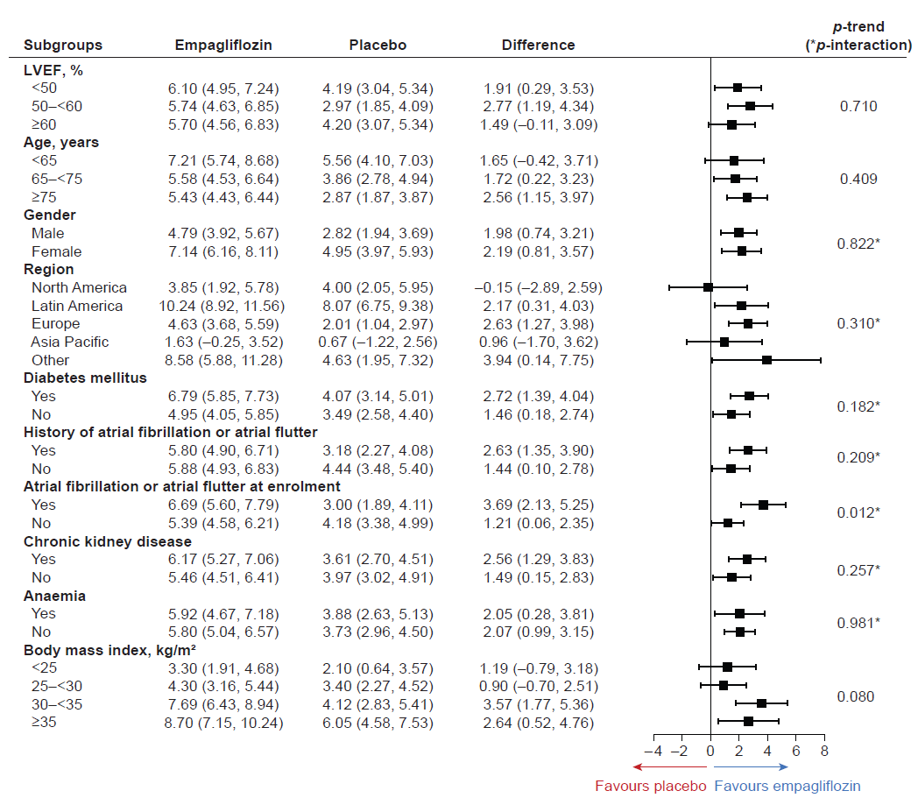
Figure S2: Effect of Empagliflozin on KCCQ Changes in Overall Summary Score at 52 weeks by sub-group.
