Supplemental Table 1. Baseline characteristics of patients with HFrEF and controls.
 | HFrEF  (N=148) | Control  (N=36) | p-value
Clinical characteristics
Age, years | 54 ± 12 | 54 ± 10 | 0.923
Male, n (%) | 127 (84) | 22 (61) | 0.004
Body mass index, kg/m² | 27.4 ± 4.5 | 28.3 ± 4.8 | 0.282
NYHA class, n (%): I-II; III-IV | 34 (23); 114 (77) | NA | NA
Ischemic HF aetiology, n (%) | 65 (44) | NA | NA
Diabetes mellitus, n (%) | 50 (33) | 3 (8) | 0.002
Ischemic heart disease, n (%) | 69 (46) | 4 (11) | 0.002
Haemoglobin, mg/L | 137.0 ± 18.3 | 139.1 ± 17.3 | 0.525
BNP, ng/L | 1019 [509; 1824] | 29 [9; 46] | <0.001
Echocardiography*
LV end-diastolic diameter, mm | 69.7 ± 8.5 | 46.7 ± 4.1 | <0.001
LV mass index, gr/m² | 128.5 ± 31.7 | 75.9 ± 14.2 | <0.001
LV ejection fraction, % | 22.0 ± 6.7 | 60.0 ± 5.0 | <0.001
Mitral regurgitation, n (%): 0-2 grade; 3-4 grade | 72 (48); 78 (52) | 36 (100); 0 (0) | <0.001
Tricuspid regurgitation, n (%): 0-2 grade; 3-4 grade | 98 (65); 52 (35) | 34 (97); 1 (3) | <0.001
Right ventricular basal dimensions, mm | 45.0 ± 3.4 | 36.0 ± 4.2 | <0.001
Tricuspid annular plane systolic excursion, mm | 15.2 ± 4.2 | 23.8 ± 4.8 | <0.001
Electrocardiography
Heart rate, bpm | 80 ± 16 | 68 ± 12 | <0.001
Atrial rhythm, n (%): Sinus; Paced; AFib or AFlu | 128 (85); 3 (2); 19 (13) | 36 (0); 0 (0); 0 (0) | <0.001
QRS morphology, n (%): LBBB; RBBB; normal; other alterations* | 31 (21); 13 (9); 36 (24); 68 (45) | 1 (3); 2 (5); 30 (83); 3 (8) | <0.001
QRS duration, ms | 120.4 ± 24.8 | 93.2 ± 18.3 | <0.001
Therapy
Furosemide, n (%) | 143 (97) | 4 (12) | <0.001
ACE, ARB or ARNI, n (%) | 103 (70) | 13 (36) | <0.001
MRA, n (%) | 128 (86) | 4 (11) | <0.001
Betablocker, n (%) | 124 (84) | 9 (25) | <0.001
Devices, n (%): ICD; CRT; none | 111 (75); 12 (8); 25 (17) | NA | NA
*Mitral and tricuspid regurgitation were assessed semiquantitatively and reported using a 4-stage grading (i.e., 0) none-trace; 1) mild; 2) moderate; 3) severe).
Abbreviations: ACE – Angiotensin Converting Enzyme Inhibitor; AFlu – Atrial Flutter; AFib – Atrial Fibrillation; ARB – Angiotensin Receptor Blocker; ARNI – Angiotensin Receptor Neprilysin Inhibitor; BNP – Brain Natriuretic Peptide; CRT – Cardiac Resynchronization Therapy; HFrEF – Heart Failure with Reduced Ejection Fraction; ICD – Implantable Cardioverter-Defibrillator; LBBB – Left Bundle Branch Block; MRA – Mineralocorticoid Receptor Antagonist; NA – Not Applicable; NYHA – New York Heart Association; RBBB – Right Bundle Branch Block. *Other alterations include: left anterior fascicular block, left posterior fascicular block, incomplete LBBB and nonspecific intraventricular conduction delay.

Supplemental Table 2. Imaging and hemodynamic data in patients with HFrEF and controls
 | HF patients  (N=148) | Controls  (N=36) | p-value
GSPECT
RV phase SD, % | 11.2 ± 4.9 | 7.6 ± 2.5 | <0.001
RV end-diastolic volume – mL | 256.4 ± 97.9 | 204.4 ± 61.1 | <0.001
RV end-diastolic volume index – mL/m² | 138.0 ± 47.9 | 103.1 ± 24.3 | <0.001
RV end-systolic volume – mL | 165.5 ± 82.1 | 96.5 ± 32.1 | <0.001
RV end-systolic volume index – mL/m² | 85.8 ± 41.9 | 48.1 ± 14.0 | <0.001
RV ejection fraction - % | 37.7 ± 14.9 | 53.1 ± 5.4 | <0.001
Right heart catheterization
RA mean pressure - mmHg | 9.6 ± 5.8 | 5.0 ± 2.9 | <0.001
RV systolic elastance (Ees) - mmHg/mL | 0.32 [0.23; 0.49] | 0.32 [0.23; 0.47] | 0.177
RV diastolic compliance - mL/mmHg | 0.03 [0.02; 0.05] | 0.04 [0.03; 0.06] | 0.003
Cardiac output, L/m | 3.8 ± 0.9 | 5.6 ± 1.4 | <0.001
Stroke volume, mL | 48.8 ± 14.7 | 76.9 ± 23.8 | <0.001
PA mean pressure - mmHg | 34.3 ± 10.8 | 16.3 ± 6.5 | <0.001
PA compliance - mL/mmHg | 1.8 [2.3; 2.6] | 4.8 [3.5; 6.5] | <0.001
PA elastance (Ea_{PA}) - mmHg/mL | 1.00 [0.73; 1.53] | 0.36 [0.26; 0.44] | <0.001
PA wedge pressure - mmHg | 22.8 ± 8.5 | 8.2 ± 4.2 | <0.001
PVR - WU | 2.9 [1.9; 4.2] | 1.4 [1.0; 2.1] | <0.001
RV ventricular-arterial coupling ratio | 0.29 [0.21; 0.51] | 0.92 [0.61; 1.37] | <0.001
Systolic blood pressure - mmHg | 109.4 ± 16.2 | 128.5 ± 20.9 | <0.001
Diastolic blood pressure - mmHg | 75.0 ± 10.0 | 77.1 ± 9.9 | 0.258
Abbreviations: GSPECT - Gated Single-Photon Emission Computed Tomography; HFrEF – Heart Failure with Reduced Ejection Fraction; PA – Pulmonary Artery; PVR – Pulmonary Vascular Resistance; RA – Right Atrial; RV – Right Ventricular; SD – Standard deviation; SVR – Systemic Vascular Resistance; WU - Wood Units

Supplemental Table 3 Effect of afterload reduction (sildenafil) and preload increase (leg rise) on right ventricular dyssynchrony, hemodynamics and cardiac volumes derived from SPECT
 | Baseline | Afterload reduction (N=15) | p-value | Baseline | Preload modulation  (N=135) | p-value
RV dyssynchrony, degrees | 44.9 ± 19.2 | 29.6 ± 13.9 | 0.004 | 40.5 ± 17.6 | 37.7 ± 16.4 | 0.080
Right heart catheterization
RA mean pressure, mmHg | 7.9 ± 3.5 | 4.3 ± 2.5 | <0.001 | 9.3 ± 5.7 | 11.7 ± 6.4 | <0.001
RV end-diastolic pressure, mmHg | 12.0 ± 4.3 | 6.3 ± 3.7 | <0.001 | 11.5 ± 6.1 | 14.4 ± 6.0 | <0.001
PA mean pressure, mmHg | 44.0 ± 8.6 | 31.2 ± 9.9 | <0.001 | 33.6 ± 10.4 | 38.5 ± 9.7 | <0.001
PA wedge pressure mean, mmHg | 25.3 ± 5.9 | 19.6 ± 8.7 | 0.005 | 22.3 ± 8.1 | 26.3 ± 7.8 | <0.001
PA elastance, mmHg/mL | 1.7 [1.1; 1.9] | 0.9 [0.6; 1.1] | <0.001 | 1.0 [0.7; 1.5] | 1.2 [0.8; 1.6] | <0.001
RV systolic elastance (Ees) - mmHg/mL | 0.48 [0.29; 0.79] | 0.50 [0.25; 0.90] | 0.889 | 0.31 [0.22; 0.49] | 0.31 [0.22; 0.49] | 0.489
RV ventricular-arterial coupling ratio | 0.43 [0.15; 0.54] | 0.57 [0.34; 0.90] | 0.002 | 0.29 [0.20; 0.51] | 0.28 [0.17; 0.47] | 0.001
Pulmonary vascular resistance - WU | 4.9 [4.3; 6.6] | 2.7 [1.8; 3.8] | <0.001 | 2.8 [1.8; 3.9] | 3.1 [2.1; 4.4] | 0.031
Cardiac output, L/min | 3.7 ± 0.8 | 4.4 ± 0.8 | 0.003 | 3.8 ± 0.9 | 3.7 ± 0.9 | 0.411
SPECT-derived data
RV end-diastolic volume, mL | 256.1 ± 77.7 | 214.3 ± 75.4 | 0.002 | 278.2 ± 98.4 | 289.8 ± 94.1 | 0.001
RV end-systolic volume, mL | 152.7 ± 75.5 | 107.1 ± 66.1 | <0.001 | 173.1 ± 86.9 | 178.9 ± 84.0 | 0.023
RV ejection fraction, % | 43.1 ± 12.6 | 54.1 ± 14.1 | <0.001 | 40.8 ± 14.9 | 41.0 ± 14.0 | 0.867
Abbreviations: PA – Pulmonary Artery; PVR – Pulmonary Vascular Resistance; RA – Right Atrial; RV – Right Ventricular; WU - Wood Units.

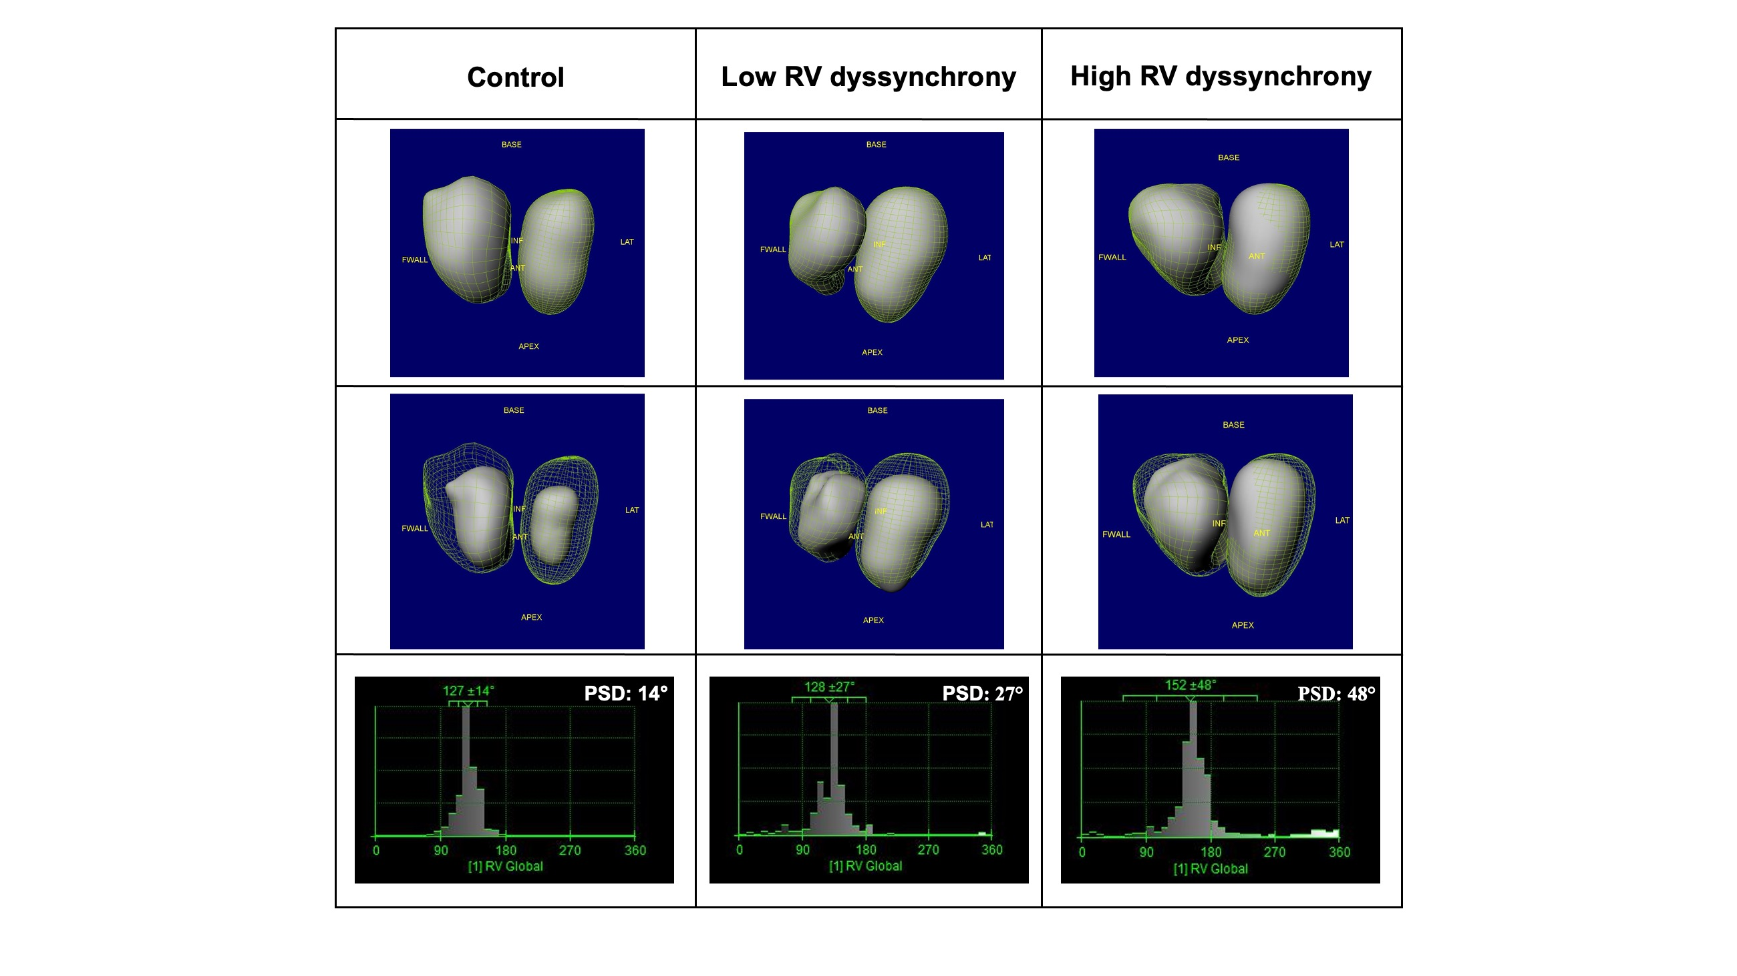
Supplemental Figure 1

Supplemental Figure 2
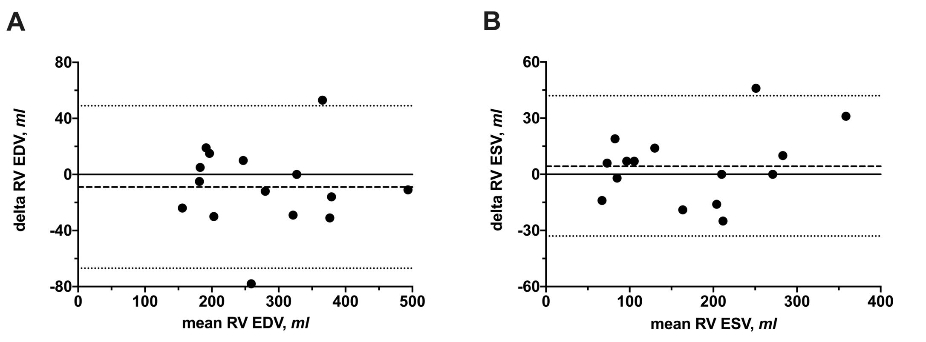

Supplemental Figure 3
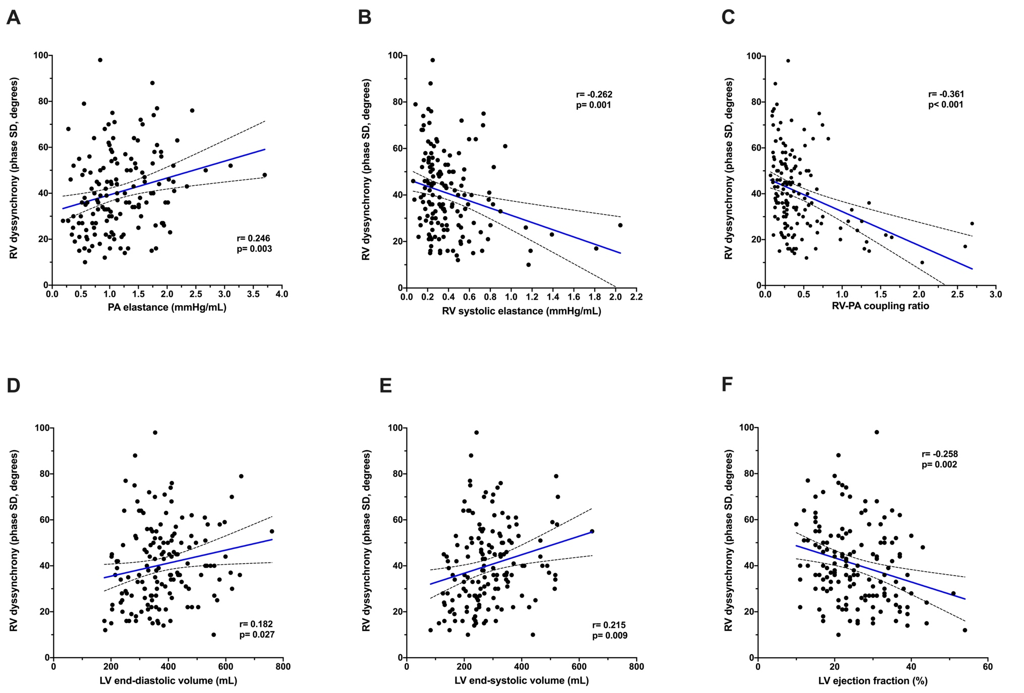
Supplemental Figure 4
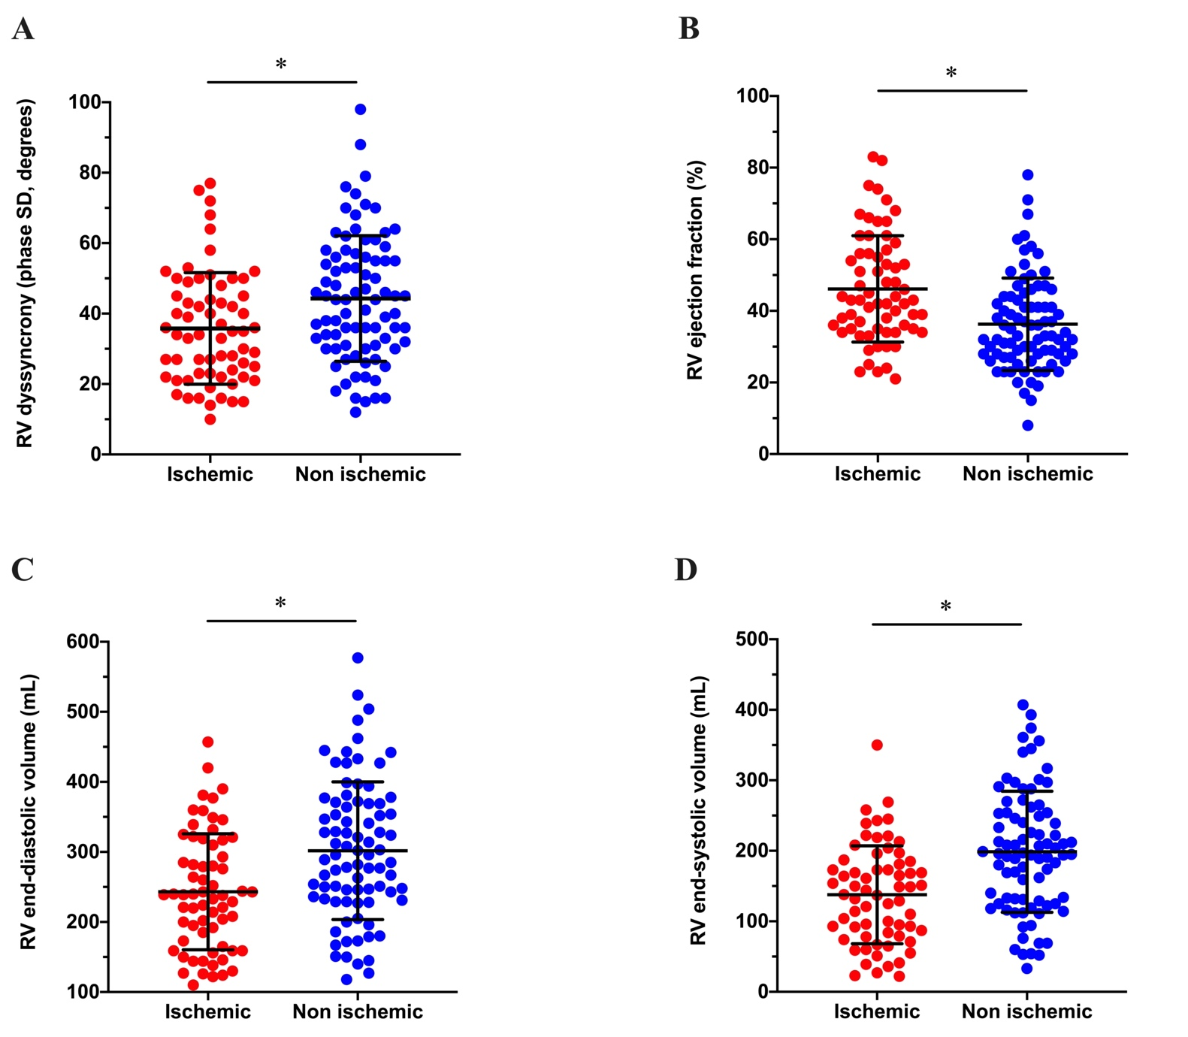
Supplemental Figure 5
