**Supplementary Material**

Extraction processes of high added value molecules from wood waste: overview and comparison of processes for an eco-friendly recovery from paper industry by-product

Renan RAVETTI DURAN, Laurence MUHR, Danielle BARTH*

Université de Lorraine, CNRS, LRGP, F-54000 Nancy, France

**HPLC-PDA Standards**

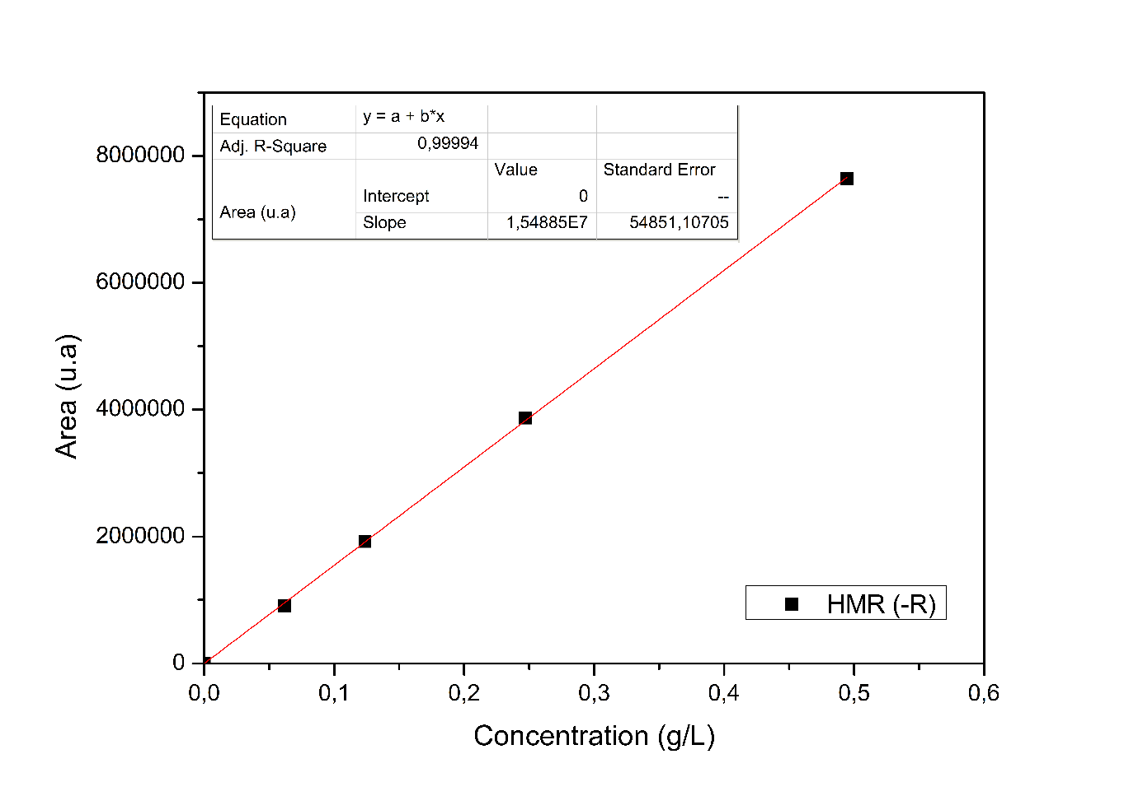

Figure S1: Calibration curve **HMR (-R)**

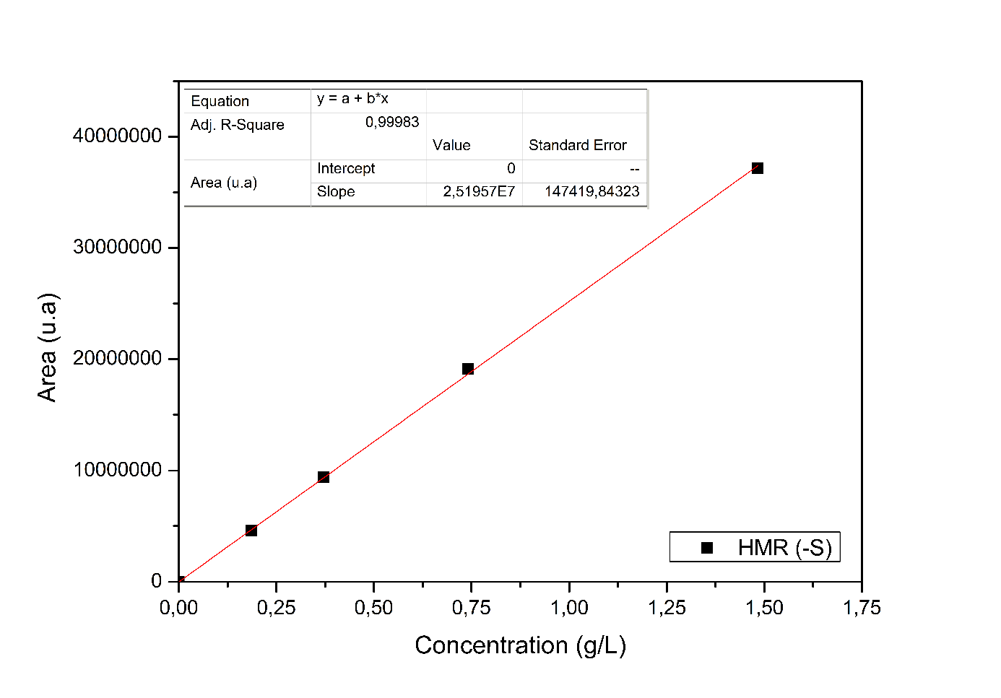

Figure S2: Calibration curve **HMR (-S)**

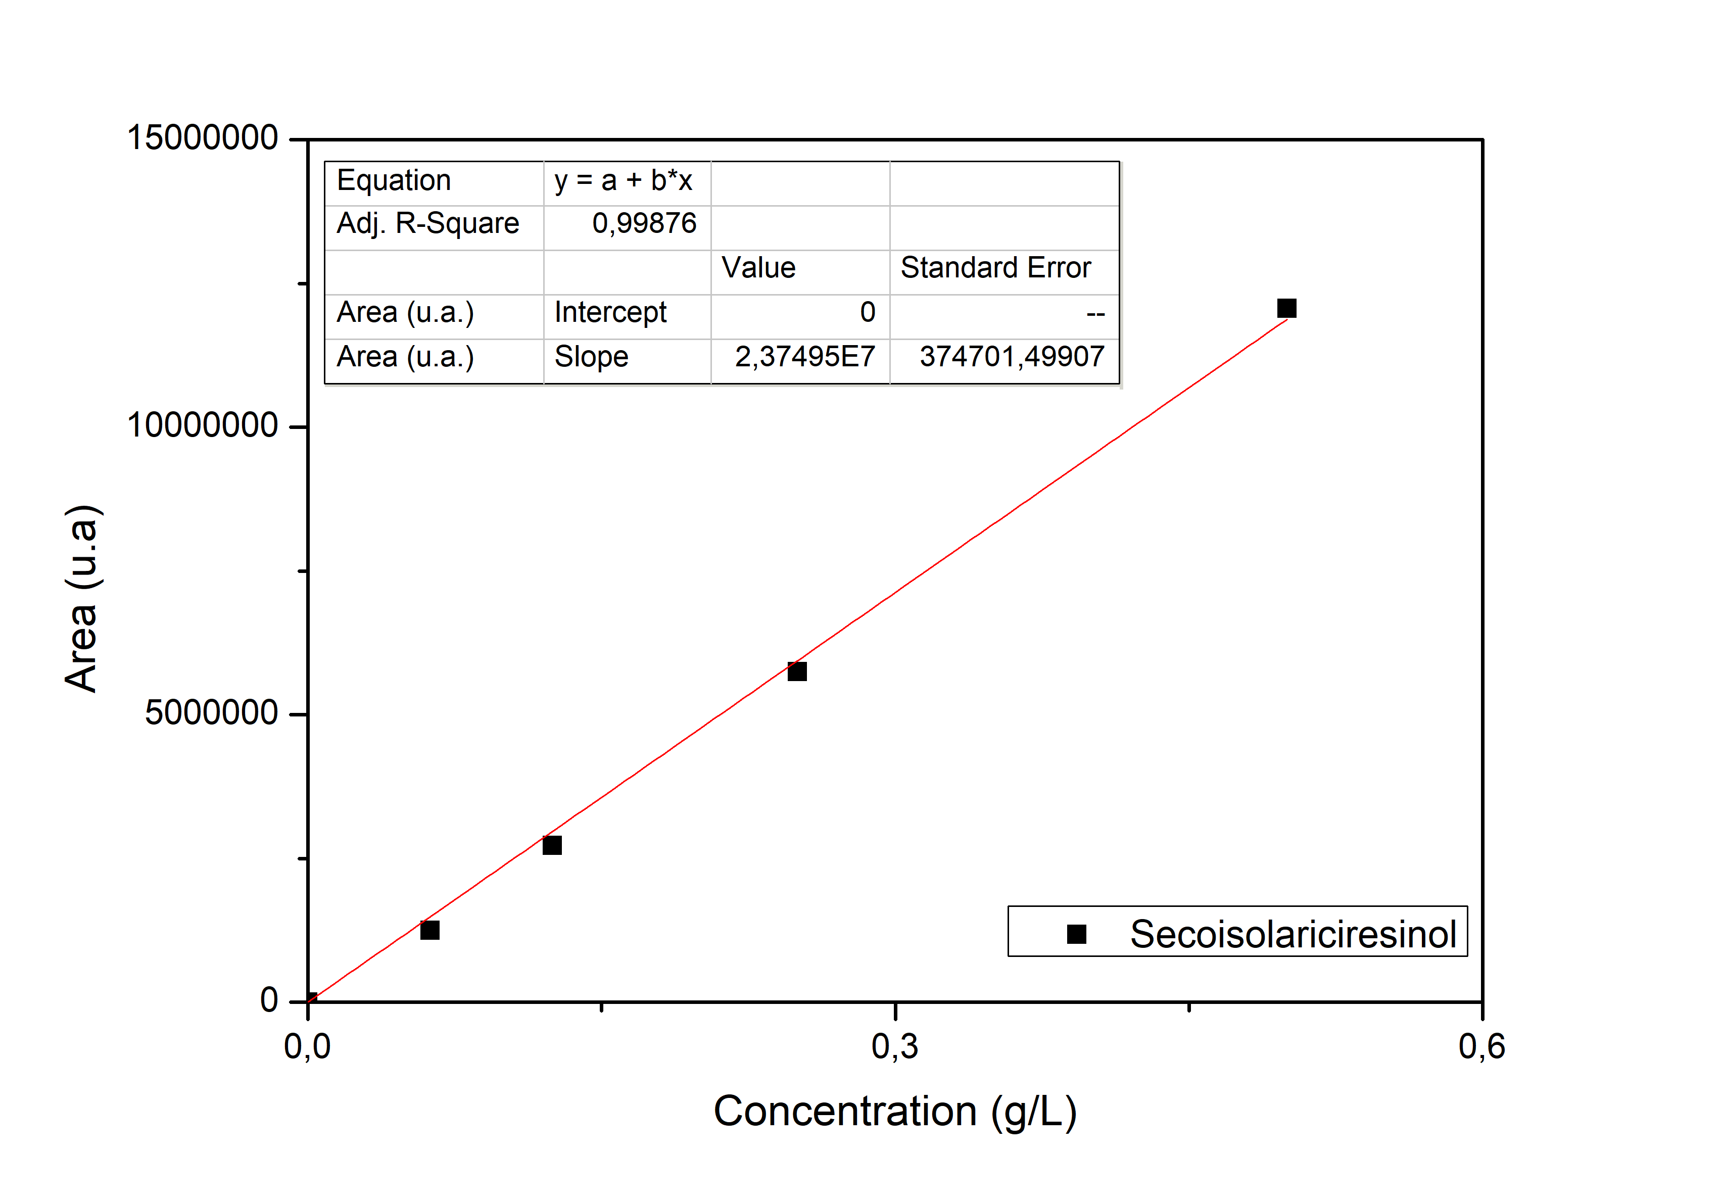

Figure S3: Calibration curve **Secoisolariciresin**

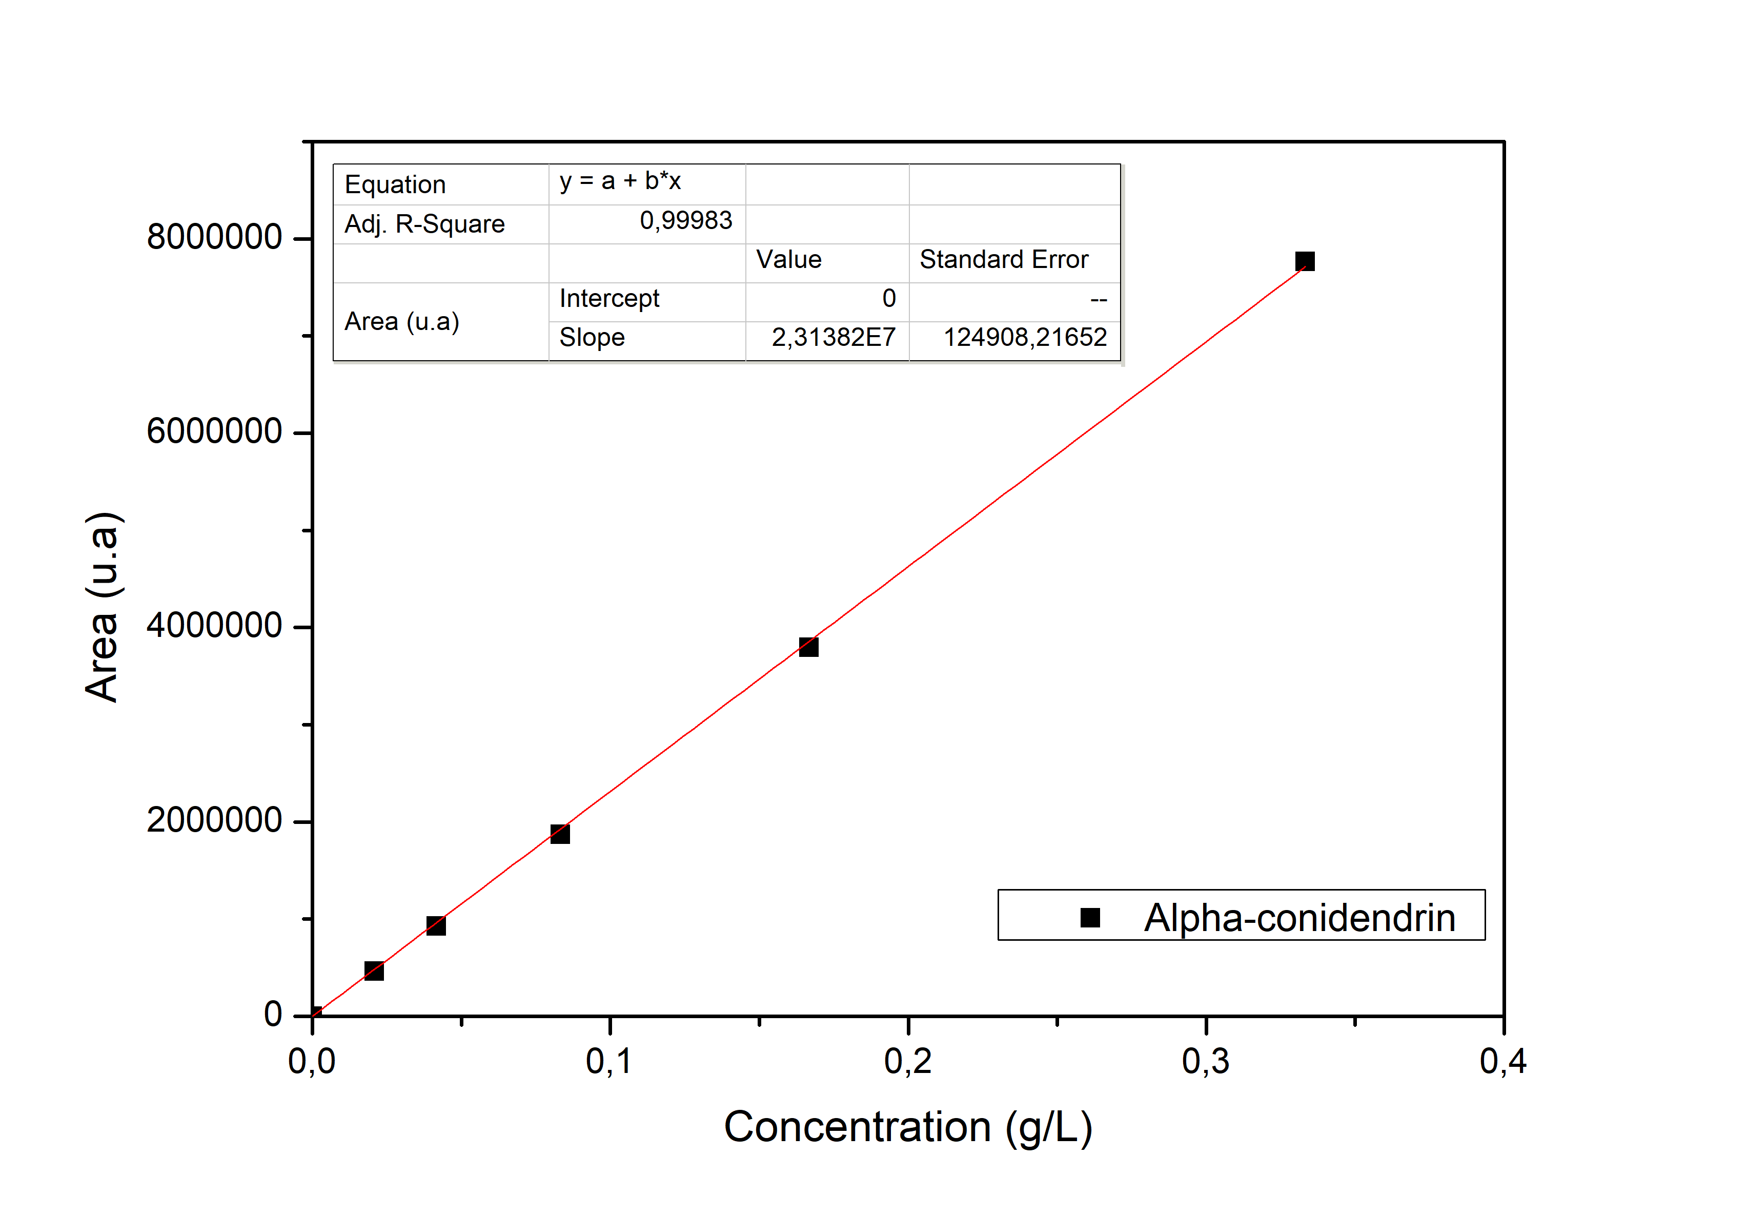

Figure S4: Calibration curve **Alpha-conidendrin**

Table S1: Retention time ofIdentified chemicals by HPLC-PDA

|  |  |
| --- | --- |
| **Retention time (min)** | **Chemical compounds** |
| 17.0 | Isolariciresinol |
| 17.6 | Coniferyl alcohol |
| 17.9 | Hydroxymatairesinol |
| 19.0 | Hydroxymatairesinol |
| 26.6 | Lariciresinol |
| 27.2 | Secoisolariciresinol |
| 28.0 | Nortrachelogenin |
| 32.9 | Guaiacol |
| 34.7 | α-conidendrin |
| 41.3 | Pinoresinol |
| 42.6 | Matairesinol |
| 42.7 | Enterodiol |
| 43.3 | Enterolactone |

**HPLC-UV Extracts**

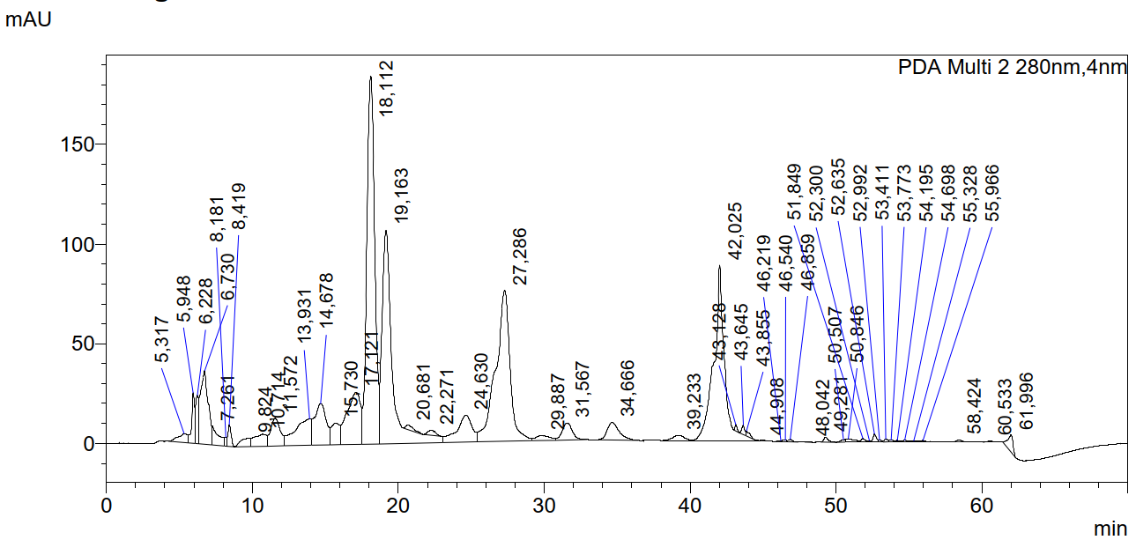

Figure S5: Single batch extract **(**40 mL of solvent, ethanol 15%, 40 °C, 1 g of wood)

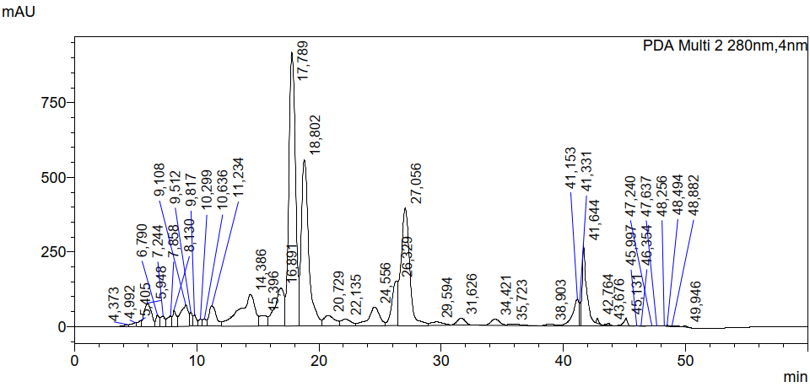

Figure S6: Simulated countercurrent**-**Fraction CC41

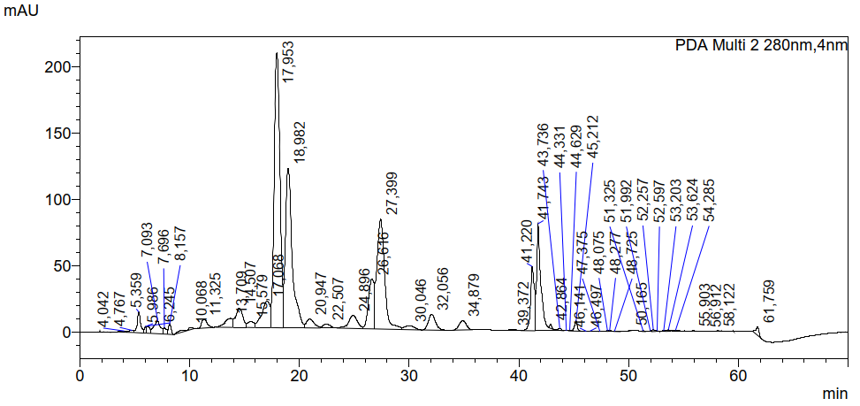

Figure S7: Percolation extract**-**Fraction 0-50 ml

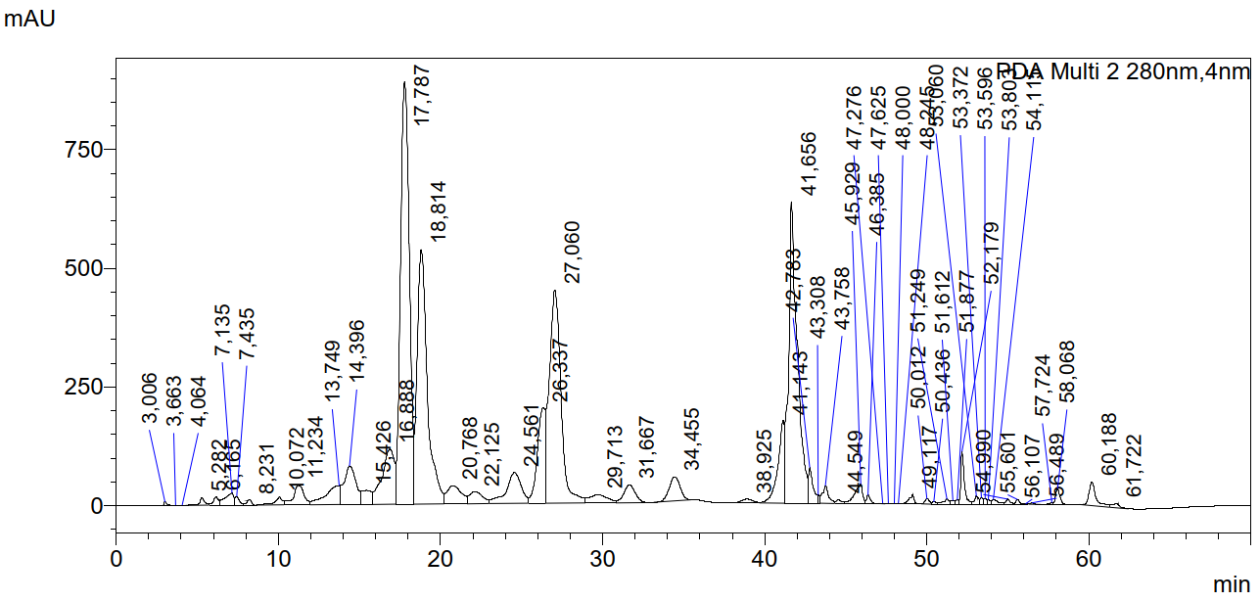

Figure S8:Supercritical extraction

(220 bar, dynamic time 120 min, static time 30 min, 40 °C, 40 mL of ethanol)

**GC-FID/MS Standards**

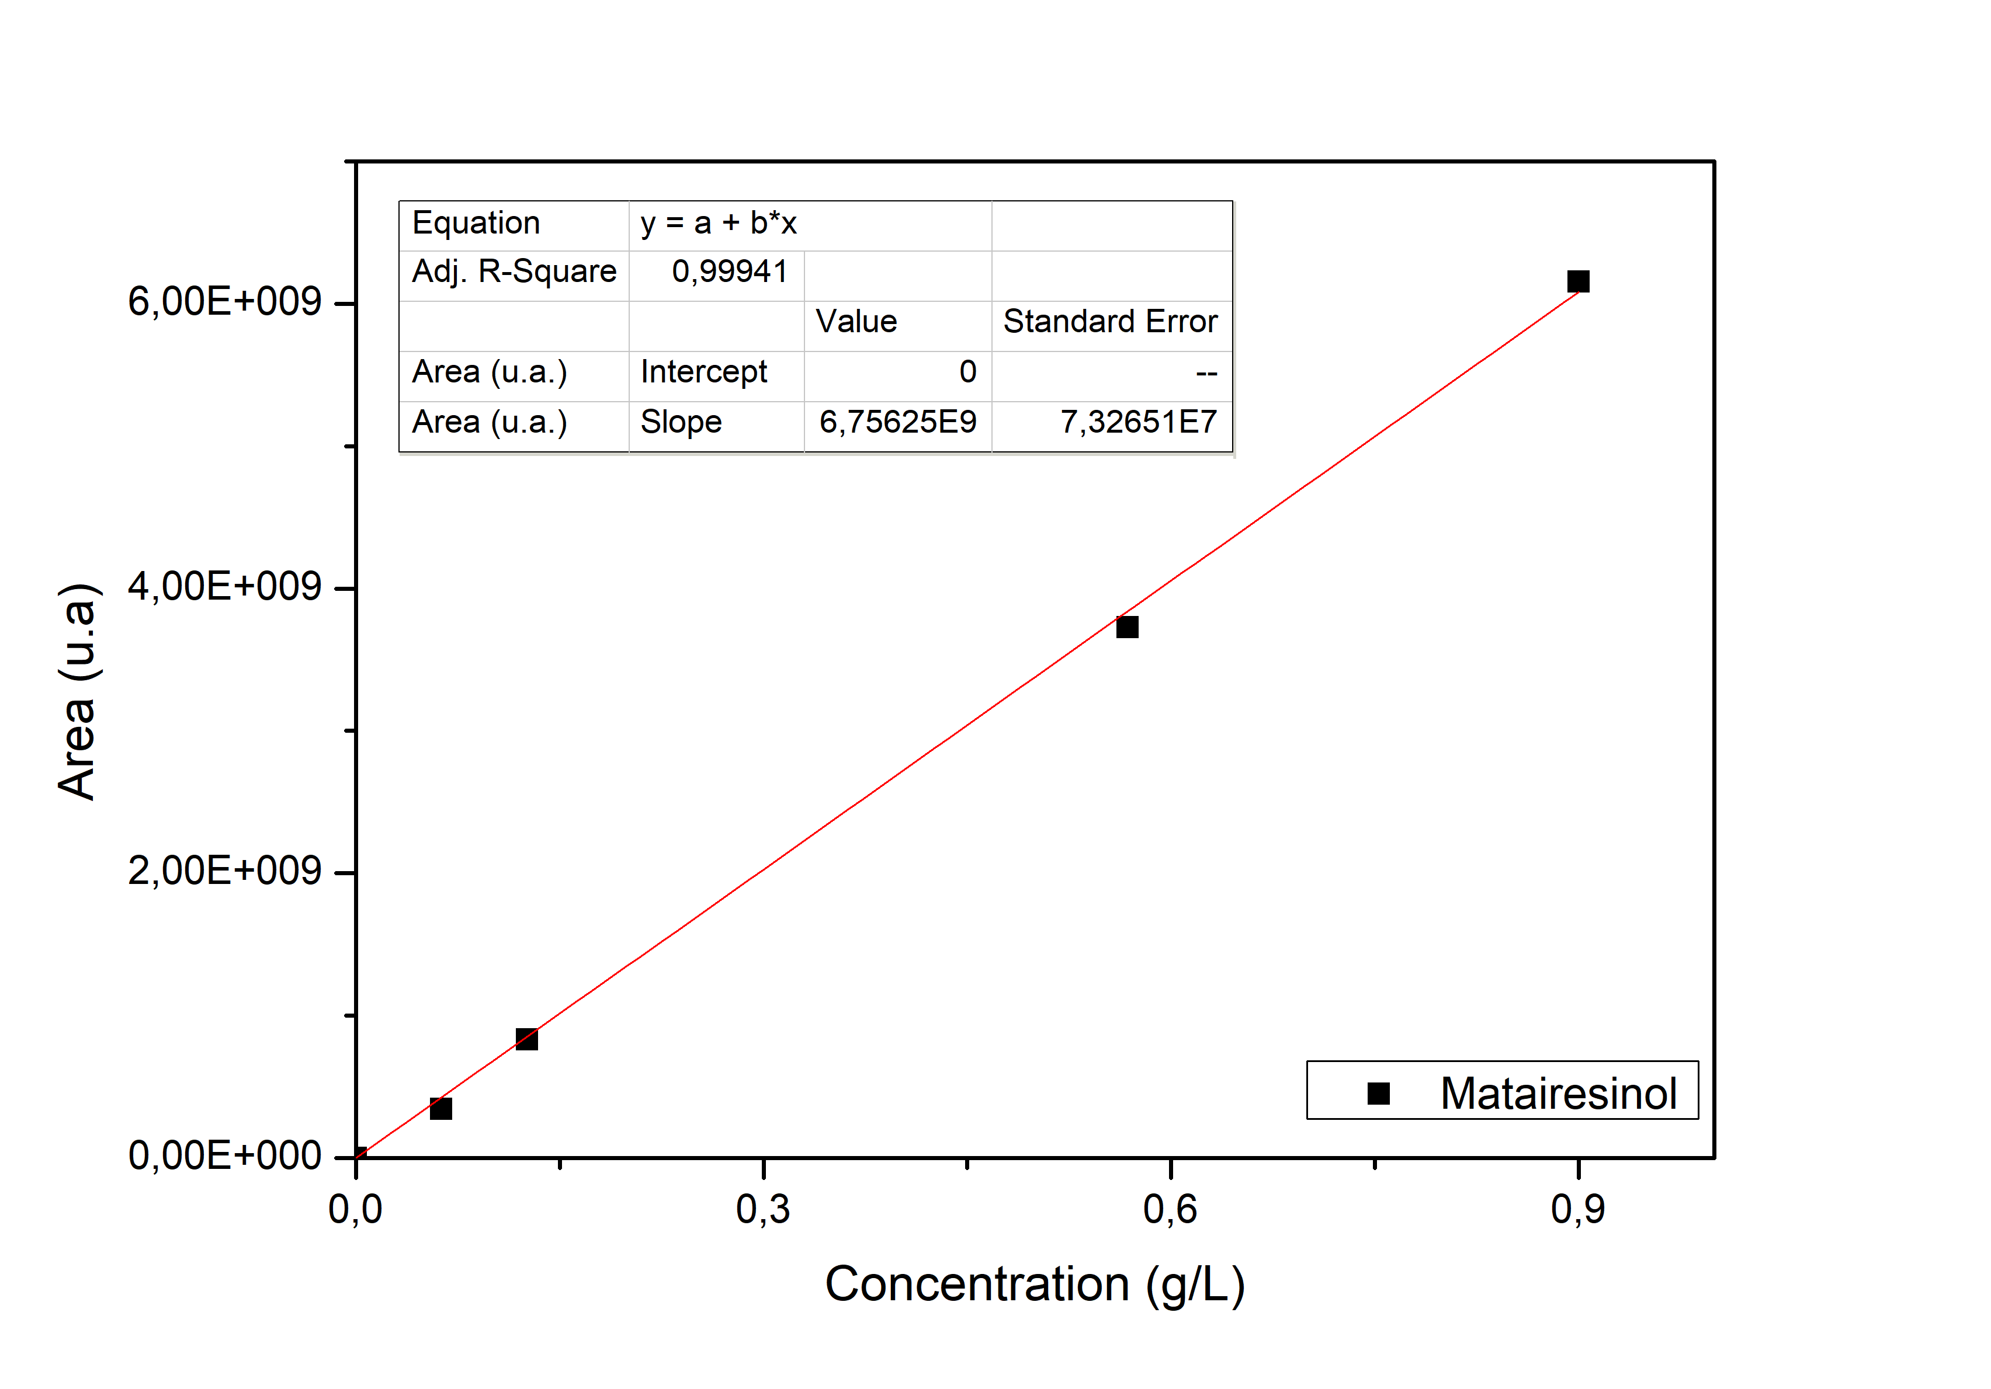

Figure S9: Calibration curve **Matairesinol (split 1:15)**

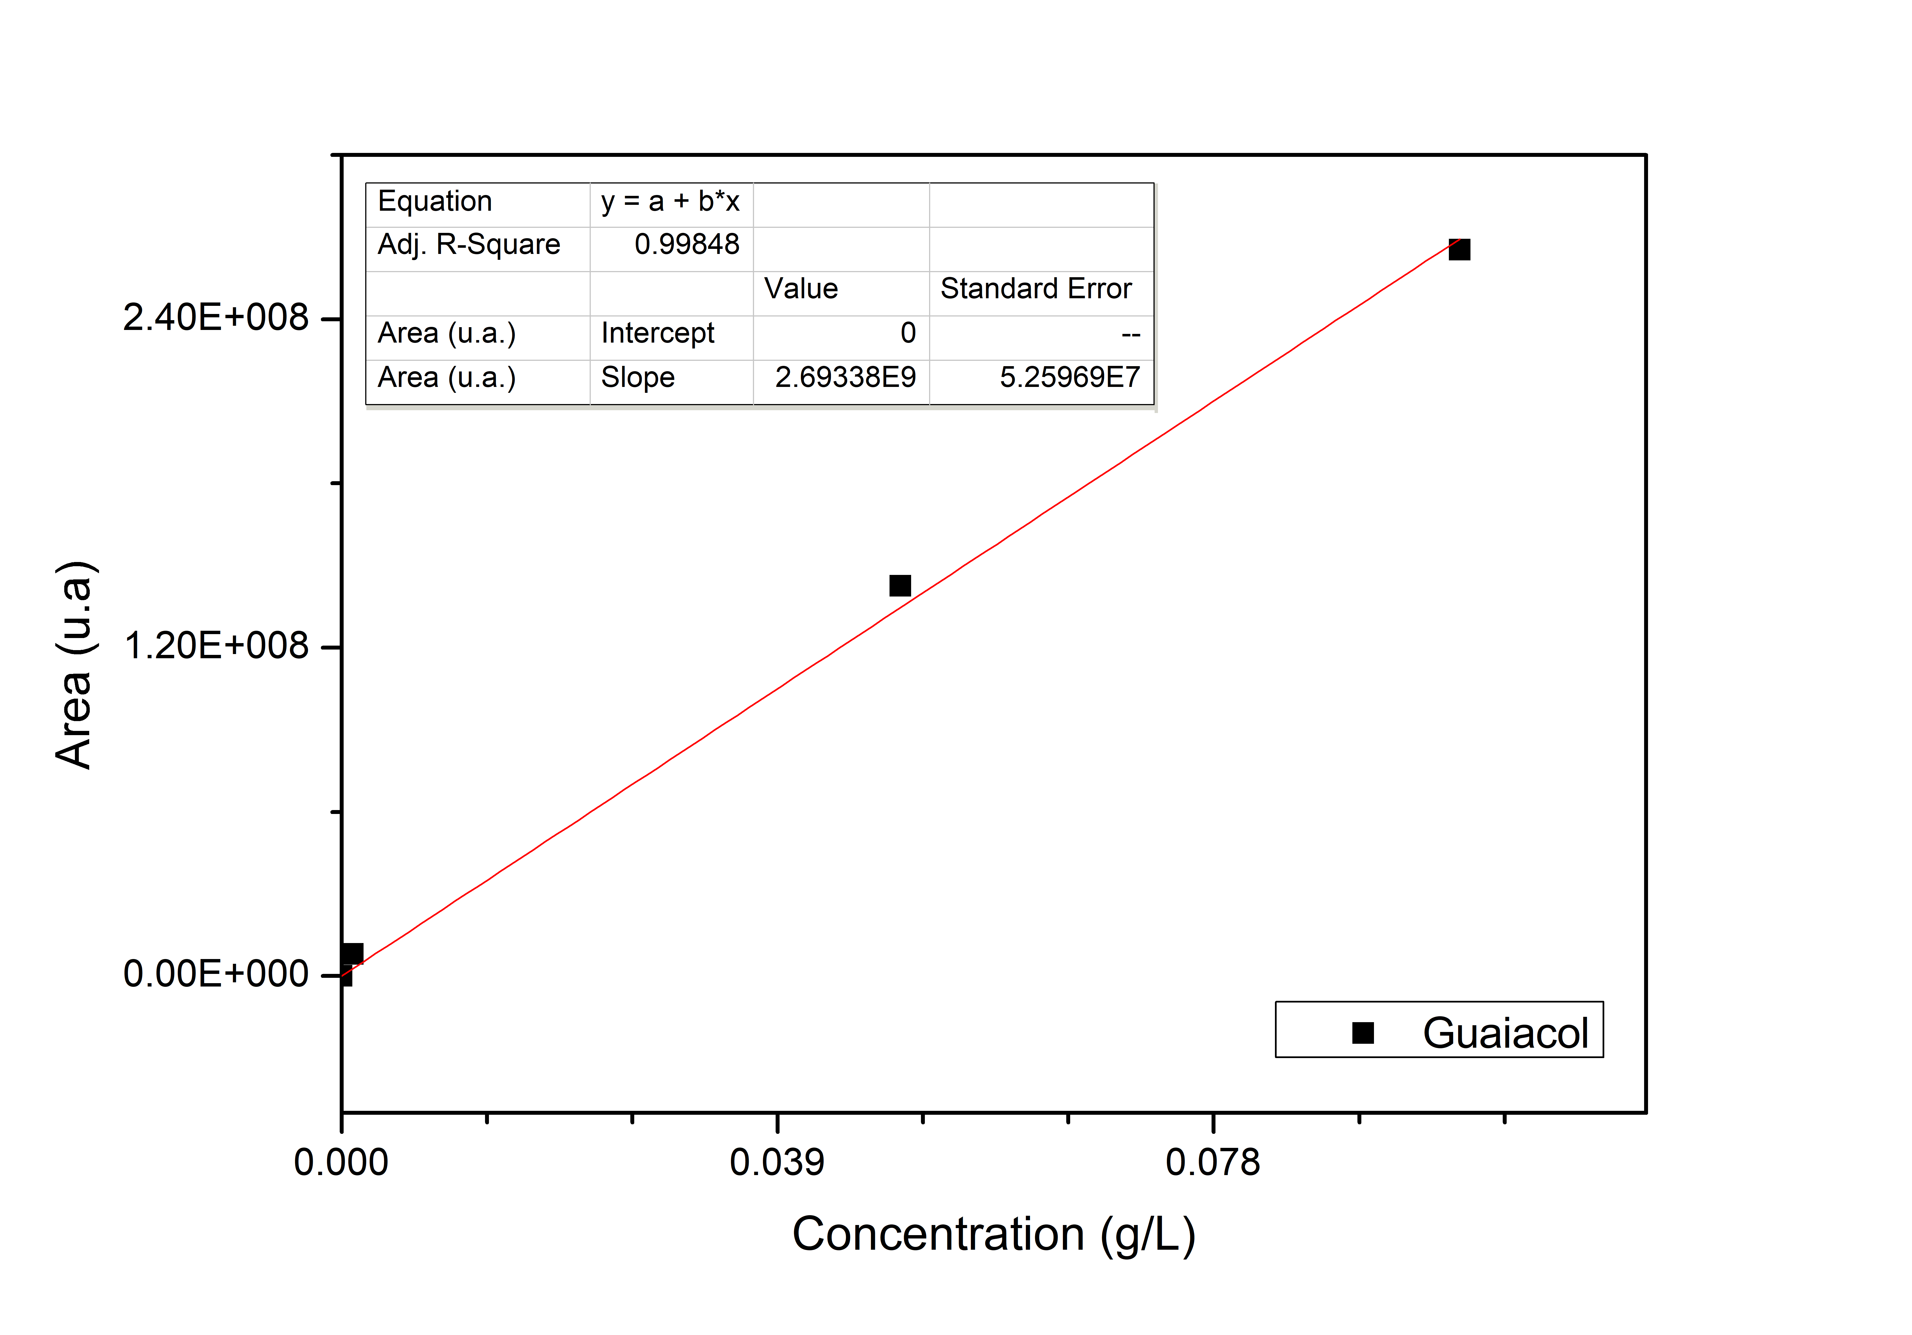

Figure S10: Calibration curve **o-Guaiacol (split 1:15)**

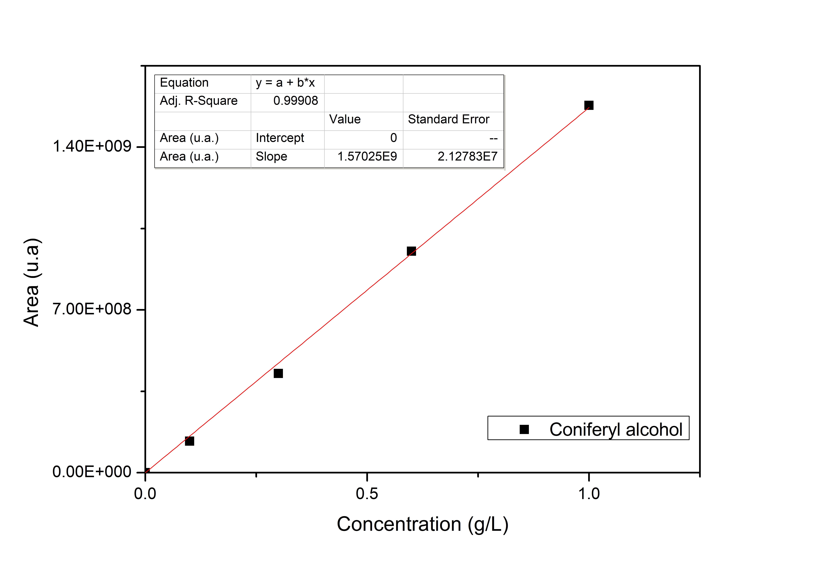

Figure S11: Calibration curve **Coniferyl alcohol (split 1:15)**

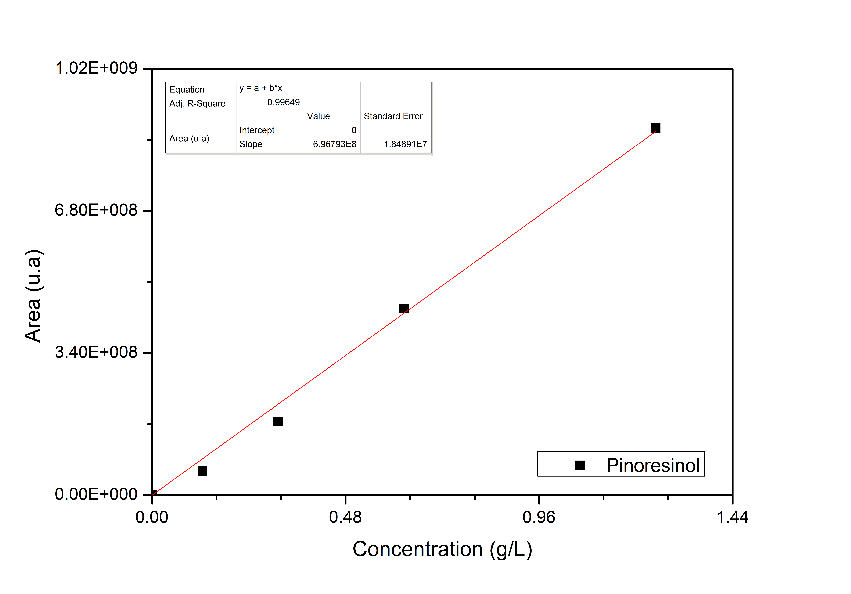

Figure S12: Calibration curve **Pinoresinol (split 1:100)**

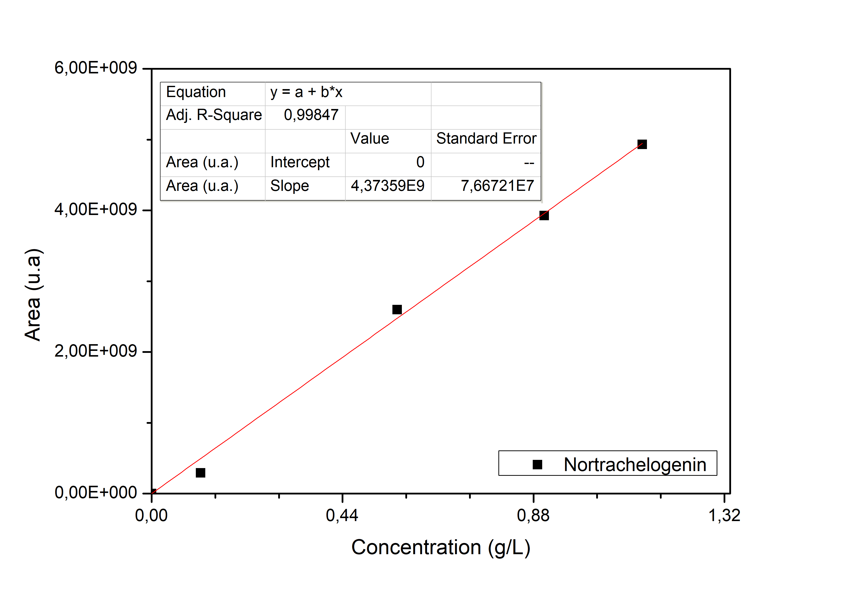

Figure S13: Calibration curve **Nortrachelogenin(split 1:15)**

FID/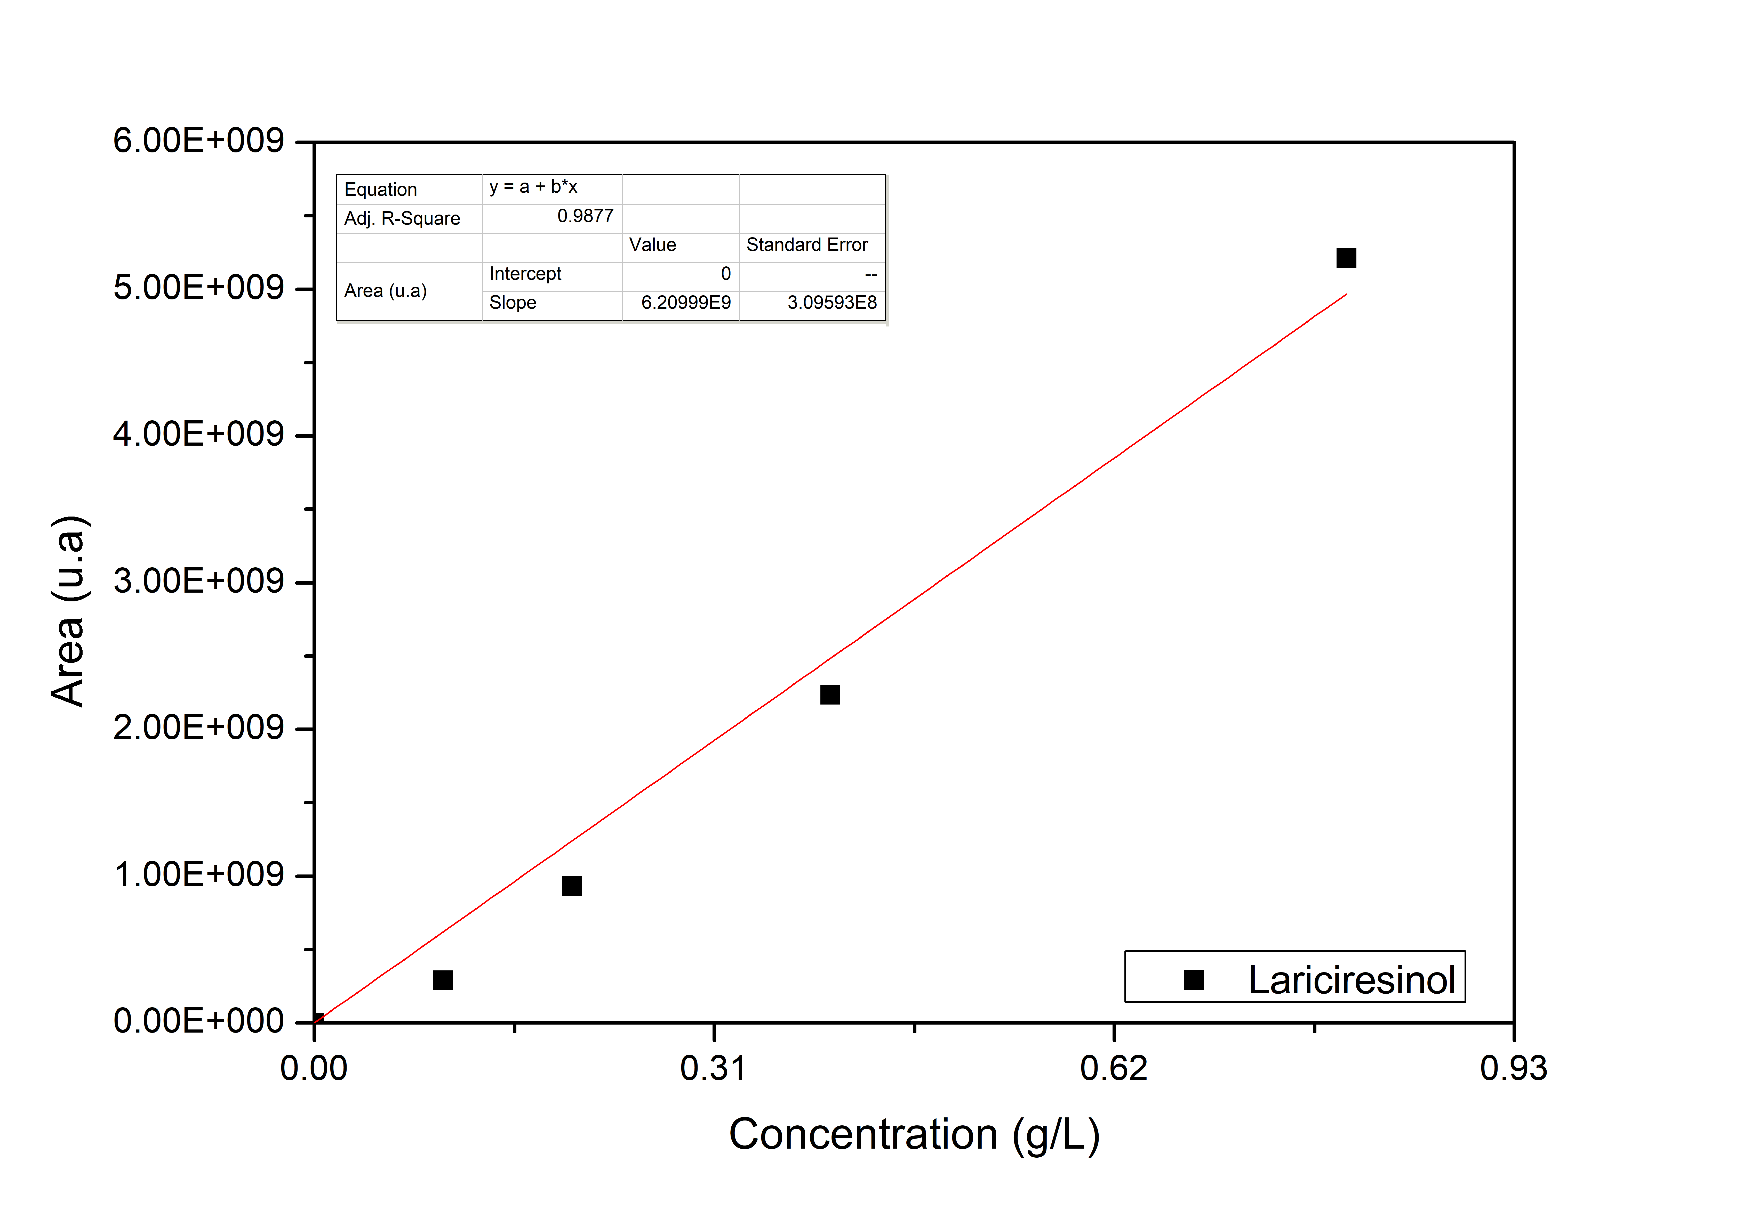

Figure S14: Calibration curve **Lariciresinol (split 1:15)**

**GC-FID/MS**

Figure S15: CO2-SC extract (40 °C, 220 bar, EtOH:30 mL)

*Table S2: Identified chemicals by GC-MS*

|  |  |
| --- | --- |
| **Retention time (min)** | **Chemical compounds** |
| 6.885 | Hexanoic acid |
| 7.644 | Eucalyptol |
| 8.174 | o-Guaiacol |
| 9.235 | Alpha-terpineol |
| 10.221 | Terpin-hydrate |
| 10.900 | Vanillin |
| 12.265 | Benzene butanoic acid,2,5-dimethyl |
| 12.420 | Nerolidyl acetate |
| 13.564 | Coniferyl Alcohol |
| 14.718 | Tumerone |
| 15.558 | Juvabione |
| 15.974 | DehydroJuvabione |
| 16.131 | Manool |
| 17.271 | 4'-methoxy-2-hydroxystilbene |
| 21.795 | Lignane1 |
| 22.307 | Lignane 2 |
| 23.427 | Lignane 3 |
| 25.244 | Lignane4 |
| 26.400 | Matairesinol |
| 26.568 | Hydroxymatairesinol |
| 27.295 | Nortrachelogenin |
| 27.986 | Hydroxymatairesinol |
| 28.484 | Secoisolariciresinol |
| 28.715 | Dehydro-Coniferyl alcohol |
| 29.728 | Lariciresinol |
| 30.070 | Isolariciresinol |
| 30.238 | Alpha-Conidendrin |
| 31.123 | HMR derivative |
| 33.459 | Gamma-Sitosterol |

**Identified mass spectra compounds**

**Hexanoic acid **

**Eucalyptol **

**o-Guaiacol**



**Alpha-Terpineol**



**Terpin-Hydrate**



**Vanillin **

**Benzene butanoic acid 2,5-dimethyl**



**Nerolidyl acetate**



**Coniferyl alcohol** 

**Tumerone** 

**Juvabione **

**DehydroJuvabione **

**Manool** 

**4'-methoxy-2-hydroxystilbene**



**Lignan 1**



**Lignan 2**



**Lignan 3**



**Lignan 4**



**Matairesinol **

**Hydroxymatairesinol 1**



**Nortrachelogenin **

**Hydroxymatairesinol 2**



**Secoisolariciresinol **

**Pinoresinol**



**Lariciresinol **

**Alpha-Conidendrin**



**Hydroxymatairesinol derivative**



Quantitative analysis of Soxhlet ethanol extract

Table S3. Experimental conditions of Soxhlet ethanol extraction

|  |  |
| --- | --- |
| Ethanol volume | 600 mL |
| Wood mass | 50.2768 g |
| duration | 8 h |
| Extract volume | 555 mL |

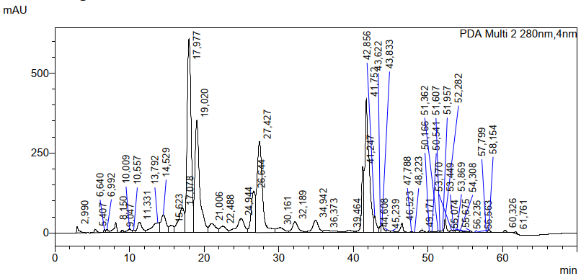

Figure S16: HPLC-PDA chromatogram of Soxhlet ethanol extract

Table S4. HPLC-PDA external quantitative analysis of Soxhlet ethanol extract

|  |  |  |  |  |  |
| --- | --- | --- | --- | --- | --- |
| Retention time  (min.) | Chemical compounds | Surface area | Calibration curve slope | C  (g/L) | m  (mg) |
| 17.98 | Hydroxymatairesinol-S | 22 263 477 | 25 195 682 | 1.767 |  |
| 19.02 | Hydroxymatairesinol-R | 15 825 854 | 15 488 497 | 2.044 |  |
|  | Hydroxymatairesinol-S+R |  |  | 3.811 | 2115 |
| 34.94 | α-conidendrin | 2 149 517 | 23 138 204 | 0.186 | 103.2 |

C = (surface area/slope) x 2

m=C x V(extract); m: extract chemical compound mass



Figure S17: GC-FID/MS chromatogram of Soxhlet ethanol extract

Table S5: GC-FID/MS external quantitative analysis of Soxhlet ethanol extract

|  |  |  |  |  |  |
| --- | --- | --- | --- | --- | --- |
| Retention time (min.) | Chemical compounds | Surface area | Calibration curve slope | C  (g/L) | m  (mg) |
| 29.728 | lariresinol | 423 108 442 | 6 209 990 002 | 0.273 | 151.3 |
| 26.400 | matairesinol | 441 276 326 | 6 756 250 096 | 0.261 | 145.0 |
| 28.715 | pinoresinol | 136 379 843 | 5 422 497 344 | 0.101 | 55.8 |
| 27.295 | nortrachelogenin | 49 353 972 | 4 373 591 181 | 0.041 | 25.1 |
| 8.174 | o-guaiacol | 42 068 376 | 9 600 753 944 | 0.018 | 9.7 |
| 13.564 | Coniferyl alcohol | 186 308 465 | 5 828 329 038 | 0.128 | 70.9 |

C = (surface area/slope) x 4

M = C x V(extract); m: extract chemical compound mass

Supercritical carbon dioxide extraction

Table S6. Supercritical extraction – P = 110 bar, tdynamic = 120 minutes

|  |  |  |  |  |  |  |
| --- | --- | --- | --- | --- | --- | --- |
| Temperature (°C) | 20 | 40 | 60 | 40 | 40 | 40 |
| tStatic (min) | 30 | 30 | 30 | 30 | 30 | 30 |
| VEtOH (mL) | 30 | 30 | 30 | 5 | 10 | 20 |
| m feed wood (g) | 8.88 | 8.70 | 8.77 | 8.52 | 12.44 | 8.85 |
| Feed wood water (wt %) | 11.00 | 11.00 | 11.00 | 11.47 | 11.47 | 11.31 |
| m raffinate wood (g) | 9.40 | 7.73 | 7.71 | 7.90 | 11.58 | 7.95 |
| raffinate wood water (wt%) | 4.48 | 2.71 | 2.51 | 5.44 | 4.74 | 3.38 |
| m CO2 (g) | 627.7 | 684.0 | 666.6 | 573.9 | 725.5 | 662.4 |
| m S1(g) | 11.71 | 12.81 | 13.48 | 1.42 | 3.30 | 6.34 |
| m S2(g) | 10.66 | 10.53 | 9.18 | 1.77 | 3.98 | 8.57 |
| mS1 dry (mg) | 185.3 | 198.7 | 244.8 | 39.2 | 68.6 | 121.5 |
| mS2 dry (mg) | 140.5 | 104.7 | 76.7 | 37.3 | 88.7 | 104.3 |
| m extractives ( mg) | 325.8 | 303.4 | 321.5 | 76.5 | 157.3 | 225.8 |
| m CO2(kg)/m extractives(g) | 1.9 | 2.2 | 2.0 | 7.5 | 4.6 | 2.9 |
| Mass balance(%) | 97.5 | 95.9 | 93.5 | 89.2 | 92.7 | 92.8 |

Mass balance (%) = ((raffinate+m S1+ m S2)/ (m feed +m EtOH)) x 100

Table S7. Supercritical extraction – P = 220 bar, tdynamic = 120 minutes

|  |  |  |  |  |  |  |  |  |  |  |  |  |
| --- | --- | --- | --- | --- | --- | --- | --- | --- | --- | --- | --- | --- |
| Temperature (°C) | 20 | 40 | 60 | 40 | 40 | 40 | 40 | 40 | 40 | 40 | 40 | 40 |
| tStatic (min) | 30 | 30 | 30 | 30 | 30 | 30 | 30 | 30 | 30 | 0 | 120 | 240 |
| VEtOH (mL) | 30 | 30 | 30 | 0 | 5 | 10 | 20 | 25 | 40 | 30 | 30 | 30 |
| m feed wood (g) | 8.75 | 9.07 | 8.71 | 8.75 | 8.39 | 8.86 | 8.96 | 8.81 | 8.85 | 8.59 | 8.81 | 8.80 |
| Feed wood water (wt%) | 11.00 | 11.31 | 11.00 | 11.00 | 11.31 | 11.31 | 11.31 | 11.00 | 11.31 | 11.00 | 11.00 | 11.00 |
| m raffinate wood (g) | 8.02 | 7.96 | 7.61 | 8.00 | 7.62 | 8.05 | 8.00 | 7.91 | 7.54 | 7.50 | 7.92 | 7.68 |
| raffinate wood water (wt%) | 4.44 | 2.80 | 2.61 | 2.52 | 2.64 | 2.53 | 3.24 | 3.10 | 2.47 | 2.63 | 3.47 | 2.39 |
| m CO2 (g) | 689.4 | 633.6 | 670.2 | 646.8 | 648.6 | 678.1 | 663.0 | 687.6 | 631.2 | 629.4 | 613.8 | 652.8 |
| m S1(g) | 9.04 | 11.52 | 10.34 | 0.14 | 2.13 | 3.63 | 9.08 | 12.77 | 9.82 | 11.78 | 12.34 | 11.89 |
| m S2(g) | 13.42 | 10.60 | 12.29 | 0.48 | 1.66 | 3.68 | 6.05 | 4.74 | 18.20 | 11.02 | 10.55 | 11.32 |
| mS1 dry (mg) | 160.3 | 204.6 | 179.4 |  | 55.4 | 71.3 | 149.7 | 240.7 | 170.1 | 195.8 | 198.1 | 227.0 |
| mS2 dry (mg) | 205.0 | 151.3 | 150.5 |  | 41.6 | 67.0 | 101.1 | 67.4 | 280.9 | 165.0 | 133.5 | 149.3 |
| m extractives ( mg) | 365.3 | 355.9 | 329.9 | 5.0 | 97.0 | 138.3 | 250.8 | 308.1 | 451.0 | 360.8 | 331.6 | 376.3 |
| m CO2(kg)/m extractives(g) | 1.9 | 1.8 | 2.0 | 129.9 | 6.7 | 2.7 | 2.6 | 2.2 | 1.4 | 1.7 | 1.8 | 1.7 |
| Mass balance (%) | 93.9 | 91.8 | 93.3 | 102 | 92.8 | 91.5 | 93.5 | 89.1 | 87.9 | 91.6 | 94.8 | 95.0 |